ENGR 115 Unity Project
Modeling Spring-Mass Systems

Project Description
Many engineering systems can be modeled as a mass-spring-dashpot model as shown in Figure 1 below. One real-life example of this is the suspension system in a car. In this model, there is a mass (m) with an applied force as a function of time (f(t)), a spring with a constant k that stores and releases energy according to F = kx where x is the displacement, and finally the dashpot with constant c that dissipates energy. Energy dissipation can also be related to friction.
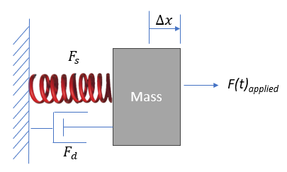
Fig. 1: Schematic a mass-spring-dashpot system
Figure 2 illustrates the force balance for this model. For an applied force (F(t)) there is a displacement x and a spring force operating in the opposite direction of the displacement. That force is proportional to the displacement via the spring stiffness, k. There is also a friction force that resists motion. This project builds a basic simulation of this model system using Unity. Project Requirements and a list of module-by-module task is described below.
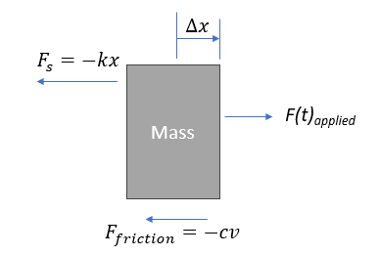
Fig. 2: Freebody diagram of a mass-spring-dashpot system

Requirements
- The simulation shall model a spring-mass system with friction
- The simulation shall enable the user to enter force values.
  - In Module 7 the simulation shall enable the user to input the force value directly from the Inspector Panel
  - In Module 8 and 9 the simulation shall allow force input from a keyboard entry
- The Simulation shall display information to the screen as described below in Module 8
- The simulation shall record force and displacement data to an comma separated values (CSV) file.

Module Tasks
Module 7: Finding The Spring Stiffness Parameters.
Actions:
- Create a new project titled “Modeling a Spring Force System (your last name)”.
- Download the Unity package in the resources provided and drag it into your assets folder. This package contains a spring-mass model prefab in addition to the grid projector package and physics materials.
- Place a copy of the spring-mass model prefab in a new scene as shown in Fig 3.
- Insert a plane and place the mass right on top of it. Apply the smooth physics material on the plane. Pick a color of your choice for the plane.
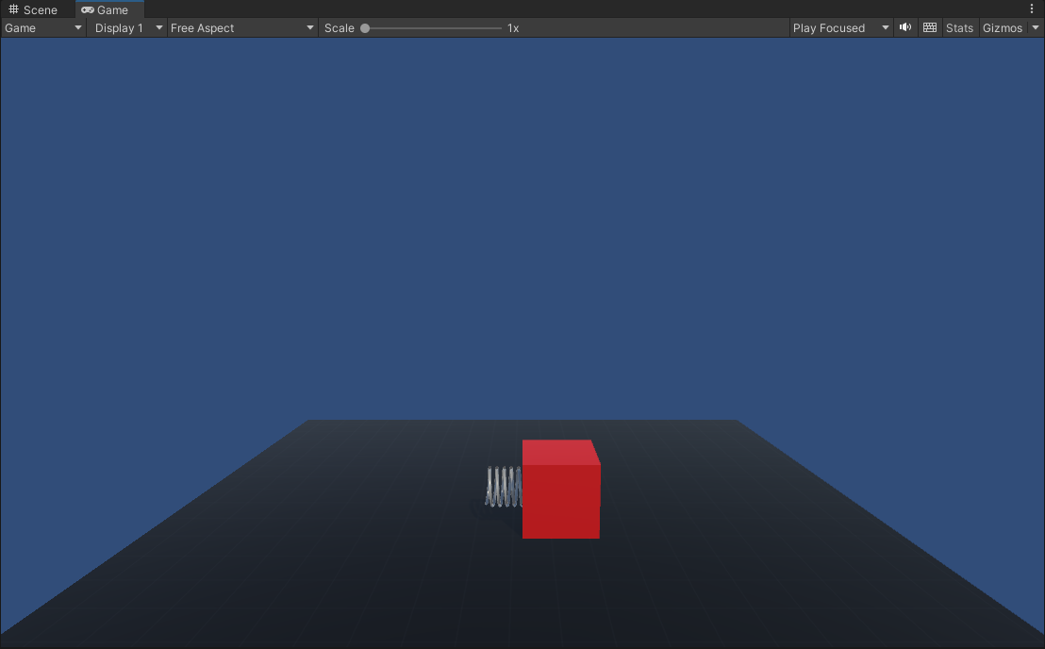
Fig. 3 – Starting Configuration of the Spring-Mass Model
    - The spring mass system controller script is attached to the SpringMassSystemController.cs. Starting with that, add required variables and instructions to move the object by applying a force. This force is computed using the following equation:

$$F_{onmass}=appliedForce-k*(∆x)$$

- These are the instructions you will need to add to make this happen.
  - Add these lines above the Start() method where it shows “Student Updates Here”

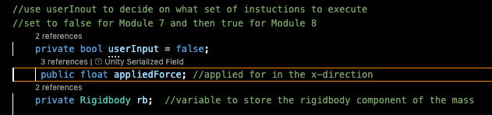

  - Add these lines to the Start() method where indicated by “Student Additions”
  - Add these instructions to the Module 7 task part in the script
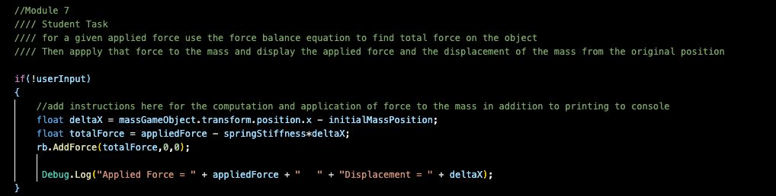

    - You are now able to incrementally increase the applied force in the Inspector panel to the spring-mass system and record the displacement for several values. Create a plot such as shown below in Figure 4. Include a linear interpolation to find the slope, which corresponds to the spring stiffness. In the example below, the spring stiffness would equal approximately 16 N/m.
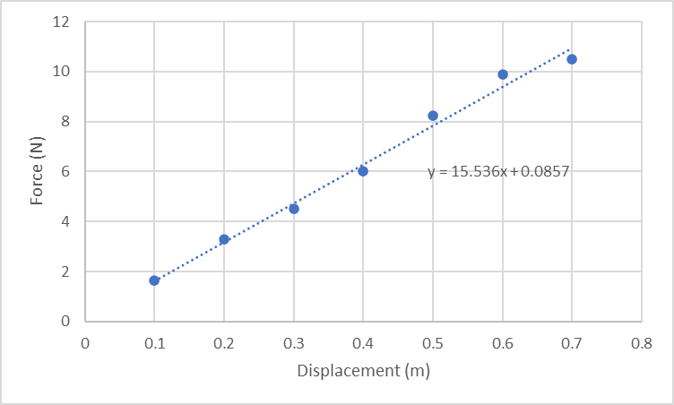
Fig. 4 – Sample Force vs. Displacement curve showing how to find the slope
- Deliverables
  - The updated SpringMassSystemController script.
  - Create a PDF document showing the simulation in action (i.e., images of a few loads being applied), the graph of Force vs Displacement, and the value of the spring stiffness k with proper units. Report the results in metric units. Add at least one paragraph that describes the images and results.
Module 8: Creating User Interface
Actions:
- Here you will apply the player input manager shown in the instructional material to control the applied force.
- Update the SpringMassSystemController script by adding controller inputs to incrementally increase the force and then release it. This can be done by pressing an arrow key or some key shown in the controller mapping slide. You must use the player input manager shown in the instructional material for this.
  - Class Level Instructions
    - Change the userInput Boolean to true
    - Add the player input manager variable as shown below
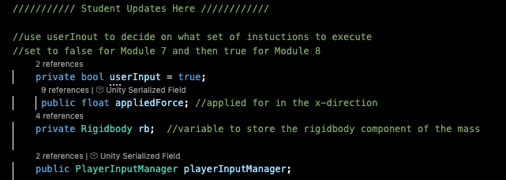
  - In the FixedUpdate() method add the following in the section titled Module 8
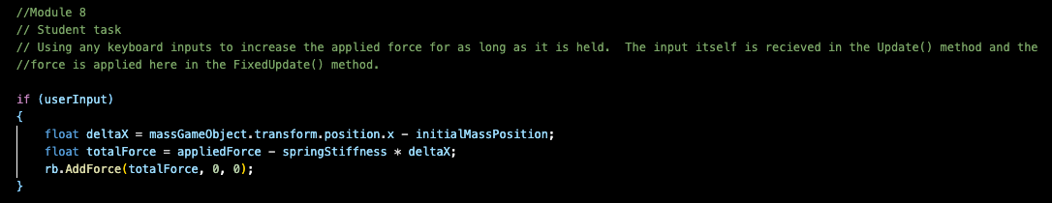
- Add this set of instructions to the Update() method
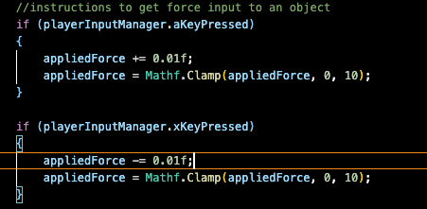
- Create a Canvas and create a DataManager Script using the template provided. Display the following data to the screen as illustrated in Figure 5:
  - Force (N)
  - Displacement (m)
  - Time (s)
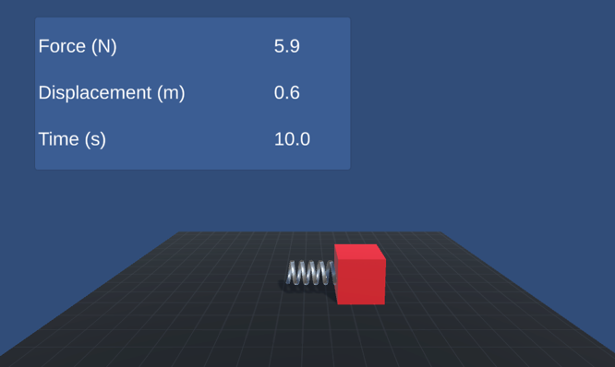
Fig. 5 – Example of Canvas Informational Display
- Deliverables
  - A narrated video showing the simulation being exercised.
  - The updated SpringMassController and DataManager scripts.
Module 9: Using the simulation to investigate the system response.
Actions:
- Change the plane physics material to the Rough material supplied in the assets package.
- Record applied force vs displacement data in a CSV file. Then add this data to the graph created earlier, so you have two sets of data on the single graph. One with a smooth surface and with the rough surface.
Deliverables:
- As specified in the assignment deliverables, and the final SpringMassSystemController and DataManager scripts.

