ENGR 115: Module 7
Problem 2: Exploring Physics Materials and Applying Forces
Problem Definition
- Comparing Friction Materials
  - Create multiple cube objects to conduct these exercises.
  - Create two different physics materials. Take a snapshot of their parameters to include in your submission with an explanation of the differences.
  - Keep the applied force the same but vary the mass. Observe and explain the motion of each considering the concept of F = ma
  - Show how the behavior varies for two objects moving on the surface. One of these has the same physics material as the surface, while the second is the other material.
- Comparing Bouncy Materials
  - Create two materials with different bounciness. Create two spheres and explore the result when the surface and the material have the same bounciness and when they are different (i.e., bounciness of the sphere is not the same as the bounciness of the plane).
  - Apply an impulse force to the spheres so they follow something close to a parabolic arc as shown in the image below. This will require you to set the add force vector with a non-zero y-component. Then add an x or z (or both) component. When they are combined, it will result in an impulse force as shown in the example in Figure 1.
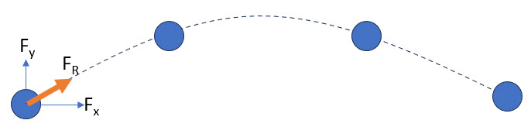
Figure 1 – Example arc traversed by a sphere with an impulse force applied.

