ENGR 115: Module 7
Problem 1: Kinematics: Circular Motion
Problem Definition
Consider an object moving in a circular motion as shown in the image. To achieve this motion the object rotates about its own axis, θ, and also moves forward in the x direction.
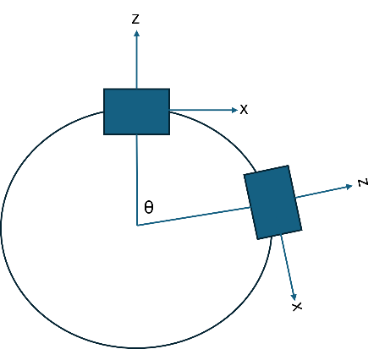
Figure 1. Object in Circular Motion as Viewed from Above
The motion of the object is described by the following equation.
$$v= \frac{2πr}{T}$$
Where:
v is the velocity of the object.
r is the radius of the circle.
T is the period (in secs) to complete a full circle (360 degrees).
Problem Task
Create a script named MoveObject_CircularMotion.cs, and fill in the necessary instructions so that the object does the following:
- Computes the rotation speed for a given radius and velocity. The rotation speed is calculated as follows:
$$\dot{θ=360/((2*π*r)/v)}$$
- Uses the computed rotation speed and velocity in the transform.Rotate and transform. Translate methods, respectively. This will result in the object moving in a circle as shown in the figure.

Compute
- For the object in motion compute the radius of the circle using:
$$r=\sqrt{x^{2}+z^{2}}$$
Where float x = transform.position.x and float z = transform.position.z
- There will be an error between the desired radius and actual radius obtained by the object. The size of the error will be dependent upon the given speed and radius. Then, compute error from the desired goal and display it to the console. Use the following equation to find the error.

$$\%error=\frac{\left|actual radius-desired radius\right|}{desired radius}*100$$

- Display both results to the console using the following command:
Debug.LogFormat("radius = {0:F2} error = {1:F2}", actualRadius, error);

