Word Count: 4000 words

Ethical Debates in Marketing & Advertising
Your academic research topic will be on Ethical Debates in Marketing & Advertising. Conduct a literature review and critically evaluate the potential ethical issues and consequences with the improper use of Social Media Marketing and CSR Marketing.
In your report, showcase TWO (2) NEGATIVE Case Studies that uncover the ethical problems behind their bad marketing, how the unknowing customers fall for such tactics and the ramifications. Discuss how we can better regulate and promote ethical marketing.

Main Topic uses 7BP Ethics Model
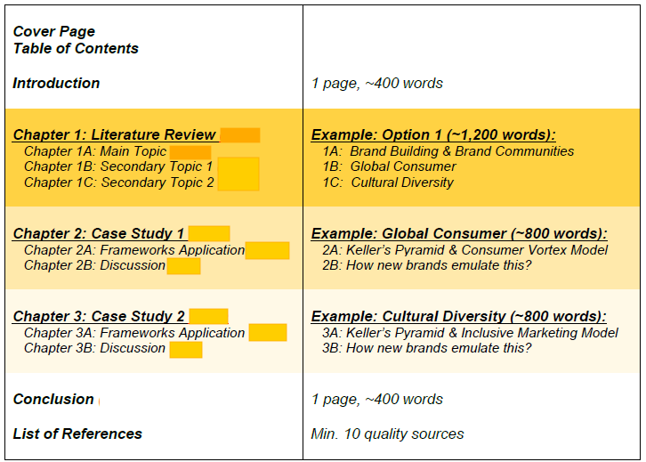

Building Your Case Study (Example)
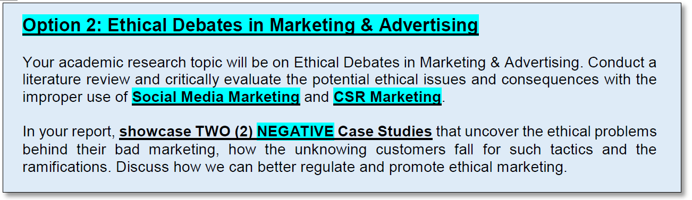
First run through the topical checklist and select the applicable issues…
Apart from the secondary issues of improper social media marketing and CSR marketing, what other types of ethical issues are involved in your selected case studies?

Functional  Areas | Sub-Disciplines  of Marketing | Specific Ethics  Related Topics
☐ Product  ☐ Price  ☐ Placement  ☐ Promotion | ☐ Sales  ☐ Consumer/Consumption  ☐ International Marketing  ☐ Ethics Education  ☐ Marketing Research  ☒ Social Marketing*  ☒ Internet Marketing*  ☐ Law & Ethics | ☐ Ethics & Society  ☐ Ethical Decision Making  ☐ Ethical Responsibility towards Stakeholders  ☐ Ethical Values  ☐ Norm Generation & Definitions  ☐ Marketing Ethics Implementation  ☐ Ethics & Religion  ☐ Discrimination & Harassment  ☒ Green Marketing*  ☐ Vulnerable Consumers

BLANK TEMPLATE:
Functional  Areas | Sub-Disciplines  of Marketing | Specific Ethics  Related Topics
☐ Product  ☐ Price  ☐ Placement  ☐ Promotion | ☐ Sales  ☐ Consumer/Consumption  ☐ International Marketing  ☐ Ethics Education  ☐ Marketing Research  ☐ Social Marketing  ☐ Internet Marketing  ☐ Law & Ethics | ☐ Ethics & Society  ☐ Ethical Decision Making  ☐ Ethical Responsibility towards Stakeholders  ☐ Ethical Values  ☐ Norm Generation & Definitions  ☐ Marketing Ethics Implementation  ☐ Ethics & Religion  ☐ Discrimination & Harassment  ☐ Green Marketing  ☐ Vulnerable Consumers
For Example:
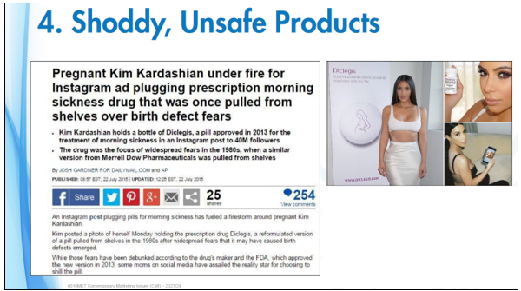
Diclegis Case Study

Practice Exercise:
Functional  Areas | Sub-Disciplines  of Marketing | Specific Ethics  Related Topics
☒ Product  ☐ Price  ☒ Placement  ☐ Promotion | ☐ Sales  ☒ Consumer/Consumption  ☐ International Marketing  ☒ Ethics Education  ☒ Marketing Research  ☒ Social Marketing  ☒ Internet Marketing  ☒ Law & Ethics | ☒ Ethics & Society  ☒ Ethical Decision Making  ☐ Ethical Responsibility towards Stakeholders  ☐ Ethical Values  ☐ Norm Generation & Definitions  ☒ Marketing Ethics Implementation  ☐ Ethics & Religion  ☐ Discrimination & Harassment  ☐ Green Marketing  ☒ Vulnerable Consumers

7BP Ethics Model
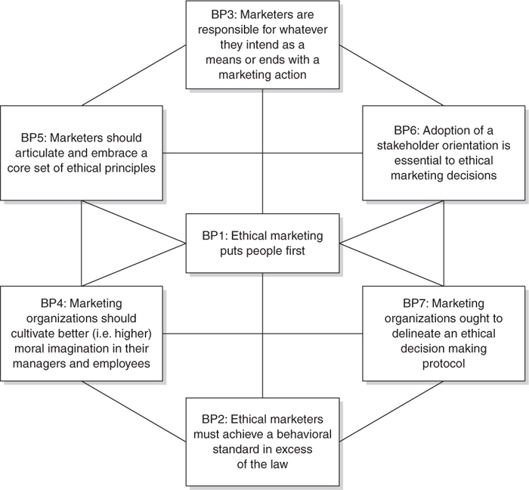

Laczniak & Murphy (2006)

BP1: Ethical marketing puts people first.
BP2: Ethical marketers must achieve a behavioural standard in excess of the law.
BP3: Marketers are responsible for whatever they intend as a means or ends as a marketing action.
BP4: Marketing organisations should cultivate better moral imagination (awareness / understanding) in their managers & employees.
BP5: Marketers should articulate and embrace a core set of ethical principles.
BP6: Adoption of a stakeholder orientation is essential to ethical marketing decisions.
BP7: Marketing organisations ought to delineate an ethical decision-making protocol.

Reading Reference Example:

BP1 | Q: Did the marketers put the customers/people first? NO  What was done Wrongly:  The company and influencer (Kim K) put their own personal interests and profits before the care and safety oft their customers and the general public.  What should have been done instead:  Both the company, Kim K herself and her team should have carefully vet thru all outbound marketing mes
BP2 | Q: Did the marketers behaved ethically in excess of the law? NO  What was done Wrongly:  The problematic IG post had violated the FDA’s guidelines for marketing and promotion of a controlled prescription drug.  So it wasn’t even legal to begin with.  What should have been done instead:  Firstly, the contents of the IG post must have been legal to begin with! All visuals and copywriting must have been proofread and ensured to be legally compliant.  Additional steps from there on the ensure that the further communications indicate clearly all health risks involved and what other steps that customers can take.  Advising customers to only make a decision after consulting with their doctors. Ensuring that customers are not forced or coerced
BP3 | Q: Were the marketers responsible for their actions throughout the incident case study?  What was done Wrongly:  Kim K deleted her initial post and subsequently posted a corrected ad on her IG. No formal apology was issued.  Kardashian-West claimed she linked out to all the relevant information at the bottom of the post, but this wasn’t “sufficient” according to FDA.  What should have been done instead:  Both the company and Kim K has underestimated the severity of the problem and instead of apologising for their misleading and potentially dangerous ad campaign, they only “corrected” it and continued with the campaign. This shows signs of not recognising the risk involved to their customers and general public. The success of the campaign (which is to promote medicine sales) was more important than anything else.  Instead, the company and Kim K should have changed their campaign direction ad gone for a more educational style to inform and allow young expectant mothers to learn and fully understand the situation and all risks involved in such medication.
BP4 | Q: Did the marketing organisation cultivate better moral imagination amongst their managers and employees? NO  What was done Wrongly:  The fact that they continued with the campaign without apologising without changing their strategy, is a clear indication that they didn’t learn their lesson. The kickback from customers,  What should have been done instead:
BP5 | Q: Did the marketers have a core set of ethical principles as part of their working process?  What was done Wrongly:  The company has valued product sales and profits above their customers’ safety. They also did not have any internal checks to prevent such a basic mistake from happening. Especially considering the company is a MNC with over 50 years of experience, operating in over 50 countries, surely they must be aware of the multitudes of legal compliance they must adhere to.  What should have been done instead:  The company can either make use of the guidelines set by FDA
BP6 | Q: Did the marketers evaluated their stakeholder concerns? NOT FULLY  What was done Wrongly:  Company & Kim K (themselves): product promo -> product sales -> profits  Govt: illegal campaign  Customers: put them at risk  Investors: put company ‘s reputation at risk  What should have been done instead:
BP7 | Q: Did the marketing organisation operate under a prescribed ethical decision-making protocol?  What was done Wrongly:  It is clear that they did not have a comprehensive or complete protocol. Otherwise, such a simple non-compliance mistake wouldn’t happen.  What should have been done instead:  Have a team of compliance and legal counsel to oversee the creation or review of a ethical decision-making protocol, to include all new FTC, FDA and AMA regulation and guidelines. Alongside with the multi-stakeholder review checklist as well.

