COIT20256 Assignment 1 Report

Student ID
Student Name

This coversheet must be completed with your submission.
Please check (X) to indicate that you have satisfied these requirements

☒ This work and my programming submission are my original work and no part of it has been copied from any other student’s work or any other source.
☒ No part of this work or my code has been written for me by any other person/student.
☒ I have taken proper and reasonable care to prevent this work and my code from being copied by another student.
☒ I acknowledge that it is my responsibility to check that the file submitted is readable and complete and that the code submitted can be uploaded in NetBeans and will compile and run correctly.
☒ I understand that plagiarism also includes the act of assisting or allowing another person to plagiarise or to copy my own work.

Description of the Program and Phase Completed
Gradebook is a console application that shows students’ performance statistics, bringing statistical functionalities like median, max, min, etc. It has been developed using the incremental approach in four major phases where each subsequent phase is an improvement of the previous. This report outlines three major parts:- a brief description of the phased approach, including screenshots, the code documentation generated from javadoc and testing plans and results.
Phase 1 completed:
In Phase 1, the fundamental class structure was implemented according and without altering the provided UML class diagram. This phase established the framework for the application, with classes created for GradeBook, StudentRecord, View and a test class Assignment1(the entry point of the application). Each class was populated with dummy/skeleton methods that returned default values.
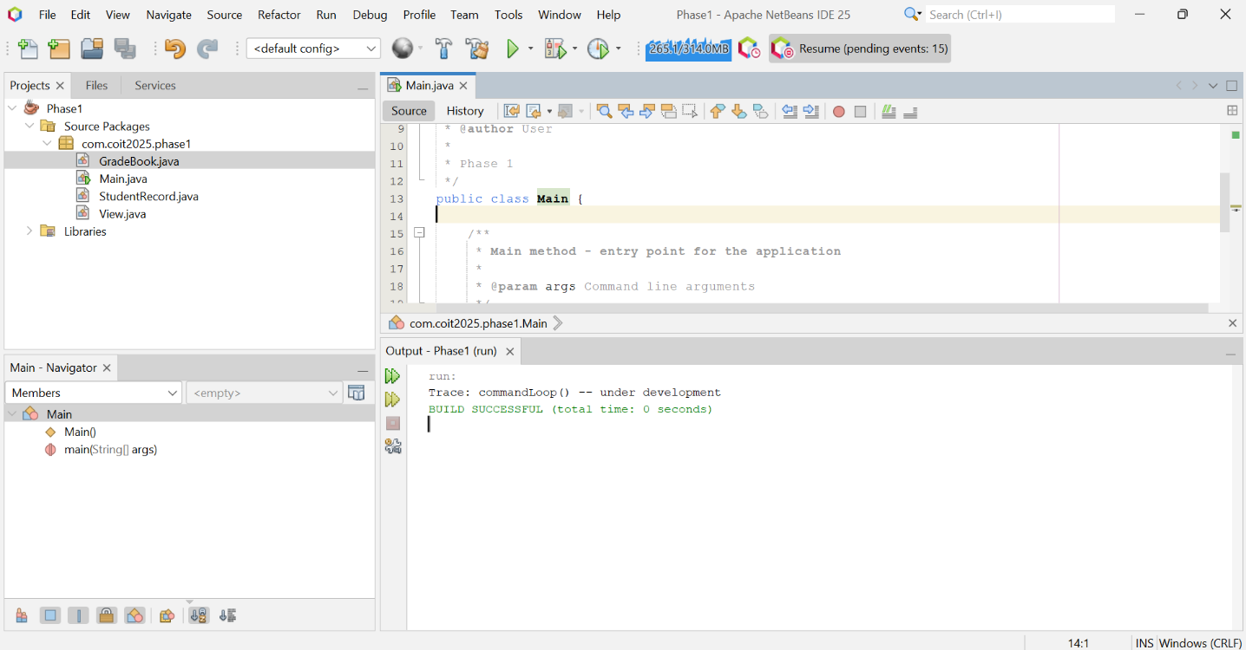
Figure 1: Phase 1
Phase 2 completed:
Phase 2A focused on implementing the command loop with trace statements to verify the menu selection functionality.
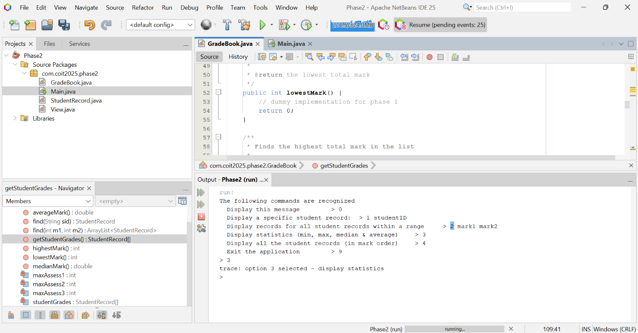
Figure 2: Phase 2a
Phase 2B extended this by invoking the GradeBook's dummy methods and displaying their results.
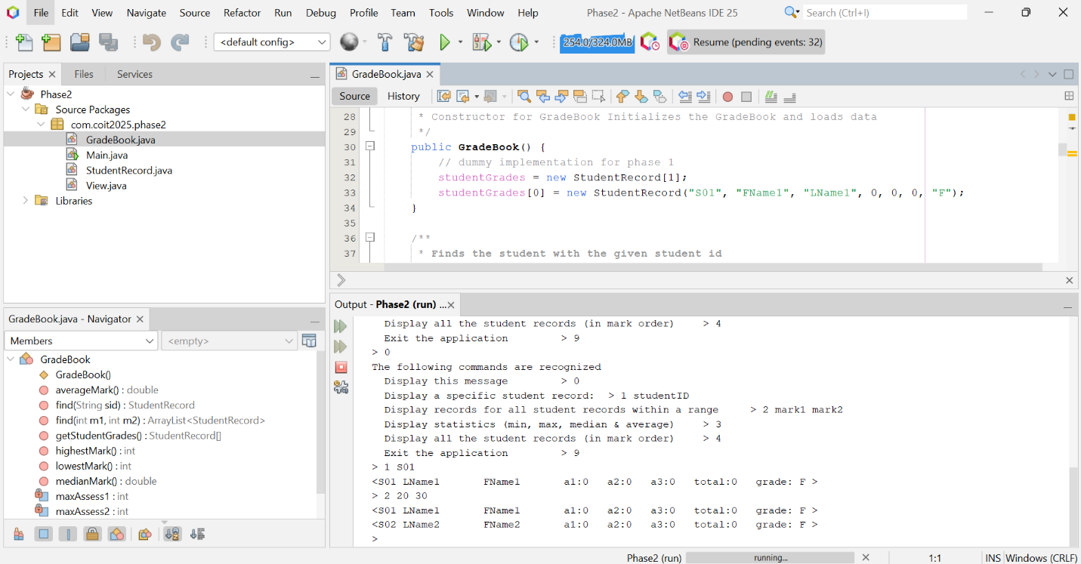
Figure 3: Phase 2b

The command loop uses a sentinel-controlled structure that terminates when the user enters option 9.
Phase 3 completed:
Phase 3a: Using the provided loadData() method which initializes test sample student records for testing
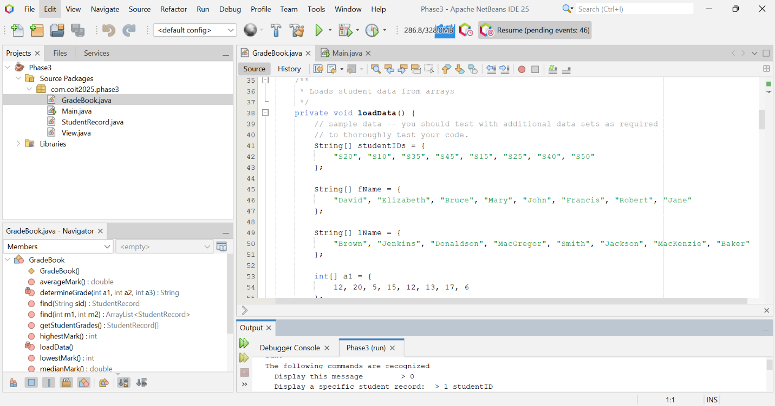
Figure 4: Phase 3a
Phase 3b: Implementing option 4(displaying all records)
This verifies that the data is loaded correctly
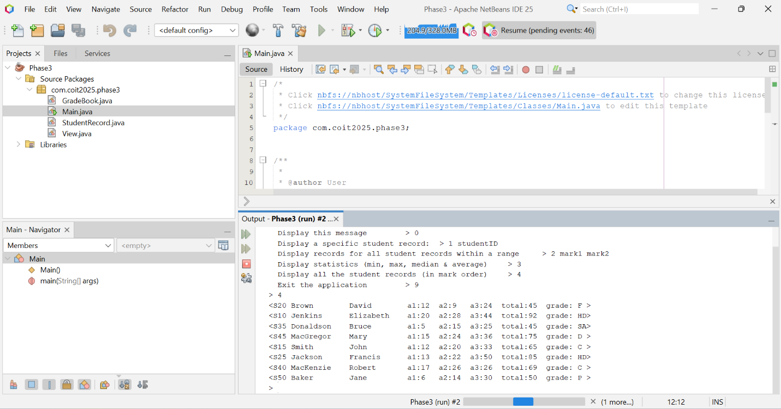
Figure 5: Phase 3b
Phase 3c: Sorting
This phase implements the selection sort algorithm inside sortByTotalMark() and the method is invoked in the constructor after loading the data.
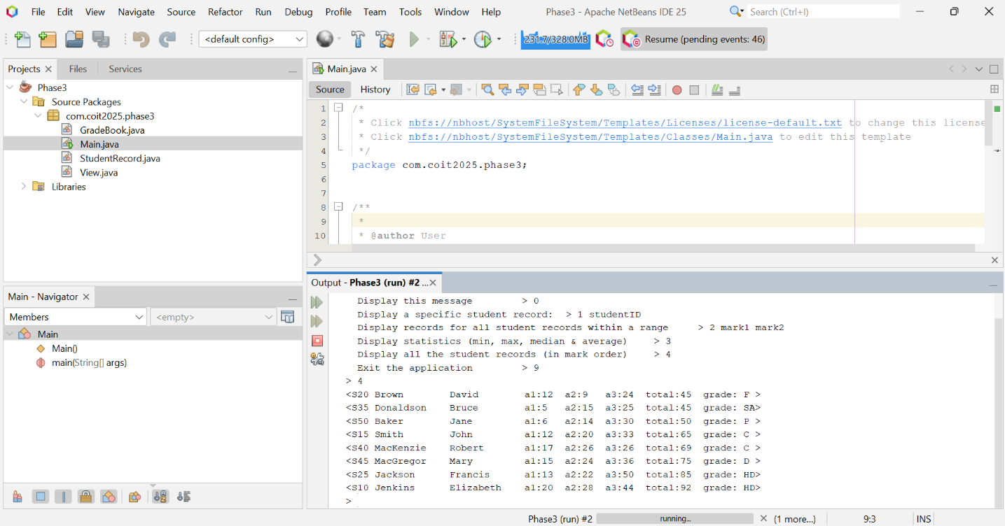
Figure 6: Phase 3c
Final Phase Completed:
This final phase ensures all the menu items are functional, i.e, through the implementation of the dummy methods
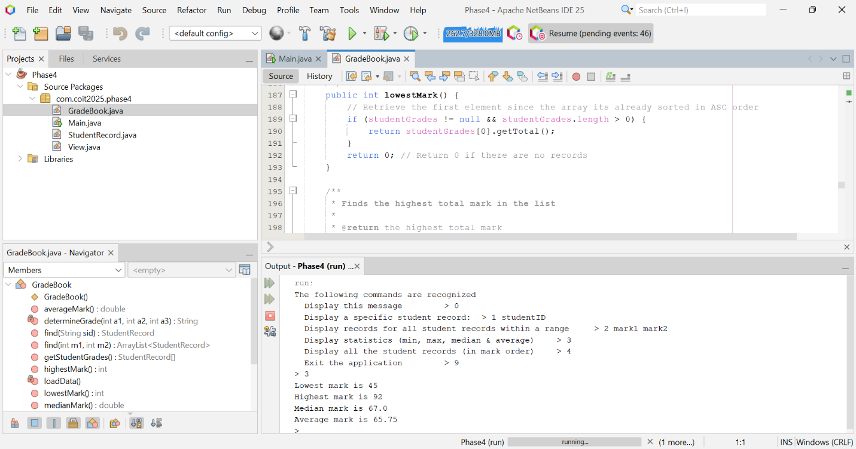
Figure 7: Phase 4 - Final part

Testing

Test Plan
Phase | Test Case | Description | Test Data | Expected Output
Phase 1 | Compile Test | Compile the program | All class files | No compilation errors
 | Run Test | Run main application | N/A | Display "Trace: commandLoop() – under development"
Phase 2 | Option 0 Test | Display help menu | Input: 0 | Help menu shown
 | Option 9 Test | Exit program | Input: 9 | Program exits
 | Invalid Option | Enter invalid input | Input: X | Error + Help menu
 | Option 1 Test | Display single record | Input: 1 S01 | Student record shown
 | Option 2 Test | Search by mark range | Input: 2 45 92 | Valid range processed
Phase 3 | Data Load Test | Load student data | Hardcoded arrays | All data loaded correctly
 | Sort Test | Sort by total marks | N/A | Data sorted in ascending order
 | Option 4 Test | Display all students | Input: 4 | Records shown in sorted order
Phase 4 | find(String) – Existing | Search by ID | Input: S10 | Record found
 | find(String) – Nonexistent | Invalid ID | Input: S99 | "Student not found"
 | find(String) – First | Search first record | Input: S20 | Record displayed
 | find(String) – Last | Search last record | Input: S10 | Record displayed
 | find(int, int) – Multiple | Range with many | Input: 45-75 | Multiple records shown
 | find(int, int) – One | One match | Input: 92-92 | Single record shown
 | find(int, int) – None | No matches | Input: 95-100 | "No students found"
 | find(int, int) – Boundary | Full range | Input: 45-92 | All matching records
 | Statistics – Lowest | Get lowest mark | N/A | 45
 | Statistics – Highest | Get highest mark | N/A | 92
 | Statistics – Average | Calculate average | N/A | 65.75
 | Statistics – Median (Even) | Median for even | 4 records | 67.0
 | Statistics – Median (Odd) | Median for odd | 5 records | 65
 | Edge Case – Empty | No student data | [] | Handled gracefully
 | Edge Case – Single | One student only | [1 record] | Handled gracefully

Test Results
Phase | Test Case | Expected Output | Actual Output | Status
Phase 1 | Compile Test | No errors | No errors | ✓
 | Run Test | Trace message displayed | Message displayed | ✓
Phase 2 | Option 0 Test | Help menu | Shown correctly | ✓
 | Option 9 Test | Program exits | Exited successfully | ✓
 | Invalid Option | Error + Help menu | Displayed | ✓
 | Option 1 Test | Student shown | Dummy data shown | ✓
 | Option 2 Test | Valid accepted, invalid rejected | As expected | ✓
Phase 3 | Data Load Test | Data loaded | Loaded successfully | ✓
 | Sort Test | Sorted records | Sorted correctly | ✓
 | Option 4 Test | Sorted display | All records displayed | ✓
Phase 4 | find(String) – Existing | Record found | Found and displayed | ✓
 | find(String) – Nonexistent | "Student not found" | Message displayed | ✓
 | find(String) – First | Record found | Displayed | ✓
 | find(String) – Last | Record found | Displayed | ✓
 | find(int, int) – Multiple | Records shown | Displayed | ✓
 | find(int, int) – One | Single record | Displayed | ✓
 | find(int, int) – None | "No students found" | Displayed | ✓
 | find(int, int) – Boundary | All matching | Displayed | ✓
 | Statistics – Lowest | 45 | 45 | ✓
 | Statistics – Highest | 92 | 92 | ✓
 | Statistics – Average | 65.75 | 65.75 | ✓
 | Statistics – Median (Even) | 67.0 | 67.0 | ✓
 | Statistics – Median (Odd) | 65 | 65 | ✓
 | Edge Case – Empty | Graceful handling | Handled properly | ✓
 | Edge Case – Single | Graceful handling | Handled properly | ✓

Bugs and Limitations

Bugs
The bug experience is the normal Scanner multiple input misbehavior. It happens when we input multiple values when only one was required, causing a series of executions. Apart from that no known bugs since all those I encountered I solved in the code

Limitations / Future Work
- This is a console application, which is limited to displaying text without clearing the screen which is not the best UI/UX feature. In the future we could make a more intuitive GUI application
- Data is not saved across the application runs since this application doesn’t use a database or API
- Presentation of results could be made better using some console asterisks(*) or better still a GUI implementation

Documentation
This is part of the documentation generated using Javadoc
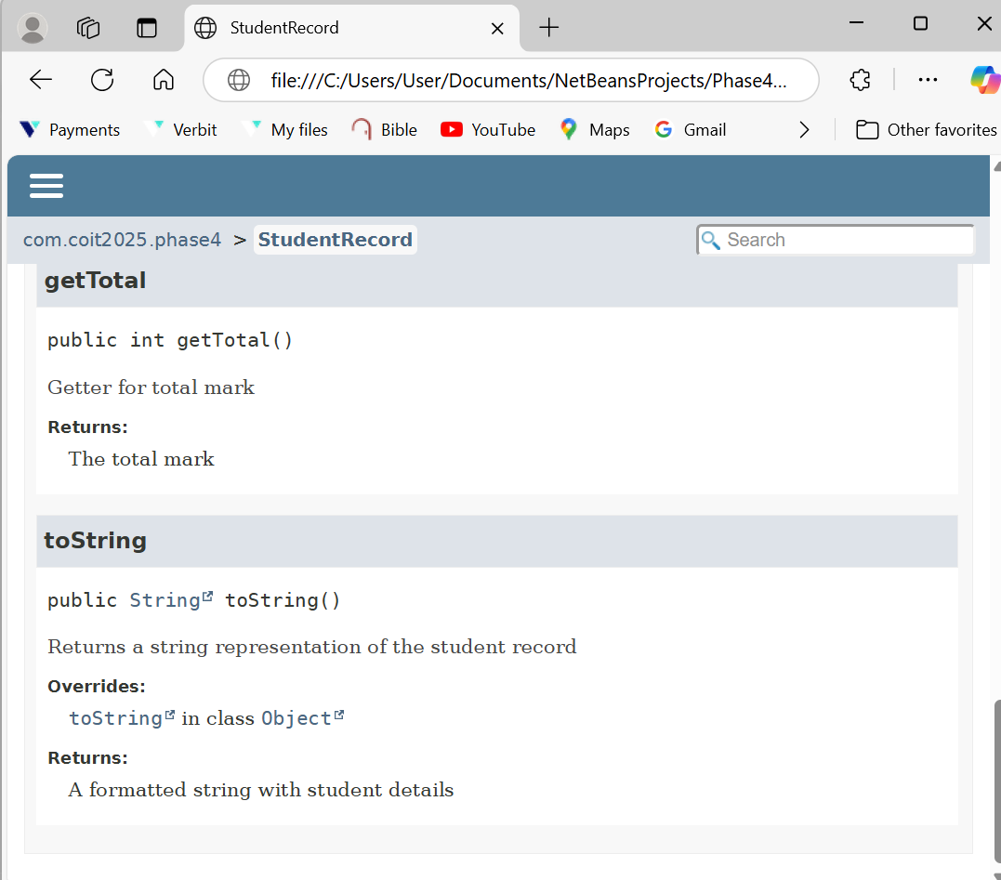
Figure 8: Javadoc
// Entry point Main.java
Class Main
- main
public static void main(String[] args)
Main method - entry point for the application
Parameters:
args - Command line arguments

// View.java
Class View
java.lang.Object
com.coit2025.phase4.View

public class View extends Object
Class to handle user interaction for the GradeBook application. Displays the menu and executes commands based on user input.
- Constructor Summary
Constructors
Constructor
Description
View(GradeBook gradeBook)
Constructor for View class
- Method Summary
All MethodsInstance MethodsConcrete Methods
Modifier and Type
Method
Description
void
commandLoop()
Main command loop that displays menu and processes user commands
Methods inherited from class java.lang.Object
clone, equals, finalize, getClass, hashCode, notify, notifyAll, toString, wait, wait, wait
- Constructor Details
  - View
public View(GradeBook gradeBook)
Constructor for View class
Parameters:
gradeBook - Reference to GradeBook object to be used
- Method Details
  - commandLoop
public void commandLoop()
Main command loop that displays menu and processes user commands

// StudentRecord.java
Class StudentRecord
java.lang.Object
com.coit2025.phase4.StudentRecord

public class StudentRecord extends Object
Author:
User Class to store information about a student's record including personal details and assessment marks. This class is to calculate the total mark and stores the grade.
- Constructor Summary
Constructors
Constructor
Description
StudentRecord(String id, String firstName, String lastName, int a1Mark, int a2Mark, int a3Mark, String grade)
Constructor to create a new StudentRecord with all details
- Method Summary
All MethodsInstance MethodsConcrete Methods
Modifier and Type
Method
Description
String
getId()
Getter for student ID
int
getTotal()
Getter for total mark
String
toString()
Returns a string representation of the student record
Methods inherited from class java.lang.Object
clone, equals, finalize, getClass, hashCode, notify, notifyAll, wait, wait, wait
- Constructor Details
  - StudentRecord
  - public StudentRecord(String id,
  - String firstName,
  - String lastName,
  - int a1Mark,
  - int a2Mark,
  - int a3Mark,
String grade)
Constructor to create a new StudentRecord with all details
Parameters:
id - The student ID
firstName - The student's first name
lastName - The student's last name
a1Mark - Mark for assignment 1
a2Mark - Mark for assignment 2
a3Mark - Mark for assignment 3
grade - The grade assigned to the student
- Method Details
  - getId
public String getId()
Getter for student ID
Returns:
The student ID
  - getTotal
public int getTotal()
Getter for total mark
Returns:
The total mark
  - toString
public String toString()
Returns a string representation of the student record
Overrides:
toString in class Object
Returns:
A formatted string with student details

// GradeBook.java

Class GradeBook
java.lang.Object
com.coit2025.phase4.GradeBook

public class GradeBook extends Object
Class to manage a collection of student records. Provides functionality to load, search, sort, and analyze student data.
- Constructor Summary
Constructors
Constructor
Description
GradeBook()
Constructor for GradeBook Initializes the GradeBook and loads data
- Method Summary
All MethodsInstance MethodsConcrete Methods
Modifier and Type
Method
Description
double
averageMark()
Calculates the average of the total marks in the list
ArrayList<StudentRecord>
find(int m1, int m2)
Finds all the students with a total mark in the specified range
StudentRecord
find(String sid)
Finds the student with the given student id
StudentRecord[]
getStudentGrades()
Gets all the student records (in the studentGrades array)
int
highestMark()
Finds the highest total mark in the list
int
lowestMark()
Finds the lowest total mark in the list
double
medianMark()
Calculates the median of the total marks in the list
Methods inherited from class java.lang.Object
clone, equals, finalize, getClass, hashCode, notify, notifyAll, toString, wait, wait, wait
- Constructor Details
  - GradeBook
public GradeBook()
Constructor for GradeBook Initializes the GradeBook and loads data
- Method Details
  - find
public StudentRecord find(String sid)
Finds the student with the given student id
Parameters:
sid - the student id
Returns:
reference to the student or null if not found
  - lowestMark
public int lowestMark()
Finds the lowest total mark in the list
Returns:
the lowest total mark
  - highestMark
public int highestMark()
Finds the highest total mark in the list
Returns:
the highest total mark
  - averageMark
public double averageMark()
Calculates the average of the total marks in the list
Returns:
the average mark
  - medianMark
public double medianMark()
Calculates the median of the total marks in the list
Returns:
the median mark
  - find
  - public ArrayList<StudentRecord> find(int m1,
int m2)
Finds all the students with a total mark in the specified range
Parameters:
m1 - the low end of the range
m2 - the high end of the range
Returns:
an ArrayList with all the records found with total marks in the range
  - getStudentGrades
public StudentRecord[] getStudentGrades()
Gets all the student records (in the studentGrades array)
Returns:
an array of StudentRecords with all the records

