Topic:
“Impact of Lack of Leadership Support and Its Implications on New Skill Development of Employees in the It Industry”

Acknowledgement
I would like to express my profound gratitude to my professors who have guided me to complete the dissertation within the stipulated period of time. The members of the Dissertation Committee have provided me with extensive personal and professional guidance with the study. I am thankful to my parents and peers who have also guided me to acquire and contribute to the research study.

Declaration
This research on the “Impact of Lack of Leadership Support and Its Implications on New Skill Development of Employees in the It Industry” is my original work. I have completed the entire part of this research by myself and any part of this research has not been submitted yet. The reference and acknowledgement part of this research is also done by me for this research.

Abstract
Background and Purpose of the Study
The research has identified a lack of leadership approaches in the IT industry of the UK that restricts the skill development aspects of the employee base. Lack of proper leadership aspect failed to contribute to the development of the employee’s skills to imply a constructive resolution. The skill development programme also supports the industry in increasing the revenue streaming of the IT industry and facilities growth approaches.
Potential Outcome of Literature Review
The literature review chapter has evaluated the use of specific theories and frameworks for conducting the study. Certain aspects of employee skills have been discussed in the study for maintaining employee engagement in the UK IT industry. The application of models such as the contingency theory of leadership, and human relations theory have helped the LR to assess the issues of high employee turnover in the UK IT industry.
Employee engagement can be addressed by the leaders of the IT industry by following the guidelines of the Kahn Model which helps them effectively participate in the employee training and development programmes. The challenges encountered by the employee in terms of training can effectively be mitigated through on-the-job training and coaching leadership.
Potential Outcome of Research Methodology and methods
The methodology chapter of this research has selected secondary qualitative research strategy to discuss the social experiences of the employees IT industry descriptively. For this reason, methods such as inter-pretivism philosophy, descriptive design, deductive approach, and other have been followed. 7 themes and 14 articles have been selected for data analysis through convenience sampling. The thematic analysis of this research has discussed each objective to evaluate the impact of leadership in developing the skills of the employees.

Key Findings
The findings and analysis chapter of the research incorporates analytical perspectives through themes which helps in the collection of a huge range of information and assists in interpreting information. The usage of thematic analysis helps in interpreting the information which is based on the development of skills of employees within the IT organisations. Skill development programmes are also effective for leaders to provide better training to employees. Collected information from the articles has established the required strategic actions to develop the skills of employees.
Research Impact and Conclusion
The IT industry has encountered potential challenges associated with the decrease in employee productivity and skills gaps within the organisation. Enforcing proper procedures and modelling is required to influence the performance within the organisation. The application of the strategic contingency theory has enacted the importance of improving the organisational performance with effective cooperation and collaboration.

Table of Contents
Chapter 1: Introduction 10
1.1 Introduction 10
1.2 Research background 10
1.3 Research Rationale 11
1.4 Aim and Objectives 13
1.5 Research questions 13
1.6 Significance of the Study 13
1.7 Justification for the topic 14
1.7 Structure of the Dissertation 14
1.9 Chapter Summary 15
Chapter 2: Literature Review 16
2.1 Introduction 16
2.2 Conceptual framework 16
2.3 Importance of leadership for the skill development of employees in the IT industry 17
2.4 Application of contingency leadership theory in improving the Skills of Leaders 18
2.5 Identification of challenges faced by employees in the IT industry regarding skill development 19
2.6 Analysis of the factors in the lack of leadership support in the IT industry 20
2.7 The implication of human relations management theory is to increase the skill of employees 21
2.8 Application of Maslow’s Hierarchy to increase employee engagement through leadership 22
2.9 Benefits of skill development of Employees in the IT industry 23
2.10 Application of the Kahn Model for improving employee engagement in the IT Industry 23
2.11 Mitigation strategies for eliminating the scope of lack of leadership support and improving the skill development of employees in the IT industry 24
2.12 Literature gap 25
2.13 Chapter Summary 25
Chapter 3: Research Methodology and methods 27
3.1 Introduction 27
3.2 Research philosophy 27
3.3 Research approach 28
3.4 Research design 29
3.5 Research Strategy 30
3.6 Data type 31
3.7 Data collection methods 32
3.8 Tools and Techniques 32
3.9 Data analysis 32
3.10 Inclusion exclusion criteria 32
3.11 Sampling method and sample size 33
3.12 Ethical consideration 33
3.13 Research Timeline 34
3.14 Resources Needed for Project Completion 34
3.15 Chapter Summary 34
Chapter 4: Findings and Analysis 35
4.1 Introduction 35
4.2 Thematic analysis 35
4.3 Discussion 42
4.4 Key Findings of the Research 46
4.5 Summary 47
Chapter 5: Conclusion and Recommendations 49
5.1 Conclusion 49
5.2 Objective Linking 49
5.3 Research Limitations 50
5.4 Future Scope 50
5.5 Recommendations 51
Reference list 53
Appendices 61
Appendix 1: Research timeline (Gantt chart) 61
Appendix 2 : Ethics Approval Certificate. 62

List of Table
Table 1: Inclusion and exclusion criteria 34
Table 2: Thematic analysis 43

List of Figures
Figure 1: Growth scale of the IT industry in the UK 11
Figure 2: Growth probability of the IT industry UK 12
Figure 3: Structure of the dissertation 14
Figure 4: Conceptual Framework 17
Figure 5: Effect of poor employee engagement due to lack of proper leadership skills in the UK 18
Figure 6: Approaches of contingency leadership 19
Figure 7: Challenge faced by employees in IT organisations 20
Figure 8: Human relations theory 22
Figure 9: Maslow’s hierarchy 23
Figure 10: The Kahn Model of employee engagement 25
Figure 11: Research Onion Model 28
Figure 12: Research Philosophy 29
Figure 13: Research Approach 30
Figure 14: Descriptive Research Design 31
Figure 15: Qualitative Research Strategy 32

Chapter 1: Introduction

1.1 Introduction
Leadership personalities regardless of any industry are responsible for articulating vision and direction and improving the skill set of the employees and driving them towards productivity and so does the IT industry. Leaders show the path to achieving the organisational goal considering the competencies of the employee base. They provide direction and vision to the employee base for aligning their activities with the decision of the management and driving them towards productivity. From a comparative view training and skill development, approaches are also beneficial for increasing productivity, reducing employee turnover and sustaining the organisational facility. Therefore, leaders are responsible for sustaining the organisational activities of the IT industry and evaluating their agility and performance in the competitive market. Leadership behaviour has a strong influence on the approaches of the employee via reaching connecting, and engaging with employees (Cortellazzo et al., 2019). Based on the influencing capabilities they can easily provoke the employee to develop their skills and develop productive outcomes for the employees.

1.2 Research background
The IT industry of the UK is one of the emerging industries that change its characteristics over time to maintain its growth in the competitive field. Concreting the growth the employees of the organisation of the IT industry are also developing their skill set to effectively contribute to this development. As per statistics, the IT industry of the UK is projected to reach an amount of US$89.22bn in 2023 (statista.com, 2023). This factor highlights the contribution of the employees working in the IT industry behind the growth of this industry. The leaders of the organisation are directly involved in this development as they are responsible for developing the skill set of their employee base that ultimately brings development in the revenue charting of the IT industry.
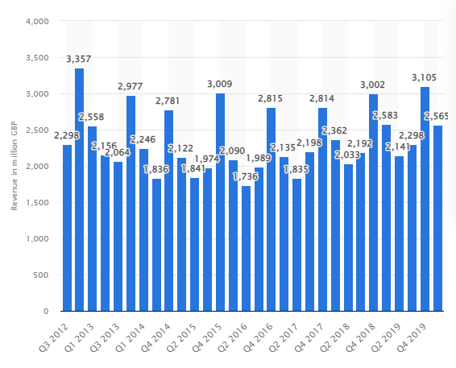

Figure 1: Growth scale of the IT industry in the UK
(Source: statista.com, 2023)
The expected growth rate of the IT industry might remain unmet due to a lack of competency among the employees. The revenue scaling of the IT industry is expected to witness an annual growth rate of 6.74% (statista.com, 2023). The growth rate might get hampered negatively due to the lack of competency of the employee base and the failure of the leaders of the IT industry to develop the skills of the employee base. Due to this reason, the IT industry failed to meet its expected growth and witnessed employee loss as they failed to get career development opportunities. Hence, lack of leadership support can be considered the main reason behind employee loss and failure to meet expectations.

1.3 Research Rationale
The diverse talent shortage is one of the major issues that create barriers in front of the IT industry of the UK to address growth. Unstable employment retention can be seen in the IT industry of The UK which restricts the growth parameters of this industry. For instance, in 2023 the IT industry of the UK registered an employment rate of 76 % where the rate was 75.6% in 2022 (statista.com, 2023). It highlights the employment growth pace of the IT industry of the UK is not sufficient or stable for coping with the challenges of the market. Unstable employment restrains the growth aspects of the IT industry which has been identified as the issue that the research is intended to investigate. Considering the contribution of the leading personalities of the It industry skill development among the employees can be evaluated which helps in stabilising the employment status of the IT industry.
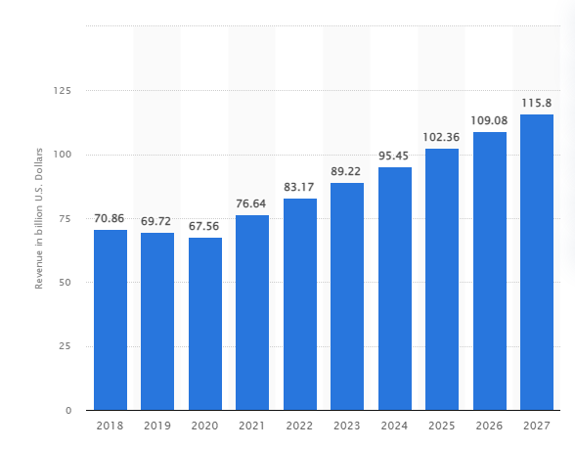

Figure 2: Growth probability of the IT industry UK
(Source: statista.com, 2023)
The leadership personalities of the organisation of the IT industry to some certain extent failed to improve the skills set of the employee base. Failure to improve the skill set restricts the employee base to meet the ever-changing aspects and characteristics of the IT industry and the gap remains. Organisations provide training and other development approaches for improving the intelligence and skills of employees (Guterresa et al., 2020). Leaders play a vital role in this training provision for enhancing the skill growth of the employee base. However, the gap in the leadership approach of the IT industry restricts them from developing the skills of their employee base.
The action parameters of the IT industry of the UK failed to meet its expected growth. Export led the tech-based companies of the IT industry to continue with either international expansion. Apart from that talent acquisition and retention has been considered as one of the major challenges encountered by the employers of the IT industry of the UK (adriasolutions.co.uk, 2023). Lack of support from the leadership approaches highlights that the employees failed to get skill development approaches and career growth opportunities remain unmet. The research has clarified the methods that the leaders of the IT industry need to consider for developing the skill set of the employee base and meeting the productivity goal.

1.4 Aim and Objectives
1.4.1 Aim
The research aims to evaluate the effectiveness of leadership approaches for skill development in the employees of the IT industry.
1.4.2 Objective
- To evaluate the role of the leaders in skill development approaches of the employee base.
- To analyse the factors that cause a lack of leadership support in the IT industry of the UK.
- To identify and critically analyse the challenges that the leaders of the IT industry might encounter during associating with a skill development programme.
- To recommend a strategic solution to the leaders of the IT industry to cope with challenges that they encounter during training provisions.

1.5 Research questions
- Why is it important to consider leadership as an essential factor for the skill development of the employees of the IT industry?
- Which factors of leadership personalities are responsible for affecting the employee approaches of the It industry?
- How lacks of leadership aspects negatively affect the new skill development aspect among the employees of the IT industry?
- What are the specific challenges that the employees of the IT industry have encountered during skill development under the guidance of their respective leaders?
- What potential strategic measures can be considered by the organisation of the IT industry for supporting the skill development programme for the employees?

1.6 Significance of the Study
The talent development approach is the main concern of this study that has been addressed with the support of leadership aspects. Talent shortage is one of the key issues that the companies of the IT industry are encountering in the current circumstances and 95% of the employers are looking for tech support (uktech.news, 2023). The study evaluates the process for developing the leadership approaches and developing the skill set of the employee base. It highlights the significance of the study for mitigating the issue that the IT industry of the UK is facing in the current circumstances.
The study is also concerned about the challenges encountered by the employees of the IT industry of the UK and provides probable solutions to mitigate those issues. Considering this approach the study provides strategic solutions that are effective for the employees to develop their skills and contributes to the growth of the IT industry of the UK. On the other hand, The IT industry of the UK is projected to reach a revenue value of 115.8 billion U.S. dollars by 2027 (statista.com, 2023). The current issues encountered by the IT industry might restrict the organisation to reach the target the study helps the organisation of the IT industry of the UK to reach their project amount by showing the methods of skill development considering the leadership approaches.

1.7 Justification for the topic
The IT industry is one of the booming industries of the UK that contributes to structuring the economic approaches of the country. The digital section of the UK has contributed more than £400 million a day to the UK economy accounting for 7.7 5 (gov.uk, 2023). It evaluates the importance of the IT industry in the development of the UK’s economy. Due to a lack of leadership approaches proper training has not been provided to the employee base of the IT industry which became a major threat as per the current situation. It highlights that the selection of the topic is justified as it highlights the method that brings growth to the IT industry.

1.7 Structure of the Dissertation
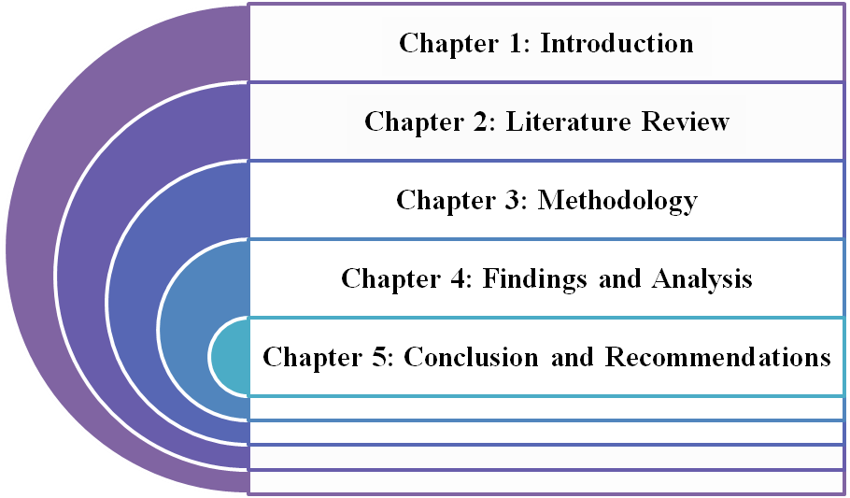

Figure 3: Structure of the dissertation

1.9 Chapter Summary
The introductory chapter of this dissertation highlights the interconnection between leadership approaches and the competencies of the employee base that supports the organisations of the IT industry to meet their business objective from a wide perspective. Training and development programmes support the employees of the IT industry and bring the opportunity for career growth that helps in retaining their attention. Apart from that it also helps in stabilising the employee retention rate and contributing to the development of production in this industry. The development of the IT industry to some certain extent also impacted the GDP approaches of the UK positively. The notion of skill development in the IT industry of the UK supports bringing cross-cultural diversity and inclusivity to develop productivity with quality.

Chapter 2: Literature Review

2.1 Introduction
The chapter is focused on the implication of specific theories and models for analysing the lack of leadership skills on the improvement of employee skills in the IT industry. The factors of poor employee skills can be one of the most potent reasons for the low profitability of the IT industry. It is expected that analysing the reasons for poor leadership skills can be effective in improving strategies for enhancing the skills. Specific mitigation strategies have also been discussed in the chapter for improving employee skills in an effective manner. A literature gap has been discussed in the chapter or understanding the limitation of the identified literature.

2.2 Conceptual framework
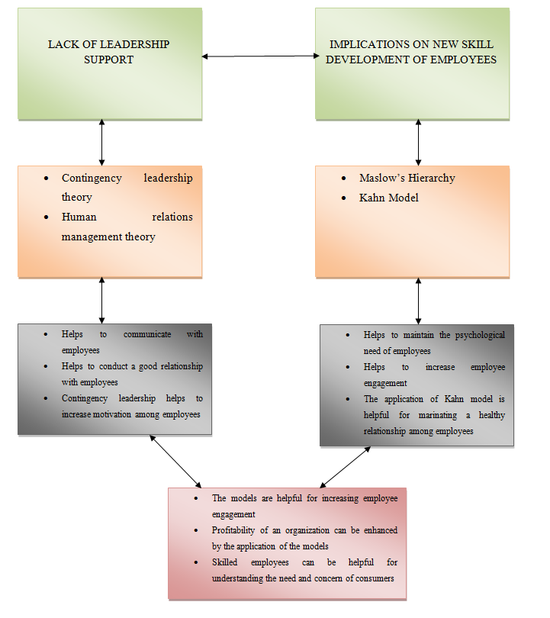

Figure 4: Conceptual Framework

2.3 Importance of leadership for the skill development of employees in the IT industry
Leaders of an organisation are responsible for analysing the potential of an organisation by making the mission and vision of the organisation. Effective performance of leaders can be helpful for employees in creating a proper management style for the organisation. Chen and Sriphon (2022), have found that the application of proper leadership approaches can be helpful in incurring employee engagement in an organisation. According to the authors, building a trustworthy relationship with employees and social exchange among employees can be possible through proper leadership approaches. It is assumed that the application of proper leadership skills can help employees to increase engagement.
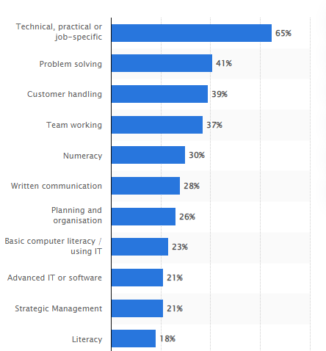

Figure 5: Effect of poor employee engagement due to lack of proper leadership skills in the UK
(Source: Statista.com, 2020)
Currently, the IT industry in the UK has been facing the issue of talent shortage. As per the report, the skill gap has become one of the primary issues in the UK IT industry that has been affecting employees to a great extent. It is evident from the report that approximately 39% of staff in the UK was reported for lacking the skill of handling employees (Statista.com, 2020). It is assumed that the job satisfaction of employees can be enhanced due to the application of proper leadership skills such as effective communication. On the other hand, Decuypere and Schaufeli (2021), positive leadership skills can help to drive employee motivation and increase workplace culture. As per the survey by the authors, a total of 22.09% of employees agreed to have diversity in the workplace for increasing work engagement by the implication of positive leadership approaches.
The emergence of the global pandemic Covid-19 can also be considered one of the most emerging issues in the UK IT industry. As per the report, the implication of a collaborative leadership approach has helped CISCO for increasing the skill of employees. As per the report, the revenue of CISCO has increased to almost 51.6 billion American Dollars due to the highly effective leadership approaches (Statista.com, 2022). It can be assessed that the implication of proper leadership skills can increase the profitability of an organisation.

2.4 Application of contingency leadership theory in improving the Skills of Leaders
Specific approaches to the contingency leadership theory can be helpful in understanding the potentiality of employees by proposing a flexible approach. According to Paradza and Daramola (2021), contingency leadership theory is based on a flexible perspective of the running of an organisation in an effective manner. The theory states that there is no universal way of running a business with its best possible approach. As per the view of the authors, a total of 19.5% of employees have increased their organisational performance and 4.9% increased their IT skills with the application of the contingency leadership approach (Paradza and Daramola, 2021). In contrast, Nor-Aishah et al. (2020), have opined that the use of entrepreneurial leadership is associated with the contingent behaviour of the leaders. As a consequence of the issue, leaders of an organisation might communicate with employees which are one of the main issues of increased employee activity. The survey of the authors has explored that SMEs contribute almost 37.1% of the total GDP of a country and it is essential for the companies to increase their profitability. It can be assured that appropriate leadership approaches can be helpful in increasing the profit margin of an organisation by increasing employee engagement.
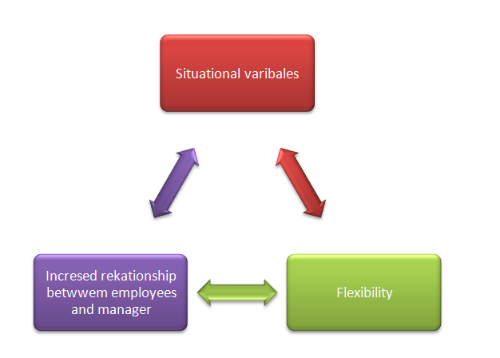

Figure 6: Approaches of contingency leadership
(Source: Influenced by Nor-Aishah et al., 2020)
The application of a contingency or situational leadership approach can be helpful for leaders working according to a specific situation. For example, the IT industry in the UK can try to adapt to flexibility for meeting the requirements of the team leaders efficiently. It can be advised for leaders to provide employees with proper training to work with efficiency in adverse situations. According to Katić et al. (2019), the situational leadership model is one of the most effective contingent models that is helpful for performing tasks in an effective manner. The study has explored that a total of 5.35% of senior managers in IT firms have been practising effective management styles with proper leadership approaches for enhancing the skills of employees. For example, the managers of an IT company can try to provide proper training to employees for adapting to adverse situations efficiently which are helpful for employees to enhance their technical skills. It can be assumed that the application of proper leadership style might help organisations to increase the performance of employees to a great extent.

2.5 Identification of challenges faced by employees in the IT industry regarding skill development
Specific challenges that have been impacting employees of the IT industry include a lack of proper training, a lack of learning scopes, and a lack of focus on work. As stated by Yoopetch et al. (2022), proper learning and knowledge are the most potent reasons for increasing the competency of employees in an organisation. The authors have opined that it is essential to measure the effect of employee learning and employee knowledge for the future benefit of companies.
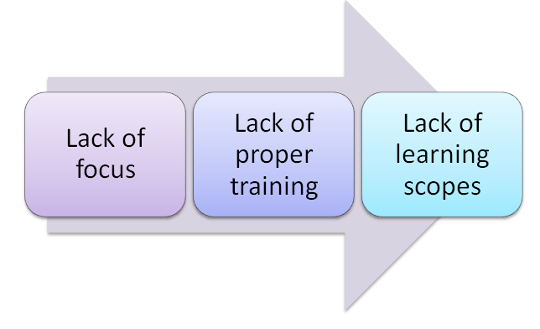

Figure 7: Challenge faced by employees in IT organisations
(Source: Influence of Yoopetch et al., 2022)
It is also essential to test the relationship between employee performance and career growth for leaders to enhance employee performance. As per the survey by the authors, a total of 1.80% of participants worked at the top management level and 95% of them agreed to the positive effect of employee learning by providing proper training to them (Yoopetch et al., 2022). On the contrary, the lack of learning scopes can also lead organisations to face a lack of knowledge sharing among employees. It can be assessed that the application of effective leadership skills can be helpful for employees in sharing knowledge among employees. The lack of focus can also be one of the most emerging issues in the lack of employee engagement. On the contrary, Farooq et al. (2021), lack of focus can negatively affect the infrastructure of the companies massively. Adverse employee behaviour might lead an organisation to a poor internal environment which is one of the most potent reasons for poor organisational performance.

2.6 Analysis of the factors in the lack of leadership support in the IT industry
Lack of leadership skills in the new skill development of employees can affect the operational performance of employees. Talent shortage and skill gap are two of the major issues of IT organisations. According to Rangacharoi and Woods (2020), an absence of leadership support may create emotional distress among employees. According to the view of the authors, the occurrence of the global pandemic Covid-19 has created emotional insecurity and erosion of trust among employees. It is evident from the report that the implication of poor leadership may help to decrease the issues. For example, Infosys is one of the leading IT organisations that feed a loss of revenue which was 16.3 billion U.S. dollars worldwide (Statista.com, 2023). On the contrary, Li et al. (2021), have stated that a poor leadership approach may lead an organisation to face a high employee turnover rate. It can be assumed that the application of an effective leadership approach can create an issue for increasing employee performance.

2.7 The implication of human relations management theory is to increase the skill of employees
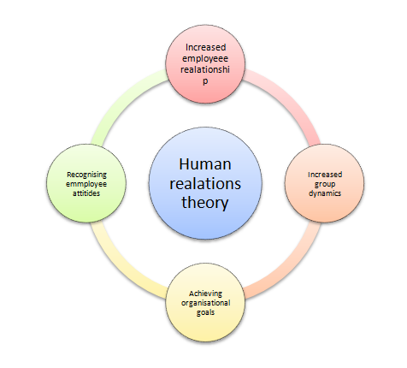

Figure 8: Human relations theory
(Source: Influenced by Cho et al., 2023)
The application of human relations management can be helpful for organisations to increase employee performance. The effective application of this theory might be helpful for understanding the personalities of employees and resigning their behaviours. According to Cho et al. (2023), human resource is one of the most useful assets for an organisation and an organisation can try to provide the coolest information about employees by using its human resources purposefully. This can help an organisation to meet its goals. On the other hand, Stevi and Brković (2020), the effective use of human resources is helpful for developing organisational goals and working accordingly. A lack of human resources can affect an organisation negatively. An IT company can try to inspire positive group relations and promote cooperative attitudes among employees. The collection of employee feedback can also be helpful for organisations in affecting the company's profitability positively.

2.8 Application of Maslow’s Hierarchy to increase employee engagement through leadership
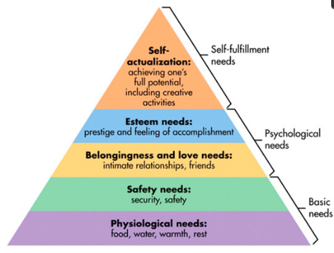

Figure 9: Maslow’s hierarchy
(Source: Influenced by Ansorger, 2021)
IT companies across the globe can use specific approaches of Maslow's hierarchy for achieving a high level of employee engagement. For example, companies can try to motivate employees by providing them with love and belonging. As per the view of Dohlman et al. (2019), Maslow’s hierarchy can be used as an effective business tool for meeting the requirements of employees. The psychological needs and safety needs of employees can be achieved through the application of motivation. IT companies in the UK can try to boost the self-esteem of employees by communicating with them on a regular basis. It can be advised for the leaders to conduct frequent meetings for employees to collect their feedback about company policies. As stated by Ansorger (2021), the application of Maslow’s hierarchy can be helpful in achieving self-actualisation by analysing the potential of employees. This step can help to maximise the potential of an individual. On the contrary, Liu et al. (2022), the application of Maslow’s hierarchy can be helpful in driving human motivation. This approach can be helpful in increasing the potential of employees.
Safety and psychological needs can be considered important requirements that need to be achieved by leaders in IT organisations. Leaders of an IT company can try to motivate employees to increase their workforce. Lorincová et al. (2019), have stated that the application of motivation can help an organisation to achieve a sustainable advantage. It can be helpful in increasing the assets of the companies.

2.9 Benefits of skill development of Employees in the IT industry
Certain benefits are associated with the skill development of employees. Specific skills such as communication skill, creativity, and decision-making can be helpful for companies to increase their profit margin. Certain benefits of having skilled manpower include increasing productivity, creating problem-solving skills for the company, and making the financial part of the company better. Profitability and expansion of the company can also be possible for the company. According to Margherita and Bua (2019), it is essential for companies to have skilled labourers. The authors have opined that the incorporation of a skilled workforce is capable of performing cooperative work with robustness and motivating the employees. On the other hand, Poon et al. (2020), have opined that the role of skilled labour is one of the most important approaches to increasing the profitability of an organisation. Therefore, it is understandable that having an efficient and skilled labour force can increase prospect for better operational outcome in organisations, especially in the IT industry.

2.10 Application of the Kahn Model for improving employee engagement in the IT Industry
Employee engagement within the organisation setting is responsible for improving work culture, reduction in employee turnover and development of productivity. Decuypere and Schaufeli (2020) mentioned Khan’s employee engagement considered the specific work characteristics which can be influenced by the leaders for enhancing engagement of the employee base at the workplace. Khan’s employee engagement theory has identified three major dimensions that influence the employee base workplace engagement which are safety, meaningfulness and availability. Silic and Lowry (2020) highlighted Employment security has the capability of intrinsic motivations for coping with learning and compliance. Considering employability as the asset of the safety dimension of the model it influences the employees of the IT industry to take part in the skill development programme actively. The theory also evaluates that the skill development programme also helps them in developing their importance in the organisation which ensures the security of their employees.
Working without any purpose creates frustration among the employee base and makes them aimless. Nazir et al., (2021), Meaningfulness to the jobs makes the employees more engaged and improves their performance in the organisational setting. The leadership personalities of the IT industry need to consider this factor while providing training to their employee base to develop their skill set. Dhir and Shukla (2019) evaluated, discretionary efforts made by individuals in their work role help simulate the investment of their psychological, cognitive and emotional energies. In other words, if the employee base of the organisations of IT contributes towards a meaningful goal which further evaluates the personal goals helps them to be more engaged in the workplace and meet the requirements of their given tasks.
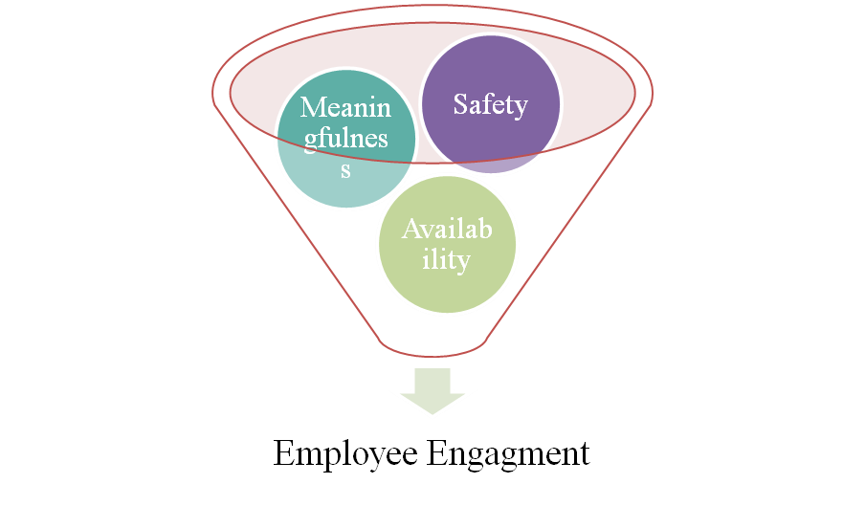

Figure 10: The Kahn Model of employee engagement
The team members of the organisation of the IT industry felt that the demand of their designation became reasonable with the personal approaches that support their physical capacity. As opined by Lai et al., (2020), work engagement mediates the relationship between the leadership and the behaviour of their followers. Concentrating on this approach the leaders of the IT industry can influence the employee base of their organisation to get training and develop their skills to be more engaged with their assigned tasks. The training provision regarding approaches to improvement of the skill set of the employee base provokes them to deliver the assigned tasks with quality.

2.11 Mitigation strategies for eliminating the scope of lack of leadership support and improving the skill development of employees in the IT industry
The issues of lack of focus can effectively be mitigated among the employee base with the application of job training. As per the survey conducted by Vasanthi and Basariya (2019), 45.11 % have agreed that on-job training is effective for developing the companies of the employee base. It highlights that on job training also mitigates the issues of lack of focus as practical learning is significantly helpful in developing competencies in comparing theoretical training. On the other hand, Na (2021) mentioned, on-the-job training has used the most recent data for developing the skill set of the employee base. The use of recent data in the learning process requires the utmost attention of the learners to get used to doing it. Considering this factor the employees of the organisation need to pay attention to learning new approaches regarding up-to-date information.
Lack of proper training is another potential barrier that restricts the learners to get training provisions to develop their skill set and career growth opportunities. As mentioned by Perera (2019), the Coaching leadership style specified in the leadership scale is effective specifically for training and instruction behaviour. Considering this aspect the IT industry needs to consider coaching leadership style to provide effective training among their employee base and for mitigating the issues of lack of training approaches. However, Hong and Jeong (2020) mentioned, the coaching leadership style is considered a mediating process that affects the team's performance. Despite having different negative approaches to coaching leadership, its effectiveness of giving training provisions can be used by the organisation of the IT industry to develop the competencies of the employee base.
Lack of learning scope occurs as the leaders of the IT industry failed to retain the attention of the employee base. As mentioned by, Böhm et al., (2019). Rewards during training generate summaries considering high human rates. The leaders of the IT industry can use this method for developing interest among the employees to take part in the training. Hence, it also resolves the issues of lack of learning approaches and brings development to the skill set of the employee base.

2.12 Literature gap
The gap in the knowledge of the discussed literature can be seen that impacted the current study negatively. In some of the literature that is discussed in the study gaps can be seen in terms of effective theoretical evaluation. On the other hand, most of the literature has considered quantitative data which restricts the study to support the arguments with statistical evidence. Statistical evidence increases the reliability of the statement and due to the lack of statistical information the study has compromised its quality.

2.13 Chapter Summary
Training provision in the IT industry significantly helps in developing the efficiency and productivity of organisations. On the other hand, the employees of the IT industry encounter severe circumstances like a lack of learning scope or improvement support from the leaders to improve their skills. However, training opportunities significantly help employees to develop their competencies and enjoy a competitive edge. It also makes the employee base contribute to the development of the organisation in terms of revenue making and other factors. Hence, through employee engagement, the IT industry can effectively improve its operations and productivity which helps them in meeting its business objectives.

Chapter 3: Research Methodology and methods

3.1 Introduction
The IT industry globally is developing due to the dynamic changes in both the market and technologies. Considering this it has followed certain methods, such as research philosophy, design, strategy, and others to execute the research process. Therefore, this entire methodology chapter has guided this research to evaluate the impact of leadership and develop the skills of employees.
3.2 Research Onion
The research on the impact of leadership support on the skills of the IT industry has followed certain methods, such as research philosophy, strategy and design to profoundly the aim of this research and evaluates its selected objectives. Constructing these stages in the right order can formulate an effective methodology in this part.
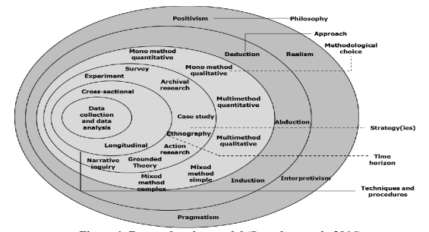

Figure 11: Research Onion Model
(Source: Influenced by Abdelhakim, 2021)
Adapting “Saunder’s research onion model” can guide this research to construct all the stages through certain layers of this model to get a complete idea of this methodology. As opined by Abdelhakim (2021), “Saunder’s research onion” formulates an effective research method by defining each section of the methodology. Considering this, the research methodology has included the research onion model to define its aforementioned stages. Therefore, the research onion model has developed the researcher to get a descriptive and constructive analysis of developing leadership support on employees' skills in the IT industry.

3.2 Research philosophy
The research on employees' skills in the IT industry and the support of leadership requires to analyse of both current and previous information to understand the impact of leadership support. Considering this understanding reality the employees of the IT industry need to gain knowledge from their experiences of them. “Interpretive research philosophy” consists of the behavioural outcome of the research phenomenon and develops a theoretical explanation to define the social perspective (Amadi, 2021). This research has used the “interpretive research philosophy” to cover the social experiences of the employees to evaluate the impact of leadership support in their learning process of new skills. This has helped the research to evaluate a theoretical explanation by discussing its variables.


Figure 12: Research Philosophy
(Source: Influenced by Park et al., 2019)
Research philosophy provides a systematic process to gather knowledge and analyse them in a certain manner. This research has focused to develop the social experiences of the employees in the IT industry based on secondary data. Contradictortiliy, positivism philosophy focuses on the individual’s experiences rather than a collective action (Park et al., 2019). Hence, this research has adopted the “interpretive research philosophy” instead of positivism to evaluate their experiences and analyse the impact of leadership in the IT industry.

3.3 Research approach
A secondary research approach in the methodology comprises the data collection, analysis and interpretation of the finding information. This research on the employees of the IT industry needs to go through some specific observations to analyse the findings of its information and justify the objectives. A deductive research approach provides an exploratory study to investigate the influences of the research and provides scope to identify the relevant ideas from the experiences (McGowan et al., 2020). Considering this, the researcher has selected a deductive approach to evaluate the experiences of the employees of the IT industry and identify the support of the leaders in developing the skills.
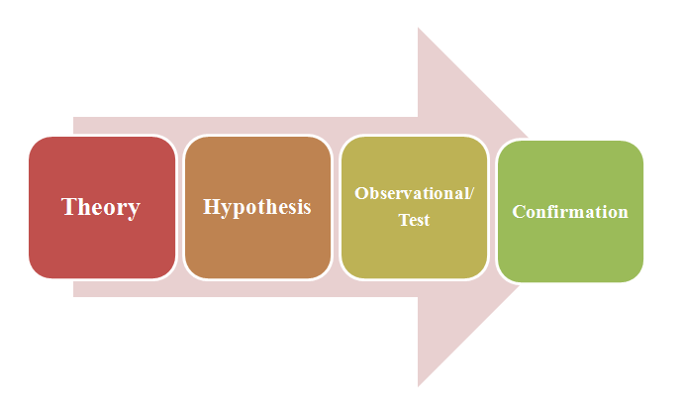

Figure 13: Research Approach
(Source: Influenced by Walter and Ophir, 2019)
The aim of this research is to evaluate the effectiveness of the leadership approaches in developing the skills of the employees of the IT industry. In contrast, the inductive research approach observes the specific data or theories to identify the patterns which create challenges in getting a descriptive analysis (Walter and Ophir, 2019). Therefore, this research has avoided following the inductive approach and used the deductive ones to determine the behaviours of research objectives.

3.4 Research design
This research has selected the employees of the IT industry globally for identifying their skills and the role of leadership support in it. Evaluating the variables of the research and meeting the research objectives is required a descriptive analysis of their social experiences in the IT industry. Descriptive research design in the research method allows the researcher to describe the dependent and independent variables to examine their significance in the research (Pandiangan et al., 2021). Following the descriptive research design, the researcher has described the variables of this research, such as leadership support and skills of employees in the IT industry to describe its significance and role.
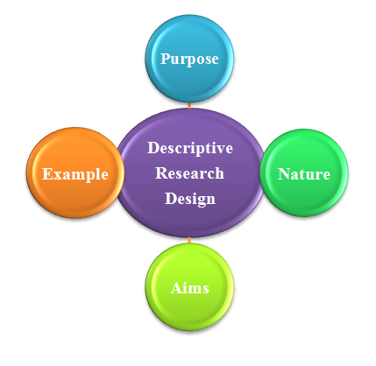

Figure 14: Descriptive Research Design
(Source: Influenced by Afum et al., 2020)
The purpose of a research approach is to provide a complete plan and legitimacy of its findings for developing the research. Explanatory research in this context explores selected information or objective which occur issues in future to develop the findings (Afum et al., 2020). Therefore, instead of following the descriptive research design the research has succeeded to establish the findings of the research based on the objectives of the research.

3.5 Research Strategy
A research strategy focuses on the key components of the research to define its different perspectives. The qualitative method in the research strategy encompasses non-numerical data to describe the findings and evaluate the objectives (Pooley et al., 2021). This research is focused to discuss the social experiences for evaluating the impact of leadership on the learning skills of employees in the IT industry utilising a secondary qualitative strategy.
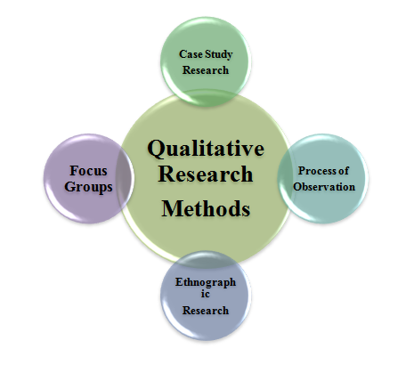

Figure 15: Qualitative Research Strategy
(Source: Influenced by Managwu et al., 2020)
The findings of this research from the secondary sources have included non-numerical data to define the social experiences of the employees and the impact of leadership approaches in the IT industry. In comparison to the quantitative research strategy, it focuses on numerical data collected from online sources, such as interviews or surveys (Managwu et al., 2020). This can create challenges for this research to develop the findings based on the experiences of employees globally. Therefore, by selecting the qualitative research strategy the researcher has provided agility to define its variables and evaluate the leadership approaches in the skills of employees of the IT industry.

3.6 Data type
Covering the data set of the IT industry globally is a time-consuming and complex process. Secondary data include specific data from various secondary sources, such as journal articles, CRO’s progress report, journal articles, magazines and others (Ruggiano and Perry, 2019). Considering this, the researcher has gained an advantage in developing the research with specific and authentic data. Contradictorily, the use of primary data type focuses on a limited section through its interview and survey process. Therefore, collecting data from secondary sources instead of primary data type has helped the researcher to include specific data in less to evaluate the social experiences of employees in the IT industry.

3.7 Data collection methods
The IT industry in the international market appoints a large number of employees and evaluating their experiences of them is a time-consuming and complex process. Considering this research has adopted certain methods based on secondary data analysis to collect the required information to follow the research objectives and evaluate the impact on employees' skills. The secondary data collection method includes information from several secondary sources, such as magazines, trade and technical journals, magazines, reports and other authentic sources (Sankar and Sankarnath, 2021). Utilising the secondary sources it has included data related to leadership approach and employees of the IT industry. Therefore, following the secondary data collection method this research has been able to comprise the relevant data based on the IT industry and employees' skills to explore the impact of leadership support.

3.8 Tools and Techniques
The research on the IT industry and the impact of the leadership approach has focused on its different variables, such as leadership support, and employee skill development. Secondary data collection methods gather relevant information from available sources to avoid complex situations and irrelevant information (Kar and Banerjee, 2022). Considering the secondary qualitative research the researcher has collected all the non-numerical data from different secondary sources, such as journal articles, magazines, and others to get specific information. The researcher also has used keywords, such as “employee skill”, “leadership approaches”, “IT industry” and others. Therefore, this has helped the researcher to make this research informative and explore various aspects of employees’ social experience in the IT industry.

3.9 Data analysis
Developing new skills for the employees in the IT industry requires a complete analysis to understand the market demand and current trends related to the IT industry. The thematic analysis explores the qualitative data and identifies its patterns based on the research objectives and questions to meet the research aim (Pearse, 2019). The aim of this research is to evaluate the effectiveness of leadership approaches in developing the skills of the IT industry. Therefore, thematic analysis has guided the researcher to justify the research objectives and evaluate the leadership approaches in the IT industry.

3.10 Inclusion exclusion criteria
Inclusion criteria | Exclusion criteria
- Specific resources have been used in the research such as Google Scholar, library catalogue, and library journal database. | - The library resources do not have authentic data-based research library resources.
- Certain research resources have been used in the study such as Boolean operators, proximity searching, and truncation searching. | - Boolean operators or proximity searching are not essential for the study
- Thematic analysis has been in the study by formulating themes for diagnostic and predictive analysis | - Thematic analysis does not follow specific theme formulation for conducting the study

Table 1: Inclusion and exclusion criteria

3.11 Sampling method and sample size
A convenience sampling has been used in the study for collecting the most relevant data. The use of convenience sampling has helped the study to collect data that have been used for generating specific objectives and research questions regarding the topic. According to Bashatah and Wajid (2020), convenience sampling is a non-probability technique that helps to conduct a deep insight into a specific subject. For example, the application of convenience sampling has helped the study to collect relevant data about the current situation of the UK IT sector having employees who lack the required skills. On the contrary, the study has avoided the use of random sampling techniques for avoiding the issue of impracticality, time and cost which justifies the application of convenience sampling for the study. A total of seven themes have been used in the study along with 14 authentic journals from Google Scholar. Secondary qualitative data sources that have been used in the study include organisational reports, authentic company websites, specific governmental reports, and blogs by entrepreneurs, and CEOs, progress reports, journals, newspapers, and magazines.

3.12 Ethical consideration
The ethical consideration of the study includes the application of informed-consent rules, respecting confidentiality, anonymity, and privacy. Research ethics are useful for the specific application of ethical principles to research activities such as research design, research implementation, and respect for society. The application of research ethics is useful for avoiding academic misconduct in conducting research. According to Gamage et al. (2020), academic integrity can be maintained by the use of research ethics and academic integrity can be used as a commitment to conducting research. This research has used the “Copyright, Designs, and Patents Act 1988” by followed for restating laws' copyrights with amendments with provisions for the rights of performers (Legislation.gov.uk, 2023). Furthermore, the study has followed the maintenance of confidentiality and ethical approval from resource authorisation for the conduction of this research. The strategies have helped the study to incorporate data with maintaining the confidentiality of data resources, and ethically becoming aware of the proper utilisation of each resource used in the study.

3.13 Research Timeline
[Refer to appendix 1]
The Gantt chart used in the study has shown every step of the research clearly. The chart has helped the study to bring consistency in the research and prepare each activity systematically. This has also helped the study to bring synthesis in the research.

3.14 Resources Needed for Project Completion
The specific time is one of the crucial resources which are essential for conducting the literature review and collecting journals and articles to conduct the study. The study has conducted a secondary qualitative research. Therefore, it is assumed that accommodation and travelling resources are not required for the study. However, collecting journals, articles and secondary statistical facts is quite time-consuming as this study is completely industry-specific.

3.15 Chapter Summary
This research is focused to build ethical and specific research on the development of employee skills in the IT industry. The qualitative research strategy has helped the researcher to explore its non-numerical data and define the findings of the social experiences of the employees. Contradictorily, based on the secondary data it has included an ethical consideration and exclusion-inclusion criteria of this research. Therefore, it can be stated that following the methods this research has been able to develop the findings on the impact of leadership approach on the skills of employees in the IT industry.

Chapter 4: Findings and Analysis

4.1 Introduction
The analysis and findings chapter of the respective research concentrates on the core aspects of the improvement of skills of employees. The usage of thematic analysis helps in apprehending different challenges faced by leaders in the skill development of employees. An in-depth discussion of the themes is highlighted to understand key perspectives of the lack of support of leaders in the development of skills of employees in IT organisations. Key findings from the thematic analysis assist in comprehending the skills that are necessary to be improvised.

4.2 Thematic analysis
Authors | Theme | Description
Aldawood and Skinner (2019), Sampson et al. (2020) | “Appropriate training helps to improve the skills of employees” | The development of strategies in providing training to the employees plays a significant role as it assists in improving the skills. The improvement of skills of the employees of the organisation helps in improving the predictability of the enterprise. According to the ideas of Aldawood and Skinner (2019), the inclusion of green “Human Resource Management” (HRM) practices increasingly focuses on the job training aspect. This strategy is significant for different IT organisations to improve the quality of their work. In this context, it is beneficial for the different leaders to impose different programmes in order to improve the skills of employees as it is also significant for the effective management of work. On the other hand, Sampson et al. (2020) stated that adequate training to the employees of the different enterprises assists the employees to feel confident as well as competent in their allocated work for the successful integration of the objectives of the organisation. According to the views of Aldawood and Skinner (2019), providing appropriate training to employees helps in the development of the ability of employees in order to enhance their skills. The improvement in training of the employees assists in the improvement in employee engagement and this assists in improving the productivity of IT organisations.
Diamantidis and Chatzoglou (2019), Federici et al. (2021) | “Skill development approach assists in improving adaptability aptitude of employees” | The development of the adaptability skills of the employees assists in the increased retention of the employees. According to the views of Diamantidis and Chatzoglou (2019), the leaders, as well as the managers of the organisations, largely need to focus on improving the culture of the organisation as it helps in boosting the performance of the organisation. One of the significant aspects is that a well-planned organised training culture assists in the identification of the needs of the employees and helps in improving the adaptability of employees. Hiring skilled employees within the organisation is beneficial as it assists in reducing training costs within the enterprise. According to the ideas of Diamantidis and Chatzoglou (2019), in the majority of organisations, 89.7% of managers are from college graduates with the presence of professional experience. This strategy can be used in different IT organisations for the effective management of the enterprise and to provide appropriate training on improving adaptability skills among the employees of firms. On the contrary, Federici et al. (2021) the inclusion of the career construction theory is beneficial as it assists the leaders of firms to examine that the career adaptability programmes trigger in enhancing job crafting behaviours as it assists in increasing employee engagement. The increase in employee engagement is beneficial for IT organisations as it helps in improving the training factors.
Wang and Siau, (2019), Joshi and Rocque (2022) | “Absence of technological training negatively impacts IT industry” | Effective training to the employees of the organisation helps the employees in providing flexibility to use the technologies in a better way. As stated by Wang and Siau, (2019), technological changes within the organisation led to the loss of jobs of the employees. In this regard, it is significant for the different IT organisations to provide appropriate training to the employees to use the technologies appropriately. Technology plays a crucial role as it helps in improving business agility. According to the ideas of Joshi and Rocque (2022), the incorporation of technological-based training is helpful for the employees of the organisation as it assists in the faster launches of the products and assists in improving the quality of the innovations. Considering these factors, leaders of different IT companies can initiate different programmes to provide training to the employees in the technological aspects. As argued by Wang and Siau, (2019), Artificial Intelligence AI in education is largely incorporated within different nations such as in the US the education on AI will increase by “47.5% from 2017 to 2021”. This reflects that different countries are focussing on providing knowledge regarding the usage of technologies such as AI. This strategy is effective for the leaders to provide effective knowledge to the employees regarding AI along with training to manage the different operations of IT organisations effectively.
Moldoveanu and Narayandas (2019), Guzmán et al. (2020) | “Lack of support from employees in skill development programme is the major challenge for leaders of organisation” | The inclusion if skill development programme is beneficial for the leaders of the different forms as it assists the leaders in the identification of the issues faced by the employees. The identification of the issues that are faced by the employees helps the leaders in providing training to the employees. According to the views of Moldoveanu and Narayandas (2019), different large-scale industries along with in-depth interviews reflected that 50% of the senior leaders focused on talent development efforts. The presence of talent development efforts among the employees assists in establishing organisational capabilities along with critical skills. One of the noticeable aspects is that lack of employee support in the skill development programme is the major challenge faced by different leaders. The major reason behind is the lack of collaboration among the employees which also creates a negative impact in effective decision making. On the other hand, Guzmán et al. (2020), stated that the 4.0 leadership approach is beneficial as in this the leaders of the organisation focus on technologies as well as innovation. This approach can be effective for IT organisations to improve their leadership skills and helps in providing skill development programmes. Thus, this strategy is significant to mitigate the challenge and assists in improving the leadership skills which helps in involving employees in the skill development programme in the different IT organisations.
Zeike et al. (2019)  Oruh et al. (2019) | “New scale of digital leadership among the leaders is associated with higher well-being among the employees within the organisations.” | Building strong leadership capabilities to envision and drive transformation within the IT industry has been adhered to. The increasing aspect of digitalisation in the complex business environment has explored the aspects of psychological well-being among leaders to manage tasks effectively. Based on the survey, 21.5 % of the leaders agreed that they ended higher levels of assistance and support for growth in the workplace (Zeike et al., 2019). The changing landscape in the IT industry has recognised inefficiency in the operational and functional processes within the organisation. Highlighting the lack of leadership approach has reduced the productivity and growth among the employees with the lack of prospects among the employees (Oruh et al., 2021). The higher degree of distress and reduction in the psychological well-being of tge employees are associated with the organisation. The aspects of job demand resources with the higher implications of simultaneous supervision of the various tasks are required in this aspect.
Guzmán et al. (2020)  Culot et al. (2019) | “Leaders need to assess the characteristics of identifying the opportunities, growth and change for far-reaching analysis towards strategic decision-making within the organisation.” | Leadership that plays an important role tailors the change in the production process and far-reaching strategic directions of decision-making within the organisations. As opined by Guzmán et al. (2020), future leaders need to be more specific and prospective to perceive the signal towards the network data in the IT industry. Stimulating the autonomy towards the ideas of the followers for new ideas for imaging directly the organisational process within the IT industry. Identification of the leadership characteristics to contribute to the work digitally within the IT workspace within effective skills development among the employees is considered as an essential factor. Technology integration and informational and functional transformation within the IT industry have stabilised new ways of communication and collaboration with the required guided decisions and leadership within the organisation. Rethinking the role of the corporate functions by encouraging learning and innovation is associated with the functions of the IT industry. Involving creative thinking with the goal-directed behaviour on which the leaders need to focus on (Culot et al., 2019). The strategic skills towards the conceptualisation of the mission and vision of the organisation with the respective skills are required in this context.
Ritala et al. (2021)  Ramanadhan et al. (2021) | “The volatility in the domestic and international systems with the broad social and economic implications has prompted the execution of the transformational leaders within the organisation” | Executing the reinvent and prompting changes by understanding the challenges faced by the leaders with the application of effective leadership is considered as an important factor. As per the view of Ritala et al. (2021), the pragmatic orientation with the implementation of the innovative and scalable robust business model will help to enhance the functionality and operational functions within the organisation. The conceptualisation of the innovation strategy with the winning business model with the technology acceptable to the broader public and helps to enhance the performance of the firms to achieve the goals and objectives within the organisation. Undermining the importance of the classic choices among the employees with the performance tracking framework is considered as an essential factor (Ramanadhan et al., 2021). The leaders need to focus on the aspects of new permutations and combinations to advent with the new technology to provide supportive guidance to employees also considered as a crucial factor.

Table 2: Thematic analysis

4.3 Discussion
Discussion on theme 1 (As per the above table.)
The improvement in the skills of the employees is significant as it helps in providing high-quality work. The importance of the quality of work within different IT organisations helps in increasing the productivity of the enterprise. In this regard, this also helps IT companies to grasp an advantage in the competitive market. According to the ideas of Aldawood and Skinner (2019), the interactive along with innovative knowledge, awareness programmes, and training are the present prevention strategies used by the leaders in improving the skills of the employees within the organisation. Providing effective training to the employees of the enterprise also plays a significant role in the reduction of turnover of employees and also assists in decreasing layoffs. On the contrary, Sampson et al. (2020) stated that effective training to the employees of the organisation assists in improving the morale of the employees as it lays a positive impact on job satisfaction. Boosting the morale of the employees is significant as it assists in enhancing the productivity of IT organisations as the employees are qualified in providing high-quality work.
The incorporation of employee engagement within the enterprise is beneficial as it assists in reducing absenteeism and helps in elevating the productivity of the enterprise. The increase in the training among the employees of IT organisations helps in improving the functionality of teams. The discussion has addressed the objective 1 and 2 in the study. The improvement in functionality among the members of teams helps in increasing collaboration and this helps in providing additional benefits to the leaders to identify the issues that are faced by the employees of firms. As stated by Aldawood and Skinner (2019), apart from regular training within the organisation the incorporation of the option to provide training on the security aspects to the employees is helpful in maintaining constant vigilance. This training is largely effective for different IT organisations as it assists in protecting the data of different enterprises. This strategy can be effective for leaders to meet the goals of the organisations.
Discussion on theme 2
Adaptability is one of the major soft skills which help different employees to adjust in different or chaining business environments. As opined by Diamantidis and Chatzoglou (2019), the leaders of the enterprise are largely focussing on improving the culture of the organisation. The improvement in the culture of the organisation helps in the increased engagement of the employees towards the organisational work. A well-planned organisational culture has a positive impact in providing appropriate training to the employees of the organisation.
One of the significant aspects is that the improved working culture assists the leaders to identify the employees lacking within adaptability skills. Adjusting in different situations is the key factor to deal with the issues within the organisation. The presence of adaptability skills among the employees assists leaders in the increased retention of skilled employees. On the other hand, Federici et al. (2021) stated that the usage of career construction theory plays a significant role for leaders as it helps in providing an appropriate idea regarding career adaptability programmes as it positively impacts job crafting behaviours. This plays a huge role in the increased engagement of the employees which assists in elevating the productivity of the organisation.
Hiring leaders or managers within the organisation with professional experience lays a positive impact in the retention of employees or within the organisation. However, Diamantidis and Chatzoglou (2019), 89.7% of managers in different organisations have professional experience which helps them to apprehend the skills of the employees. The identification of the skills of the employees is beneficial for the leaders to provide jobs according to the skills of the employees. The increased investment of the companies in the development of the skills of the employees helps in the reduction of turnover costs. Thus, it helps in increasing the efficiency of different IT enterprises.
Discussion on theme 3
The increase in technological training within the organisation is beneficial for the employees to use technologies within the IT organisations effectively. The effective usage of the technologies is beneficial as it lays a positive impact on the improvement in business agility. As opined by Joshi and Rocque (2022), increased focus on technological-based training is beneficial as it concentrates on the faster launches of the products in the market. In this context, it is beneficial for leaders to impose training on AI to improvise the skills of employees in the technological field. On the contrary Wang and Siau, (2019), changes in different organisations such as adaptation of the advanced technologies lead to the loss of jobs. The reason behind the loss of jobs of skilled employees is a lack of knowledge in the field of technology.
In the hiring of employees, the leaders of firms are able to select the employees based on their specialised skills. According to the ideas of Wang and Siau, (2019), in the present situation, the education system of the US is focussing on providing knowledge regarding AI. The improvement of skills in the field of technology lays a positive impact on the leaders for the hiring of employees specialised in the field of technology. The improvement of skills on technology assists the leaders of the firms to increase productivity and efficiency within different enterprises.
Discussion on theme 4
Support from the employees in enforcing the skill development programme is significant as it is obtained to meet the goals of the different IT organisations. According to the views of Guzmán et al. (2020), the incorporation of 4.0 leadership helps the leaders of the enterprise to focus on improvement in the technologies. Grasping support from the employees helps in the inclusion of a skill development programme in order to improve the skills of the employees. On the contrary, Moldoveanu and Narayandas (2019), 50% of leaders of different organisations are concentrating on talent development efforts. This is the major focus area in order to achieve the goals of the enterprise. The increase in collaboration among the different teams as well as leaders helps in imposing skill development programmes. The presence of skill development programmes is beneficial to improve the overall skills of employees. This also assists in increasing the productivity and efficiency of employees of IT organisations.
Discussion on theme 5
The strategic use of the organisation's digital assets with the undergoing digital transformation with an emphasis on the employee's development trust and innovation are considered as essential factors. The total revenue of the IT services is US$1,029 billion in 2021 where IT outsourcing represents a higher percentage (Statista.com, 2023). Preparing the employees towards the aspects of digitalisation within the IT industry is required with a collaborative and cooperative approach towards decision-making within the organisation. Over the years the industry has encountered fluctuations in its revenue and profit with 8% from the previous years and still expects a decline in profitability (Connect.comptia.org, 2023). Stimulating the employee's engagement with the higher choice of the overload and direction towards more adaptability to achieve the desired goals and outcomes are identified. Influencing others and initiating sustainable changes within the organisation through better access to information and establishing relationships are considered as essential factors within the IT industry (Zeike et al., 2019). The cognitive capabilities with the identity of the values to the cultural context are required as an important approach to the leadership skills within the organisation.
Discussion on Theme 6
The strategic decision-making process of an organisation requires going through a complete procedure of far-reaching analysis needs to identify certain characteristics, such as growth, change, and opportunities. As opined by Guzmán et al. (2020) future leaders need to be responsive in terms of perceiving the patterns of signals and networking data in the IT industry. A survey report has shown that around 90% of employees appeared in the interview for different roles, such as manager, analyst and other needs to upgrade their skills. The strategic action of a leader in the change process and far-reaching strategic directions guides to adapt to change and improve the performances of the employees. Considering this, future leaders need to practice estimated collaborative directions in the growth, opportunity and change process of the company from multiple agents.
Embracing the physical and mental skills of the employees in the organisation a strategic action guides the change process. Although, Culot et al. (2019) stated that developing the compatibility of the employees requires following both the new and previous approaches to understanding the change for an effective outcome. Therefore, this can help the employees to take part in the change process effectively and increase the talent rate of the company.
Discussion on Theme 7
Rapid changes in the domestic and organisational systems are affecting broadly the economic and social implications to execute the task in the organisation. As stated by Ritala et al. (2021), employees of corporate organisations proactively channel their time and skills to challenge the risk status and bring changes by developing the organisation. Considering this, support from leadership approaches needs to guide them to enhance their skills and utilise them in the right order. Though the organisational condition depends on some factors, such as “innovation-related behaviour” and “supportive climate” to adopt the change pattern and process it with the required strategic action. Therefore, leaders need to focus on these aforementioned conditions before developing their strategic actions for the better growth of the organisation.
The innovation strategy of an organisation depends on its technologies and the performance level of the company. Considering this, adopting a winning business model to accept technology which may be acceptable to the broader public and provide help in enhancing the performance level of the firm. Contradictorily Ramanadhan et al. (2021) stated that focusing on the aspects of new permutations and combinations can provide supportive guidance to advent the technologies and develop the skills of the employees. Therefore, motivating the employees in the organisational premises increases work engagement and their improved skills also help in providing a better service.

4.4 Key Findings of the Research
IT industries in the current situation are going through rapid changes which require analysing the traits and following its outcomes for adapting the change process. As opined by Aldawood and Skinner (2019), the HRM practices of an organisation need to take charge in developing strategic action to improve the predictability of the firm. Considering this, this article has profound the significance of strategies in the IT industry to improve the quality of the work. This article also mentioned that training and awareness can reduce the severity level of environmental changes and establish control over the performances of the employees. Contradictorily, Diamantidis and Chatzoglou (2019) stated that focusing on the culture of the organisation and boosting the performance level of the employees also can take charge of the growth of an organisation. Therefore, following this approaches the IT industry can mitigate its existing issues to develop employees’ skills.
Leadership support in the organisational growth and enhancing the skills of the employees need to follow a strategic action to guide them in a proper manner. Considering this Wang and Siau (2019) have explained that technological changes in an organisation create issues for the employees to cope with the change process. Appropriate training related to the change process and advanced technologies may help to learn new skills and reduce the rate of job loss. For example, Moldoveanu and Narayandas (2019) have mentioned that identifying the issues of skill-developing programs may help the employees to meet the demand of the leaders to upgrade their skills. Hence, this can leave a noticeable impact on the organisation to increase its capabilities and promote a collaborative culture for developing employees’ skills.
The aim of this research is to evaluate the impact of leadership approaches in developing the skills of employees. Change processes in digital organisations also interchange the leadership approaches on a large scale. Considering this, the leaders need to provide a supportive approach to enhance the skills of the employees. Zeike et al. (2019) stated that highlighting the issues in leadership approaches can guide the development of their skills to provide required training for the growth of the employees. Therefore, this also may help in the psychological well-being and develop the tasks to develop the skills of employees.
The strategic decision-making process in the organisation provides growth to the company by analysing its change and opportunities. As opined by Guzmán et al. (2020), leaders need to be more specific about the change process in the organisation and provide knowledge to their employees for enhancing their skills. Stimulating new ideas in the organisational activities provides agility to adopt innovative ideas and build the performance level of the organisation for better growth. On the other hand, Ritala et al. (2021) stated that to win a business model in the organisational practice a leader needs to generate innovative ideas. This may help the employees to learn new ideas and skills to generate better performance. Therefore, in innovation strategy in the decision-making process, a leader can gain advantages in achieving the goal to evaluate the impact of the leaders in developing the skills of employees.

4.5 Summary
Providing better training to the employees of IT organisations lays a positive impact on providing high-quality work. The incorporation of the skill development approach among the leaders of firms positively impacts in improving the skills of employees such as technological training and others. The increase in the adaptability skill among the employees sheds a positive impact on dealing with the changes within the organisation appropriately. Improving technological-based training lays a positive impact on IT organisations as it improves the efficiency of the organisation. The skill development programmes shed a positive impact on leaders as it helps in the identification of skills that are necessary to be improvised.

Chapter 5: Conclusion and Recommendations

5.1 Conclusion
Poor leadership have a substantial impact on the team and the organisation as a whole. The lack of employee engagement, higher turnover rates and lower productivity has crippled the business in the IT industry. The implication of a broad spectrum to perform with the best abilities to build a work environment management has influenced the sound and stable growth within the IT industry. Poor motivation among employees degrades productivity within the organisation (Kim et al., 2021). Considering this, leadership has the power to change, innovate and build a road towards success within the organisation. Impacting the aspects of the visionary leadership approach helps to improve the industry like IT with the fast execution of results and performance.
The leaders within the IT industry need to have the proficiency to determine the tasks with agile decision-making to manage cross-cultural business with inclusion and diversity in the workplace. Being honest with the experience and focusing on the positives for engaging the employees to focus on the tasks which are needed to meet with an active goal forward are needed to be initiated. The leadership approach within the industry forges connections which result in exceptional performance. The absence of potential leadership support with the constant downfall of performance is noticed within the IT industry. Transforming the organisation and increasing growth and engaging the team to deliver excellent performance on which the organisation needs to focus on.
The IT industry has encountered potential challenges associated with skill gaps which have negatively resulted in decreased performance within the organisation. Enforcing proper procedures and modelling the correcting behaviours on which the IT industry needs to focus on. The application of the strategic contingency theory has evaluated the situational effects of the success or the failure of the leaders. The pivotal effects of leadership need to focus on the ability to provide direction and motivate the organisational staff to meet the goals and objectives within the framework. The aspects of situational awareness and shifting skills with greater adaptability have affected the business towards success (Miceli et al., 2021). Thereby, the application of the theory initiates constructive skills development and teamwork to determine the tasks within the IT industry. Hence, a collaborative approach and holistic acceleration with leadership are needed for the success of the IT industry.

5.2 Objective Linking
The objective 1 is to identify the role of the leaders associated with the skills development approach and enhance the employee base within the IT organisation is met in theme 1 in the research. Objectives 2 and 3 associated with the cause of leadership support in the various organisations in the IT industry have been met in the themes 2 and 3 in the study. The challenges which the leaders faced while managing the skill sets within the organisation associated with the skills development programmes provided in objective 3 are met in the themes 4 and 5 in the study. The recommendations of the strategies for the development with the utilisation of prompt execution of effective leadership associated with the transformational strategies as mentioned in the objective 4 are comprehended in the themes 6 and 7 in the study.

5.3 Research Limitations
The overall research is successful with the factors to support the leadership within the IT industry. The encountered challenges by the employees within the organisation are also determined in the study. However, the research lacks the specification of the leadership traits and contingency followed by the leaders within the organisation. The IT organisation does not reveal the rate of employee turnover and attrition rates within the framework. Furthermore, the leadership approach followed by the organisation is also not determined effectively in many of the articles.
The insights into the IT markets services with the overall market development with the continuing growth rate are not effectively determined in many of the articles. The changing leadership approach within the decreasing support systems of the employees is not effectively evaluated in many of the articles. The compressive overview of the performance with detailed insights into the market performance is also not determined in the study effectively. The industry-specific data with the key players within the IT industry associated with exclusively professional development are missing in many of the journals. The quality of response and the way of communication among the leaders and employees with the industry-specific applications are not adequately mentioned in the articles.

5.4 Future Scope
The overall research is fruitful and has generated insights into the challenges faced by the employees considering the skill gaps and rising complexity in the rapidly changing business environment. The future scope for implementation lies in the act of providing learning initiatives of the sectoral skills with the inclusion of extensive research that is needed to be identified in the study. The industry-specific data of the approaches to leadership with the effective evaluation data needed to be incorporated in the study to determine the highly emergent context of actions to improve leadership skills within the organisations. The application of skill management with talent-specific implications is needed to be evaluated within the organisation to determine the aspects of the implications of the new skills development within the industry (Malik et al., 2021). The scope of the research lies in the facts of determining the random set of competencies with optimal leadership development within the organisation. Pursuing innovation, not an obligation, is identified as an essential factor towards the success of team achievement and learning is needed to be evaluated effectively in the research.

5.5 Recommendations
Complex business scenario in the UK, the drive towards an effective leadership approach towards skills development within the organisation needs to be initiated with the supportive approach of the elders. The various recommendations are forwarded against the leadership effectiveness within the IT industry:
Supporting the influence of the organisation towards the growth and development of the teams
Creating a management culture with the incorporation of training programs to relish the opportunities of the skills required to enhance productivity within the organisation. Establishing clear goals, roles and responsibilities and encouraging a growth mindset is required within the organisation for the team to make smart decisions (Li and Bates, 2019). The adoption of a transparent approach towards the employees helps the teams to gain confidence and work toward meeting the goals and objectives within the organisation. Proper identification of the skills and competencies are required to essentially augment the effectiveness of the leaders to start a positive trend within the organisation. The leaders need to recognise the priorities of the business within the IT organisation. Knowing the strengths and business purpose to provide close guidance to the supporters are required in this aspect (Zonnenshain and Kenett, 2020). Communicating complete visibility with the achievement of the organisation goals on which the organisation has focused.
Evaluating the Aspects of Continuous Performance Management within the Organisation Effective leadership needs to be addressed by involving the team members to achieve the goals and objectives within the organisation. Tracking the employee's performance and providing regular feedback provides corrective measures towards the elimination of the risks and challenges within the organisation (Nikolić et al., 2020). Continuous performance management with an established relationship to anticipate the changes are pivotal towards success in the future. Avoiding the aspects of favouritism, nepotism and biases has helped the employees to achieve the goals within the organisation with an attribute towards cooperative learning and improvement of the skills while working within the framework. As per the view of Chaudhry et al. (2021), bridging the culture of inclusion has resulted in innovation and success to achieve the objectives within the organisation. Hence, taking strategic decisions by the leaders ensures alignment with the goals and objectives of the organisation by inviting sustainable changes within the organisation.
Fostering a growth mindset with the inclusion of the aspect of diversity and inclusion in the workplace
Communicating the aspects of the importance of managing bias and promoting pay equity among the employees helps to enhance the performance to participate in the employee's resources groups within the organisation are identified as an essential factor. As per the view of Harvey et al. (2019), an inclusive mindset towards the work with the expression of curiosity and an open mind to differences has provided a safe place to work within the organisation. The Background of offering the views, experiences and expertise has provided varying perspectives towards problem-solving and creativity and a more effective decision-making process within the organisation.
The procedures within the organisation are needed to focus on the ability to identify the social characteristics and integrate everyone in the workplace. Increasing the potential top productivity by giving effective training and development programs to these employees has influenced the overall outcomes within the organisations. Creative thinking in the process of career path or peer-to-peer feedback is required to create a collaborative environment for offering personal and professional development among the employees (Venner and Washburn, 2021). Providing the advice for improvement will also help to strategically determine the tasks and meet the goals and objectives of the organisation.

Reference list
Abdelhakim, A.S., (2021). Adopted Research Designs by Tourism and Hospitality Postgraduates in The Light‎ of Research Onion. International Journal of Tourism and Hospitality Management, 4(2), pp.98-124.
adriasolutions.co.uk, (2023). “Problems Faced By Employers In The IT Industry”. Available at: https://www.adriasolutions.co.uk/problems-faced-by-employers-in-the-it-industry/, [Accessed on: 218th June, 2023]
Afum, E., Osei-Ahenkan, V.Y., Agyabeng-Mensah, Y., Owusu, J.A., Kusi, L.Y. and Ankomah, J., (2020). Green manufacturing practices and sustainable performance among Ghanaian manufacturing SMEs: the explanatory link of green supply chain integration. Management of Environmental Quality: An International Journal, 31(6), pp.1457-1475.
Aldawood, H. and Skinner, G., (2019). Reviewing cyber security social engineering training and awareness programs—Pitfalls and ongoing issues. Future Internet, 11(3), p.73.
Amadi, A.I., (2021). Towards methodological adventure in cost overrun research: linking process and product. International Journal of Construction Management, pp.1-14.
Ansorger, J., (2021). AFthn analysis of education reforms and assessment in the core subjects using an adapted maslow’s hierarchy: pre and post COVID-19. Education Sciences, 11(8), p.376.Liu, X.Y. and Cheng, K.M., (2022), September. The Preliminary Exploration of Multimedia Effects in Sculpture Creation Inspired by Maslow’s Hierarchy of Needs. In Proceedings (Vol. 82, No. 1, p. 62). MDPI.
Bashatah, A. and Wajid, S., (2020). Knowledge and disposal practice of leftover and expired medicine: a cross-sectional study from nursing and pharmacy students’ perspectives. International journal of environmental research and public health, 17(6), p.2068.Gamage, K.A., Silva, E.K.D. and Gunawardhana, N., (2020). Online delivery and assessment during COVID-19: Safeguarding academic integrity. Education Sciences, 10(11), p.301.Legislation.gov.uk, (2023). “Copyright, Designs and Patents Act 1988”. Available at: https://www.legislation.gov.uk/ukpga/1988/48/contents, [Accessed on: 29th June, 2023]
Böhm, F., Gao, Y., Meyer, C.M., Shapira, O., Dagan, I. and Gurevych, I., (2019). Better rewards yield better summaries: Learning to summarise without references. arXiv preprint arXiv:1909.01214.
Chen, J.K. and Sriphon, T., (2022). Authentic leadership, trust, and social exchange relationships under the influence of leader behavior. Sustainability, 14(10), p.5883.
Cho, W., Choi, S. and Choi, H., (2023). Human Resources Analytics for Public Personnel Management: Concepts, Cases, and Caveats. Administrative Sciences, 13(2), p.41.Stević, Ž. and Brković, N., (2020). A novel integrated FUCOM-MARCOS model for evaluation of human resources in a transport company. Logistics, 4(1), p.4.
Connect.comptia.org, (2023). “IT INDUSTRY OUTLOOK 2023”. Available at: https://connect.comptia.org/content/research/it-industry-trends-analysis, Accessed on: 22nd June, 2023]
Cortellazzo, L., Bruni, E. and Zampieri, R., (2019). The role of leadership in a digitalized world: A review. Frontiers in psychology, 10, p.1938.
Culot, G., Fattori, F., Podrecca, M. and Sartor, M., (2019). Addressing industry 4.0 cybersecurity challenges. IEEE Engineering Management Review, 47(3), pp.79-86.
Decuypere, A. and Schaufeli, W., (2020). Leadership and work engagement: Exploring explanatory mechanisms. German Journal of Human Resource Management, 34(1), pp.69-95.
Decuypere, A. and Schaufeli, W., (2021). Exploring the leadership–engagement nexus: A moderated meta-analysis and review of explaining mechanisms. International journal of environmental research and public health, 18(16), p.8592.
Dhir, S. and Shukla, A., (2019). Role of organizational image in employee engagement and performance. Benchmarking: An International Journal.
Diamantidis, A.D. and Chatzoglou, P., (2019). Factors affecting employee performance: an empirical approach. International Journal of Productivity and Performance Management, 68(1), pp.171-193.
Dohlman, L., DiMeglio, M., Hajj, J. and Laudanski, K., (2019). Global brain drain: how can the Maslow theory of motivation improve our understanding of physician migration?. International journal of environmental research and public health, 16(7), p.1182.
Farooq, K., Yusliza, M.Y., Wahyuningtyas, R., Haque, A.U., Muhammad, Z. and Saputra, J., (2021). Exploring challenges and solutions in performing employee ecological behaviour for a sustainable workplace. Sustainability, 13(17), p.9665.
Federici, E., Boon, C. and Den Hartog, D.N., (2021). The moderating role of HR practices on the career adaptability–job crafting relationship: a study among employee–manager dyads. The International Journal of Human Resource Management, 32(6), pp.1339-1367.
gov.uk, (2023). “Digital sector worth more than £400 million a day to UK economy”. Available at: https://www.gov.uk/government/news/digital-sector-worth-more-than-400-million-a-day-to-uk., [Accessed on: 218th June, 2023]
Guterresa, L.F.D.C., Armanu, A. and Rofiaty, R., (2020). The role of work motivation as a mediator on the influence of education-training and leadership style on employee performance. Management Science Letters, 10(7), pp.1497-1504.
Guzmán, V.E., Muschard, B., Gerolamo, M., Kohl, H. and Rozenfeld, H., (2020). Characteristics and Skills of Leadership in the Context of Industry 4.0. Procedia Manufacturing, 43, pp.543-550.
Guzmán, V.E., Muschard, B., Gerolamo, M., Kohl, H. and Rozenfeld, H., (2020). Characteristics and Skills of Leadership in the Context of Industry 4.0. Procedia Manufacturing, 43, pp.543-550.
Hong, E. and Jeong, Y., (2020). Coach leadership style and Korean professional soccer team performance: Collective efficacy as a mediator. Social Behavior and Personality: an international journal, 48(8), pp.1-14.
Joshi, C. and Rocque, S.R., (2022). Technology-Based Training: Empowering Workplace Ownership and Accountability. INTERNATIONAL JOURNAL OF INCLUSIVE AND SUSTAINABLE EDUCATION, 1(6), pp.29-35.
Kar, S.K. and Banerjee, K., (2022). The Challenges of Sustainable Development in Employee Retention of Large-Scale Industries in West Bengal Through Decent Work Indicators. International Journal on Recent Trends in Business and Tourism (IJRTBT), 6(3), pp.51-62.
Katić, I., Knežević, T., Berber, N., Ivanišević, A. and Leber, M., (2019). The impact of stress on life, working, and management styles: how to make an organization healthier?. Sustainability, 11(15), p.4026.
Kim, D.G. and Lee, C.W., (2021). Exploring the roles of self-efficacy and technical support in the relationship between techno-stress and counter-productivity. Sustainability, 13(8), p.4349.
Lai, F.Y., Tang, H.C., Lu, S.C., Lee, Y.C. and Lin, C.C., (2020). Transformational leadership and job performance: The mediating role of work engagement. Sage Open, 10(1), p.2158244019899085.
Legislation.gov.uk, (2023). “Copyright, Designs and Patents Act 1988”. Available at: https://www.legislation.gov.uk/ukpga/1988/48/contents, [Accessed on: 29th June, 2023]
Li, L., Zhu, B., Che, X., Sun, H. and Tan, M., (2021). Examining effect of green transformational leadership and environmental regulation through emission reduction policy on energy-intensive industry’s employee turnover intention in China. Sustainability, 13(12), p.6530.
Lorincová, S., Štarchoň, P., Weberová, D., Hitka, M. and Lipoldová, M., (2019). Employee motivation as a tool to achieve sustainability of business processes. Sustainability, 11(13), p.3509.
Malik, A., De Silva, M.T., Budhwar, P. and Srikanth, N.R., (2021). Elevating talents' experience through innovative artificial intelligence-mediated knowledge sharing: Evidence from an IT-multinational enterprise. Journal of International Management, 27(4), p.100871.
Managwu, C., Matthias, D. and Nwaibu, N., (2020). Random forest Regression Model for Estimation of Neonatal Levels in Nigeria. SSRG International Journal of Computer Science and Engineering, 7(7), pp.41-44.
Margherita, E.G. and Bua, I., (2021). The role of human resource practices for the development of Operator 4.0 in Industry 4.0 organisations: a literature review and a research agenda. Businesses, 1(1), pp.18-33.
McGowan, L.J., Powell, R. and French, D.P., (2020). How can use of the Theoretical Domains Framework be optimized in qualitative research? A rapid systematic review. British Journal of Health Psychology, 25(3), pp.677-694.
Miceli, A., Hagen, B., Riccardi, M.P., Sotti, F. and Settembre-Blundo, D., (2021). Thriving, not just surviving in changing times: How sustainability, agility and digitalization intertwine with organizational resilience. Sustainability, 13(4), p.2052.
Moldoveanu, M. and Narayandas, D., (2019). The future of leadership development. Harvard business review, 97(2), pp.40-48.
Na, K., (2021). The effect of on-the-job training and education level of employees on innovation in emerging markets. Journal of Open Innovation: Technology, Market, and Complexity, 7(1), p.47.
Nazir, O., Islam, J.U. and Rahman, Z., (2021). Effect of CSR participation on employee sense of purpose and experienced meaningfulness: A self-determination theory perspective. Journal of Hospitality and Tourism Management, 46, pp.123-133.
Nor-Aishah, H., Ahmad, N.H. and Thurasamy, R., (2020). Entrepreneurial leadership and sustainable performance of manufacturing SMEs in Malaysia: The contingent role of entrepreneurial bricolage. Sustainability, 12(8), p.3100.
Oruh, E.S., Mordi, C., Dibia, C.H. and Ajonbadi, H.A., (2021). Exploring compassionate managerial leadership style in reducing employee stress level during COVID-19 crisis: the case of Nigeria. Employee Relations: The International Journal, 43(6), pp.1362-1381.
Pandiangan, S.M.T., Resmawa, I.N., Simanjuntak, O.D.P., Sitompul, P.N. and Jefri, R., (2021). Effect of e-satisfaction on repurchase intention in Shopee user students. Budapest International Research and Critics Institute-Journal (BIRCI-Journal), 4(4), pp.7785-7791.
Paradza, D. and Daramola, O., (2021). Business intelligence and business value in organisations: a systematic literature review. Sustainability, 13(20), p.11382.
Park, Y.S., Konge, L. and Artino, A.R., (2020). The positivism paradigm of research. Academic Medicine, 95(5), pp.690-694.
Pearse, N., (2019). An illustration of a deductive pattern matching procedure in qualitative leadership research. Electronic Journal of Business Research Methods, 17(3), pp.pp143-154.
Perera, H., (2019). Does the coach leadership behavior mediates the influence of factors affecting coach leadership behavioral styles on team success. International Journal of Human Movement and Sports Sciences, 7(3), pp.155-57.
Pooley, S., Bhatia, S. and Vasava, A., (2021). Rethinking the study of human–wildlife coexistence. Conservation Biology, 35(3), pp.784-793.
Poon, J., Chow, Y.W., Ewers, M. and Ramli, R., (2020). The role of skills in Islamic financial innovation: Evidence from Bahrain and Malaysia. Journal of Open Innovation: Technology, Market, and Complexity, 6(3), p.47.
Rangachari, P. and L. Woods, J., (2020). Preserving organizational resilience, patient safety, and staff retention during COVID-19 requires a holistic consideration of the psychological safety of healthcare workers. International journal of environmental research and public health, 17(12), p.4267.
Ritala, P., Baiyere, A., Hughes, M. and Kraus, S., (2021). Digital strategy implementation: The role of individual entrepreneurial orientation and relational capital. Technological Forecasting and Social Change, 171, p.120961.
Ruggiano, N. and Perry, T.E., (2019). Conducting secondary analysis of qualitative data: Should we, can we, and how?. Qualitative Social Work, 18(1), pp.81-97.
Sampson, J.P., Kettunen, J. and Vuorinen, R., (2020). The role of practitioners in helping persons make effective use of information and communication technology in career interventions. International Journal for Educational and Vocational Guidance, 20, pp.191-208.
Sankar, D. and Sankarnath, P.R., (2021). Effect Of Brand Equity On Consumer Purchase Intention With Special Reference To Two-Wheeler Industry. International Journal of Mechanical Engineering, 6(3), pp.3104-3112.
Silic, M. and Lowry, P.B., (2020). Using design-science based gamification to improve organizational security training and compliance. Journal of management information systems, 37(1), pp.129-161.
Statista.com, (2020). “Cisco Systems' revenue worldwide from 2006 to 2022”. Available at: https://www.statista.com/statistics/271853/worldwide-net-sales-of-cisco-systems-since-2006/, [Accessed on: 29th June, 2023]
Statista.com, (2020). “Skills lacking among staff with skills gaps in the United Kingdom (UK) in 2017”. Available at: https://www.statista.com/statistics/290684/skills-gaps-skills-lacking-among-staff-in-the-uk/, [Accessed on: 29th June, 2023]
statista.com, (2023). “Employment rate in the United Kingdom from March 1971 to April 2023”. Available at: https://www.statista.com/statistics/281992/employment-rate-in-the-united-kingdom/, [Accessed on: 218th June, 2023]
statista.com, (2023). “Information Technology (IT) revenue in the United Kingdom (UK) from 3rd quarter 2012 to 1st quarter 2020”. Available at: https://www.statista.com/statistics/274807/information-technology-it-revenue-in-the-united-kingdom-uk/, [Accessed on: 218th June, 2023]
Statista.com, (2023). “IT Services - Market data analysis & forecast”. Available at: https://www.statista.com/study/108044/it-services-report/, [Accessed on: 22nd June, 2023]
statista.com, (2023). “IT Services - United Kingdom”. Available at: https://www.statista.com/outlook/tmo/it-services/united-kingdom#:~:text=Revenue%20in%20the%20IT%20Services,US%2431.15bn%20in%202023., [Accessed on: 218th June, 2023]
statista.com, (2023). “IT Services - United Kingdom”. Available at: https://www.statista.com/outlook/tmo/it-services/united-kingdom?kw=&crmtag=adwords&gclid=CjwKCAjw-vmkBhBMEiwAlrMeF1b4Hr7zCznt7k3H_gfZL4aqVaera_oxfEjyY7Uz2tPBOxM_gznifxoCgPkQAvD_BwE, [Accessed on: 218th June, 2023]
Statista.com, (2023). “Revenue of Infosys Limited worldwide from financial year 2014 to 2022”,. Available at: https://www.statista.com/statistics/900303/india-infosys-revenue/, [Accessed on: 29th June, 2023]
statista.com, (2023). “Revenue of the IT services market in the United Kingdom from 2018 to 2027”. Available at: https://www.statista.com/forecasts/963831/it-services-revenue-in-united-kingdom, [Accessed on: 218th June, 2023]
statista.com, (2023). “Revenue of the IT services market in the United Kingdom from 2018 to 2027”. Available at: https://www.statista.com/forecasts/963831/it-services-revenue-in-united-kingdom, [Accessed on: 218th June, 2023]
uktech.news, (2023). “DSIT must prioritise fixing the UK’s tech talent shortage”. Available at: https://www.uktech.news/guest-posts/tech-talent-dsit-20230228#:~:text=According%20to%20the%20recruitment%20firm,from%2089%25%20the%20previous%20year., [Accessed on: 218th June, 2023]
Vasanthi, S. and Basariya, S.R., (2019). On the job training implementation and its benefits. International Journal of Research and Analytical Reviews (IJRAR), 6(1), pp.210-15.
Walter, D. and Ophir, Y., (2019). News frame analysis: An inductive mixed-method computational approach. Communication Methods and Measures, 13(4), pp.248-266.
Wang, W. and Siau, K., (2019). Artificial intelligence, machine learning, automation, robotics, future of work and future of humanity: A review and research agenda. Journal of Database Management (JDM), 30(1), pp.61-79.
Yoopetch, C., Nimsai, S. and Kongarchapatara, B., (2021). The effects of employee learning, knowledge, benefits, and satisfaction on employee performance and career growth in the hospitality industry. Sustainability, 13(8), p.4101.
Zeike, S., Bradbury, K., Lindert, L. and Pfaff, H., (2019). Digital leadership skills and associations with psychological well-being. International journal of environmental research and public health, 16(14), p.2628.

Appendices

Appendix 1: Research timeline (Gantt chart)
Tasks | Week 1 | Week 2 | Week 3 | Week 4 | Week 5 | Week 6 | Week 7 | Week 8
Initiating the Research
Preparing aims and objectives
Article selection
Selection of methods
Collecting data
Conducting thematic analysis
Summing up the research
Final Submission

Appendix 2 : Ethics Approval Certificate.

