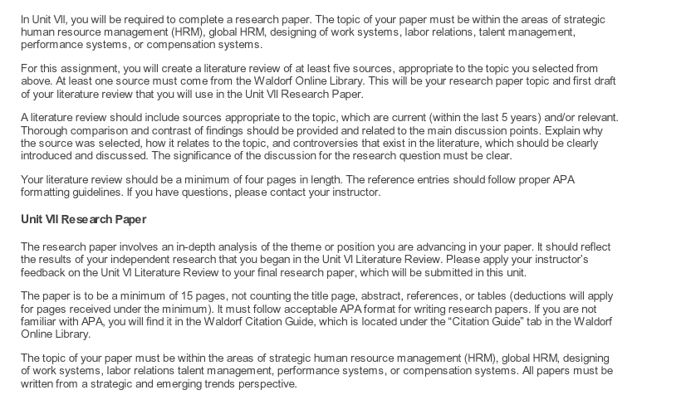

I require two papers focusing on Strategic Human Resource Management (HRM). The first is a 4-page paper that examines employee retention strategies, workforce diversity and inclusion, and the impact of technology on HRM. This paper must utilize at least 5 sources, one of which must be from the Waldorf Online Library. Source selection should prioritize relevance and recency, with all sources being within the last 5 years. The paper must be double-spaced and formatted in APA style.

The second paper is a more in-depth, 15-page analysis which builds on the themes of the first paper. This paper should be written from a strategic and emerging trends perspective, examining the same three areas: employee retention strategies, workforce diversity and inclusion, and the impact of technology on HRM. This paper should also incorporate strategic HRM frameworks, emerging trends in HRM, and best practices in HRM implementation.

Ideal skills for this project include strong research and academic writing skills, an understanding of HRM, and proficiency in APA formatting. Experience with writing and sourcing academic papers will be an advantage. I look forward to your bids.

