Systems Development Life Cycle – Systems Design

Student’s name
Institution affiliation
Assignment due date

PART A – Context and Data flow diagrams

Task 1 – System requirements
Input | Process | Output | Performance | Control
Book details | Recording book details to the system | Recorded book in the system |  | All book details must be provided
Customer details | Customer registration | A registered customer |  | Customer personal details must be provided

Task 2 – Context diagram
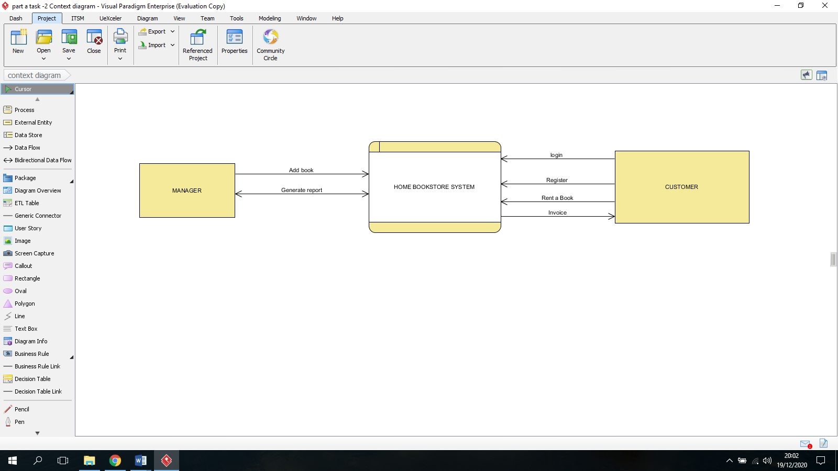

Task 3 - Level 0 Data Flow Diagram (DFD)
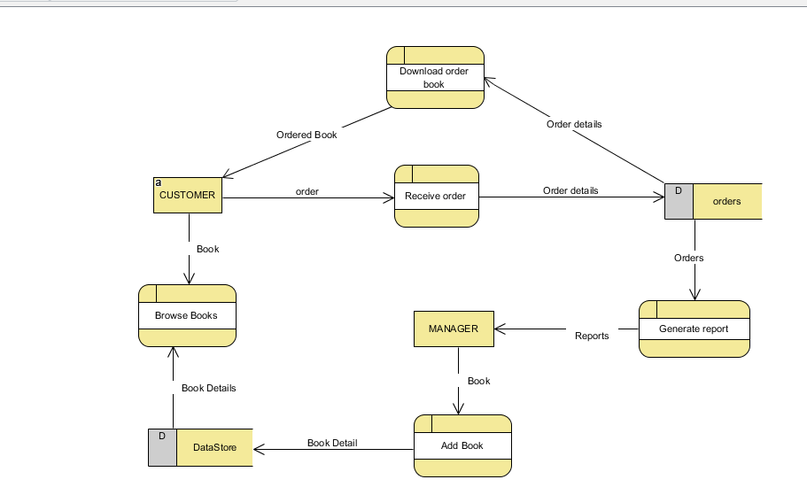

Task 4 – Decision Table

Developing a system is a process that involve several steps and activities where all of them leads to a final delivered system. One of the step during system development is system analysis and design where the logical and physical design of the system is carried out (Wolf 2018). Several tools are used to design the system, one of them being decision table. Decision table is a tool that help system analyst to visualize the actions to perform based on conditions. In Home Bookstore, a customer can only rent a book after registering to the system and providing credit card details. If the customer is not registered or the credit card details not verified, the rental order is declined. The system also allow the customer only to rent a maximum of ten books at any given time. If the books rented by a customer are ten, the current order for the customer is declined by the system.

PART B – System prototype
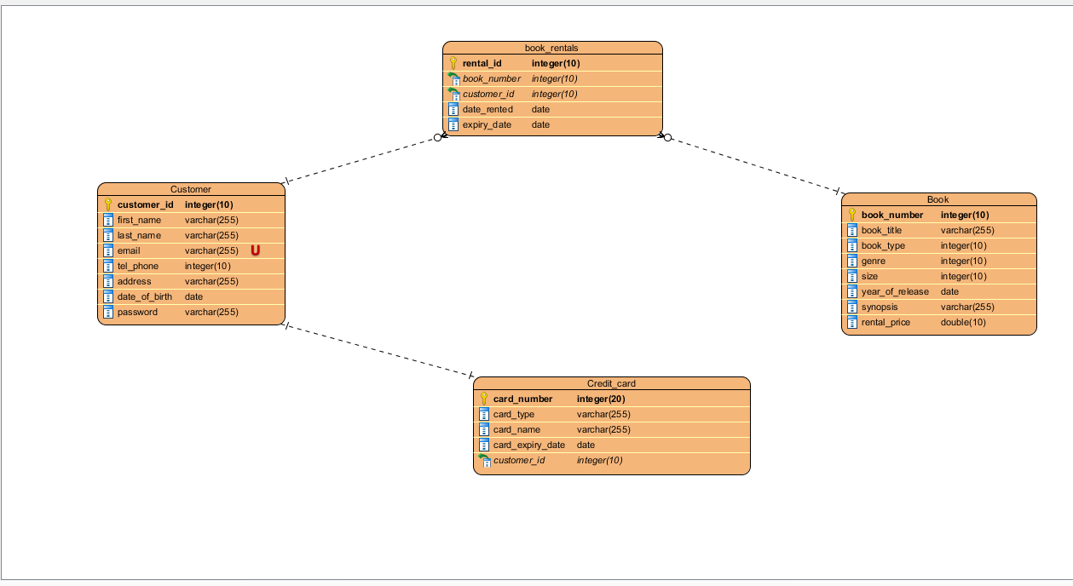
Task 1 – Entity Relationship Diagram (ERD)

Task 2 – Data Dictionary

Element description
Data element name | username | password | email address | book
Alias | username | password | email_address | book
Type | VARCHAR | VARCHAR | VARCHAR | VARCHAR
Length | 30 | 255 | 255 | 255
Acceptable values | Valid email address | Uppercase letter, lowercase letter, number, a symbol | Valid email address | Letters and numbers
Description and comments | Customer username for login | Customer password for login | Customer email address | Book available for rental
References
Liu, Z., Navathe, S. B., & Stasko, J. T. (2011, October). Network-based visual analysis of tabular data. In 2011 IEEE Conference on Visual Analytics Science and Technology (VAST) (pp. 41-50). IEEE.
Wolf, W. (2018). Tools and Methodologies for System-Level Design. In EDA for IC System Design, Verification, and Testing (pp. 3-1). CRC Press.

