Student Name

Unit Code –Unit Name

Student ID

Course

Date

**Task 1**

1. **Use Case Diagram**

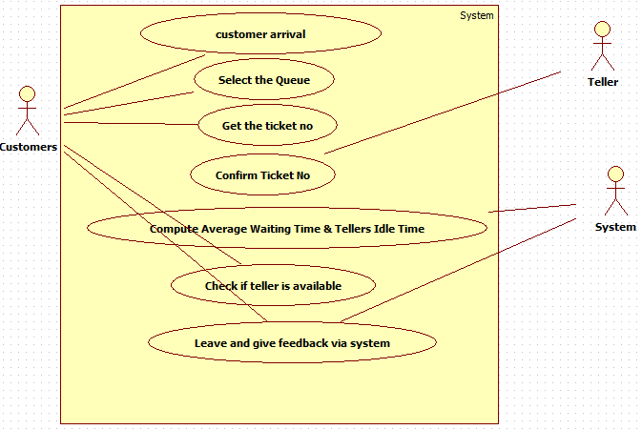

1. **Activity Diagram**

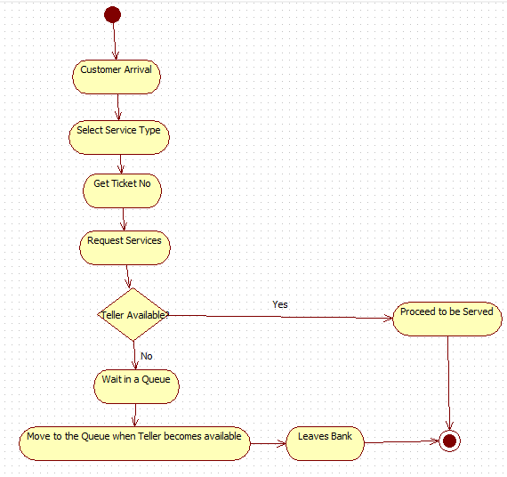

1. **Sequence Diagram**

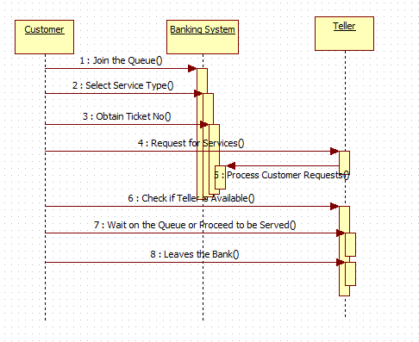

1. **Communication Diagram**

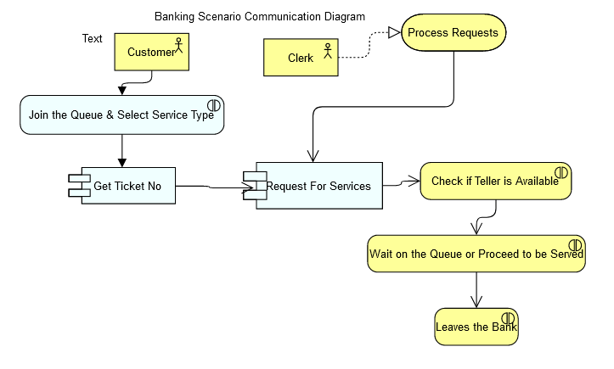

**Task 2**

1. **Use Case Diagram**

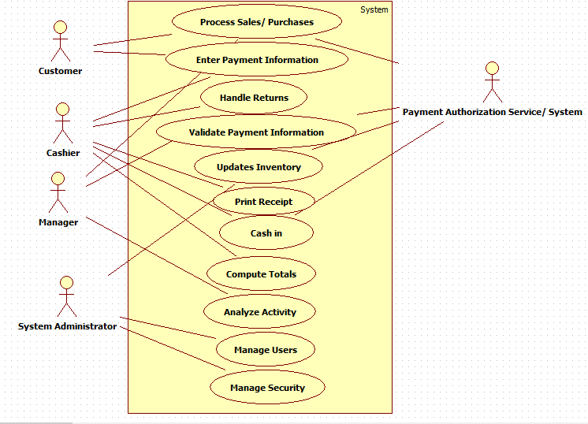

1. **Activity Diagram**

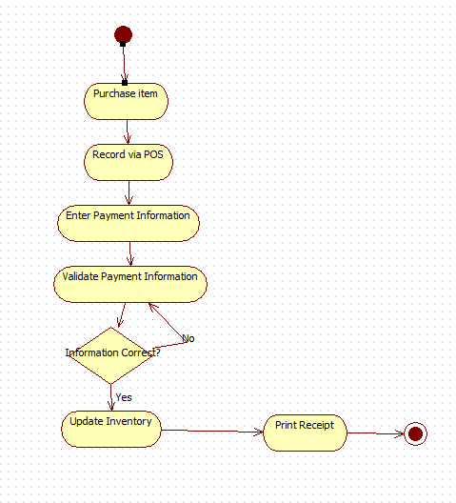

1. **Sequence Diagram**

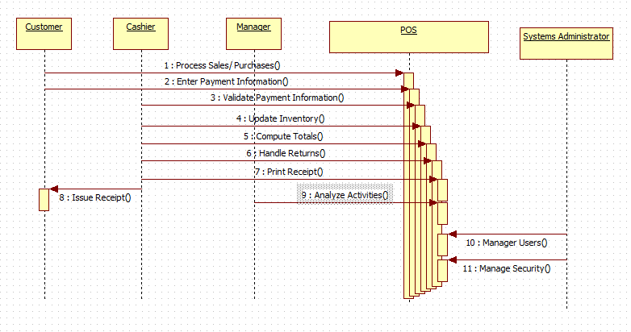

1. **Communication Diagram**

