How Tesla Motors can manage the extreme competition from large and premium manufactures
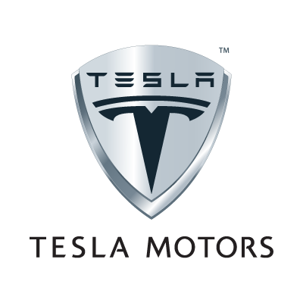

Daniil Chaika (119102547)
Workshop Tutor: John Davison
SIM336 - Strategic Management

Contents
- Introduction ……………………………………………………………………………….3
- Company Background………………………………………………………………….….3
- PESTEL Analysis……………………………………………………………...…………..3
  - Political……………………………………………………………………………..3-4
  - Economic……………………………………………………………………………...4
  - Social………………………………………………………………………………….4
  - Technological…………………………………………………………………………4
  - Environmental………………………………………………………………………...5
  - Legal…………………………………………………………………………………..5
- Porter’s 5 Forces Analysis…………………………………………………………………5
  - The Threat from New Entrants……………………………………………………..5-6
  - The bargaining power of Buyers……………………………………………………...6
  - Threat of Substitution…………………………………………………………………6
  - The bargaining power of Suppliers…………………………………………………..6
  - The Intensity of Rivalry in the Industry……………………………………………6-7
- Value Chain Analysis (VCA)……………………………………………………………...7
  - Primary Activities…………………………………………………………………..7-8
  - Support Activities…………………………………………………………………..8-9
- SWOT Analysis……………………………………………………………………………9
  - Strengths…………………………………………………………………………..9-10
  - Weaknesses………………………………………………………………………10-11
  - Opportunities………………………………………………………………………...11
  - Threats……………………………………………………………………………….11
- Bowman’s Strategy Clock …………………………………………………………...11-12
- Conclusion……………………………………………………………………………12-13
- Recommendations…………………………………………………………………….13-14
References
Appendixes

1.0 Introduction
The auto manufacturing market is very competitive, especially for alternative fuel vehicles that has become more popular with the rise of environmental concerns. This research will describe the electric vehicle manufacturing company, Tesla Motors, and how it can manage the extreme competition from large and premium manufactures.
The report starts from introduction of ‘Tesla Motors’ company. Next, the company strategic position will be analysed through main strategy models, including PESTEL and Porter’s five Forces frameworks, Value Chain and SWOT analysis. Afterwards, based on the findings from the models the conclusion and recommendation will be provided.

2.0 Company Background
Tesla Motors was established in 2003 by Martin Eberhard and Marc Tarpenning (Tesla, 2014), Silicon Valley engineers, as an electric car manufacture, and in 2006 the company launched the production of the first electric sports car, the Roadster, which eventually sold 2,250 vehicles (Fuel-efficient-vehicles.org, 2008). Nowadays, Tesla Motors provides power train components for car producers, including Daimler and Toyota, designs and manufactures Model S (Tesla.com, 2014), the first world’s premium zero-emission sedan that became the third best-selling all-electric car in the U.S (HybridCars.com, 2013) and Europe (Pontes, 2014). The company is worth more than $25 billion (Groom, 2014) – roughly half that of General Motors (GM) and has one of the highest growth rate in U.S. This success of the company is contributed to Elon Musk, the CEO and Product Architect of Tesla (Tesla, 2014), who has a very strong vision of company’s future.

3.0 PESTEL Analysis
The PESTEL framework evaluates the external environment variables to identify general opportunities and risks of particular strategies, because changes in these factors can lead to the significant transformation of industries, especially over the long run (Witcher and Chau, 2010). PESTEL highlights Political, Economic, Social, Technological, Environmental and Legal group factors.
3.1 Political
With selling cars in 17 countries of North America, Western Europe and Asia (Tesla, 2014), Tesla Motors has to deal with distinctive political patterns influencing its business operations. One of the major political factors affecting the industry is environmental protection laws to induce production of more environmental cars to meet strict emission levels (Environmental-protection.org.uk, 2014). The second important factor is US government energy loan programs for research and development of new vehicle technologies (Department of Energy, 2014). In this case, many auto manufacturers will be interested in entering the market.
3.2 Economic
Economic factors include economic growth in the alternative energy industries and increase in the cost of using the cars mainly due to the rise in fuel prices in the short period (BBC News, 2014). Therefore, the demand for more-efficient cars is higher than before. Next, recovery of GDP and inflation rate in most of the developed countries from the recessionary period in 2008/2009 has a significant impact on the customer purchase power (World Bank, 2014).
3.3 Social
Social factors are related to increase environmental concerns, attitudes and emphasis on products, which are “eco” friendly (Baki, et al. 2004). Buyers are losing faith in gasoline fuel and associated cost in production, trying to help the environment. Moreover, undoubtedly the current society judges people based on the type of the car they own (Autospies.com, 2008) and the idea of having electric vehicles improves the social status of an individual. Another social change is increase in ageing population with most wealth and savings, who would likely to spend more money on premium electrical cars (Reuters, 2014).
3.4 Technological
Technology advancement, rapid globalization and Internet impact have a huge effect on the automotive industry. Over the last years, much technology advancement has taken places within the industry, including the introduction of fully electrical cars and computerization of cars that allowed automotive driving and prevent drivers from accidents (Haveit-eu.org, 2011). This leads to more variety and more improvements in safety and convenience of cars in the future. Moreover, B2B platforms and market places have also given increased opportunities to the car industry that in turn increased efficiencies and reduced costs (Kachaner, et al, 2011)

3.5 Environmental
Over the last several years, many car manufacturers have faced the competitive pressure to produce eco-friendly or fuel-efficient vehicles. Environmental factors such as increasing awareness of climate change lead to changes in operations and companies’ products and services, because customers are getting more aware of environmental effects of production (Ypte.org.uk, 2014).
3.6 Legal
Many regulations emanate from green movements introducing energy loan programs and putting pressure on production eco-friendly cars such as increase taxation to incorporate the new methods of green business, the much expanded “carbon tax” and other green policies (Muller, 2013). Another major concern is franchise laws in US that protect car dealers and creates challenge to Tesla selling its car directly to customers (Fisher, 2014). Other factors that might affect the manufacturing of battery car include the tax incentives and subsidies to increase the demand among consumers (Ministry of Transportation, 2010).
The issues covered throughout the PESTLE analysis shaped many opportunities for Tesla Motors for further expansion and success of electrical cars within automotive market. However, together with opportunities they also creates threats, thus, the company should be concerned about rapid technology advancement and political regulations within the industry it operates.

4.0 Porter’s 5 Forces Analysis
Porter’s 5 competitive forces model is starting point for strategic analysis that is used for assessing the attractiveness of an industry (Johnson, et al, 2008) and discovering a desirable strategic innovation that improve the industry and company profitability (Wit and Meyer, 2005).
4.1 The Threat from New Entrants
The threat from new entrants is very high. Entering the electric automotive industry in 2003, Tesla itself faced the challenges of being the new entrant into the market having numerous financial troubles that required high capital investments, building the brand and distributions channels. However, for established manufacturers with considerable economic power to enter this market is relatively low due to their capabilities and governmental program support for developing electric vehicle (Shirouzu, 2011).
4.2 The bargaining power of Buyers
Overall bargaining power of buyers is modest. According to Tesla Annual Report (2014), they rely on their relationship with Daimler and Toyota (Brown, 2013). The partnership is very important for Tesla, because supplying these companies constitutes the high share of their profit and thus, they cannot lose them, making their power considerably high. However, they also sell their cars to individual customers, and many government incentives give potential customers tax credit deduction (Ministry of Transportation, 2010). These programs stimulate the demand of electric cars that makes bargaining power low.
4.3 Threat of Substitution
The threat of substitutes is considerably law in automotive industry, because there are only few choices in the substitution of car. One of the substitutes can be walking or biking that is very inconvenience for long distances. Moreover, mass transportation such as trains, buses, and subways are substitutes that are suitable for local and distant travelling (Dutch, 2008). However, many people prefer to have their own car that is more convenient.
4.4 The Bargaining Power of Suppliers
The power of suppliers is very high due to the fact that company is highly dependent on these suppliers and any problems with components delivering will result in production disruption that negatively reflects on company image. This is due to purchasing components from over 200 suppliers over the world. Despite of building close relationships with main suppliers such as Panasonic (Tesla Motors, 2014), working together on the development of new battery cell and replacing Lotus supplier’s chassis with manufacturing by themselves (Tesla Motors, 2014), many suppliers stay single sources of components used in their cars (Harryson and Keller, 2013).
4.5 The Intensity of Rivalry in the Industry
The rivalry in the whole automotive industry is very competitive. However, within electrical vehicle market in which Tesla position itself, the rivalry is modest because of small number of competitors in the face of 18 different current models, the main of which are Nissan Leaf, Ford Focus BEV and Chevrolet Volt (Insideevs.com, 2014). However, this market is very attractive and expanding fast, therefore more companies, including BMW, Audi and Volkswagen, has entered it recently with their plug-in models (White, 2013). In addition, every company is trying to create their niche, developing many alternatives in term of environmentally friendly cars, including hybrids, small performance turbo diesels and biodiesel cars. Thus, in future, the rivalry will be more intensive and companies will need to keep innovative, improving and making better cars.
Porter’s 5 forces and industry structure are likely to be favourable in most cases for the company future growth. However, the automotive market is very competitive and attractive for big players. Therefore, Tesla Motor’s should be able to keep up with larger companies and not to be squeezed out.

5.0 Value Chain Analysis (VCA)
David (2011) states that Value Chain analysis helps a company to determine its own strengths and weaknesses along the functions and activities that add value in developing and marketing the product or service. It consists of primary activities that are directly concerned with production, and support activities that help to enhance the effectiveness of primary activities (Johnson, et al, 2008).
5.1 Primary Activities
Inbound Logistics. The most important components Tesla manufactures in-house. (Bowman, 2010). Other components are produced and delivered from numerous suppliers in a timely manner. It reduces its waiting period to the minimum and improves production efficiency (Liker, 2004).
Operations. All cars are made in Northern California, Fremont factory with all necessary manufacturing operations (Tesla Motors, 2014). Manufacturing process is highly innovated and automated, with multi-function robots those can produce up to 83 vehicles per day and easily reprogrammed to produce different car models (Hill, et al, 2014).
Outbound Logistics. Tesla Motors distribution channel consists of their own stores across 18 countries (Tesla Motors, 2014) that play role to educating customers about the benefits of electric cars. While purchasing of a product is made over the online reservation and showrooms (Harryson and Keller, 2013), selecting the preferred delivery address (Tesla Motors, 2014).
Marketing and Sales. Tesla spends no money on traditional marketing and does not employ an ad agency (Foley, 2013). Instead, they developed the network of their own stores, located in high foot traffic and wealth’s districts, to interact brand awareness (Tesla Motors, 2014). Many Hollywood celebrities, including Morgan Freeman and George Clooney (Miller, 2012), are the owners of Model S, have an enormous impact on the popularity and fashionable image of Tesla products. Additionally, the company use web-based short films and “Conceptualizing the Car Buying experience” ad campaigns in YouTube (Tesla Motors, 2014).
Service: Together with stores Tesla also owns their own service centres in North America, Europe and Asia (Tesla Motors, 2014). They built and expand the super-fast free charging station network for their customers’ vehicles, enhancing the value of the products. Moreover, they provide their customers with 50, 000 mile warranty policy to increase their confidence and reduce operational costs (Baliga, 2009).
5.2 Support Activities
Infrastructure: Tesla motors adopted a flat/horizontal organizational structure (Tesla Motors, 2014), with the CEO at the top making decisions and then delegating authority to lower level manager (Allbusiness.com, 2014). Tesla Motors benefits from having flat organization structure due to better communication process and faster decision-making, eliminating delays and lag time (Hill and Jones, 2008). Elon Musk, who has necessary leadership qualities to build a strong corporate culture to perfect execution of company’s strategic vision, leads the management team (Forbes, 2014).
Procurement: They have developed good relationship with strategic suppliers, such as partnership with Panasonic, allowing to gain significant benefits for each party and sharing of information (Ellram and Krause 1994, cited in Waters, 2003) and short-term agreements with other suppliers, to replace them with alternative sources in the case of their failure to provide necessary components (Tesla Motors, 2014).
R&D: R&D is the key part of Tesla Motors that allows being so competitive in their field that no other competitors can currently beat them. The company focuses on plowing back all free money on R&D to reduce the cost, remain innovative and sustain their image (Musk, 2006). It also adds the elegance to the product’s design that creates the impression of superior value and quality (Hill and Jones, 2008). All their ideas are protected with patents (Edelstein, 2013) to decrease the threat of exploiting their invention and being copied.
H&R: Growing fast on the global market, Tesla uses High Street Partners for hiring process to employ the talented workforce and preserving its culture (High Street Partners, 2014). Next, Tesla provides employees with company shares (Harryson and Keller, 2013), motivating managers to adopt strategies that increase the share price of the organization (Hill & Jones 2008).
SUPPORT ACTIVITIES | Infrastructure | Flat/horizontal infrastructure, small management team, strong leadership  PROFIT
 | HRM | Strong management team, Outsourced recruitment, company shares reward policy, close relationships among managers and employees
 | Technology Development | Leading edge in technology, reinvesting in R&D, cost reduction, excellent products’ design, patents
 | Procurement | Partnerships and alliances with suppliers, short-term agreements
 | Inbound  Logistics | Operations | Outbound  Logistics | Marketing  & Sales | Service
 | -In-house production  -Numerous suppliers  -JIT | -Innovated and automated  -Multi-functional robots  -Easily reprogramming | -Own stores in 18 countries  -Online reservation  -Showrooms | Celebrities  -Web-based short movies  -Campaigns | -Service centers  -Charge stations  -Warranty  policy
 | PRIMARY ACTIVITIES
Figure 1. Porter’s Value Chain of Tesla Motors

6.0 SWOT Analysis
SWOT highlights the main issues from the external environment and the strategic capabilities of a firm that have an impact on strategy development (Johnson, et al, 2008). Furthermore, they will be useful in developing strategic options and future courses of action (Thompson and Martin, 2005).
6.1 Strengths
There are several strengths within Tesla Motors that have helped them to be over others in the automotive industry. First, outsourcing of secondary components helps to keep low cost and focus primarily on technological advancement (Welch, 2009). This, in turn, moves to strong R&D department, creating high productivity battery systems and electric powertrain (Tesla Motors, 2010) and overwhelming other competitors in this market. This made Model S the winner of 2013 Motors Trend’s Car of the Year award (MacKenzie, 2013).
Lean management system in which all employers work together in relatively small and cheaply decorated offices (Welch, 2009). This allows to simplify the decision making process, skipping writing proposal and its submission and approval through the chain of command, enhancing trust and relations between employees and managers.
Tesla has acquired numerous investors from well-established companies such as Google, and built the successful strategic partnerships with Daimler, Toyota Motors and Panasonic (Tesla Motors, 2014) that brings mutual benefits to both parties, sharing their expertise in production processes and technologies, and provide the trust for Tesla’s customer, future investors, and may also enhance the company brand recognition.
Finally, good distribution though own stores placed in high traffic retail locations to increase interactions with potential customers, integrating with e-commerce and digital marketing. This means they eliminate franchise dealership, saving money and increasing sale efficiency, as there is no 10% dealership commission.
6.2 Weaknesses
Tesla biggest problems is the lack of liquidity. Despite the high sales of new Model S in 2013, company continue to have lost over 70 million (Appendix B) because of the large sum of debt, the slow rate at which clients are buying Tesla motors and failure to achieve planned cost reductions and controlling operational cost.
Second, company’s limited manufacturing capacity, only Fremont factory, can lead to failure to meet the increased customer demand in future, especially with the Tesla’s expanding strategy to Europe and Asia. Additionally, company struggles with lithium battery cell shortage (Reuters, 2013) and heavy reliance on suppliers that can harm brand image due to delays in delivering vehicles to its customers.
Finally, Tesla motors founded in 2003, having limited operating history, lack of brand recognition and expertise in auto-manufacturing industry compared with well-established company such as Ford or General Motors. This creates additional concern about how they can manage problems that may emerge and affect the business.
6.3 Opportunities
Tesla Motor’s has many opportunities, which were created by external factors in automobile environment. Obviously, one the most significant changes is customer awareness about benefits of having electrical car, especially during the substantial rise in the price of petroleum and increasing concerns about environmental pollution and global warming create a good opportunity for the company to generate demand for its vehicles.
Next, US governmental subsidy programs and loans for green-energy companies help to find additional investments for growth, as well as government incentives across many developed countries in support of “green” car adoption will encourage customers to purchase of such vehicles.
Finally, the company is in the market segment which is largely untouched and rapidly growing in terms of demand. Due to factors mentioned above, this gives them opportunity to expand and produce more vehicles, thus, acquiring more market share and earning more profit.
6.4 Threats
Possible threat facing Tesla is the established manufacturers entering the market with greater economies of scale capabilities and higher expertise in automobile market which will position their car within lower prices, and thus, take away potential customers and surpass Tesla’s battery cell development. Next, due to attractiveness of market, competitors invest in alternative energy technologies and potential major breakthrough such as a hydrogen powered vehicles may weaken Tesla’s current technology advantages as well. Finally, any problems associated with electrical car usage such as catching fire or smoke or short-term decrease in the price of oil will raise concerns about safety and discourage buyers’ adoption of electrical vehicles.

7.0 Bowman’s Strategy Clock
Strategy Clock introduce by Cliff Bowman ‘represents different position in a market where customers (or potential customer) have different ‘requirements’ in terms of value for money’ (Johnson, 2010:224). These positions also represent a range of generic strategies for gaining competitive advantage. Each of the routes defined by Johnson, et al (2008) are in Appendix One in further detail.
Tesla Motors has a focus of differentiation strategy, concentrating only on small group of people, who are rich and environmental conscious, attracted by stylish and beautiful look of its cars. Because, it will be hard to reach out and compete with other auto-manufactured brands as common person would not go and buy an electric car with short-distance travel and weak charging network with the price more than $60000 (Tesla Motors, 2014). Tesla cannot adopt the low cost or hybrid strategies, because it does not have the scale, capital and production capacity to compete on a cost basis, and actually, it is surviving on only due its product uniqueness design and leading-edge technologies, which allows attracting people to buy their cars. Thus, this is a very suitable position for Tesla in current environment that gives core competitive advantage.
Porsche
Lamborghini
Ferrari

BMW
Audi
Mercedes
Chevrolet
Skoda
Toyota
Volkswagen
Honda
Dacia
Tata
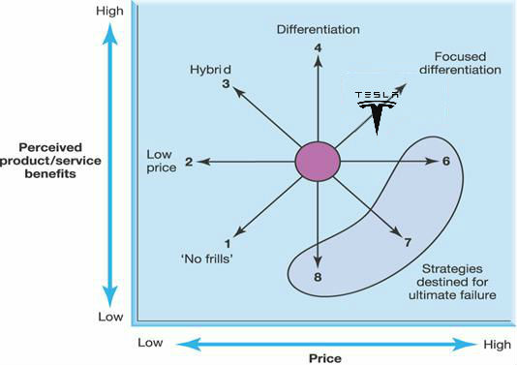
Figure 2. Bowman’s strategic clock (Johnson, G., Scholes, K. And Whittington, R.,
2008: 225)

8.0 Conclusion
In this report, Tesla Motor’s current situational analysis has been performed to provide future company strategy to survive in highly competitive environment. Tesla is a successful start-up that has become the leading edge company due its innovation ideas and good leadership management in car-manufacturing industry. They have realized the importance of renewable energy and environmental protection, and how they can solve these issues with rapidly development of high technologies. Thus, they have revolutionized the automotive industry and provided the worthy alternative to gasoline vehicles.
The macro-environmental factors with company internal processes create good conditions for Tesla growth in future and making it one of the leading automantufacturing companies that provides excellent products with the best technologies and design at convenient cost. However, the entrance of established manufactures on the electronic vehicles market those have greater economic scale, strong management teams and developed brands have created the serious threat to Tesla on surviving in this market. Finally, the company has adapted focus differentiated strategy, targeting upper-income level customers, and providing high performance and creative vehicles that gives them core competitive advantage.

Recommendations
Within Bowman’s Strategy Clock it is recommended to shift the company strategy from Focus Differentiation to Differentiation, providing benefits that are different from those of rivals and widely valued by customers at the same prices. This in turn will increase market share and long-term profitability.
In order to achieve differentiation strategy, it is recommended to widen the range of models within premium and small premium vehicle segments that allow competing with other companies. They should aim to be affordable and available for different markets segments and not just for premium segment alone.
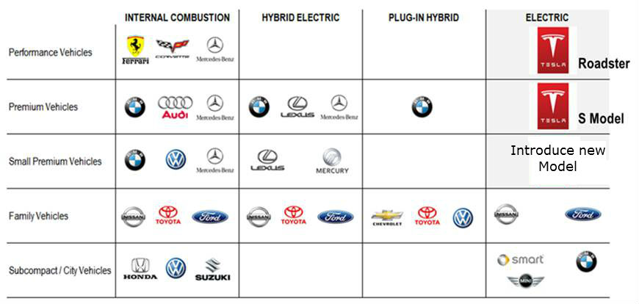
Figure 3. Positioning of Tesla Motors’ cars within automobile market (Tesla Motors, 2014)
Furthermore, despite Tesla’s products have technological advancement, it must continue to stay on the cutting edge of innovation and quality, and accelerate new product development. For example, they may reduce the time of recharging the car to the point that it will be a 1:1 comparison to gasoline models, and improving battery types and modularity, to increase the travel distance on a single charge.
Pursuing differentiation the company’s cost structure must be carefully managed to keep lower cost in areas not related to differentiation and higher costs in main processes with a distinctive edge (Akroyomare, et al, 2012), such R&D and Marketing. Advertising is very important for the company, because they relatively new brand, and through media applications, Tesla can build brand identity and become well known all over the world.
Word count 3,280

References
Akpoyomare, O., Adeosun, L. and Ganiyu, R. (2012). Differentiation and Positioning Strategy: A Toss of the Same Coin. International Journal of Management and Sustainability, 1(2), pp.53--65.
Autospies.com, (2014). Can You Judge A Person By The Type Of Car They Drive? - AutoSpies Auto News. [online] Available at: http://www.autospies.com/news/Can-You-Judge-A-Person-By-The-Type-Of-Car-They-Drive-27859/ [Accessed 6 April. 2014].
Baki, M., Copus, S., Green, M., Highfill, D., Smith, J. And Whineland, M. (2004)
Automotive Industry Analysis - GM, DaimlerChrysler, Toyota, Ford, Honda,
Kansas State University, Unpublished
Baliga, B. (2009). Advanced power rectifier concepts. 2nd ed. New York: Springer.
BBC News, (2014). Petrol price reaches record high. [online] Available at: http://www.bbc.co.uk/news/business-17490088 [Accessed 4 April. 2014].
Bowman, R. (2010). Tesla Motors: A Tale of Beauty and Pain. [online] Supplychainbrain.com. Available at: http://www.supplychainbrain.com/content/blogs/think-tank/blog/article/font-size2tesla-motors-a-tale-of-beauty-and-painfont/ [Accessed 4 April. 2014].
Brown, N. (2013). Daimler Wants Increased Cooperation With Tesla Motors. [online] CleanTechnica. Available at: http://cleantechnica.com/2013/11/07/daimler-wants-increased-cooperation-tesla-motors/ [Accessed 6 April. 2014].
Edelstein, S. (2013). Could Tesla’s electric-electric hybrid powertrain eliminate range anxiety?. [online] Digital Trends. Available at: http://www.digitaltrends.com/cars/tesla-motors-patents-electric-electric-hybrid-powertrain/#!Ih3eP [Accessed 6 April. 2014].
Energy.gov, (2014). Loan Programs Office | Department of Energy. [online] Available at: http://energy.gov/lpo/loan-programs-office [Accessed 13 April. 2014].
Environmental-protection.org.uk, (2014). Car Pollution | Environmental Protection UK. [online] Available at: http://www.environmental-protection.org.uk/committees/air-quality/air-pollution-and-transport/car-pollution/ [Accessed 8 April. 2014].

Fisher, D. (2014). Tesla's Elon Musk Learns An Old Lesson Fighting Protectionist Dealer Laws. [online] Forbes. Available at: http://www.forbes.com/sites/danielfisher/2014/03/18/teslas-elon-musk-learns-an-old-lesson-fighting-protectionist-dealer-laws/ [Accessed 3 April. 2014].
Foley, M. (2013). Here’s Why Tesla Doesn’t Need Traditional Automotive Marketing. [online] Wall St. Cheat Sheet. Available at: http://wallstcheatsheet.com/stocks/heres-why-tesla-doesnt-need-traditional-automotive-marketing.html/?a=viewall [Accessed 15 April. 2014].
Fuel-efficient-vehicles.org, (2008). TESLA Roadster | Fuel-Efficient-Vehicles.org. [online] Available at: http://fuel-efficient-vehicles.org/energy-news/?page_id=52 [Accessed 10 April. 2014].
Greentechmedia.com, (2014). Tesla Giga Factory: $4B to $5B Price Tag, With Battery Production Slated for 2017 : Greentech Media. [online] Available at: http://www.greentechmedia.com/articles/read/Tesla-Giga-Factory-Update-4-to-5-Billion-Price-Tag-With-Production-Slate [Accessed 5 April. 2014].
Harryson, S. and Keller, S. (2014). Tesla Motors Case II: From Technology Start up to Commercialization Vehicle. CIEL. [online] Available at: http://ciel-lab.dk/wp-content/uploads/2013/04/Case_Tesla-Motors-Part-II.pdf [Accessed 1 April. 2014].
Haveit-eu.org, (2011). Driving without a Driver – Volkswagen presents the “Temporary Auto Pilot”. [online] Available at: http://www.haveit.eu.org/displayITM1.asp?ITMID=117&LANG=EN [Accessed 6 April. 2014].
Hill, C., Jones, G. and Schilling, M. (2014). Strategic management: Theory & Cases: An Integrated Approach. 11th ed., Cengage Learning
Hill, C. and Jones, G. (1998). Strategic management. 2nd ed. Boston: Houghton Mifflin Co.
HybridCars.com, (2014). December 2013 Dashboard - HybridCars.com. [online] Available at: http://www.hybridcars.com/december-2013-dashboard/ [Accessed 16 April. 2014].
Industryweek.com, (2014). Warranty Management: Your Strategic Advantage | Companies & Executives content from IndustryWeek. [online] Available at: http://www.industryweek.com/companies-amp-executives/warranty-management-your-strategic-advantage [Accessed 3 April. 2014].
Insideevs.com, (2014). February 2014 Plug-In Electric Vehicle Sales Report Card | Inside EVs. [online] Available at: http://insideevs.com/february-2014-plug-in-electric-vehicle-sales-report-card/ [Accessed 3 April. 2014].
Kachaner, N., Lindgardt, Z. and Michael, D. (2011). Innovating low-cost business models. Emerald, [online] 39(2), pp.43-48. Available at: http://www.emeraldinsight.com/case_studies.htm/case_studies.htm?articleid=1911692&show=html [Accessed 3 April. 2014].
Liker, J. (2004). The Toyota way. New York: McGraw-Hill.
MacKenzie, A. (2013). 2013 Motor Trend Car of the Year: Tesla Model S - Motor Trend. [online] Motor Trend Magazine. Available at: http://www.motortrend.com/oftheyear/car/1301_2013_motor_trend_car_of_the_year_tesla_model_s/ [Accessed 6 April. 2014].
Miller, D. (2012). Is the Tesla Model S the First Sexy Green Car?. [online] The Hollywood Reporter. Available at: http://www.hollywoodreporter.com/news/tesla-model-s-morgan-freeman-395593 [Accessed 20 April. 2014].
Ministry of Transportation, (2010). Newsroom : Ontario Paves The Way For Electric Vehicles. [online] Available at: http://news.ontario.ca/mto/en/2010/06/ontario-paves-the-way-for-electric-vehicles.html [Accessed 4 April. 2014].
Muller, J. (2013). The Real Reason Tesla Is Still Alive (And Other Green Car Companies Aren't). [online] Forbes. Available at: http://www.forbes.com/sites/joannmuller/2013/05/11/the-real-reason-tesla-is-still-alive-and-other-green-car-companies-arent/ [Accessed 11 April. 2014].
Musk, E. (2006). The Secret Tesla Motors Master Plan (just between you and me) | Blog | Tesla Motors. [online] Teslamotors.com. Available at: http://www.teslamotors.com/fr_CH/blog/secret-tesla-motors-master-plan-just-between-you-and-me [Accessed 6 April. 2014].
NASDAQ.com, (2014). TSLA Income Statement. [online] Available at: http://www.nasdaq.com/symbol/tsla/financials?query=income-statement [Accessed 4 April. 2014].
Nicholas Groom, R. (2014). Tesla Motors Inc shares rise as Elon Musk says Model S deliveries to surge more than 55%. [online] Financial Post. Available at: http://business.financialpost.com/2014/02/19/tesla-motors-inc-shares-rise-as-fourth-quarter-earnings-top-expectations [Accessed 4 April. 2014].
Pontes, J. (2014). EV Sales: Europe December 2013. [online] Ev-sales.blogspot.ca. Available at: http://www.ev-sales.blogspot.ca/2014/01/europe-december-2013.html [Accessed 6 April. 2014].
Reuters, (2014). America’s aging population undermines monetary policy. [online] Available at: http://blogs.reuters.com/great-debate/2013/09/24/americas-aging-population-undermines-monetary-policy/ [Accessed 6 April. 2014].
Reuters, (2013). Tesla outlook, deliveries fall short amid capacity constraints. [online] Available at: http://www.reuters.com/article/2013/11/06/us-autos-tesla-idUSBRE9A415E20131106 [Accessed 4 April. 2014].
Reuters.com, (2014). Tesla Motors Inc (TSLA.O) Company Profile | Reuters.com. [online] Available at: http://www.reuters.com/finance/stocks/companyProfile?symbol=TSLA.O [Accessed 10 April. 2014].
Tesla Motors, Inc., (2014). Form 10-K Annual Report. Palo Alto, California. [online] Available at: http://ir.teslamotors.com/secfiling.cfm?filingID=1193125-14-69681&CIK=1318605 [Accessed 2 April. 2014].
Tesla Motors, (2010). FORM 424B4. San Carlos: [online] Available at: http://ir.teslamotors.com/sec.cfm [Accessed 7 April. 2014]
Tesla Motors, (2014). About Tesla | Tesla Motors. [online] Available at: http://www.teslamotors.com/about [Accessed 20 April. 2014].
Tesla Motors, (2014). Tesla Motors Receives Research and Development Grant from the California Air Resources Board and California Energy Commission | Press Releases | Tesla Motors. [online] Available at: http://www.teslamotors.com/fr_BE/about/press/releases/tesla-motors-receives-research-and-development-grant-california-air-resources-b [Accessed 14 April. 2014].
Thompson, J. and Martin, F. (2005). Strategic management. 3rd ed. London: Thomson Learning.
Waters, D. (2003). Global Logistics & Distribution Planning. 2nd ed. London: Kogan Page.
Welch, D. (2009). A Long Bet on Electric Cars. [online] Businessweek.com. Available at: http://www.businessweek.com/magazine/content/09_41/b4150031046560.htm [Accessed 6 April. 2014].
Wit, B. and Meyer, R. (2005). Strategy synthesis. 3rd ed. London: Thomson Learning.
World Bank, (2014). Global Economy at Turning Point, Says World Bank. [online] Available at: http://www.worldbank.org/en/news/press-release/2014/01/14/global-economy-turning-point-world-bank [Accessed 3 April. 2014].
Witcher, B. and Chau, V. (2010). Strategic management. 1st ed. Andover: Cengage.
Ypte.org.uk, (2014). Pollution :: Environmental Facts :: Young People's Trust for the Environment. [online] Available at: http://www.ypte.org.uk/environmental/pollution/32 [Accessed 17 April. 2014].

Appendix – Bowman’s Strategic Clock Routes
Route 1 is defined as “the ‘no frills’ strategy, which combines a low price with low perceived product/service benefits and a focus on a price-sensitive market segment”. (Johnson, G., Scholes, K. And Whittington, R., 2008)
Route 2 is defined as “the low-price strategy, seeks to achieve a lower price than competitors whilst maintaining similar perceived product or service benefits to those offered by competitors.” (Johnson, G., Scholes, K. And Whittington, R., 2008)
Route 3 is defined as “A hybrid strategy seeks simultaneously to achieve differentiation and low price relative to competitors. The success of this strategy depends on the ability to deliver enhanced benefits to customers together with low prices whilst achieving sufficient margins for reinvestment to maintain and develop bases of differentiation.” (Johnson, G., Scholes, K. And Whittington, R., 2008)
Route 4 is defined as “is a broad differentiation strategy providing products or services that offer benefits different from those of competitors and that are widely valued by buyers. The aim is to achieve competitive advantage by offering better products or services at the same price or enhancing margins by pricing slightly higher.” (Johnson, G., Scholes, K. And Whittington, R., 2008)
Route 5 is defined as “A focused differentiation strategy provides high perceived product/service benefits, typically justifying a substantial price premium, usually to a selected market segment (or niche)”. (Johnson, G., Scholes, K. And Whittington, R., 2008)

Appendix B - Historical Financial Data
 |  |  |  | ‘Year Ended December 31,
 |  | 2012 |  |  |  |  |  | 2011 |  |  |  | 2010 |  |  |  | 2009 |  |  |  | 2008
 |  |  |  | (in thousands, except share and per share data)
Consolidated Statements of Operations Data:
Revenues:
Automotive sales |  | $ | 385,699 |  |  |  |  | $ | 148,568 |  |  | $ | 97,078 |  |  | $ | 111,943 |  |  | $ | 14,742
Development services |  |  | 27,557 |  |  |  |  |  | 55,674 |  |  |  | 19,666 |  |  |  | — |  |  |  | —
Total revenues |  |  | 413,256 |  |  |  |  |  | 204,242 |  |  |  | 116,744 |  |  |  | 111,943 |  |  |  | 14,742
Cost of revenues (1):
Automotive sales |  |  | 371,658 |  |  |  |  |  | 115,482 |  |  |  | 79,982 |  |  |  | 102,408 |  |  |  | 15,883
Development services |  |  | 11,531 |  |  |  |  |  | 27,165 |  |  |  | 6,031 |  |  |  | — |  |  |  | —
Total cost of revenues |  |  | 383,189 |  |  |  |  |  | 142,647 |  |  |  | 86,013 |  |  |  | 102,408 |  |  |  | 15,883
Gross profit (loss) |  |  | 30,067 |  |  |  |  |  | 61,595 |  |  |  | 30,731 |  |  |  | 9,535 |  |  |  | (1,141 | )
Operating expenses (1):
Research and development |  |  | 273,978 |  |  |  |  |  | 208,981 |  |  |  | 92,996 |  |  |  | 19,282 |  |  |  | 53,714
Selling, general and administrative |  |  | 150,372 |  |  |  |  |  | 104,102 |  |  |  | 84,573 |  |  |  | 42,150 |  |  |  | 23,649
Total operating expenses |  |  | 424,350 |  |  |  |  |  | 313,083 |  |  |  | 177,569 |  |  |  | 61,432 |  |  |  | 77,363
Loss from operations |  |  | (394,283 |  | ) |  |  |  | (251,488 | ) |  |  | (146,838 | ) |  |  | (51,897 | ) |  |  | (78,504 | )
Interest income |  |  | 288 |  |  |  |  |  | 255 |  |  |  | 258 |  |  |  | 159 |  |  |  | 529
Interest expense |  |  | (254 |  | ) |  |  |  | (43 | ) |  |  | (992 | ) |  |  | (2,531 | ) |  |  | (3,747 | )
Other expense, net (2) |  |  | (1,828 |  | ) |  |  |  | (2,646 | ) |  |  | (6,583 | ) |  |  | (1,445 | ) |  |  | (963 | )
Loss before income taxes |  |  | (396,077 |  | ) |  |  |  | (253,922 | ) |  |  | (154,155 | ) |  |  | (55,714 | ) |  |  | (82,685 | )
Provision for income taxes |  |  | 136 |  |  |  |  |  | 489 |  |  |  | 173 |  |  |  | 26 |  |  |  | 97
Net loss |  | $ | (396,213 |  | ) |  |  | $ | (254,411 | ) |  | $ | (154,328 | ) |  | $ | (55,740 | ) |  | $ | (82,782 | )
Net loss per share of common stock, basic and diluted (3) |  | $ | (3.69 |  | ) |  |  | $ | (2.53 | ) |  | $ | (3.04 | ) |  | $ | (7.94 | ) |  | $ | (12.46 | )
Weighted average shares used in computing net loss per share of common stock, basic and diluted (3) |  |  | 107,349,188 |  |  |  |  |  | 100,388,815 |  |  |  | 50,718,302 |  |  |  | 7,021,963 |  |  |  | 6,646,387 | ‘

Source: Tesla Motors, Inc., (2014). Form 10-K Annual Report. Palo Alto, California. [online] Available at: http://ir.teslamotors.com/secfiling.cfm?filingID=1193125-14-69681&CIK=1318605

Appendix C - Tesla Model S and Roadster Images
Roadster
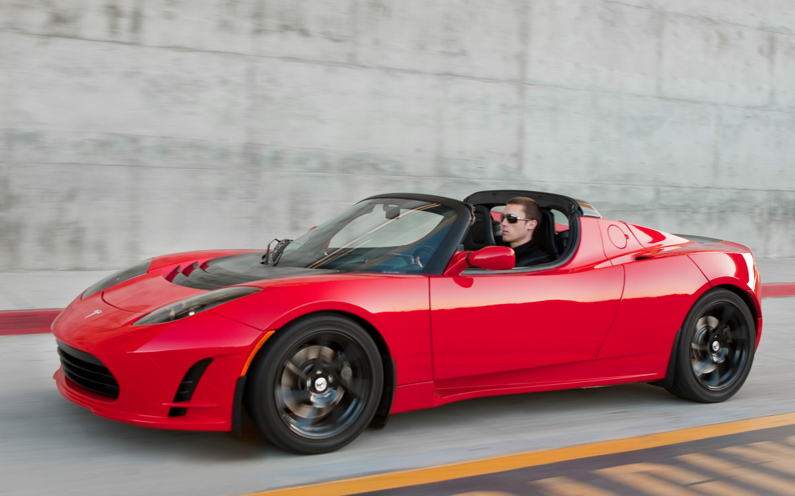
(Image source: Tesla Motors, 2014)
(Image source: Tesla Motors, 2014)
The Tesla Model S
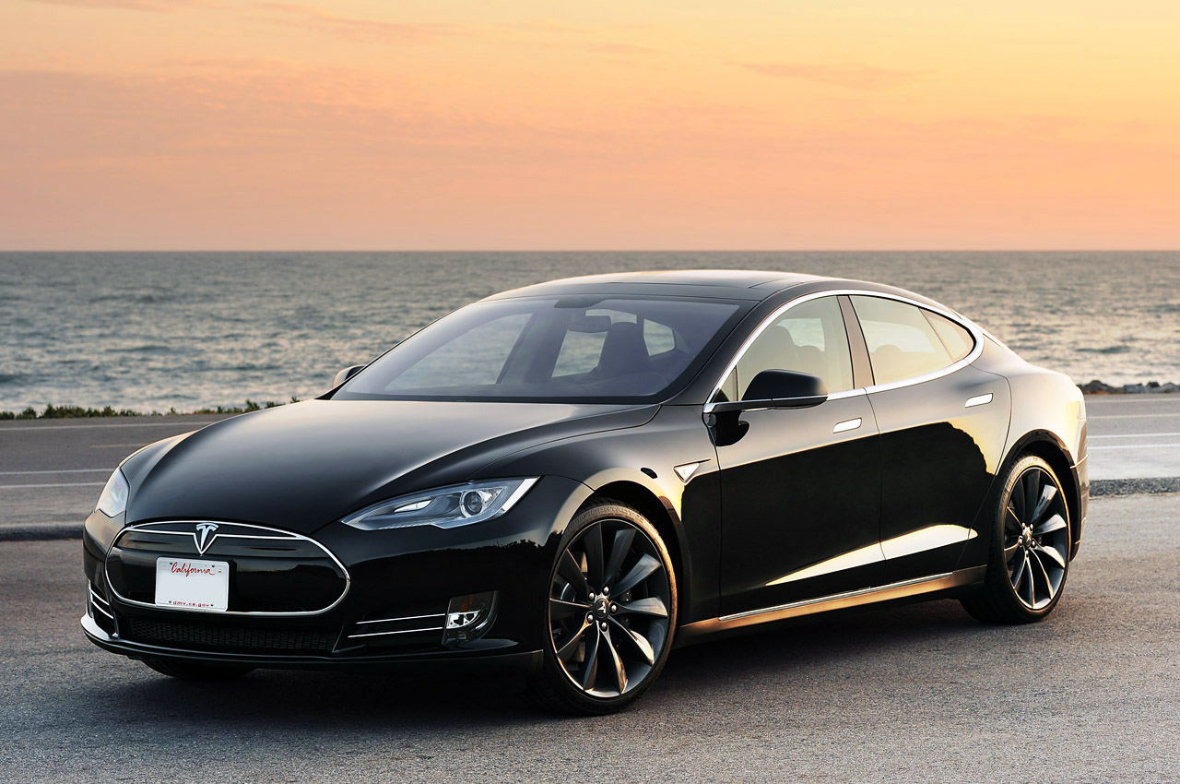
(Image source: Tesla Motors, 2014)
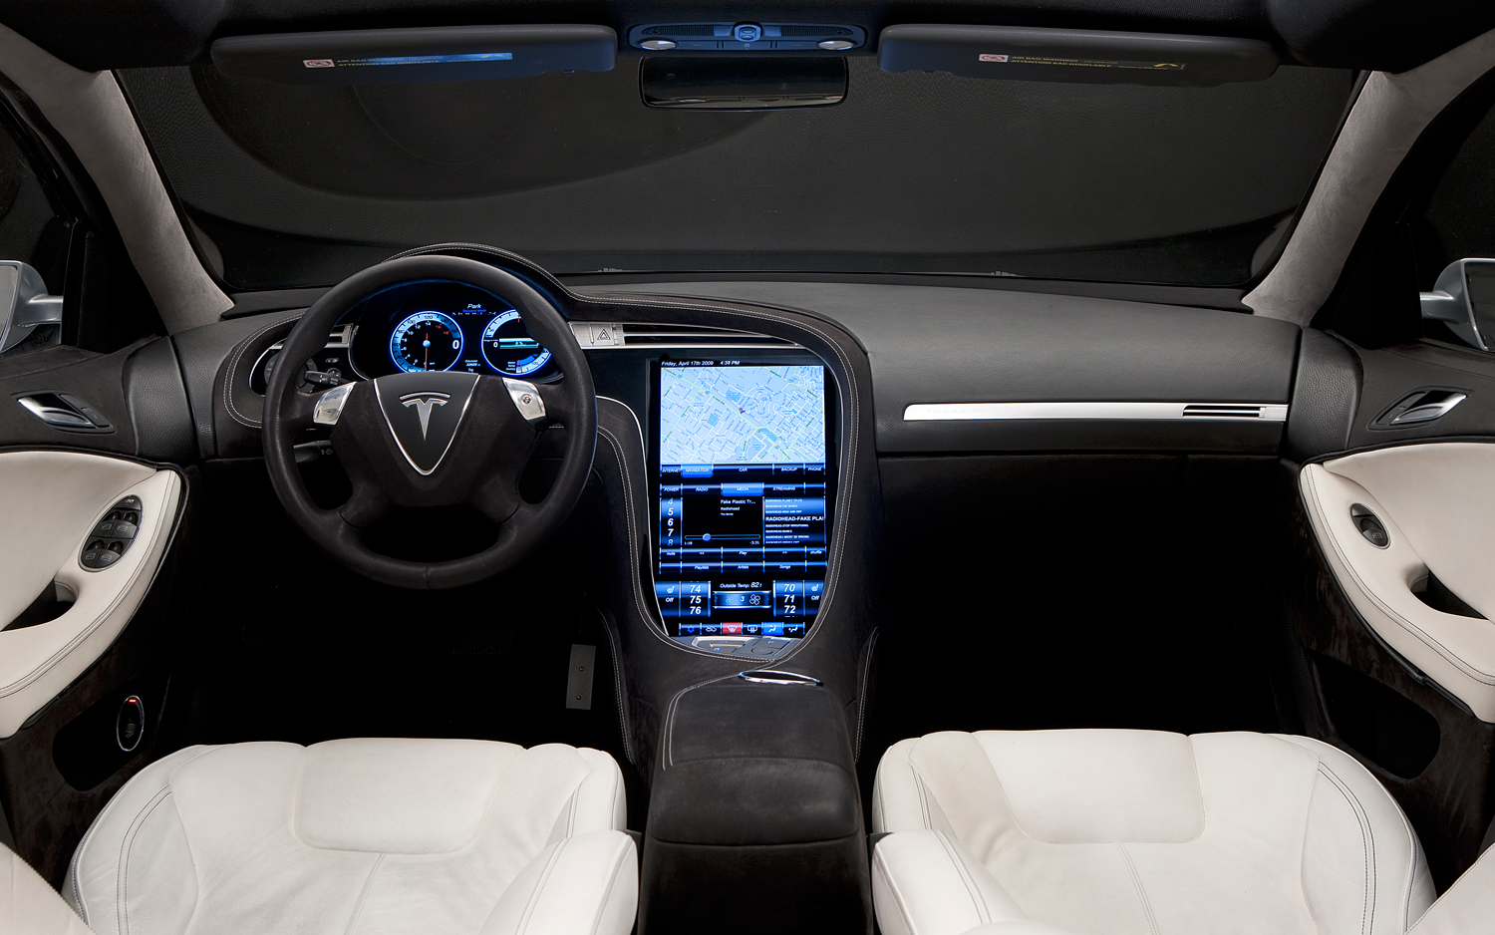
(Image source: Tesla Motors, 2014)
Appendix D - Tesla Retail Store and Charging Station Images
Retail Store
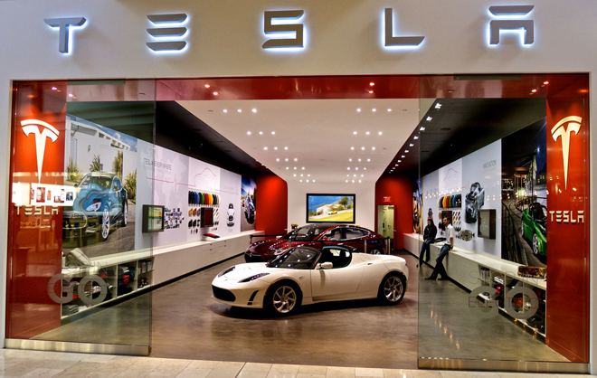
(Image source: Tesla Motors, 2014)
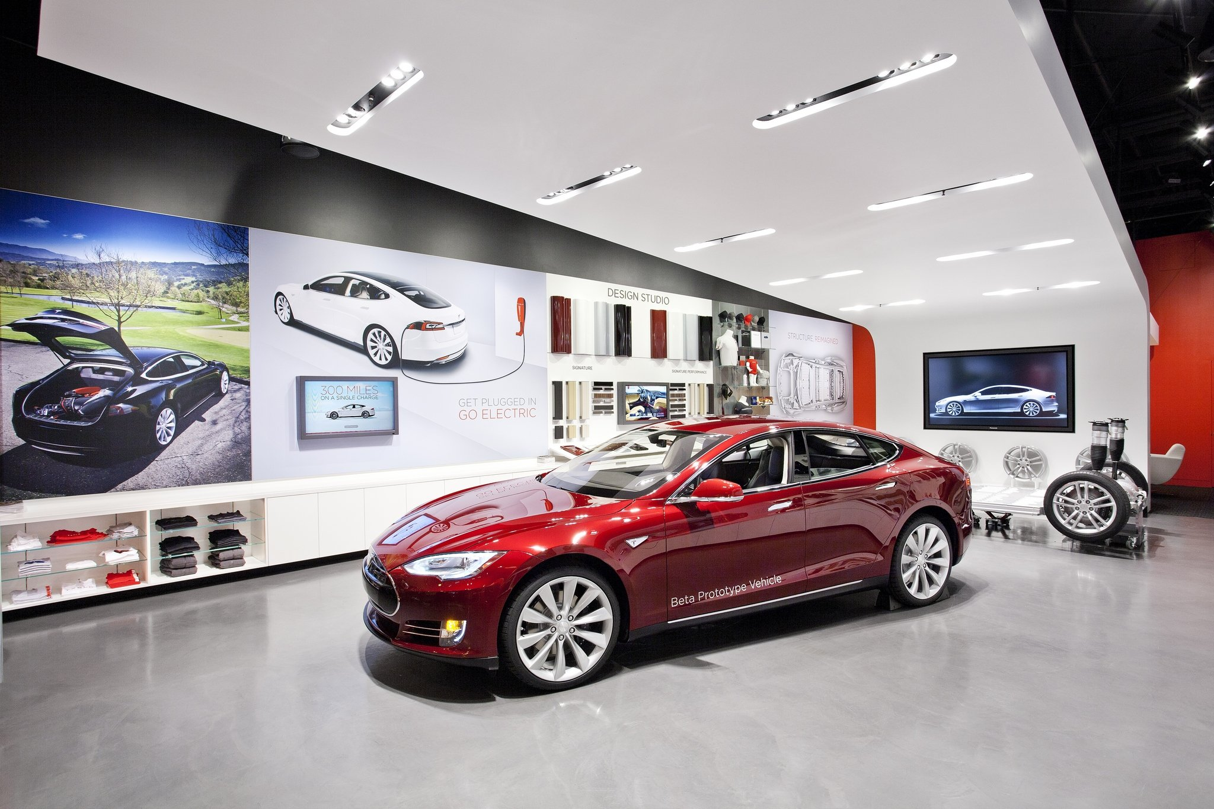(Image source: Tesla Motors, 2014)
Charging Station
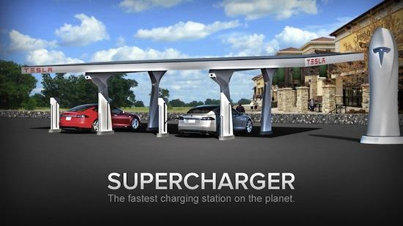
(Image source: Tesla Motors, 2014)

