Abstract
These pages after formatting. Please should be minimum 6 full pages without title page and reference page. No problem if it come 7 pages or more. Please add more information and references. The references must be more than 6.
The modern works are one with an increasing need for internet threat and congestion control. Internet congestion control is critical in ensuring the congestion with internet traffic. Internet models with an access link which has the capacity of responding to congestions signals from the networks and study bifurcation of such system are critical in the congestion control. By choosing the gains parameters as a purification parameter, it is possible to enhance the congestion control. The Transmission Control Protocols TCP has over time been uses successfully in governing of the interments congestion control for an over two decades. It is now known as the TCP and has started to reach limits, and that new congestions control protocols are required soon. This element has spurred intensives research efforts whose aim is searching for the new congestions designs of control. The new design has the capacity of searching for the novel designs to meet the future needs for the internets scaled up to size, capacity and the element of Heterogeneity, through the use of the techniques the new internet control system to become sufficient for the various needs of the internet congestions.
Introduction
As the internet becomes crucial in the contemporary world, congestions control becomes an ever-important aspect of internet operations. To preserve good system recital, various machines must always be put in place to prevent internet networks from being jammed for any momentous dated. Michael Welzl offers background and competes of internet congestion control in an accessible and more straightforward format (Zhang, Wang, Yang, & Jiang, 2019). The description focuses on the element of how this is done and why complex technologies inducing the transmission control protocols TCP and the actives Queue management. Internet traffic is often the cause of congestion that is witnessed (Tamar et al, 2019, May). This is where the first decisions are made when the traffic originates from the sender. For the simplicity of the internet congestion control to occur, it is critical to assume that there is only a single sender at the point of sending. Depending on the particular scenario of the interest, each packet often transverse to a given number of the intermediate nodes.
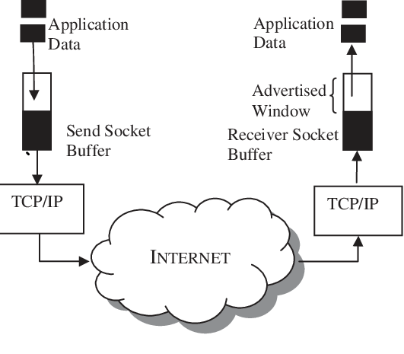

Figure 1: transmission control protocols TCP (adopted from TCP model.com)
Internet congestions control offers a description of some of the most critical topics in the computer networks' congestions controls. It is also special attention to the analytical modeling of congestions control algorithms (Cao, 2019). The field of congestion controls has witnessed a variety of advances in recent days, and this has seen a better operation of internet networks in various areas. Internet congestion control offers practical network engineers and researchers the most comprehensives and accessible coverage of the congestion control algorithm's analytical models. This gives the readers all that matters for the understanding of the latest development in these areas (Liu, Liu, Jing, & Zhou, 2018). Network congestion in data networking and queueing theory is the abridged excellence of facility that happens once a network bulge or link is loud additional data than it can handle. Networks use cramming control and congestion evasion techniques to try to avoid collapse.
There are two types of internet congestion control, which are preventive. The preventives of congestion control is a method that the Internet fights congestion over a procedure named TCP. TCP is a supervisor that's considered to assign Internet volume consistently crossways all requests that use it (Cao, 2019). This 'internet cramming control' saves the Internet from existence dazed. Each lone CPU, smartphone, smart TV, and web server — every solitary internet-connected item or device — rely on this procedure. Therefore, to promote the TCP procedure one would have to promote the whole creation's internet plans. Numerous to them. Concurrently. The Applied answer for TCP advance is (Tamar et al, 2019, May). The advantages associated with internet congestion control are based on the enhancement of the computer-based system's internet performance. Through such methods of congestion control, the individual can improve the different elements of the commuter operation.
A network congestion control arrangement and technique enable the broadcast of data on a communication network by checking the information brooks pending out of the message system for congestion notices, as well as vigorously degree regulatory the end user claim meetings founded on such bottleneck notices to simplify the network congestion. This offers crowding control for the system and can be used to avoid cramming realization the point where the grid has to abandon data (Zhang, Wang, Yang, & Jiang, 2019). The end user sessions can be separated into mission critical sessions and non-mission critical sessions. These assembly types can be ranked so that non-mission critical sittings are rate measured during periods of congestion, while mission critical sittings remain genuine. Mission dangerous meetings are successfully earmarked a precise amount of bandwidth with the break of the existing bandwidth (up to the cramming point) being billed dynamically to the non-mission dangerous times (Tamar et al, 2019, May).
Key consideration for the control
Closes loop against the open loop control
In control-theoretic terms, systems that use feedback are often termed as the closed loops internet congestion control instead of the open-loop control systems, which lacks any feedback (Liu, Liu, Jing, & Zhou, 2018). Systems with nothing but the open-loop have real values in life; for example, considers a light swathe that automatically turns off the light after every minute. In computer networks applying open look control, using the prior knowledge about the computer networks, for example, the bottleneck bandwidth. The aces link is primarily the challenge today. This property is often known as the end-user. An application that works and asks about the networks link bandwidth during the installation process or make it possible to adjust the systems preferences probably and correctly reasonable open loop congestion controls (Liu, Liu, Jing, & Zhou, 2018). A piece of news that is purely based on the open-loop congestion control would make the resource reservation an aspect that is very critical in protecting internet users from experiencing the element of excessive traffic.
Congestion control and flow control
Internet congestion control is a very crucial aspect of human life today. Since the intermediate nodes can act as a means of controlling and measuring the point simultaneously, a congestion control scheme could theoretically be in existence where neither the sender nor that receiver is involved in it (Zhang, Wang, Yang, & Jiang, 2019). However, this is not a practical choice as network technologies are often designed to operate in a considerably wider environmental situation. This often includes the smallest possible type of set up. A sender and the receivers are interconnected through a single link. While congestion does collapse in a matter of less of a problem associated with the scenarios, the receivers should stall have some means of slowing down the sender if it is busy doing more pressing things than receiving the packets of networks it is simply not fast enough. In such a case, the sender's primary function in reducing its rate is often termed as flow control (Liu, Liu, Jing, & Zhou, 2018). Therefore, the control system needs to pay closer consideration to the flow of information within the network systems.
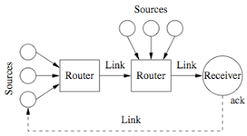

Figure 2: Internet congestion control system (from TCP model.com)
The solution
Internet congestion happens when the collective plea for a fallback such as link bandwidth surpasses the reserve's available Size. Resultant belongings from such contestation comprise extended stays in data transport, wasted possessions outstanding to missing or let go sachets, and unfluctuating probable overcrowding flop—all messages in the entire network. Internet infiltration and uses lasts to increase at exponential capacity. The subject is not just a rising internet populace. It is the rising loyalty stresses of modern internet people. Revolution in satisfied class has beaten revolution in internet distribution. Nowadays, a large population is increased by the equal pipes to dispense billions of HD television records. To achieve the best element of internet congestion control (Zhang, Wang, Yang, & Jiang, 2019). The need for internet users is often an essential aspect. There is a need to understand the best control method that would not interfere with the other part of the control systems.

Conclusion
Internet congestion control is a method used in evaluating and monitoring the process regulating the total value of the information or data that enters the networks to keep the traffic rate at an acceptable level. This is often to avoid communication networks reaching what is timed as the congestive collapse. The congestion control's primary goal is to keep the internet out of this failing trough entering the congestive failure. It is consequently clear that to uphold good network presentation, specific mechanisms must be provided to stop the net from being congested for any unique retro of time. The solution is based on the development of the best and most compatible systems

References
Jay, N., Rotman, N., Godfrey, B., Schapira, M., & Tamar, A. (2019, May). A deep reinforcement learning perspective on internet congestion control. In International Conference on Machine Learning (pp. 3050-3059).
Cao, Y. (2019). Bifurcations in an Internet congestion control system with distributed delay. Applied Mathematics and Computation, 347, 54-63.
Jay, N., Rotman, N. H., Godfrey, P., Schapira, M., & Tamar, A. (2018). Internet congestion control via deep reinforcement learning. arXiv preprint arXiv:1810.03259.
Cao, Y. (2019). Bifurcations in an Internet congestion control system with distributed delay. Applied Mathematics and Computation, 347, 54-63.
Liu, Y., Liu, X., Jing, Y., & Zhou, S. (2018). Adaptive backstepping H∞ tracking control with prescribed performance for internet congestion. ISA transactions, 72, 92-99.
Zhang, L., Wang, M., Yang, Z., & Jiang, Y. (2019). Machine learning for internet congestion control: Techniques and challenges. IEEE Internet Computing, 23(5), 59-64.

