INFO498 Final Case Studies Name______________________________

Instructions:
Your essays will be graded on content to include grammar and spelling. Each case should take 1-2 pages including diagrams. The essay answers for both #2 and #3 should be 500 to 700 words each, in order to completely answer the questions. Please submit as one document.
Assignment:
#1. Forest Point Construction (System Planning)
- What is the correct total time?
As per the schedule, the total time for project completion is given by 3+3+5+3+15+7++3+2+2=48days

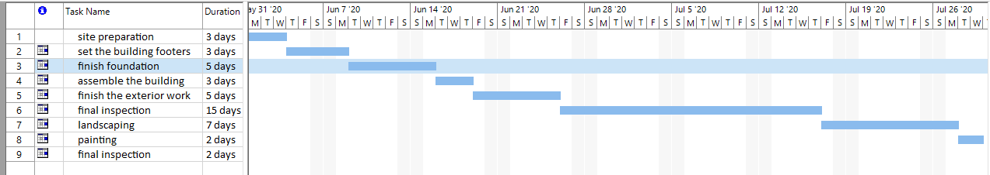
- Create a Gantt chart that shows the WBS.

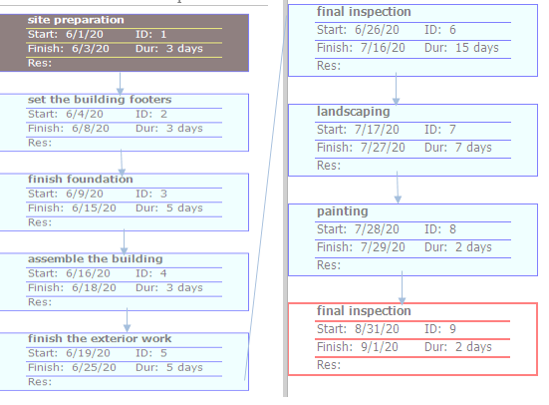
- What is the critical path?
#2. Atrium Bio-Medical Supply, Inc. (System Analysis)
- What options does Atrium have for acquiring a new system?
With response to this question Atrium Bio-Medical Supply, Inc can opt to choose developing a new software or purchasing the readymade software. The concept is referred to as make or buy. If the company decides developing its own software, requires requirement collection and elicitation based on the problem, and then performing the analysis and design of the system, before proceeding to coding.

- What are the pros and cons of in-house development versus purchasing a system?
In-house development has several pros and cons, as discussed below.
Pros: With in-house development, it is geared towards proving satisfaction as per the requirements of the users. It is important to note that for the unique requirements of the user to be met, the available option is to develop and in-house software. Secondly, developing an in-house software, is paramount in meeting the constraints of the existing system. In this case, with in-house software development can provide a platform of interfacing the new system with the old one.
Cons: Developing an in-house software for Atrium, would consume a lot of organization resources, such as finances. In-house software development is a costly approach, and it means that the company must set aside the required resources. Additionally, in-house software development is a process that can consume several months, since software development life cycle must be followed to the latter.

- If the decision is made to purchase a new system, what are three options for customizing the software?
The three options available as per this question include purchasing of basic package that can be customized by the sellers to suit the needs of the company. The second available option is negotiating with the software vendors to make enhancement of the new system. To meet the needs of the company, this would require paying extra fee for the changes to be made. The third and the last option available for Atrium in case the company decides on purchasing a new system, is purchasing an existing software package and then doing the required changes for the system.
- Based on Part C of the Systems Analyst’s Toolkit, what financial analysis tools should you use to evaluate the software acquisition options for Atrium? Explain how you would apply each of the tools.
In evaluating software acquisition process, there are many financial tools available to achieve this. The first tool is use of cost benefit analysis method is mostly performed in the stages of SDLC to ascertain if it is worthwhile to develop or acquire a new system or not. Other tools available is performing return on investment calculations, among other tools. Cost benefit analysis can be done by calculating the cost and comparing it with the expected benefit, to check if it is feasible to acquire a new system.

.#3. Nothing But Net (System Design)
- Should an organization choose a new system based on client/server architecture? Why or why not?
An organization can choose a new system to be based on client / server architecture, because the enterprise world requires the interconnection of information architecture to be based the client –server architecture. Ideally, this form of architecture, the client is responsible on dealing with user interface as well as the logic, while server is responsible on handling issues such as access, data storage, among others. One advantage with this architecture it is highly flexible. Therefore, Atrium choose the new system that is based on client/ server architecture.

- Explain the pros and cons of thick or thin client characteristics.
Pros: It is easier to deploy since there are no requirement of additional or specialized software. Secondly, with thin clients, there is reduced security threats.
Cons: With this architecture, if the server goes down, the client will go down too. Additionally, if the option is thick clients, it is important to understand that this is very expensive

- What is the difference between physical and logical topology? Provide examples.
Physical topology provide a layout of the network media, which depicts the interconnection of the devices within the network. On the other hand, logical topology is all about how data is transmitted between the network nodes.
A good example of physical topology is mesh topology layout. Logical bus is an example of logical topology.

- Will mobile devices replace desktop system units and traditional laptop computers? How would networks have to change if that were to happen?
Based on this question, indeed mobile devices will eventually replace desktop systems. The rationale behind this is that computing has become ubiquitous and due to the rampant production of the mobile devices, most of the developments are geared towards replacing desktop application with mobile applications. Additionally, the current technology and apps developments focuses on digital platforms and ensuring that the mobile networks are stable enough to sustain the new developments.

