Root Cause Analysis and Quality Issues
Student’s Name
Institutional Affiliation

Root Cause Analysis and Quality Issues
Introduction
Problem solving involves root-cause analysis is one of the key techniques adopted in helping people to answer the question on why a particular problem occurred in the first place. Understandably, the technique is important in identifying the cause of the problem using some steps, which are often associated with related tools. The reason for identifying the root cause of the problem is determine what happened, why it happened, and finally to identify possible solution in reducing the likelihood that such a problem will never happen again (Doggett, 2006). Some of the applicable tools in achieving this is by using cause and effect diagram, tree diagram, activity diagrams, among others. In this paper, the goal is to assess various problem happened in the campus, which include, University management system failing frequently, broken fences, damaged water supply pump, building elevator not operating, and lastly the problem of defective fuel pump. This paper aims to discuss the problem statement based on the five quality issues identified above, why, and how the problem happened-which is the root cause, and improvement activities on solving the above quality problem
Problem Statement
Based on my daily life in campus, there are various quality issues experienced as identified above. As mentioned, about the university management system not working accordingly as that this system has been failing and hanging during operations. What happen normally happens and has been happening is that. The second set of problem is software maintenance/ operating problems, which is the root cause of this system having issues in the campus. Elsewhere, in the university there is an issue of broken water supply pump, which normally pose a security issue to the students as well as to the campus facilities. What happened is mostly the constructions within the universities that led damaging of water pump in some areas. Where this happened within the campus is near the main gate and exit gate. It appeared that the contractor, given the work to build electrical fence interfering with the water supply pump.
The third issue/ problem within the campus is the issue of damaged water supply which serves as a key point/ area in supplying water to all buildings in the university. What happened and has been happening most often is interference by the staff and students from agriculture department, who have been performing irrigations and other farming technologies within the university. The problem specifically happens in the irrigation and water supply section within the campus. The fourth problem identified in this paper most of building elevators not functioning accordingly, which is mostly due to mechanical issues, and so on. When this happens/ happened is mostly during the movement of people from one university block to another as well as during the transportation of different facilities using elevator. In terms of where this problem happens/ happened is within different building blocks in the university, that use elevators. The problem mostly happens due to lack of proper maintenance by the relevant personnel. The last problem within the campus area that has been occurring on daily basis is the issue of no electricity in some areas. What mostly happens is because poor within different areas of the campus. The contractor given the contract to contract to electrify some areas appears to have done substandard work
Root Causes Analysis
Ideally, root cause analysis is a systematic process that identifies the root causes of problems of an event or events and identifying the best approach to them. Mahto and Kumar (2008) argue that systems are interrelated where an action in one area may trigger an action in another area. Further studies show that there are three basic types of causes, which could also be attributed to the problem identified in the campus. In this section, the goal is to use different tools to assess and analyze the root causes of the problems identified.
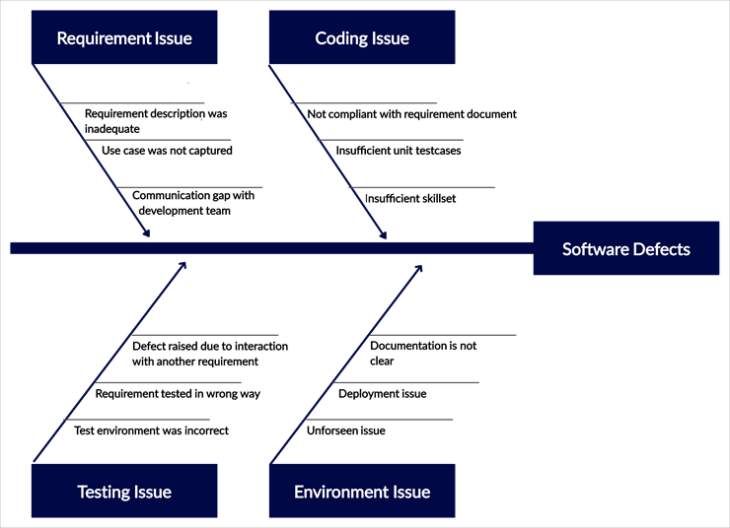
To start with, university management system is a comprehensive system with different modules such as student management modules, administration modules, among others. Based on a detailed analysis conducted to identifying the root cause of the issue of the system going down frequently, it was noted that there could be issues such as system requirement issue not implemented accordingly, which could also be caused of failure of communication by the development team, Secondly, the second root cause could be coding issue, testing issue, thus amounting to software defects. The whole analysis on the root cause analysis if the university management system has been illustrated using the fishbone diagram below.
Figure 1: Root cause of University/ Campus Information System Problem
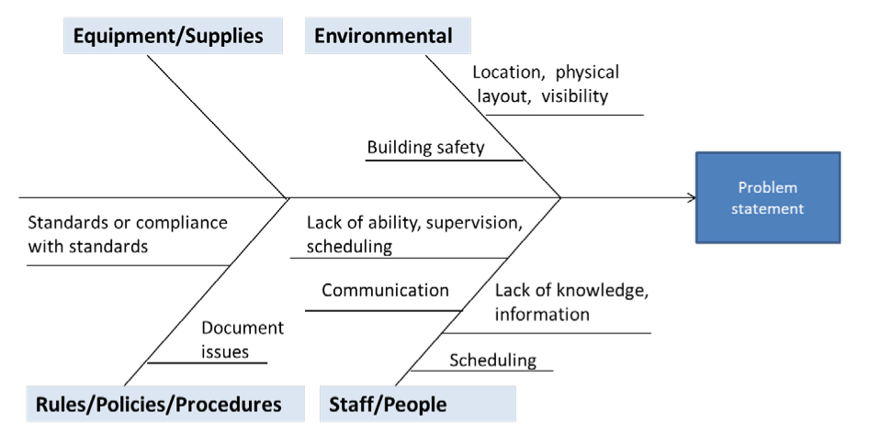
Based on the second root cause analysis of the second problem, which is related to some building elevators becoming problematic. The root cause of the elevator failing can be attributed to equipment/ supplies-where the supplier seems not to have adhered with the compliance standards, thus rendering the building elevators failing to work. Another problem is environment and building safety, failure to have supervision scheduling, and staff lacking knowledge on how to maintain the system, among others. The whole root-cause analysis can be presented using the fishbone diagram below
Figure 2: Root Cause Analysis of Elevators Problem in the Campus
The root cause analysis for defecting fuel pumps can be attributed to many causes relating to human being, materials, methods environment, management, and equipment. Issues that led to having defecting fuel pump include unskilled worker, inexperienced inspector, breaking down of winding wire, missing of the soldering process, spring miss in release valve, and focusing on the use of low-quality materials. Other root causes include rotor jam, lack of flow rate, overcurrent drawn, etc. The root cause analysis if the defective fuel pump can be described using the fishbone diagram below. The root cause analysis if the defective fuel pump can be described using the fishbone diagram below. Other root causes include rotor jam, lack of flow rate, and overcurrent drawn

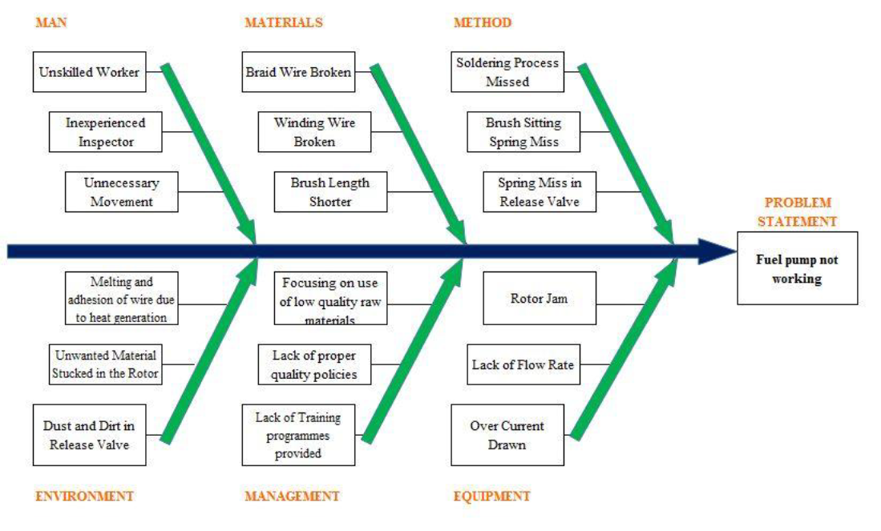
Figure 3: Root Cause Analysis of Defective Fuel-Water Pump
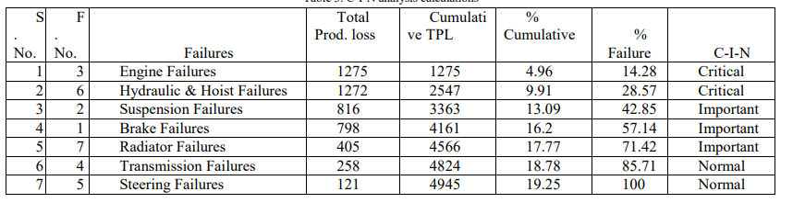
Regarding the problem of water supply within the campus, the root cause analysis the seven key failures, which have been broken down into man, machine, material, and miscellaneous were identified to be engine failure, hydraulic and hoist failures, brake failures, transmission, radiator, and steering failures. From the data used in identifying the root cause, it shows that the total production loss emanating from the problem with water supply pump encompasses of a substantial amount of loss, amounting to $4945. The operation states of this machine seem to not to be good with seven listed failures such as brake, hoist failures, engine issues, steering issues, among others. This can be presented as per the table below, which has also been presented using a graph. This can be presented as per the table below.
Table 1: Analysis of failures of the water supply pump
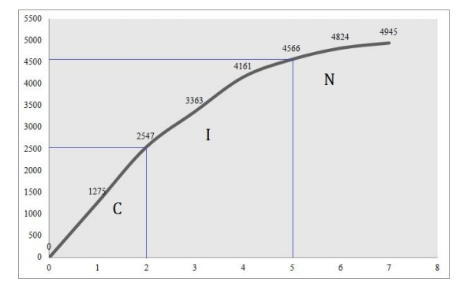
This graph provides a description of breakdown of the cumulative loss emanating to the root cause of water pump having issues
Figure 4: Graphical representation of Root Cause Analysis of Water Supply Pump Problem
Improvement Activities. Section, it checks what need to be done to improve
Upon identifying the problem and root cause analysis of that problem of various facilities in the university, different solutions have been pointed out as mechanisms of improvement activities. For the issue of University management system having issue, the management have opted to perform an upgrade and system maintenance, which would solve issues such as system hanging. The management has also resolved to have a team of able developers, who would focus on testing the system comprehensively, checking if all the requirements were met, and correcting all the software coding issues. According to Mehdiyev (2017), information systems maintenance is meant to improve the functionalities and operability of a system. Regarding the elevators problem, management has resolved all the substandard supplies to enhance the operability of this machine. The management has also opted to employ highly qualified inspector to be supervising elevators frequently. About fuel pump being defective together with the water supply pump having a problem, the management has decided to replace the components that are having issues, so that their functionality can be greatly boosted.
Conclusion. In this section, the goal is to provide an overview of all aspects checked
In conclusion, in resolving the problems with different facilities in the campus, it is important to identify the real problem. Upon realizing the real problem, root cause analysis need be performed to know the defects and the actual cause of such defects. Similarly, when problems/ defects have been identified, it is important to propose and implement the improvement activities that need to be done to enhance the functionality of such facilities. In this paper, the goal was to identify five quality issues to be solved in the campus, analysis of such problems, through appropriate root causes analysis, and providing improvements in the problem domains identified. Therefore, it can be affirmed that through problem identification and root causes analysis, the solution is realized to improve the functionalities of such facilities. the solution is realized to improve the functionalities of such facilities.

References
Mahto, D., & Kumar, A. (2008). Application of root cause analysis in improvement of product quality and productivity. Journal of Industrial Engineering and Management (JIEM), 1(2), 16-53.
Mehdiyev, S. (2017). COMPUTER SYSTEM'S MAINTENANCE IN A CORPORATE ENVIRONMENT. Problems of information technology, 8(1), 84-90.
Doggett, A. M. (2006). Root cause analysis: A framework for tool selection. Quality control and applied statistics, 51(3), 279-280.

