Web-Based Parcel Management System
Student’s Name
Institutional Affiliation

Web-based Parcel Management System
Introduction
Pos Malaysia is a company that deals with various services such as mail for corporate and individual customers, courier services that deliver resolutions, for air, sea, and land in national and international destinations, retail services that deal with payment of bills, and financial products, and express services. It is engaged in receiving and dispatching postal articles, postal financial services, philatelic products, and postal stamps sales. In developed countries, online postal services are more popular with customers. The development and use of this process have led to the improvement of service performance and customer satisfaction to the company. Based on product functionality, the customer can register on the system and when the customer tries to register again the system can track for any transaction, deliveries, and pick up the customer has made. Additionally, the system keeps track and updates after every payment made by a customer and it generates a report, scheduling, and delivery mechanism. This paper aims to suggest system/ product/ technology that can be implemented or managed by the company; in this case the paper discuss POS Malaysia with a case study of parcel management system. This paper also aims at discussing various concepts of project management.
System implementation involves the improvement of all modules and assimilation. The performance of the web-based parcel management system to the Pos Malaysia Company involves the client and server-side that will be monitoring and tracking parcel numbers that are sent and received from customers in the company (Anwar & Khatoon, 2009). It will also be accomplishing all the information on parcels, bills, payments, email notifications, customers, and deliveries. The development of the proposed system will be using a barcode system, Microsoft Visual Basic 6.0, and Active Server Page 3.0 system as the interface for intended performance. The system will further capture the customer name, ID, telephone number, and E-mail address. When a parcel is received in the company, the recipient is typed in the computer system and coordinated to the customer database. The barcode reader then scans and automatically amalgamates the customer with a Global System for Mobile Communications (GSM) system. Parcel hub as a multi-carrier for delivery management and tracking integrates e-commerce platforms and order management system for shipping in the company, customers can receive their letters and parcel effectively. Since the mobile application has developed tremendously, the technology has offered an option to the end-user information. Additionally, the system has provided some objectives to the company through introducing customers to the new perception of structure and an attempt on how to use the technology and be benefited.
Project Team/Development Structure
The project team involves of project manager and a group of individuals to undertake activities and implementation of the project to achieve goals and objectives for the development of a web-based parcel management system (Biskupek, 2019). Effective teamwork within the project environment is crucial for the achievement of the intended objectives. The project manager must be very careful when selecting the team to participate in any project. The management of the teams in a project environment may affect the project delivery time, project budget, and other issues relating to such a project. The role played by the project team, especially in the development of a project, system design, and coding, cannot be underestimated. Moreover, the project manager needs to be careful when selecting the team to be involved in the project. This project team includes the project manager as the overall of the team to ensure project success and other team members that will be involved include project team members, software developers, system analysts, system tester, and stakeholders. The project team can have different structures and features for a project in an organization.
The project manager will be playing a role and responsibility of developing a project plan, managing deliverables according to the project plan, leading and managing the project team, establishing a project schedule and determining each phase, assigning tasks to project team members, and providing a regular update to upper management. However, Project team member works with the diverse phases of the project to contribute to overall project objectives, complete individual deliverables, providing expertise and processing the documents. System developer’s rea people who develop, implement applications and programs for the backend processing system that are used in an organization. Such duties and responsibilities that they perform are: discussing client's requirements, creating software of operating system and application system, testing software's before delivering to the users, monitoring software performance, and updating programs as per user requirement.
System analyst acts as a mediator between clients and the technical team to analyze and design organization problems using information technology. They perform roles such as defining user's needs, they act as a researcher to gather facts and data from users of the system, and they also act as a mediator between customers and stakeholders. For the System tester, the test system is conducted on a complete integrated system with a specific requirement that plays roles such as analyzing the system, preventing software issues, and mitigating risk disputes. Additionally, stakeholders involve any individual, group, or company that has an interest in the outcome of specific projects. They play the role of educating the designers, financing the projects, identifying customer’s desires, and detecting constraints of the project.

Project Team Development Structure
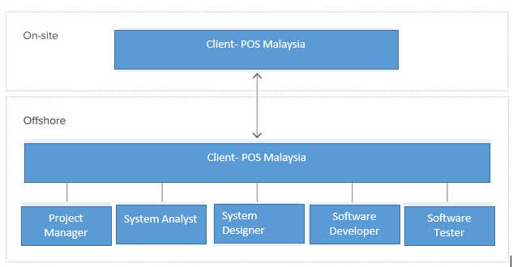
Project team development structure for Parcel management system for POS Malaysia can be captured using the structure below.

Project Deliverables
Project deliverables are tangible or intangible goods and services created as a result of project deliveries. They can be reports, documents, software products, and any building block of a project. These deliverables are classified as external or internal. Big or small, and tangible or intangible deliverables. External deliverables are those delivered as an outcome of a project to meet customers need while internal deliverable is any work done that is not a part of the business by the customers to accomplish project objectives. They are entailed to run a project in creating documents, statutory reports, and keeping accounts. Deliverables are generated in a different phase and we will have several modules of the project wherein customer module the system will capture customer name, email address, and destination location. The payment module system will detect customer ID, amount. Product type, date of payment, and method of payment. Work break down structure (WBS) as a project deliverable key organizes teamwork into adaptable segments. The project is broken into small components which are further divided into sub-components. These sub-components are divided into tasks that form the framework of estimated cost and effort that will be used to develop a schedule. WBS includes all the work requested to be completed in the project.
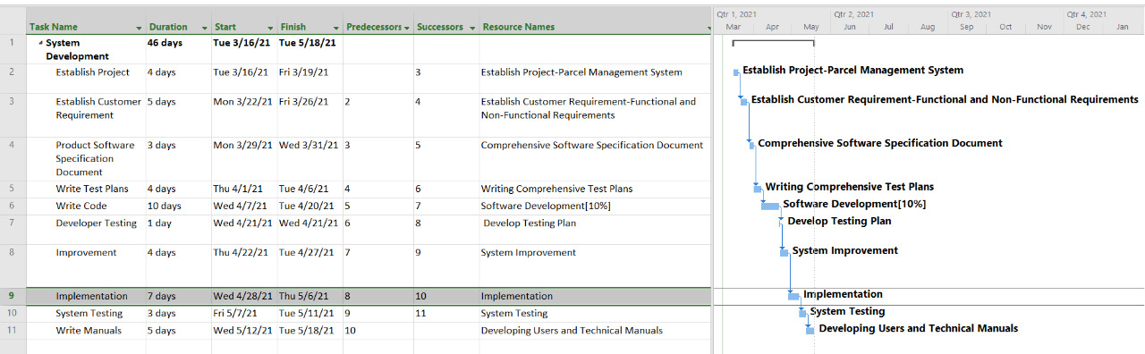
Work Breakdown Structure and Gantt Chart
Project plan
Activity | Expected Start Date | Expected Finish Date
Establish project | 16th March 2021 | 19th March 2021
Establish customer requirement | 22nd March 2021 | 26th March 2021
Product software specification document | 29th March 2021 | 31st March 2021
Write test plans | 1st April 2021 | 6th April 2021
Write code | 7th April 2021 | 20th April 2021
Developer testing | 21st, April 2021 | 21st April 2021
Improvement | 22nd April 2021 | 2th April 2021
Implementation | 28th April 2021 | 6th May 2021
System testing | 7th May 2021 | 11th May 2021
Write manuals | 12th May 2021 | 18th May 2021
The software Project plan is a document that regulates tasks, resources, organization, and time scale to complete the project. This plan outlines a strategic model for the project to use for an effect of the strategic plan. In milestone planning process model, it describes the key project objective and progress report. Accessing the work of (Dvir et al.,2003), it is important to note that, planning document forces the function of making decisions to stakeholders and performers that changes subject to the objective process. Additionally, the project planning committee organizes meetings, conducts surveys, and gathering of information on the project. Below is the project plan and network diagram to determine the critical path for the implementation of the parcel management project, it encompasses the 10 main stages, which include establishing the project, establishing customer requirements, product software specification document, write test plans, write code, developer testing, improvement, implementation, system testing, and write manuals. The table below presents the project plan for the project under consideration that is POS Malaysia Parcel Management System (Web-Based System)
Network diagram
The network diagram, below is for POS Malaysia Parcel Management System which shows different aspect of software implementation. It has been derived using MS Project Professional application

Functional Requirements
Functional requirements are part of system analysis and they define what the system should do. Additionally, functional necessities describe the facilities that should be offered by a system. With the Parcel management system, system has the following functional requirements:
- The system should allow a customer to access web clients from any web browser. (i.e. Mozilla Firefox and Internet Explorer)
- The system should allow the customer to log into the system with their details.
- The system should allow the user/customer to ship with the shipping address and payment method.
- The system should allow the customer to collect the product for shipping.
- The system should allow the customer to record order and pickup time.
- The system should allow the customer to record product information and payment received.
- The system should allow the customer to record delivery products.

Non-Functional Requirements
- Availability: The system should be available throughout to offer services and deliveries to the customers.
- Usability: The system should be easy to use, understand, and operate.
- Security: The system needs to be secured by installing antivirus and diversifying backup to avoid data loss and theft.
- Reliability: The system should be highly reliable in terms of performance and should provide the expected results.
- Maintainability: the system should accommodate continuous refinement to make it better as technology advances.
Project Initial Schedule
Project scheduling involves arranging, controlling, and optimizing work in a production process. Forward scheduling designs on tasks from date resource to determine shipping data while backward scheduling plans tasks from the due date to establish a start date. Accessing the work of Ronald (2013), in project organization, a formal schedule carries out a specific project for the construction of a building and development of products. However, it gives a list of project activities, milestones, and deliverables with the projected start and finishes time. Scheduling of the project compels identification of tasks with the earliest time and latest time to complete a project. Gantt chart analysis encourages project management to focus on monitoring the schedule if the tasks are completed on time to avoid delays of the pre-defined delivery date. Project schedule is well defined in under the project plan.

References
Alsaleh, S., & Haron, H. (2016). The Most Important Functional and Non-Functional Requirements of Knowledge Sharing System at Public Academic Institutions: A Case Study. Lecture Notes on Software Engineering, 4(2), 157.
Anwar, M., & Khatoon, T. (2009). Web-based Parcel Management System using Mobile Station.
Biskupek, A. (2019). Research on the Impact of the Project Team on Selected Areas of Project Management. Trends Economics and Management, 13(34), 29-46.
Dabbagh, M., Lee, S. P., & Parizi, R. M. (2016). Functional and non-functional requirements prioritization: empirical evaluation of IPA, AHP-based, and HAM-based approaches. Soft computing, 20(11), 4497-4520.
Das, R. (2009). Key Tools For Project Managers (EG Work Breakdown Structure, Network Diagrams (Critical Path Analysis), Gantt Charts, Resource Histograms, Establishment of Gates and Milestones. R. Das, Handbook of Management Principles: MNC Perspective, Saarbrücken: Verlag Dr. Müller (2010), ISBN-13, 978-3639261783.
Dvir, D., Raz, T., & Shenhar, A. J. (2003). An empirical analysis of the relationship between project planning and project success. International journal of project management, 21(2), 89-95.
Dvir, D., Raz, T., & Shenhar, A. J. (2003). An empirical analysis of the relationship between project planning and project success. International journal of project management, 21(2), 89-95.
Li, Y. B. (2012). Concurrent Engineering Based Vehicle Development Project Management. In Advanced Materials Research (Vol. 403, pp. 2829-2834). Trans Tech Publications Ltd.
Ssesmpebwa, R. (2013). Project Schedule. Retrieved from ttps://www.researchgate.net/publication/273759807_Project_Schedule_Management.

