Implementation of E-Tool for ElderCare
Student’s Name
Institutional Affiliation

Table of Contents
Introduction 3
Statement of the Problem 3
Objectives of Study 4
Technical Specification and Functional Requirements 4
Non-Functional Requirements 6
Design of the Proposed e-Tools for Elder Care (Mobile App Development) 6
Use Case Diagram 7
Sequence Diagram 8
Security Implementation in e-Tool for Elder Care Mobile App 8
Project Timeline 9
Development and Testing 9

Implementation of E-Tool for ElderCare

Introduction
The modern technology has become ubiquitous, and with the use of smartphones, different mobile apps can be integrated to solve a specific need. The innovation of mobile technologies offers a tremendous impact on the people and society at large. According to Islam et al. (2010), mobile applications are rapidly growing in different sectors, such as social interactions, businesses, and others. The reason why most people are shifting their focus on the use of mobile applications is due to the portability and ease of use. The implementation of the "e-tools for eldercare" is deemed an important proposal, an electronic platform for allowing the delivery of online training for the elderly. The development of this app will be a great deal in providing practical tips and demonstrations to the caregivers. Additionally, it will help them manage the health and other problems experienced by older people in society. This paper aims to develop a technical proposal revolving around mobile app development that supports e-Tools for the senior people.

Statement of the Problem
Elderly people require specialized care in terms of their health and social life, especially from caregivers. The central gap is a lack of knowledge and understanding for both the older people and the caregivers. Such knowledge that lacks include on how to ensure the healthy lifestyles of the older people, treatments in case they fell sick and interacting with older people with different problems. In providing the solution to the above problem, implementing a mobile application that can deliver online elderly training and real-life demonstrations for both the elderly and the caregivers is the key consideration. The proposed mobile applications will help interested party access and download the materials to provide specialized care to older people.
Additionally, the proposed mobile app will have an interface with different screening tests on common problems that affect aged people. This app will provide recommendations to the users based on their problems and give direction on where to access the training materials. The proposed app's training materials or screens will cover different tops that include hearing, vision, memory, and depression. Other areas will consist of oral health, incontinence, basic self-care, mobility, nutrition, sarcopenia, and frailty.

Objectives of the Study
- To develop a mobile app that is community-based, designed around geriatric problems training in elder care
- Developing a mobile app would enable older people with their caregivers to identify problems through screening tests by themselves.
- To develop a mobile app that would have a care-centered plan.
- To develop a platform that would provide useful training materials as well as community resources for the users.
- To perform data collections for evaluation of the project.

Technical Specification and Functional Requirements
The development of the mobile application that would provide relevant training materials for elderly people will be implemented in phases. The first thing is to provide technical analysis and requirements of the application to be developed. Additionally, the development will involve Android and IOS platforms, special consideration being using Android Studio. The proposed app will be responsive in all mobile phones’ devices, i.e., smartphones and tablets. The focus on developing the user interface and mobile phone design for the elderly is based on understanding the user's ability (Yusof et al., 2014). The interface design for the elderly mobile application should fulfill all the needs of older people. Such a design should have proper visual designs, which requires more significant text for the senior and caregivers to view them accordingly. The elderly will also need to have big screens and views.
In developing the e-Tools for elderly care, it is always good to ensure to factor in the accessibility for the disabled, which requires following the World Wide Web Consortium (W3W) for mobile phone accessibility. The rationale behind adopting the application of W3W is to help enable the new and the next generations of mobile phone applications, especially in communities with geriatric populations who need specialized care and treatments. Another essential feature that is part of the technical specification is implementing the mobile application that supports multiple languages, including Chinese, Traditional, and English. This will be useful in training supporting older people with various needs, who understand different languages. According to Klimova(2018), due to the increasing shift from traditional-desktop applications to mobile phone technologies, smartphones are now embedded with apps with different languages. The proposed mobile app will support the use of the three languages mentioned above.
Ideally, the proposed mobile application will have the questions and answers, such that when the use selects or search for a specific question, answers will be displayed with immediate effect. The availability of training course links will help the users to access the materials and any other form of training sessions. The existence of the feedback form in the application will help the users to provide project evaluation and experience during their interactions with the mobile app. Additionally, the user interface of the proposed mobile application will be implemented using usability and design principles and heuristics for easier interactions by the seniors and caregivers. The app should have a menu below the logo to allow the user to choose the form of screentest they want. In any selection made by the user, the system should be able to provide different materials and in-depth explanations about such services. Additionally, questions in the app will be brief and to the point, and some will be multiple-choice, including true or false. Lastly, the app should have a push notification where the user can just push on it to be provided with any news release.

Non-Functional Requirements
The idea behind non-functional requirements is to provide and present the criteria necessary for judging the operation of the system rather than the specific behaviors of such a system or application. For the case of the proposed mobile app for assisting the elderly, below will be the non-functional requirements.
- The application should provide a higher level of security and privacy of information. Additionally, authentication token should be stored within the local device and should require users’ permissions to have access to it.
- The app should guarantee 100% reliability to perform the required operations, such as downloading the training materials or any other form of operation.
- The mobile app should provide a high level of usability, which should make it easier for users to understand without any guidelines.
- The application should be highly scalable, especially when increased usage is concerned.

Design of the Proposed e-Tools for Elder Care (Mobile App Development)
The proposed mobile application development is presented using Use Case and Sequence diagrams to capture how the system will operate. This can be represented, as shown in the diagrams below.

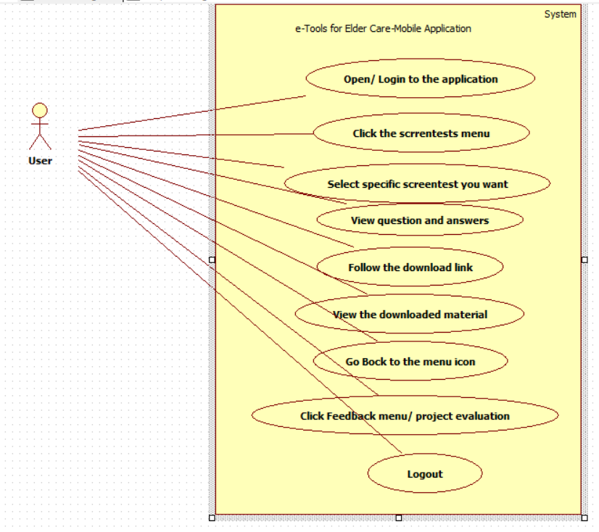
Use Case Diagram
Figure 1: Use Case Diagram

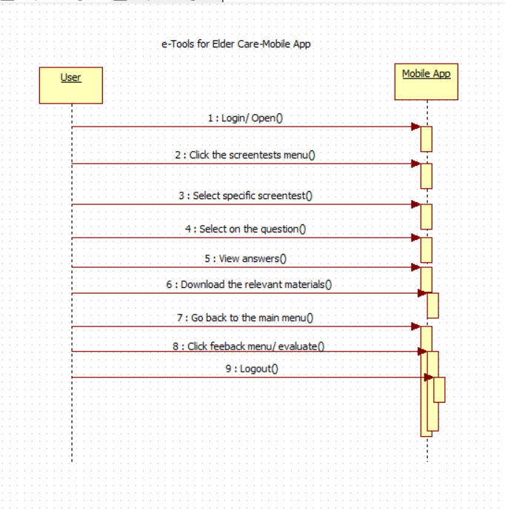
Sequence Diagram
Figure 2: Sequence Diagram

Security Implementation in e-Tool for Elder Care Mobile App
Security is a major concern in the implementation of any software application. Mobile app security is a key measure and mechanism used in preventing mobile devices from digital fraud, hacking, and other criminal manipulation. Security can be implemented in two ways, i.e., from the mobile phone level and mobile app level. In this section, the coverage area is the mobile app level, especially during the development stage. In ensuring that the security is enhanced, the code to be written will be secure, and this will be enhanced by the use of secure libraries and coding from scratch. Most of the security threats in mobile apps appear due to using existing libraries, which could have several vulnerabilities. Additionally, the design of e-Tool for elder care will use encryption techniques to ensure that the data exchanged via the app is secure and intact. Similarly, the use of authorized APIs will be critical because the use of APIs that are loosely coded can grant hackers opportunities to penetrate to the mobile apps. Another key security consideration is the use of high-level authentication because one of the key weaknesses that lead to security breaches is the use of weak authentication. Lastly, the proposed e-Tool mobile app will be based on the deployment of proper session handling, which will be based on the use of tokens rather than the device identifiers. The reason for using tokens is because they can be revoked at any time, thus making them more secure as they can be revoked anytime, especially when the device is lost.

Project Timeline
The development of e Tool mobile app for elder care is expected to take six months and kick off from 1st October 2020 to 31st March 2021. The development will encompass various app development stages, which will include requirement elicitation, systems analysis, and design, coding, testing, and deployment, as illustrated in the table below.

Project Activity | Start Date | End Date
Requirements Elicitation | 01/10/2020 | 14/10/2020
System Analysis and Design | 15/10/3030 | 31/10/2020
Coding/ Programming | 02/11/2020 | 20/02/2021
Testing | 22/02/2021 | 14/03/2021
Deployment | 16/03/2021 | 31/03/2021

Development and Testing
During the proposed mobile application development, two developers and one tester will embark on this task. The development of the application will be done one module at a time until all the modules are completed. Once all the modules have developed, each module will be tested independently, and then they will be integrated, and comprehensive testing will be done to ensure that the application is okay to be deployed. Finally, both user and technical documentation will be developed for future reference.
References
Islam, R., Islam, R., & Mazumder, T. (2010). Mobile application and its global impact. International Journal of Engineering & Technology (IJEST), 10(6), 72-78.
Klimova, B. (2018). Mobile phones and/or smartphones and their apps for teaching English as a foreign language. Education and Information Technologies, 23(3), 1091-1099.
Yusof, M. F. M., Romli, N., & Yusof, M. F. M. (2014). Design for elderly-friendly: Mobile phone application and design that suitable for the elderly. International Journal of Computer Applications, 95(3).

