Data Management Strategy by NCMSG
Student’s Name
Institutional Affiliation

Data Management Strategy by NCMSG
Executive Summary
The primary objective of this paper is to develop a data management strategy for National Cat Management Strategy Group (NCMSG). The institution was formed in New Zealand, through collaborative as well as proactive approach, to deal with humane cat management. The idea is to is to define the fundamental principles of the strategy, that would be essential in cat management, and environmental protection. In ensuring that there is accurate quantification of the cat population by NCMSG, the use of data management strategy is deemed necessary. The rationale behind this is because data relating to cat population in this country is unavailable or not estimated with accuracy.
Data collection and presentation methods, as well as the definitions requires the standardization to ensure that accuracy is guaranteed. For the case of NCMSG, the establishment of data management strategy is critical in accounting for the data, for all the cat population. Clear business goals are essential as they must be mapped together with the data management strategy under consideration, aims at ensuring that data collected is consistent for it can be presented for decision making. Additionally, the collected data from all the regions must be scrutinized before recorded in the system. For the accuracy to be guaranteed, entering of the data via the system should be entered by an experience personnel from the information technology department. In this paper, detailed overview of data management strategy for NCMSG has been presented, which defined the business goals, challenges in developing a top-notch data, management strategy. Additional considerations in this work include data management goals, which are both long term and short term in nature, the actual data management strategy that should guarantee accuracy and quality in terms of presentations. Other things that ensure that the data management strategy remains intact is data content, which has three main components, which include meta data, reference data, and master data. All this information will be solely meant for cat. Conceptualization of the whole idea is also involved in this paper, which involves modelling using ERD, developing an action plan, and lastly defining success indicators for data management plan.
Definition of Business Goals
Business goals in this case, are essential in the realization of an optimal solution for data management strategy. According to Roman (2019), the volume of data provides a special context, in which data management becomes a fundamental part or asset to an organization. It is important to appreciate that cats are essential animals in New Zealand, and they should be responsibly owned and managed, to ensure that their welfare are well protected. Cats occupies a substantial population, and with their continued increase in population, National Cat Management group, was established to develop a comprehensive strategy on regulating ownership, management, and environmental protection. The primary business goals for NCMSG include the following:
- Implementing a data management strategy that promote the protection of cats and that supports them to be responsibly owned, by protecting their welfare.
- To adopt a regulatory framework, that measures to provide protection of the cat’s welfare especially where lethal management methods are used.
Challenges
NCMSG is the only organization that has been mandated to provide strategies to manage and control cat population. Lack of providing comprehensive information about the cat population by some cat’s owner, provides a real challenge in presenting a clear and accurate data. Another critical challenge will be identifying, which parts are likely to be cost effective, and the measures needed, to provide ethical, humane as well as sustainable mechanism. Another key challenge the collection of the required data and then preparing and recording it via the system and be used for decision making. Indeed, all these aspects poses a real challenge in enhancing the value for the data collected to implement the cat management strategy.
Undoubtedly, it is not possible to provide 100% accurate data about cat management and their actual populations. Therefore, all the data gathered should be accurately used and recorded to ensure proper implementation of the cat management strategy, to control its population.
Data Management Goals.
The idea in this case, is to provide an effective database management system, to capture all the necessary details relating to the cat’s population, for an effective decision making. The system should accommodate data from all the regions, providing accurate reports about the cat population as well as supporting the future planning, based on the cat population control strategy program (Gatner, 2019). Ideally, data management strategy, should focus on determining the key data sets that need to be collected for a specific period of time., which must be mapped with both long-term and short-term goals. The section below provides both the long term and short-term data management goals that revolves around cat management by NCMSG.
Long-term Goals
Before highlighting the long-term goals, it is important to note that a data management strategy, is not once and done effort, but it is mostly used to identify most-year set of goals. The fundamental idea here is not to build a perfect environment or world that can solve all the data needs (Sas, 2018). The long-term goals that relates to this paper, include:
- Development of cat population database in various regions, especially those we quite high cat populations.
- Providing the availability of data that can be used when doing an evaluation on the impacts relating to the behavior of cats as well as their effects on the environment.
- Monitoring the implementation of cat management legislation, as well as complying with mandatory requirements.
- Defining the appropriate metrics, that would be used in evaluating the effectiveness of cat management legislation,
- Identifying and evaluating cat management strategies with an intention of determining their effectiveness.
Short-term Goals
- Providing the appropriate meta data required, based on the scenario given.
- Having an approach to reduce the number of stray cats, with an aim of remaining with very few or no stray cats.
- Creation of cat registry with specified criteria and implementation details.
- Developing a national cat management task force, for overseeing research and developing cat management contract
Data Management Strategy
Data management strategy is all about how to manage the data assets and the choices involved. Based on the case study of NCMSG, the data management strategy is for cat management project in New Zealand. With data management NCMSG, it requires stakeholder involvement as well as their active participation. Based on the problem under consideration, there are several proposed data management strategies, that can be adopted. First, it is worth noting that the amount of data that need to be collected is very huge, and therefore, would require comprehensive strategies by the data management and collection team. Additionally, the nature of the data that need to be collected by NCMSG, may vary in nature, depending on the attributes and the structure of the dataset.
A comprehensive data management strategy to be adopted by NCMSG, must involve a comprehensive process of planning, creating strategies for handling the data that has been created, stored, managed, as well as processed by the by an organization. For this organization to achieve its goals, there must be adequate plans to ensure that the whole process of data collection is not compromised. In addition to this, collection of high data that revolves around the cat population, may require a multiagency approach, to ensure that accuracy, consistency, and the volume of data collected is inline with the objectives of NCMSG. One of the approaches that can supplement the data management strategy to be adopted by this organization, is by following the data lifecycle management (DLM). According to Nelson (2019), data lifecycle management involves the definition as well as the structuring of steps followed by the information by an organization to ensure optimization and usefulness of data. For NCMSG, its data management requires the use of adequate resources provided the information technology in its automated processing. Based on this approach, it is possible to easily collect the data to be analyzed and tracking it until the time of storage or purging of such data.
The benefits that can be accrued by NCMSG as a result of adopting data lifecycle management as well as ensuring proper handling of the information about the cat’s population, include the following.
- With adequate data lifecycle in the management strategies, it facilitates all the requirements that ought to be implemented for data storage, to be met with great ease.
- Additionally, with data lifecycle management, it guarantees an adequate data protection infrastructure, which is essential in ensuring that the data stored is secure and reliable.
- The collection, extraction as well as maintenance of information throughout data lifecycle, ensure that the updated values are readily available.
- The last advantage of data lifecycle management is that, the whole process ensure the availability of consistent data, to the organization, which can increase the agility and efficiency of the organization that is bestowed in collecting and processing such useful data.
NCMSG considers above as the underlying benefits, that it would accrue as a result of following the data lifecycle management, when collecting, analyzing, processing and storing the data or information about the cat’s population in New Zealand. Based on the data lifecycle management that the organization consider following, they include the phases below.
- Data collection -this is a paramount stage, which acquisition and capturing of the required data by the organization that need such dat. In this case, NCMSG must understand first the nature and structure of data to be collected. Additionally, all attributes and behavior of the data subject, which in this case is cat’s population must also be clearly understood, before such essential data is collected. Data collection can be done with an automated application such as Excel for analysis, before such data is stored in the system.
- Data maintenance-this phase involves scrutinizing the data and keeping it clean. This stage is essential in ensuring that data collected and stored is consistent and highly accurate. Data maintenance will be ideal for NCMSG due to the varying needs and the nature of data.
- Data Synthesis- This phase might not be common, but it is essential when creating valuable data through inductive reasoning. Data capturing the cat’s information is valuable to NCMSG as well as the whole country. Additionally, recording the information would be ideal in developing humane national cat management strategy based on a collaborative as well as proactive approach.
- Data Use- In this phase of data lifecycle management, is based on the application of the data collected. The data management of data in this phase, must be channeled to the right use.
- Data Publication and Storage- The publication of data is important in ensuring that all the stakeholders. Publication of cat’s details will be crucial in ensuring that all the stakeholders take part in protecting them and ensuring that the whole cat’s population is treated in a humane way. Once the data has been published, it can be stored to ensure for future reference and decision making.
Data Content
The section covers three aspects of data content, which include meta data, reference data, and master data as described below
Meta Data
Meta data is a set of data that provides information about other data. Meta data information relating to a specific scenario, play a fundamental role in identifying all items of interest (Attoe, 2016). Meta data in this case, it provides information about cats, which may include describing all the attributes of cats. Apart from this, the data should be accompanied with the meta data which include name/ title, descriptions of the personnel capturing the data, the date of capture, the location, among other important attributes. The data to be stored in the database should also include the relationships that exists between the records or tables. When all these meta data descriptions are given, it would be easier to scrutinize, analyze and map this data accordingly (Hunter, 2004). The data should not only relate to the cat’s breeds, but also the cat breeders, cat owners. Due to the varying needs of data set, an overview of the intended use of data should also be provided, such as why such data is required, who is intending to use the data, how the data will be used . If data requests are done, a careful consideration must be done, to ensure that the data is channeled to the right use. The detailed of the personnel requesting for such data must also be recorded, such as name, phone number, email, location, the use of data.
Reference Data
Reference data is the set of data that defines the permissible values that are required to be adopted by other data fields In this case, the issue of cat management require data sources in all the regions, so that the right data is collected, analyzed and stored, by ensuring higher level of integrity and accuracy. Reference data would be essential in presenting detailed information about the cats as well as definition of different forms of data for different forms of cats in consideration. The reference data for different cat types can be presented as shown in the table below.

Reference Code | Description | Definition
001 | Owned Cats | These types of cats are those considered to be owned by a specific individual and they depend on human being
002 | Feral Cats | These are those cats that can be found in the forest, and are wild animal species, and may pose a real threat to the native species
003 | Socialized Stray Cats | These are those cats that can socialize and depend on human being
004 | Unsocialized Stray Cats | These are those cats that cannot socialize on human being and do not have any degree of dependence on human being
005 | Semi-Owned Cats | These are those cats that are partly owned by human being and are not part of the cat’s colony.
006 | Managed Colony Cats | These are those cats that are within a colony
Master Data
Master data is a uniform as well as consistent set of data, with the attributes that are extended, which describes the entities within a given scenario. According to Gartner (2019), master data management is a technology-based discipline, where business and information technology work together, with an aim of ensuring, consistency, accuracy and consistency of master data assets.
The master data for cat would involve various attributes, which include Cat ID, Cat Group, Cat Type, Area, , Strategy Action, Status, as shown in the table below.

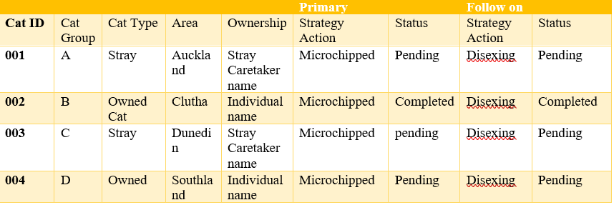
Entity Relationship Diagram

Meta Data Management data model is a pictorial representation of the core fundamental entities in NCMSG cat population control project. It is important to model the entities to identify and separate which ones are the master and reference data in addition to transactional entities. Figure 1 shows the sample data model for Cat entity and other supported entities. Now it is clear that Cat Group, Cat Type, Area, Ownership, Primary strategy action etc are entities use to validate the CAT entity. In this case, it is clearly visible that Asset is a master data entity and all the other entities are reference data entities.
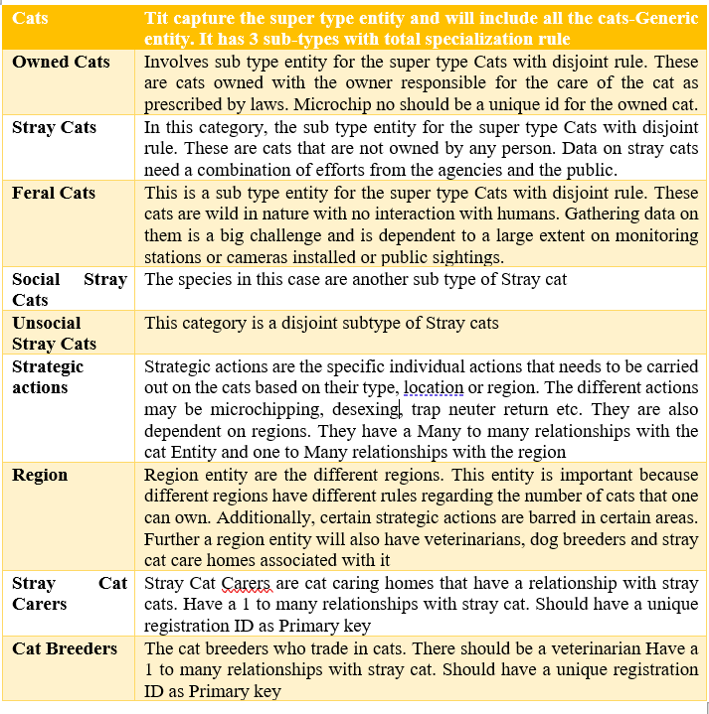
Description of Entities

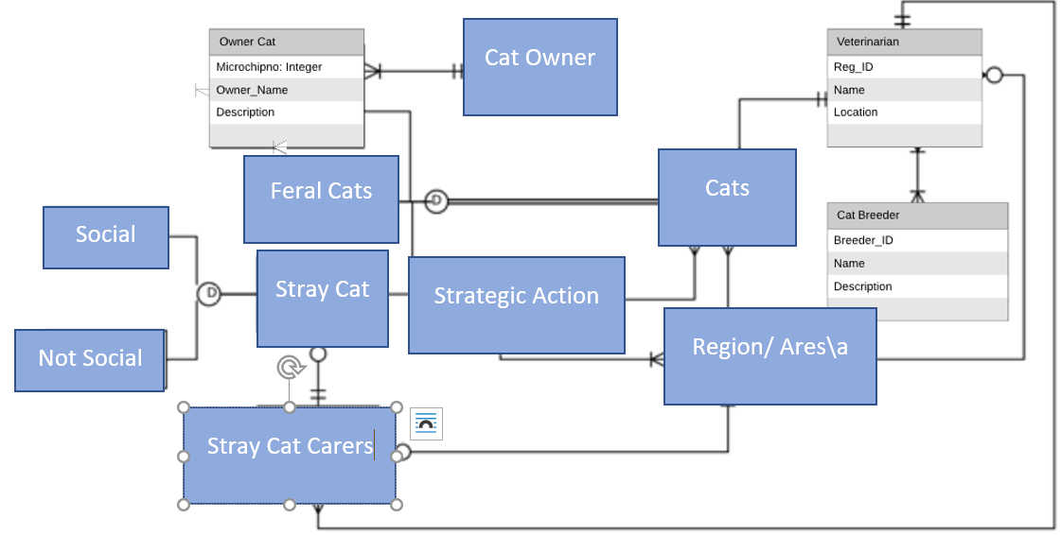
ERD

Action Plan
The data management strategy implementation by NCMSG as planned play a critical role in ensuring that there is a success strategy for the organization. Upon finalizing on the strategy, the actions plan would be adopted as follows. The action strategies to be adopted by NCMSG are meant to realize the data stewards and identify their roles as well as the responsibilities. These are the individual to develop and manage the data. Therefore, in circumstances where there are, dataset that is spatially enabled, even though a GIS individual may be managing as well as capturing the the data, there must be a decision on the kind of information to be collected and in format that is acceptable. Other aspects of action plan is ensuring that the necessary data rules for analyzing, processing and storing information, are maintained (McFadden, et al., 2015). The rules must be related to both internal as well as external access to data, to ensure that it is being protected, and applied for the right use. Another plan or strategy would be proper scrutiny of the cats data collected from different sources, to ensure the right data has been stored in the database.
Data Management program success indicators
The success indicators of the data management program, may be solely based on the following parameters
- Data users may rate its consistency accuracy, and timeliness of the data on a tri-dimensional scale., which can be used to have high quality data score and used for continual improvement.
- The risk related with the minimization of the events for for instance reducing the in incidences of data loss, can be used to quantify if the data governance issue is headed at the right direction. such issues which would resolves that data management strategy has gained its maturity.

References

Al-Masree, H. K. (2015). Extracting Entity Relationship Diagram (ERD) from relational database schema. International Journal of Database Theory and Application, 8(3), 15-26.
Attoe, R. (2016). Digital forensics in an eDiscovery world. In Digital Forensics (pp. 85-98). Syngress.
Gatner, G. (2019). Master Data Management. Retrieved from https://www.gartner.com/en/information-technology/glossary/master-data-management-mdm
Hunter, J. E., & Schmidt, F. L. (2004). Methods of meta-analysis: Correcting error and bias in research findings. Sage.
McFadden, E. T., LoPresti, F., Bailey, L. R., Clarke, E., & Wilkins, P. C. (1995). Approaches to data management. Controlled clinical trials, 16(2), 30-65.
Nelson, G. S. (2017). Developing Your Data Strategy: A practical guide.
Sas. (2018). The 5 Essential Components of a Data Strategy. Retrieved from https://www.sas.com/content/dam/SAS/en_us/doc/whitepaper1/5-essential-components-of-data-strategy-108109.pdf
Xiaofeng, M., & Xiang, C. (2013). Big data management: concepts, techniques and challenges [J]. Journal of computer research and development, 1(98), 146-169.

