Installation and Configuration of Windows Server 2012 and 2008
Student’s Name
Institutional Affiliation

Installation and Configuration of Windows Server 2012 and 2008
Introduction
Windows Server 2012 being the fifth version of Windows Server operating features has got more features that are administrative in nature. Installation of Windows Server is made easier by using VM workstation application. Installation and configuration of this server require one to have VM installed and a copy of Windows Server 2012R or 2008. Installation starts by creating a new Virtual Machine, choosing ISO file to be installed, and then following the wizard. This paper aims to demonstrate how Windows Server is installed and configured via VMWare Workstation. The paper also aims dhow how users are created and linked to each other, how to assign user roles and setting up group policy.
Installation of Windows Server 2012R via VMWare Workstation
Installation of Windows Server 2012R and 2008 simply follows the following steps when using VMWare Workstation 15.
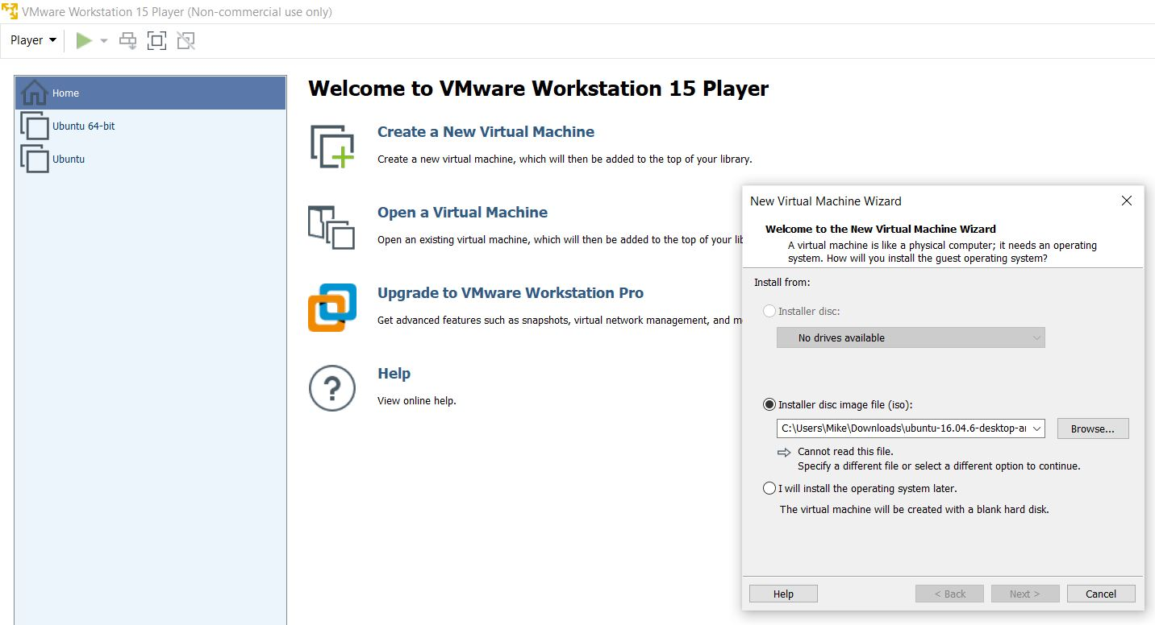
- Run VMWare Workstation 15 Player, then select New Virtual Machine as shown in the screenshot below.
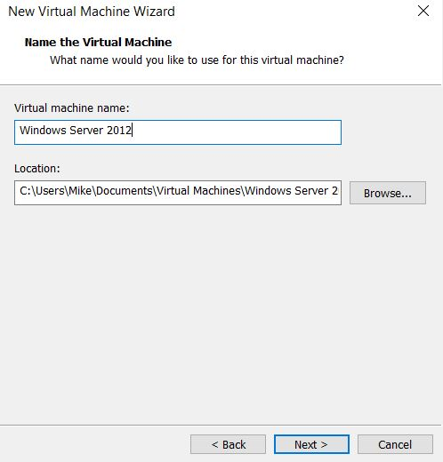
- Complete the New Virtual Machine wizard then click next.

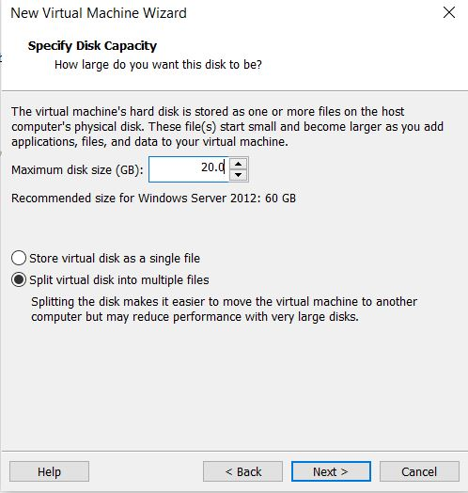
- Allocate the disk capacity to the server then click next

- Choose the default settings and click finish

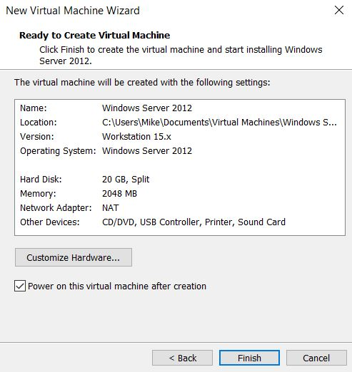

Windows server 2012R ISO now runs in the virtual machine, then next thing is to prepare installation of Windows Server 2012. This involves selecting the system language and type of Windows Server Operating system to be installed as shown in the screenshot below.

During installation, you need to set up Administrator credentials to have all the privileges as shown in the screenshot below.
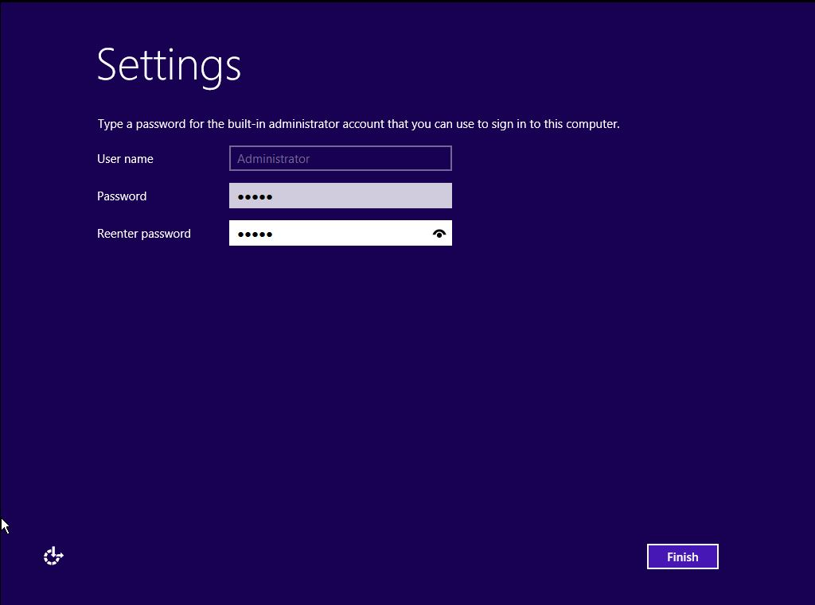
Similarly, you need to Add Roles and Features to have privileges to execute some operations via the server. This can be captured via the screenshots below.
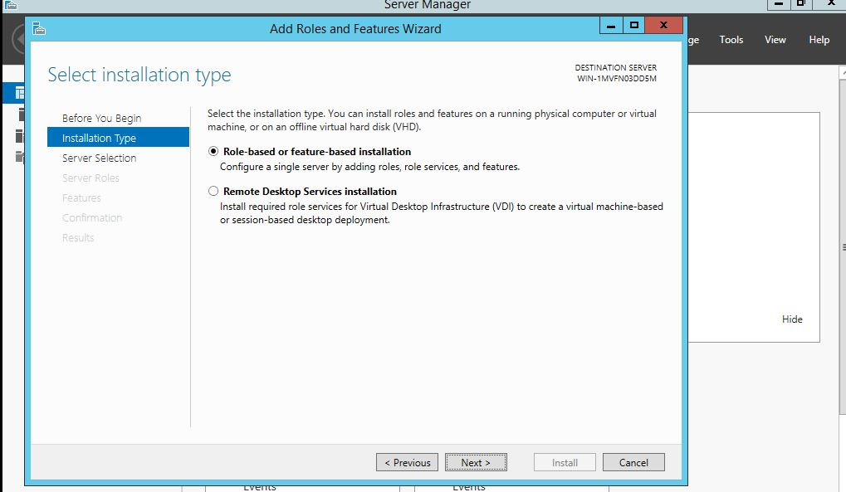
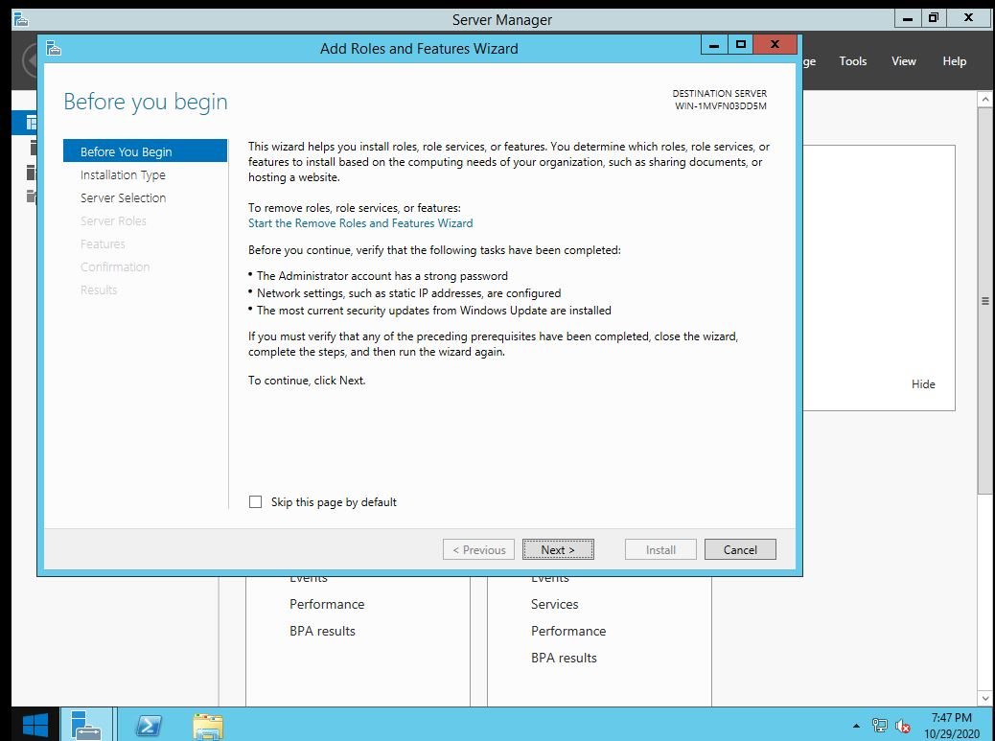

When adding a user in Windows Server 2012R, you can either use the Command Prompt or follow the Server Dashboard. In this paper, this will me achieved via Command Prompt as illustrated in the section below. For the testing purposes, we shall use 2 uses by name tester and Programmer.
- Open CMD command and run it as administrator
- Type the following command to create the 2 users net user tester abcd@1234 /add
For the second user follow the same step: net user Programmer abcd@1234
- Add new user accounts to the local group administrators as shown below.
net localgroup administrators tester /add.
net localgroup administrators Programmer /add.
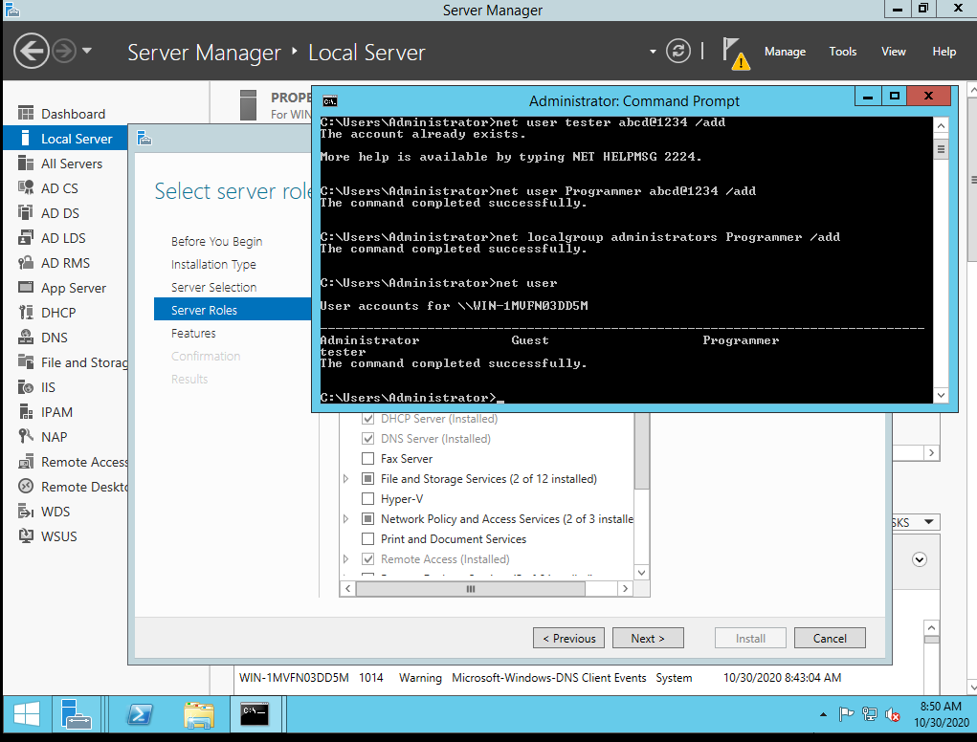
This can be illustrated as shown in the screenshots below.
When command is written successfully and run, type net user command and then press enter to view the users created.
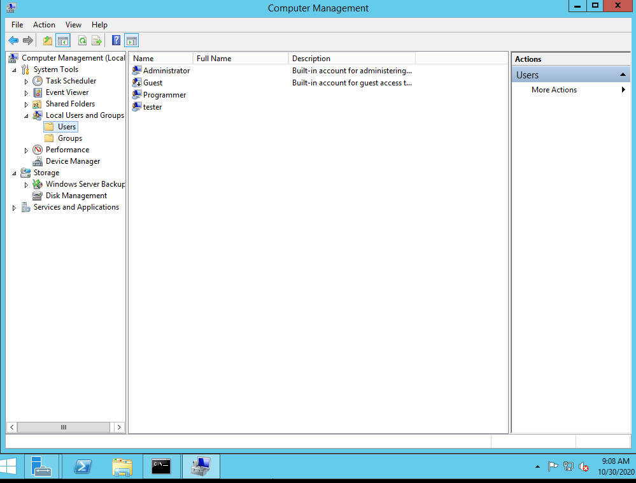
The user created can viewed on the Local Users and Groups under Computer Management Section as shown in the screenshot below.
Upon creating users via the command prompt, it is now possible to create more users and assign roles by right clicking on the Users under the Local Users and Groups.

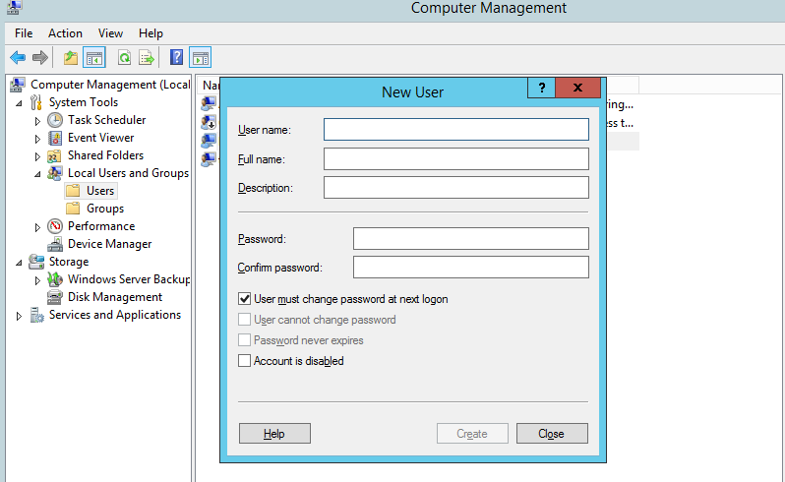
Assigning of Privileges in Windows Server 2012 and Window Server 2008.
Administrative policies in both window server 2012 and 2008 can be implemented to have a specific level of control to the computer or server resources. Such privileges can be configured for access both for local and remote users. In Windows server, what users can do is mostly restricted to Group Policy Management, which comprises of various settings such as Account Log on for validating the credentials inserted by the users. The console also has account management console for auditing the account management operations such as any operations done to users or group accounts. Other administrative settings include Active Directory Access, object access, and privilege use settings that defines the roles that powers that each user can be assigned. The screenshots below show how such powers and privileges can be assigned allocated to users in both Windows Server 2012 and Windows Server 2008

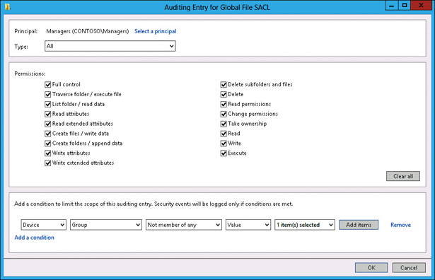
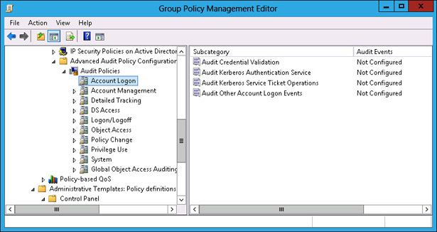
Windows Server users can also be assigned permissions for accessing server resources such as read, write and execution permissions. This is configurable in the auditing entry under the Group Policy Management as shown in the screenshot below.
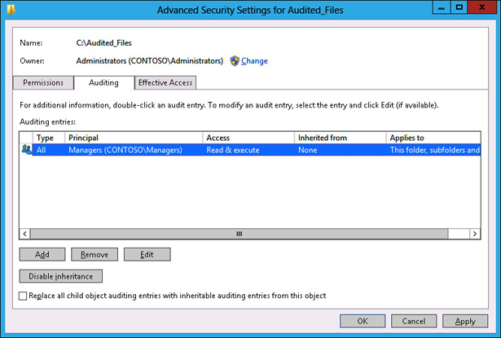
In testing the communication between users within the network for both Windows Server 2012 and Windows Server 2008, several terminal commands can be executed. The first thing is to view the number TCP communications via the command prompt. Additionally, it is important to view Ethernet statistics and TCP-UDP protocols used during communications. The commands for view include use of netstat with other parameters as follows:
netstat -e -s for viewing ethernet statistics for all protocols
netstat -s -p -tcp -udp for viewing statistics for TCP and UDP protocols
netstat -o 5 for viewing active TCP connections
netstat -n -o for viewing active TCP connections in numerical form
This can be represented as shown on the screenshot below.

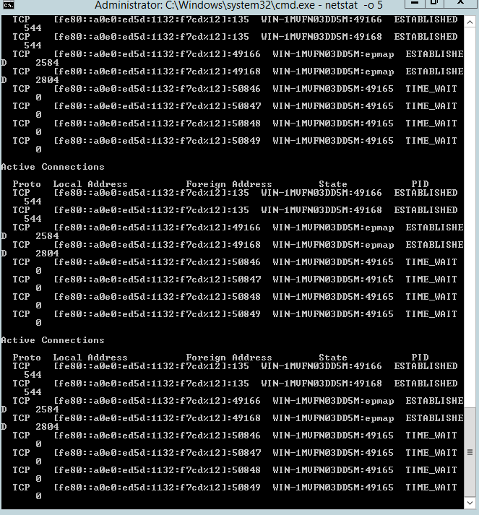

Installation and configurator=ion of Windows Server 2008
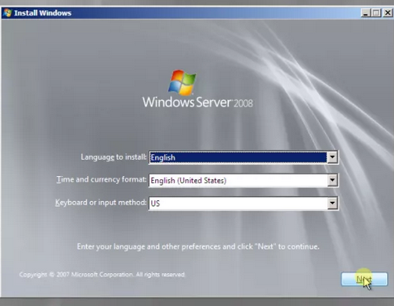
Ideally, there is no difference in installation and configuration of Windows Server 2012 and 2008. Setting up of this server in VM follows the same process. Below are some of the screenshots when installing Windows Server 2008.
Selecting Windows Server Operating system for 2008 can be captured as shown in the screenshot below.
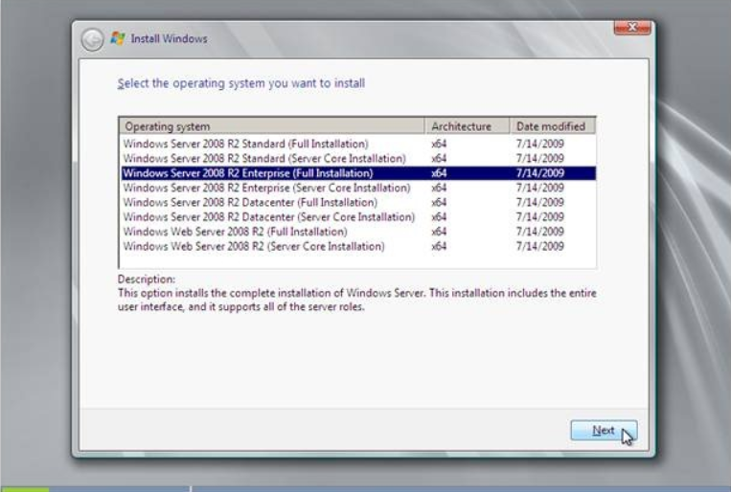
Setting up of Administrator account in Windows Server 2008
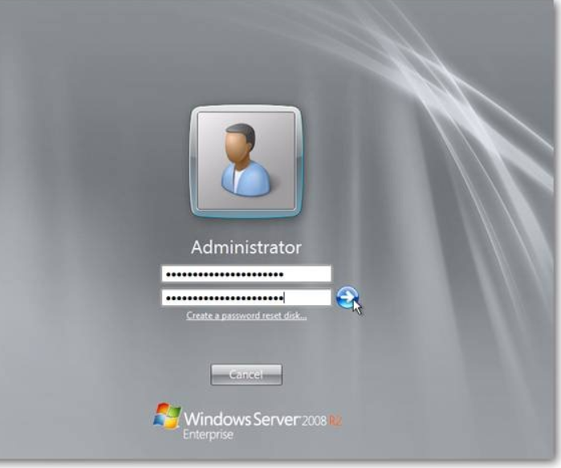

Configuration of Server Roles in Windows Server 2008
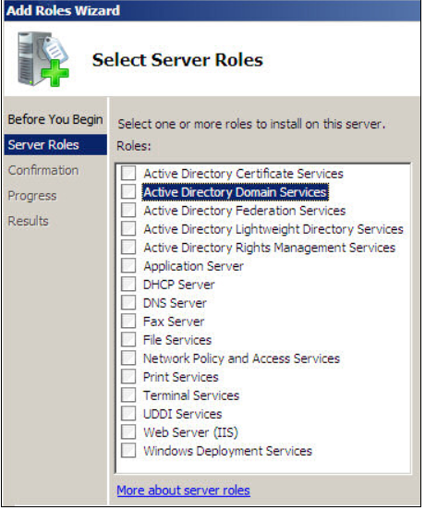
As mentioned earlier, installation and setting up of Windows Server 2012 follows the same procedure as Windows Server 2008. Additionally, when configuring server roles in 2008, the screenshot below shows how this can be achieved.
All the necessary roles should be configured to ensure the server run and operate accordingly.
Adding Users in Windows Server 2008
When it comes to adding users accounts in Windows Server 2008, it is slightly different as compared to Windows server 2012. This requires additional role of Active Directory Service, when one can add users from. Adding users in Windows Server 2008 can be captured as shown in the screenshot as show below.

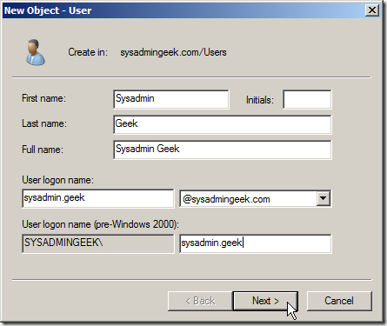
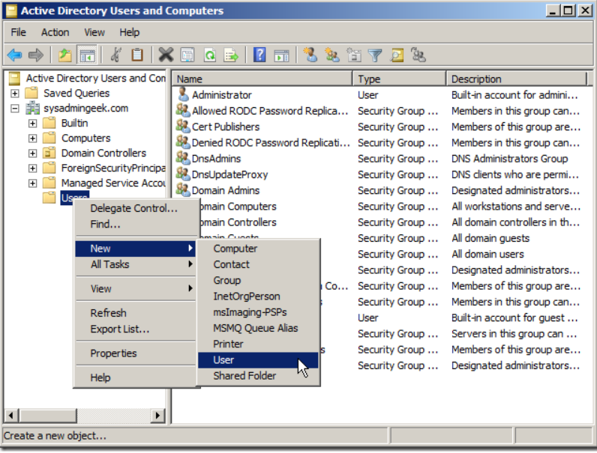
Assigning of Privileges or Powers in Windows Server 2008
Just like in Windows Server 2008, assigning user permissions and privileges in Windows Server 2008 is the same as it is in Windows Server 2012. This can be achieved in the dashboard, under Group policy tab, and then local policy as shown in the screenshot below.

Communication Between Users in Windows Server 2008
Communication in Windows server 2008 require assigning IP address to the server, then this is followed by performing initial configuration tasks, that is configuring the network settings as shown in the screenshots below.

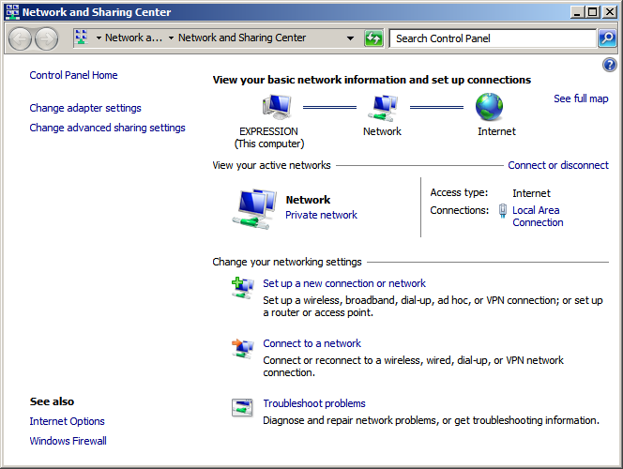
All the IP addresses that you want the server to use must be configured for the communication to be effective. The screenshot below shows how this is achieved in Windows Server 2008.
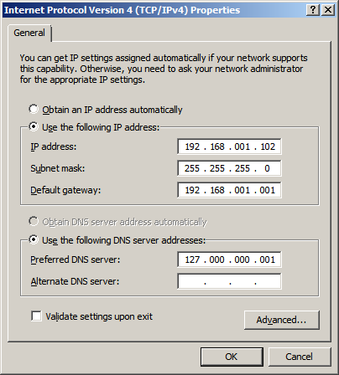
Other configurable networking settings available in Windows Server 2008 include setting the domain controller, Static or Dynamic IP address settings, among others.
Conclusion
Installation of Windows Server 2012 and 2008 involves various steps and configurations such as setting up the VMWare Workstation and setting the Servers by creating the new Virtual machine as has been demonstrated in this paper. Installation also requires setting roles and users privileges to define the level of access to the server resources. This assignment has demonstrated how installation of the two server versions can be implemented and communications between users and finally setting of user permissions and privileges.

References
Finn, A., Lownds, P., Luescher, M., & Flynn, D. (2013). Windows Server 2012 Hyper-V Installation and Configuration Guide. John Wiley & Sons.
Minasi, M., Greene, K., Booth, C., Butler, R., McCabe, J., Panek, R., ... & Roth, S. (2013). Mastering Windows Server 2012 R2. John Wiley & Sons.
Stanek, W. (2008). Windows Server 2008 inside out. Pearson Education.

