Distributed Network Design and Architecture
Name:
School Affiliation:

The network architecture that is suitable for AT&T distributed network
The suitable architecture suitable for the AT&T network is the peer-to-peer network. This is ideal for the company since it does not have tasks being allocated to each component on the network. All the computers and other data transmitting machines are regarded as equivalent and all possess the same capability to use the assets available in the network (Fitzek, 2009). There will be no central server to act as the shared drive since each PC, which is linked to this network will play the role of as a server for the files it will store. This is the best network architecture since it will not need a dedicated server thus will be less expensive. When one computer halts in performing, the rest of the machines linked in the network will carry on working and also, the installation and set will be less complex due to the built-in support in the modern operating systems.
The visual model that identifies the major components
The C4 model software architecture will be used. It shows the relationship between the system itself and factors like human and non-human systems (external systems) (Enríquez & Salazar, 2018). It will help in identifying the potential dependencies that must be managed. The model involves three levels of design. The first is the system design, which elaborates the technical services needed, and how it relates to the bigger enterprise context. The second is the application design, which refers to the combination of services needed and how they will be implemented. The last is the service design, which refers to the pattern and considerations that are involved during the implementation of specific services. The system enables the communication to stakeholders to enable them to understand without necessarily having to elaborate details that will change as the architecture changes.
The physical design of the system
One of the things that will be considered is the central processing unit. The CPU will have a higher frequency of state change to have swift execution speed of instructions. In the physical design also is the memory. The physical memory is the circuit consisting of capacitors that are used to keep bit representations of data. The other component will be a disk. How the storage will be used will determine the type of storage. Swap partitions will be utilized as memory whenever there is a shortage of physical memory. Database machines will have a bigger storage capacity to store more data. The physically designed systems will communicate with each other in a relatively infrequent manner and with extra handlers on failures to ensure communication reliability. There will be a focus on confidentiality and to ensure security on the infrastructure access, there will be security rules on AT&T infrastructure providers. The physical design of the system will look as below.
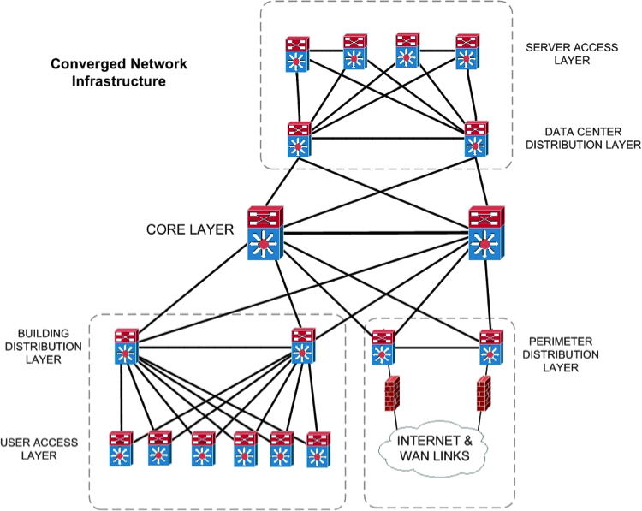
Software required for AT&T network and Operating system

One of the software that will be used is the SolarWinds network performance monitor. It helps discover network apparatus and deploys in a short time (Dissmeyer, 2013). It will be tailored for the entire network. It is recommended since it helps pinpoint issues within network performance. The software will also help observe hardware health of all servers, switches, routers and more. The other software that will be utilized is ManageEngine OpManager. It helps analyze network traffic. Nagios XI will also be incorporated. It assists in monitoring the network, the infrastructure and the database. Zabbix will also be used. It is a monitoring tool that focuses on trending functionality. It will help forecast future behaviour based on historical data. It has the advantage of allowing freedom of using the open-source solution without vendor lock-ins (Hernantes, Gallardo & Serrano, 2015). Lastly, OP5 monitor will be used to monitor applications, servers, networks and storage irrespective of the location.

The operating system that will be used is the Windows OS. It will act as a multiuser, multiprocessor, multitasker and multi-reader. The OS will be able to read the set of commands. All the software identified above work well with this OS and thus the reason why it is recommendable for AT&T.

Summary of the estimated cost of the network infrastructure and network software.

The costs of the infrastructure and software will vary from time to time. It will be determined by the size of the network, frequency of upgrading and the state of the current environment. The costs will also be determined by installation costs, operational costs, maintenance and downtime costs. The storage area networks, firewall access control, routers and load balancers are estimated to cost about 5000 dollars. The software is expected to cost half of that at 2500 dollars. On adding miscellaneous costs of 1000 dollars, the total cost is expected to be in the region of 8500 dollars for the distributed network architecture at AT&T

References

Fitzek, F. H. P. (2009). Mobile peer to peer (P2P): A tutorial guide. Hoboken, N.J: Wiley.

Enríquez, R., & Salazar, A. (2018). Software Architecture with Spring 5. 0: Design and Architect Highly Scalable, Robust, and High-Performance Java Applications. Birmingham: Packt Publishing Ltd.

Hernantes, J., Gallardo, G., & Serrano, N. (July 01, 2015). IT Infrastructure-Monitoring Tools. Ieee Software, 32, 4, 88-93.

Dissmeyer, J. (2013). SolarWinds Orion Network Performance Monitor. Packt Publishing.

