PRINCE 2 Agile in Implementation of Hotel Booking System
Student’s Name
Institutional Affiliation

PRINCE 2 Agile in Implementation of Hotel Booking System
Introduction
With the advancement of the technology, businesses are shifting their focus to enhancing their efficiencies in their operations. Businesses are benefiting tremendously with the use of technology, which is considered to provide platform for communication and providing the required services either internally or externally to their customers. The world of business has transformed remarkably over the past decade due to the influenced of the contemporary sophisticated technology that is increasingly applied by many managers. According to Zhang & Jiangtao (2017,) technology has affected many areas in a business organization including the production methods among others. However, questions have been raised on whether or not technology is enhancing firms’ chances of success. This paper aims to present implementation of the project, namely hotel booking system using agile methodology, which is to be used internally by staff. This paper also seeks to critically explain, analyze, and critically evaluate various project management techniques applicable in the development and implementation of hotel booking system.
One of the greatest benefits that have come with advanced technology is the improved efficiency in communication. For the case of implementation of hotel system for use internally by employees, it serves the needs of the organization by ensuring that there is efficiency in communication, sharing of information, as well as maintain all the records for employees and for the customers. Nguyen et al. (2015) maintain that the success of a business in today’s world lies in the effectiveness of communication it attains both internally and with external stakeholders (207). Most successful businesses across the global economy have leveraged on information technology to improve customer engagement, increase interactions with the suppliers and attain communicate with their employees efficiently.
Project Management Techniques
The application of project management techniques makes the management of the project to be much easier. In the modern technological and project management arena, the application of different project management techniques, presents an efficient way of completing projects. Understandably, there are several project management techniques that can be applied in projects managements. Such techniques include Agile, which is a technique known for collaboration and iteratively delivering whatever that is working in any project (Alleman, 2005). The second technique is Scrum which is an enabling technique to small, cross-functional, self-managing team, and aims at delivering the project fast. The third methodology is Kanban which improves the speed as well as the quality of delivering the project, by increasing the visibility of the work in progress through the limitation of work in progress. Scrumban is another project management approach that is geared towards combining features of Scrum and Kanban. Ideally, the Scrum framework combines the structure as well as the predictable routines. Other methodologies include waterfall, PRISM, integrated project management methodology, and PRINCE2. In this project the consideration is PRINCE2 which has also been widely adopted in various organization’s project across the globe.
The application of PRINCE2 Agile project management technique is considered to be the world most complete agile project methodology which provides solutions and combines flexibility and responsibility of agile with governance of PRINCE 2. Ideally, this methodology comprises of the PRINCE2 Agile guidance, certification scheme (that is the foundation and professional level). Applying this methodology in the implementation of hotel booking system will serve as a great deal because of various reasons. One of the key reason is because its main focus is based on both the management and delivery (Richards & Cooper, 2015). Secondly, the approach is deal in working with any established approach. Third, the technique is critical in helping to hit projects deadline in a more consistent manner. Fourth, this technique is based on a collaborative approach which is a corporate friendly with increased stakeholder’s confidence. Lastly, PRINCE2 Agile comprises of tools that are critical in managing and reacting to changing requirements.
PRINCE2 is a combination of two main methods, which are agile method and Projects IN Controlled Environments. Understandably, this technique is a process and product –based approach, which provides seven key ‘Processes’, ‘Principles’, and ‘Themes’, which forms how, why, and what components of project management in that respect. In terms of how this method works, it is developed in response to demand from community users, which is key in providing structure, governance, and controls while working with agile concepts, approach, and techniques. In organization perspectives and development of applications such as hotel booking management system, it is critical in helping the professionals to tailor / establish management controls when operating within agile environment (Cooke, 2016). The important aspect of this approach is to understand its governance requirements clearly and comprehensively and the interface that is between PRINCE2 and agile.
The application of project management techniques makes the management of the project to be much easier. In the modern technological and project management arena, the application of different project management techniques presents an efficient way of completing projects. The management method assists managers of different areas of businesses to accomplish their goals. The strategic plan process identifies the growth, decision-making process, information systems, and system re-evaluation to transform the business environment that has changed current business measures for directions and business governance. In the customer relation method, the relationship between the product quality and services to the consumer is determined by the willingness of customer payment reflecting on profit identification (Malachovský and Mazúchová, 2018).
With automated hotel booking system, customers can book a reservation online, visit or make a call directly to the office. This order consists of the type of the room with their respective prices, and meals one to take. Customers can fill in the details such as name, address, profession, date of arrival, passport number, and destination on a card for effectiveness. An effective reservation has engaged to the latest technology by sanctioning the owners to have a competitive advantage. The creation of a database for the hotel management helps in storing significant information and fast retrieval when the data is obligated. Additionally, this database reduces cost and time for the development process on optimal performance and productivity level. The use of information systems in productivity increases support to businesses in terms of capital, labor, and management. Over the last period, hospitality researchers have gathered efforts to determine the impact of information system service to the production implementation.
Achievement of the Set Objectives
Modern technology has helped modern managers to produce results for the project on time due to fast technology. The organization has projected change on forward-looking goals for better control of the environment and businesses. However, the development of individual contribution and production has endorsed different approaches to the businesses. Management by Objective (MBO) serves all organizations to attain one goal from the top management. Hotels always develop new services by filling empty rooms during the peak season to build a good relationship with customers. This makes the work of the staff to maintain and access relevant information relating to the customers and hotel books. In accessing the work of Ottenbacher (2007), if organization to be successful in hospitality, needs sophisticated marketing techniques. On the other hand, employee management is integrated by the human resource approach, training employees, and authorization. Additionally, innovation activities to organizations respond based on actual customer demands. Marketing aspects for appealing communication makes effective promotion than competitors, creating a brand, image, advertisement, and marketing plan. In agile methods the project requires small number of team that collaborates with the project team to ensures togetherness in working places. It is important to note that in order for project team to make decision they require cohesion among themselves.
Demonstration on Self-Management and Team Skills
Companies choose the best applicants who can work effectively and fit their organizations. They utilize a lot of money on training and identifying the hard and soft skills from the teams they are dealing with in the working area. Based on hard skills are skills that deal with technical aspect to accomplish the work (Vaníčková, 2017). They always demand acquisition knowledge and cognition nature from a person's brainpower results. On other hand, soft skills are outlined as the behavioral skills of a person required to apply technical services and information in the working place. Self-management indicates that any employee without outside control resolves to adopted less appealing. Its technique comforts in organizing working place, increase for self-motivation and achievement of tasks. Additionally, self-management consists of self-perception that indicates people tell when and why to establish positive practices, self- objective involves success and performance of unbiased, self-reward, and self-discipline.

PRINCE2 Agile Process in Hotel Booking Management System.
Implementation of hotel booking system that is to be applied for internal use by employees, will follow the six key processes associated with PRINCE2, which include: starting up a project, initiating a project, directing a project, controlling stage, managing product delivery, and managing a stage boundary (Raharjo & Purwandari, 2020). Arguably, PRINCE2 is a process-based approach for project management, which is geared towards to provide a tailor and scalable methodology for the management of all kinds of projects. Additionally, with this approach, each process has defined inputs and outputs associated with specific objectives that ought to be achieved. The diagram below presents subsequent explanations of PRINCE2 processes to help in guiding you in managing or handling projects with PRINCE2.
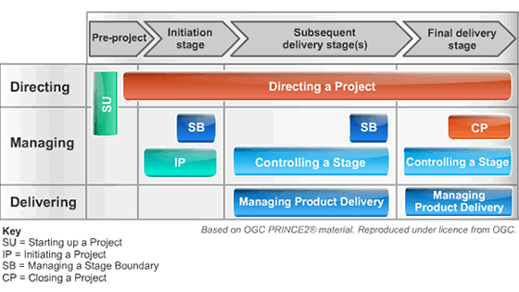
- Starting a Project
When starting hotel booking projects, it is important to understand all the functional requirements of this project. Additionally, this being the first process in PRINCE2, it revolves around pre-project process that is being designed in ensuring that all the prerequisites meant to initiate this project are in place. Ideally, within this context of implementing hotel booking system for internal use envisages the availability of a project mandate which provides definition for the high terms for project implementation. In the starting of a project process for hotel booking system, it will comprise of three critical productions of the three elements. The first element is geared towards ensuring that the information required for the project team is available. The second element is designing and appointing the project management team, and lastly is the creation of the initiation stage plan. The project team in the implementation of Hotel Booking System will include three software developers, one system analyst, and one tester. The information that this team need to know in the development of this project using PRINCE2 include the scope of the project, modules to be implemented, and all the systems requirements (both functional and non-functional requirements).

1.1 Composition of the Project Management Team
The project management team is critical for the successful completion of the project tasks. Effective teamwork within the project environment is crucial for the achievement of the intended objectives. Project manager must be very careful when selecting the team to participate in any project. The composition and the management of the teams in a project environment may affect the project delivery time, project budget and other issues relating to such a project.
The role played by the project team, especially in the development of a new project, system design and coding, cannot be underestimated. Moreover, it is important for the project management department to be careful when selecting the team to be involved in the project. According to Mesicek & Svoboda (2012), in teamwork projects, knowledge, composition of members who can share their knowledge for the successful completion of the projects, may yield better results.
Rules governing the project teams must be put in place to ensure that every member of the team is engaged in his part of the project. Every member participating must be competent for the task, for instance, the team member working on the analysis and design, must have knowledge and experience in those areas. Same case applies to coding and testing of the project. Finally, when acquiring the project team, to ensure that the project has the prerequisite of effective as well as high performance, there are various factors to put into considerations. Such factors include communication skills, team roles, experience, social relationships, and qualification, among others. Based on the above factors, there is assurance that the composition of the project teams will be good enough to complete the project successfully and achieve the intended results. In summary, definition of the project and its characteristics is imperative for the project to be completed successfully. It is the role of the project management to ensure proper planning, resource allocation, project costing, managing and analyzing the risks is done.
  - Project Plan
Below is the project plan for the implementation of hotel booking project, it encompasses the 5 main stages, which include requirements elicitation, systems analysis and design, coding/ programming, testing, and deployment.
Project Activity | Start Date | End Date
Requirements Elicitation | 01/03/2021 | 15/03/2021
System Analysis and Design | 16/03/2021 | 31/03/2021
Coding/ Programming | 02/04/2020 | 02/05/2021
Testing | 03/05/2021 | 10/05/2021
Deployment | 11/05/2021 | 12/05/2021

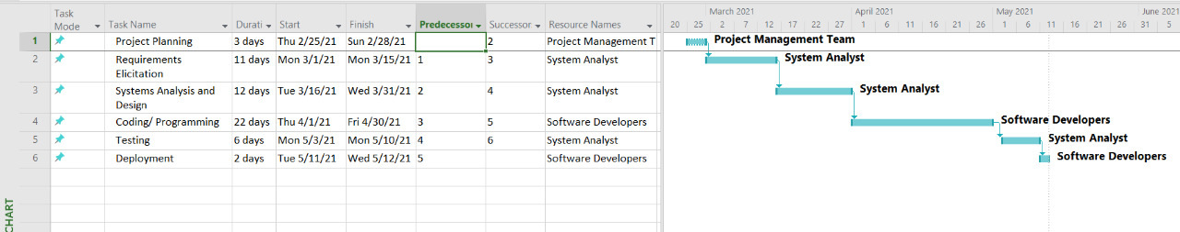
Gantt chart

  - Functional Requirements
Functional requirements are product features that defines what the system should do. Additionally, such features must be implemented by the developers in enabling users to accomplish their tasks effectively. The functional requirements for hotel booking system must be made clear for both the development team as well as the stakeholders of the project. For the case of the project under consideration, the following will be the functional requirements:
- The system should allow user to register and login to the system
- The system should allow user to view all the bookings done by the customers.
- The system should allow user to search and find the most relevant booking options.
- The system should allow users to cancel books made by the customers
- The system should allow user to add and delete rooms in the system.
- The system should allow user/ admin to view the bookings made and the customers.
- The system should facilitate sharing of booking information both internally and with the customers.
The use case diagram below capture various use cases and actors who are the employees of the organization and interact with the system internally. The two main actors are the staff and administrator of the system. The use cases of hotel booking system in this case include login, encoding customer information, accept and confirm customer information, check in customers, view booking reports, add user, modify user, and delete user.
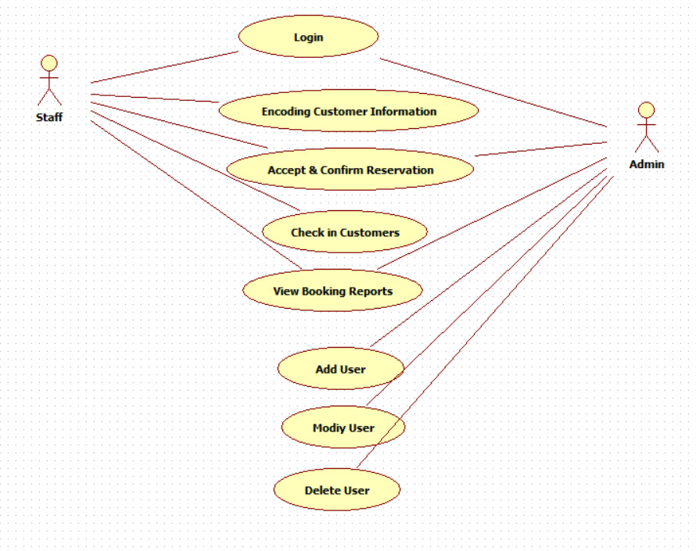

  - Non-Functional Requirements
Non-functional requirements are meant to define system attributes which include security, performance, reliability, usability, scalability, maintainability, among other non-functional requirements. Non-functional requirements serve as constraints in the design of the system along with many backlogs. Additionally, such requirements are key in enhancing the usability as well as effectiveness for the entire system. The idea behind non-functional requirements is to provide and present the criteria necessary for judging the operation of the system rather than the specific behaviors of such a system or application. For the case of hotel booking system, below will be the non-functional requirements.
- The application should provide a higher level of security and privacy of information. Additionally, authentication token should be stored within the local device and should require users’ permissions to have access to it.
- The app should guarantee 100% reliability to perform the required operations, such as downloading the training materials or any other form of operation.
- The mobile app should provide a high level of usability, which should make it easier for users to understand without any guidelines.
- The application should be highly scalable, especially when increased usage is concerned.
- Initiating a Project.
Upon identifying the project team to be involved in developing the project under consideration, that is hotel booking system, it is important to identify the objectives and the project plan for the project implementation. A project plan is a series of formal document that defines execution of a project as well as the control stage. In this project implementation, the project plan will comprise of the business case, which is hotel booking system. Additionally, with the plan there is project costs estimates, which must identify the management stages as well as other key control points that will be applied. Ideally, the project plan is used by the project board as a baseline against monitoring of the progress of the project. This is also important in comparing the progress with the actual plans of the project. The project management team also define the stage plans which gives an outline of the product to be delivered, resources required, activities of the project, specific controls that will define and capture the progress of the project, thus allowing the specific level of project monitoring the progress against the set baseline. PRINCE2 recommends that project plans should cover not only the products for creating products, but also the products for managing creation of the products. This include activities for assurance, configuration management, quality management, risk management, among other project controls. Similarly, in PRINCE2, defining the activities for creating the products may be ideal for predictive projects such as implementation of hotel booking system, where it is easier to define the key aspects of project activities

- Directing a Project
After initiating the project, the project manager moves to this step of directing the project through the agile process. PRINCE2 proposes the process approach that a project management can take throughout the project. This methodology designates change of traditional management and focusing on direct supervision and standards of the workplace. Project directing in agile emphasis on self-managing teams for opportunities, benefits, challenges and complexity This process monitors the project through reports and manipulates small decision points of the project that identifies the decision making process and authority. Project board as a communication channel it gives directions and guidelines to project managers to ensure there is continuous business growth and informal advices for the necessary project. Additionally, agile provides software project management to handle challenges arousing and integrating management activities to the project. Additionally, PRINCE2 as a process driven project management method builds the development and strategies of the project. Project board assist on managing and supervising project through reports and controls for number of decisions outlet. An adhoc trend monitors evolvement and provides guidance and reaction to the expected situation within the project. Also confirms project outcome and coordinated closure. Besides, high management implements the planning and approval of the project plan, implementation, progress, and success for the completed project.

- Controlling a Stage
Thea controlling g stage is categorized by collaboration, rich communication, self-organization and flexibility. This process defines daily activities of the project manager to oversee evolution of the project and individual accomplishments. In PRINCE2, Project manager outlines activities such as information gathering, work approval, risk monitoring, situation review, and reports of the project. Opening a hotel is complex because it requires skilled participants no matter the size. In modern hotel management incorporates with the core functions of the business such as planning, organizing, staffing, and controlling activities in business process. For the past decade, development on quality of businesses and implementation of hotels that increased rapidly. Agile method has changed bottom-up approach for software development that has successfully implemented small to medium projects to production planning. Notably, in order to safeguard project achievement, the project team has to manage and manipulate all forms of changes within the project. Change control implements process that ensures project teams successful plans for the integration of changes of the project. In agile methodology it has leveraged to encounter the need and facts for individual interaction over processes. In traditional methods, communication and self-organizing has improved due to introduction of computational model. Additionally, agile project management has supported organization to achieve power over the competitors that have privilege for flexibility and response. Gathering information progress of the project is determined by the performance of the work done and profits that occur to the project. Focusing on strategic plan, improvement on quality of performance to businesses has integrated standards in hotel management.
- Managing Product Delivery
This process certifies communication between project manager and teams when a project team comes from a contractor It plans, verify, reconcile, and assigns teams work depending on requisite quality, reporting to the manager and receiving the product. The agreement of the product is delivered to the stated quality standards, with greed cost, efforts and time constraints. This process is linked between customer and supplier requirements on the team manager on the work done. The team manager synchronizes the area of the work that can convey one or more project products. It ensures accurate progress information is provided to the project manager. Customers satisfaction defines the number of customers who has experience for the firm, products and services. The market entails companies on reductions of products and process management time and cost in order to decline competition for global marketing. The project management for product introduction has played a paramount role due to new introduction of products (Karamitsos et al., 2010). Through this idea companies have find a way of managing products for a shorter time. Product introduction comprises of events related to product and production system development that requires cooperate and implemented management approach. Additionally, companies have thought of delivering projects on time with high degree of reliability to customer’s satisfaction (Richards, 2005). Due to this reason, successful management of the projects using cycle time reduces to delivery final production
In many companies the introduction of logistics service for cycle time reduces the framework of company project. When the demand occurs and projects are completed on time within a budget an additional capacity can be unconfined within the production structure of an organization. Despite the flaws, critical path method(CPM) has performed effective management
of project cycle time. In most operations the project deferrals across sequence of accumulated tasks and large delays to the project.
Manage a Stage Boundary
In the implementation of PRINCE2 Agile approach, the primary goal is to enable the project board adequate information by the project manager with the aim of reviewing the success of the current stage. Ideally, managing a state boundary process comprises of an interface to direct and manage the project to both initiating a project as well as controlling the stage. Additionally, the stage of boundary comprises of five main activities which are connected with various objectives (Karamitsos et al., 2010). Such objectives are critical in the implementation of hotel booking system in ensuring the development of a flexible, collaborative, and productive project. The first key stage is designing a stage plan for the next stage. The second stage checking the project initiation document. Thirdly, recording the information or lessons learned from the stage boundary to other projects. The fourth activity is crosschecking all the products by ensuring that they have been approved. The last stage is sending a request for authorization of the next stage.
Ideally, in this stage is to ensure that project board assurance for all products in this case being implementation of hotel booking system for internal use has been completed and approved as well as preparing the stage plan for the next stage by the project manager. Providing the information required such as the activities of hotel booking system is paramount in assessing the continuing the viability of this project including the risk of exposure. Additionally, recording and lessons that are helpful in the later stages of this project of implementing hotel booking system ensure methodological approach for the project implementation. For the case of managing the state boundary, the whole processes is predicated in ensuring that the project is divided into management stages. Implementation of hotel booking system needs to ensure that the products it seeks to create delivers key benefits as well as giving the value of money being invested by an organization. The manager stage boundary process provides a mechanism through which an outstanding process can be implemented through this process.

References
Alleman, G. B. (2005). Agile project management methods for IT projects. The story of managing projects: An interdisciplinary approach, 324-333.
Cooke, J. L. (2016). PRINCE2 Agile An Implementation Pocket Guide: Step-by-step advice for every project type. IT Governance Ltd.
Karamitsos, I., Apostolopoulos, C., & Al Bugami, M. (2010). Benefits management process complements other project management methodologies. JSEA, 3(9), 839-844.
Nguyen, T. H., Newby, M., & Macaulay, M. J. (2015). Information technology adoption in small business: Confirmation of a proposed framework. Journal of Small Business Management, 53(1), 207-227.
Raharjo, T., & Purwandari, B. (2020, January). Agile Project Management Challenges and Mapping Solutions: A Systematic Literature Review. In Proceedings of the 3rd International Conference on Software Engineering and Information Management (pp. 123-129).
Richards, K. (2007). Agile project management: running PRINCE2 projects with DSDM Atern. The Stationery Office.
Richards, K., & Cooper, L. (2015). PRINCE2 Agile. TSO.
Vaníčková, R. (2017). Application of PRINCE2 project management methodology. Studia Commercialia Bratislavensia, 10(38), 227-238.
Zhang, Y., & Wen, J. (2017). The IoT electric business model: Using blockchain technology for the internet of things. Peer-to-Peer Networking and Applications, 10(4), 983-994.

