Heathwick Airport Refurbishing and Runaway Extension Project
Student’s Name
Institutional Affiliation

Table of Contents
Project Details 3
Introduction 3
Mission Statement 4
Relationship and Role of Each Stakeholders 4
Resource Scheduling and Costs 4
Project Controls 7
References 12
Appendices 13

Heathwick Airport Refurbishing and Runaway Extension Project

Project Details

Introduction
A radical plan regarding the refurbishing and extension of runway for Heathwick airport hub, featuring 5 billion pounds, high-speed railway line between Heathrow and Gatwick has been considered to be a key agenda for implementation. The idea of this airport was put forward by as a way to the politically inedible refurbishment of Heathwick after being examined by the minister who were under pressure to increase the capacity of the airport. With the refurbishment of this airport as well as extension of runaway, the goal is to increase the capacity of the airport. This proposal is believed to make the airport have a new look as a result of refurbishing it. In this paper, the goal is to provide comprehensive requirements for this project from the project management point of view, resource scheduling and costs, project controls, among other issues.
The structure of the whole project is based on the original scheme presented at public enquiry, which envisaged the refurbishing of a core terminal block 40 metres (130 feet) high (1,300 feet) long and 176 metres (575 feet). The terminal master plan consist of hierarchy of elements which are geared towards providing flexibility, thus facilitating the refurbishment of the airport terminal section and extension of runaway with the aim of responding to changes in requirement and making adjustments to include information in a dynamic planning process. Additionally, the refurbishment of the proposed airport terminals and runaway extension will start with complying with the general working conditions, long lead procurements of items that will be used in the refurbishment process, mobilization of site, sit e grading and utilities, building foundation for the runaway extension and refurbishment of the airport to kick start (CAPA, 2019). Other work to be involved in this refurbishment of the airport project will include masonry work, roofing, plumbing, airport lane preparations and marking, division of terminals, building emergency centers, and finally completing final inspections of the project.

Mission Statement
The mission key mission of this project is to apply project management techniques in the refurbishment and extension of the proposed Heathwick airport with the aim of modernizing it.

Relationship and Role of Each Stakeholders
This project will involve various stakeholders, who will include relevant government agencies, who will facilitate for the refurbishment and extension of runaway in terms of the finances. Another key stakeholder will be ministry of construction and public works, who will ensure that the construction meets the required threshold. Additionally, Turner Construction Co is the firm given contract to refurbish and do extend airport. Lastly, ministry of health will be involved in ensuring that health guidelines have been preserved such as ensuring that no pollution of emission during the refurbishment process (Turner, 2016). Turner Construction Co being the key in the refurbishment of airport, will have the project manager taking the lead, construction engineer, site surveyor, among other personnel. All the stakeholders highlighted in the above section will have a direct relationship in ensuring that the refurbishment Heathwick Airport has been completed promptly.

Resource Scheduling and Costs
Resource scheduling is key in determining when work elements are to be completed, milestones achieved, and completion of the whole project. Ideally, the budget is also key in determining how much each element should cost as well as the cost of each level of the WBS and the total cost of the project. The estimated cost for the refurbishment of Heathwick airport and runaway extension is £ 2.8 billion. This cost include purchasing of the adequate space for the refurbishment and runaway extension, procurement of the materials, labour costs, airport signage, parking lot, improvement of runaway safety area, security access systems. These are areas within the airport that need refurbishment and extension.
The table below presents overview of cost breakdown for the refurbishment of airport and extension of runaway of the airport.
Cost Item | Amount | Expected Duration
Procurement of refurbishing and runway extension materials | £ 250 million | 3 weeks
Refurbishment of airport signage | £ 150 million | 8 weeks
Extension of the parking lot | £ 50 million | 6 weeks
Perimeter fencing | £50 million | 4 weeks
Extension of runaway safety area | £ 148 million | 7 weeks
Labour cost | £ 300 million | n/a
Miscellaneous Expense | £ 100 million | n/a
Total | £ 1.048 Billion | 28 Weeks
The above table present resource scheduling in terms of the budget and duration that each will take to complete the construction process. Below is the Work Breakdown Structure (WBS) for the construction of Hethwick Airport
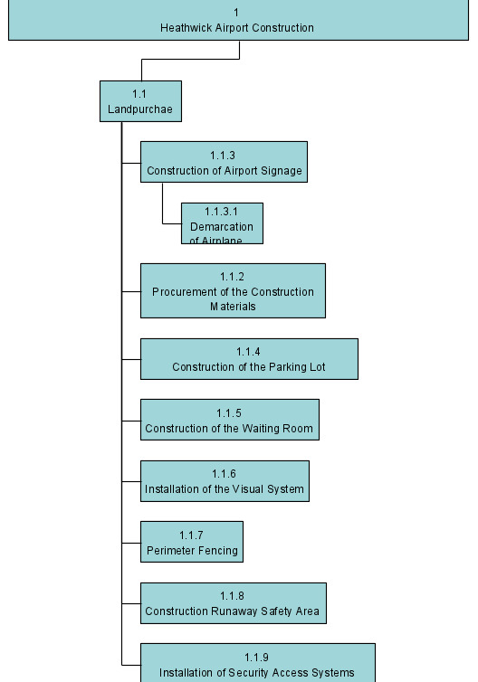

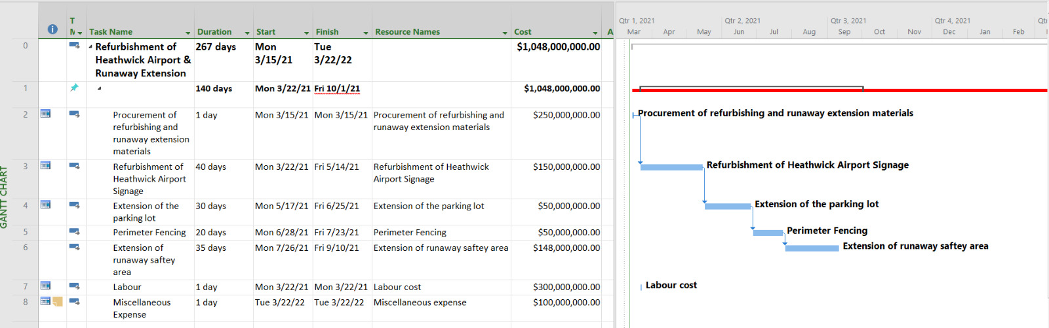
Gantt chart

Project Controls
In managing and controlling the refurbishment and extension of runaway o Heathwick airport, there are a lot of challenges to be involved. Consequently, various bodies are also interested in ensuring that safety and refurbishment procedures have been followed up promptly (Alnasseri, 2015). For the case of the refurbishment of Heathwick airport, there are various controls that must be put in place to ensure the success of this project. The project controls put in place, must be geared towards ensuring there are comprehensive project management strategies as well as human-related competencies in the implementation process. Ideally, the construction works play a paramount role in the economic development; therefore, the whole process must be completed in an effective and efficient way.
In ensuring the proper management and control of this project, the roles and responsibilities of each project team must be well defined to ensure the project will be completed and controlled accordingly. In this case, the project manager will be the lead in this project, especially in planning, executing, controlling and controlling of the projects. Additionally, other team members will report directly to the project manager, who will be responsible in handling of ensures, and ensuring that the available resources have been allocated accordingly. Other stakeholders such as construction engineer, site surveyor, civil engineer, will report direct to the project manager. Construction engineer will be responsible in managing and of this construct project by carefully inspecting all the drawings of the airport refurbishment and runaway extension areas. Civil engineer will be responsible planning, designing, and overseeing the refurbishment and extension, and maintenance of the airport structures
The refurbishment will undergo and approved by the quality assurance department, to ensure that quality procedures have been followed to the latter. Quality assurance by approved bodies will be responsible in ensuring that all the required standards and compliances have been followed, and no environmental issues exist. The whole project will comply airport construction/ refurbishment standard (AC150/5370-10). Based on the Cost Benefit analysis (CBA), it is worthwhile to undertake as it have financial implications. It is anticipated that the project will payback its initial cost outlay in 5 year; hence feasible.
The introduction of this project will bring about change in terms of the product under consideration. Quality of work will be guaranteed because in each month, walkthrough testing will be done and quality analysis by the qualified personnel and government agencies. In terms of project risks, it is important to note that every project is associated with the risks, in this project the key risk is financial risk committed to this project. The budget for the implementation of this project might end up changing due to the prevailing market conditions in terms of materials and other unforeseeable events.

References
Alnasseri, N. (2015). Managing and controlling airport construction projects: a strategic management framework for operators (Doctoral dissertation, Northumbria University).
Turner, T. (2016). Heathrow Airport Expansion, London. Retrieved from https://www.turnerandtownsend.com/en/projects/heathrow-airport-expansion-london/
Mahamood, T. A., & Waghmare, A. P. (2019). Construction Planning and Management of Airport: A Case Study of Purandar Airport.`
CAPA (2019 December, 6). Airport Construction: Overall Expenditure on New Existing Airports is not Increasing. Retrieving from https://centreforaviation.com/analysis/airline-leader/airport-construction-overall-expenditure-on-new-and-existing-airports-is-not-increasing-503759

Appendices
The expansion and construction of Heathwick airport will be a great deal in increasing the capacity. Additionally, this construction is deemed important in bringing the connectivity, trade and movement of people who are considered to be the cornerstone for business. To ensure successful completion of the construction process, Heathwick airport management will appoint Turner and Townsend Company, to complete the whole process. This company is also meant to provide strategic support for Heathwick in its expansion and construction. The primary goal goal in the project management of this initiative is to ensure that this programme achieve quality and cost management in this project. The costing of this project has been achieved using complex cost estimation modelling technique and balance in ensuring that Heathwick achieves the right balance and best outcomes from this project. Additionally, the contractor is keen in helping Heathwick to achieve its strategic objectives. Having implemented several other projects that are similar to this one in many years, it has been noted

