PROJECT MANAGEMENT THE NEW TESLA GIGAFACTORY IN TEXAS
Student’s Name
Course
Professor’s Name
Institutional Affiliation
City
Date

Project Management the New Tesla Gigafactory in Texas
Introduction
Tesla, Inc is an American company based in Palo, California, mostly focusing on electric vehicle and clean energy. With the construction plans of new Tesla Gigafactory in California, the company is focusing on various project management approaches to achieve its mission and vision. The company want to invest heavily on the project, which is intending to start in 2022 to 2024, by committing all the require project management resources for its completion. In every project management task, it is important to understand and discuss the methods that appropriate in project planning and project control. The rationale behind project planning is to define the required project activities, milestones, and allocation of required resources. This paper aims to provide an overview of the project planning by determining the project activities and completion dates. This paper also provides the breakdown of the project that will facilitate the completion of new Gigafctory and understanding the ideal project management methodologies for the successful completion of this project.
Project Planning
Project planning can be defines as a heart of project lifecycle and tells everyone involved about what needs to be achieved. The main idea in this project is to complete the two phases of upcoming Gigafactory. Importantly, this project will start by identifying an area in Austin, Texas before proceeding with site selection within the area. Ideally, as per the project plans, the site selection is expected to take 30 days approximately. After sourcing the land/ site selection land preparation work will begin immediately which will be followed by designing and planning for activities simultaneously. Completion of designing is estimated to be 35 days, and planning 55 days. The next phase based on the project planning will be built/ construction of the building, which will take 150 days on estimate. However, the construction process will require an additional of 60 days to make watertight and rood. Plumbing activities will be done within 30 days and electrification will take 60 days. The last stage of phase one will be inspection, which will take 10 days. The total duration that will be taken for the first phase of this project will be take 400 days. The CEO of Gigafactory by name Elon Musk and his project management team are very keen on the delivery of a successful project.
In the project plan of the construction of Gigafactory, the second phase of the construction process comprises of internal assembly and support systems. Ideally, this involves the construction and integration of the internal assembly system. The first section of phase two, which is fitting the battery and drivetrain assembly area will take 70 days approximately. Fitting of the assembly area will take 50 days, while fitting of the final vehicle assembly will take approximately 80 days based on the project plan and schedule. Finalizing of the production stage will require painting and development of the ventilation area, which will be completed in 90 days. In supporting the production of central supply, building needs, this will require 100 days. Lastly, within the project plan and schedule a test track will need to be established outside the building, and will be completed within 80 days. The second phase of this project will take a total of 340 days, which will be depicted in the project schedule.
For the purposes of project planning, there are several project management techniques that can be considered. One of those techniques is the application of Work Breakdown Structure (WBS). According to Burke (2013, p.26) is used as iterative tool throughout various phases and should eventually comprises of deliverables that are produced the project. In most cases, the creation of each deliverable in WBS is assigned a new to a team leader for delivery as well as execution. The project team through this technique or method can decide or define how deliverable are produced. Ideally, the significant benefit with this technique is that the project teams are forced to undertake a detailed planning as a part of their work.
Project Schedule
For this project to be completed successfully, project schedule will guide the project management team on the project tasks and project timelines allocated. Understandably, project schedule defines what needs to be done and by when, and the resources that must be utilized for the successful completion of the project. Oberlender (2014, p.1) affirms that the project schedule is used in line with WBS as a mechanism for evenly distributing work among team members. In ensuring that all tasks are tracked in this project among the team members, the project schedule should be updated regularly, to understand the current status of the project. The construction of Gigafactory is complex and will require care and attention by the project team to ensure that the project does not remain behind the schedule. Completing this project behind the schedule might be costly, thus requiring additional resources. Project owners may feel not comfortable adding more resources for the project. However, they will keep on emphasizing for the project management team to complete project management activities within the tight dread. The table below presents a project schedule for this project.
In terms of the critical path of this project, it is determined through identification of the longest stretch of dependent activities and measuring the time required for the project completion from the start time to the finish time. The critical path is the path if the project is to be completed and delivered on schedule, any further delay would amount to execution of an activity on critical path; hence delaying the completion time of the entire project (Aliyu, 2012, p.204).
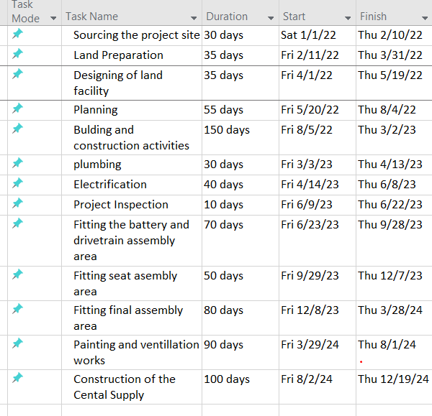
Regarding improving the time schedule for the construction of Gigafactory to be completed before 100 days earlier, this calls for scheduling strategies. Such strategies are driven by the scheduling trigger, which is the circumstance driving the scheduling approach. Another strategy is to identify project activities that can be ran simultaneously thus saving on completion time. Simultaneous execution of tasks can be achieved through linking task dependencies. However, those tasks that that are dependent on others to start of finish before others can start. Such task dependencies must be mapped/ linked in the schedule. Execution of the group tasks and assigning them priorities is also an ideal option for improving the time schedule. Since delaying this project will be costly, Gigafactory through the project management team will need to consider the highlighted strategies for improving the time schedule. The project schedule for Gigafactory as per the project schedule can be described as shown below.
Figure 1: Project Schedule
Gantt chart
Gantt chart is a project management tool for assisting in project planning and scheduling. Application of Gantt chart in the construction of Gigafactory will serve as a great deal in scheduling the project activities. Additionally, this will provide guidance to the project team in controlling and execution of different of different project activities. In this case, Gant chart will capture the following activities of this project as identified earlier: sourcing of the project site, land preparation, designing and preparing land facilities, building and construction activities, plumbing and electrification. Other activities that will be captured in the Gantt chart include internal assembly and support systems installation, painting and ventilation works, construction of the central supply, and project inspection.
The rationale behind using Gantt chart in this project especially in the construction projects like the one under consideration, is due to their ability to communicate the construction schedule as outlined. Gant chart are also important in presenting the schedule and assigning work to the project team or the sub-contractors if any. In the construction project management of Gigafactory project, there are schedule to wrangles, budget to balance. Changes made in one stage of the project will definitely affect the other stage especially when it comes to the delivery date in line with the project schedule. Ideally, with Gantt chart, the project is divided into phases, which can be easily converted into subgroup. Additionally, since every project must have milestones that provides guidance on the things that have been achieved and hose that are yet to be achieved in the project, Gant chart in this project will help track things in the right direction.
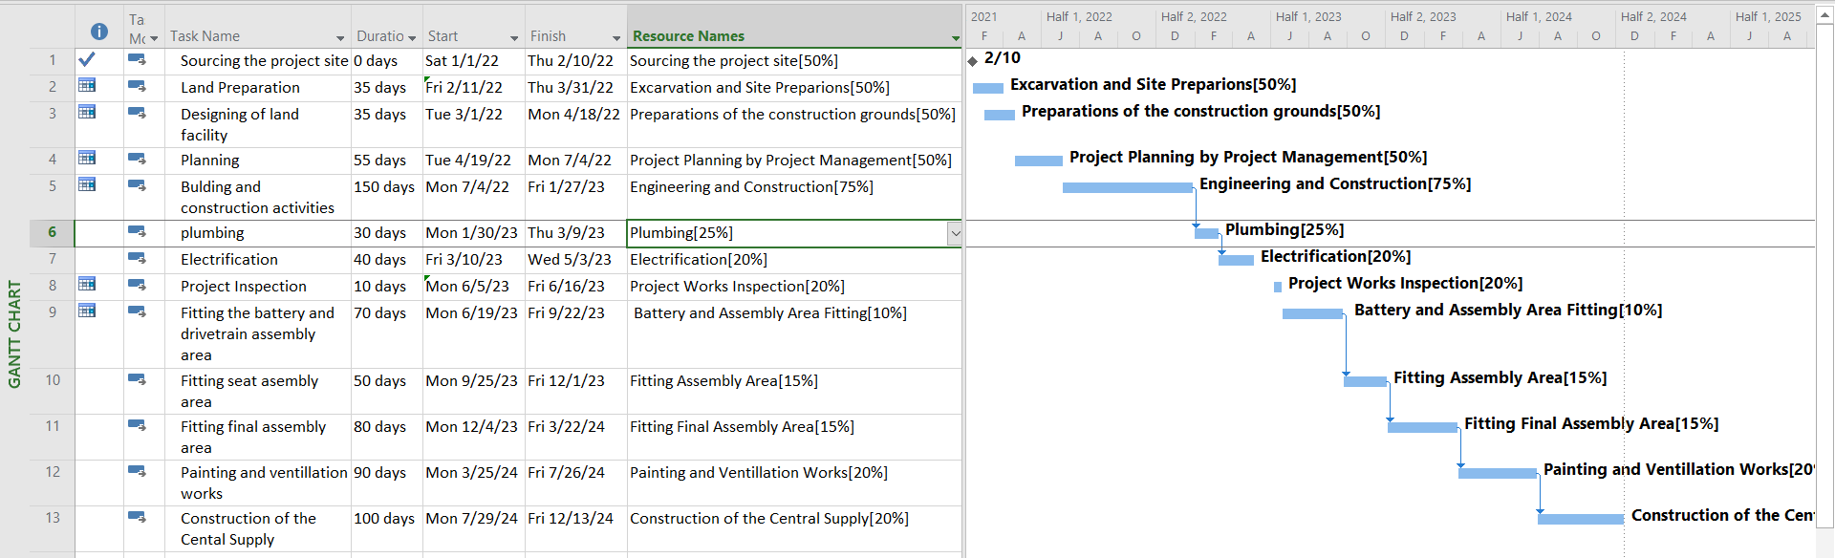
The application of Gantt chart is associated with various limitations especially when creating and updating the chart. Since the construction of Gigafactory involves a lot of complexities, one of the key limitation that would be associated with designing Gantt chart is because it is tedious to manage and update. The rationale behind this limitation is due to the fact that activities in the project keeps on changing with time to time; hence this would affect the structure. Secondly, Gantt chart work well with smaller projects; once the tasks and project durations becomes complex, it start losing its functionality. Third, Gantt chart do well when dealing with the triple constraints, which include time, time, cost, and the project scope. Additionally, the cost of the project is not depicted on the Gantt chart, hence might be challenging to compare the cost incurred in the project at a specific level vs the time taken. Lastly, Gantt charts are predictably unpredictable as they only predict how long the tasks will take. Such predictions in most cases hardly hold true since they are usually made up-front. However, the application of Microsoft Project serves as a great deal in the development of the Gant chart as shown in the diagram below.
Figure 2: Gantt Chart
Network Schedule for the Project
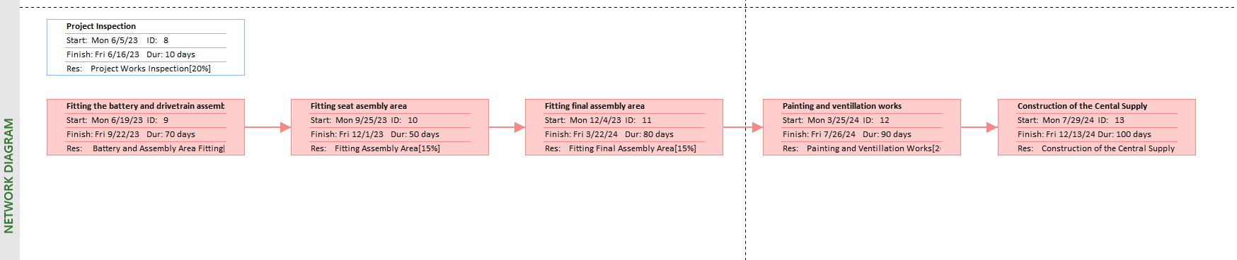
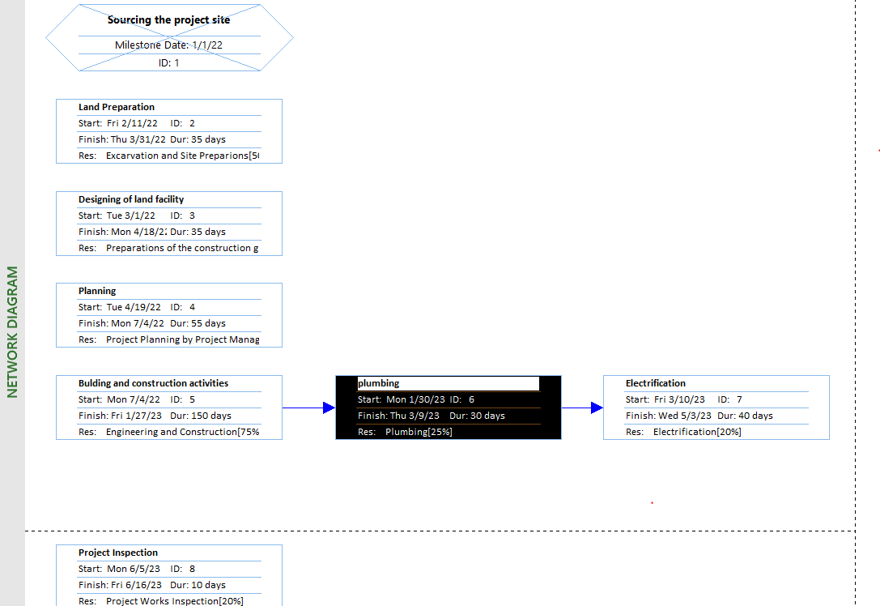
The network schedule for the project can be presented using network diagram as shown in the diagram below.
Figure 3: Network Diagram

Budget
The total cost of this project is approximately $ 1 billion from the start to its completion. The company is keen on ensuring that the project is completed within the deadline, since delaying his project would lead to additional cost of $1,000,000 per day. The cost breakdown will be for the whole project is described in using the table below.
Project Task | Cost
Sourcing the project site/ Purchasing of Land | $ 200 million
Land preparation | $30 million
Designing and preparation of land facilities | $35 million
Building and construction activities | $500 million
Plumbing and electrification installation | $20 million
Project inspection | $20 million
Internal assembly and support systems installation | $40 million
Painting and ventilation works | $15 million
Construction of central supply | $60 million
Miscellaneous expenses | $100 million
Table 1: Budget
As mentioned earlier if this project is delayed, it will require the company to inject more money to facilitate for the time not provisioned. Construction of Gigafactory in Texas. According Mukuka et al. (2013, p.1), project completion delay can either be compensable delays or non-compensable delays. If the delay is compensable, it means it is caused by the project owner or the company. Hence, the contractor is entitled to be added more time to complete the project as well as additional budget. On the other hand, if delay is non-compensable, the delays are triggered by the third parties or incidences that are beyond the control of the project owner. In this case, no compensation is provided to the third party or the contractor. For this project of constructing Gigafactory, the additional budget estimated to be $1000000 on daily basis.
Based on the cost estimation as presented in the above table, this projected adopted parametric costing, whereby historical data and statistical modelling are applied to assign cost to the project. In this approach, it determines and defines the underlying unit cost of the component of a project. The reason behind selecting this method is based on the fact that it is highly accurate. However, it require some initial data to accurately assess and estimate the cost (Stobierski, 2019, n.p). Ideally, the cost estimation as provided in the budget presented above is based on the key deliverables for this project. Nevertheless, this cost estimation approach is associated with some weaknesses such us large size of data, which makes it difficult to perform calculation for the whole data. Additionally, parametric cost estimation can be time consuming and costly. Also, this technique applies random component, which causes results to vary significantly when running multiple times using the same data, unless initiation parameters are fixed.
Project Management Methodologies
A project management methodology is a set of principle and practices that provides guidance in organizing the project to ensure that it has an optimal performance. Generally, this is a framework that helps the project management team to manage the project in the best way possible. Seveval project management methodologies exist each having its own pros and cons. Some of the criterion to consider when selecting ideal project methodology include cost and budget. This helps in answering the question on what sort of the budget is being worked with. Other considerations include the team size, ability to take risks flexibility, project timeline, and stakeholder collaboration.
Different project methodologies that are available for use include Waterfall, Agile, Scrum, Scrumban, among others. For the waterfall methodology, it is a traditional approach to project management, where tasks must be completed in a linear or sequential manner. Each stage of the project must be completed before the beginning of the next stage. For the case of agile methodology, in which the construction of Gifactory will be based on will follow, it is an iterative approach for delivering the project throughout its lifecycle. Agile methodology is quickly gaining popularity in the modern world, in an approach to complete work within a complex and eve-changing world. The rationale for selecting agile in the construction of Gigafactory is because of its four main key values, which include individual’s interactions over tools and processes, working on a project over comprehensive documentation. Third, there is existence of customer’s collaboration over contract negotiation, and lastly responsiveness to change over following a plan. In this project, implementation will be based on the following basic processes: project planning, product roadmap creation, release planning, and sprint planning.

References
Aliyu, A.M., 2012. Project management using Critical Path Method (CPM): A pragmatic study. Global Journal of Pure and Applied Sciences, 18(3-4), pp.197-206.
Burke, R. (2013). Project management: planning and control techniques. New Jersey, USA, 26.
Mukuka, M., Aigbavboa, C. and Thwala, W., 2013. A theoretical assessment of the causes and effects of construction project delay. In International Conference on Civil and Environmental Engineering (CEE’2013), November (pp. 27-28).
Oberlender, G.D., 2014. Project management for engineering and construction. McGraw-Hill Education.
Stobierski., 2019. What is Cost Estimation in Project Management? https://www.northeastern.edu/graduate/blog/cost-estimation-in-project-management/

