Web Design
BUSINESS
PROPOSAL
MAPLE TOURISM MANAGEMENT SYSTEM PROPOSAL

Prepared By
Student name Doe

Address
Email

Table of Contents
Overview 3
Requirements analysis 3
Business Description 3
Business process 3
Solution Discussion 4
Scope 4
Purpose/Objective of the system 4
Existing solutions 4
Challenges in the existing system 5
System Implementation design 5
Workflow 6
Schedule and timelines 7
Conclusion 7

TOURISM MANAGEMENT SYSTEM PROPOSAL

Overview
The goal of this project is to provide a dynamic and responsive integrated system for the tourism industry that can handle the constraints such as manual bookings, record management. All processes associated with tour planning, booking, tours, etc. are presumed to be addressed by the system. This system facilitates two-way communication between consumers and agents, offers vacationers a way to submit feedback, make reservations, manages a database containing information about those vacationers, and provides a portfolio of travel-related services.

Requirements analysis

Business Description
Maple, a travel and tourism company is a family owned business based Babuda of west indies. It was founded 6 years ago and it hosts visitors both domestic and foreign. Traveling to new destinations is an amazing experience, but it may be challenging to organize. Thus, this is where tour companies and related organisations come in handy. They are in charge of the nitty-gritty details involved in arranging vacations. Maple provides services in the hotels and restaurants (i.e catering and accommodation), tour operator services travel agencies, tourist guide services and other related services.

Business process
Maple advertises their business using social media and magazines, then the clients make a booking through a call. Great percent of their system is manual, they keep visitors data and payment information in a manual register. The information technology support they use utility of social media, call center – they user Cisco IP phones and car tracking system. This project purposes to automate Maples business processes.

Solution Discussion

Scope
The proposed tourism management system is an integrated web application whose primary objective is to assist Maple in managing its business processes. It makes the entire functioning of the tour company simple and efficient. The stand-alone platform simplifies tourist administration by managing client requests. The system will also ensure the details of the various places so that customer can easily get all the information from system. Different modules will been in cooperated in this project to handle different parts and sector of the tour management field such as booking, vehicle selection etc.

Purpose/Objective of the system
The system aims to incorporated different modules to handle different processes of the tour management field such as registering customers, making bookings, vehicle hiring, selecting guide and drivers etc. The project's overarching goal is to develop a system that automates the processes and activities of a travel agency and customer details, and help the tourism companies to manage their customers, vehicles and agents. When it comes to managing guests, the technology will make life much simpler by efficiently responding to agency demands and meeting the needs of clients in different regions of the world.

Existing solutions
Travel Booking BD, established in 2014, maintains travelbookingbd.com, the country's first and only website devoted just to booking flights and hotels. Over 500 people are using our expertise & availing our services almost every month, and this number is only increasing due to the tremendous support and feedback they receive. Travel Booking BD caters to all your traveling needs - from planning tours, estimating costs, providing hotel suggestions, bookings, transport options, and tourism information, to planning guided tours for sightseeing, shopping – you name it! They add blog list here all the places information like the festive time,places location are included in that.
At travelbookingbd.com we guarantee the best prices and a wide range of choices for your accommodations and travel plans. Its wide itinerary ideas are the result of intensive research and collaboration amongst skilled travel companies(obokash,2022).
Obokash.com is a full-service Bangladeshi outbound travel agency. The creator of Obokash is a tourism expert with vast knowledge of the majority of the world's tourist destinations and services. Their sections with expertise provide a range of services. Each section operates independently to deliver the greatest services to our prospects and to become the premier travel agency in Bangladesh by emphasizing friendship and long-term relationships with our most cherished customers. The facilities they provide are given below:
- Boats, Railways and Bus Ticketing
- Visa processing
- Hotel reservation
- Car rental
- Services for ground handling
- Tour Guides
- Excursions and itineraries
- Incentives, special interest groups

Challenges in the existing system
To arrange a trip, the user must visit the agency's physical location. It takes a long time for clients to get their orders processed because of all the paperwork that needs to be done by manually. The current systems are insufficient in that they do not provide proper information and guidance to the agencies and clients regarding tour arrangements. When estimating how long something would take and how much it will cost, organizations are sometimes forced to depend on estimation. The following are some issues with conventional systems:
There will be a lot of people using the portal, so we need a solid front end that can keep them there, and there is need for secure database for customer's data to be stored.

System Implementation design
This website will have several requirements, but they may be summed up as:-
- Signup: Registration requires new users to submit their full names, addresses, email addresses, and phone numbers.
- Login: User inputs password and username for authentication.
- Holiday packages: Thereafter, customers may book their desired trip, number of rooms, travel dates, and room type (e.g Deluxe and Premium) by entering their departure and arrival dates.
- Best deals: During the festival season, users may find the finest bargains and discounts tailored to their own tastes.
- Feedback: Customer can give their reviews and recommendations
- About us: Customer may learn more about the tour company.
- Contact us: This page will display contact details.

Workflow

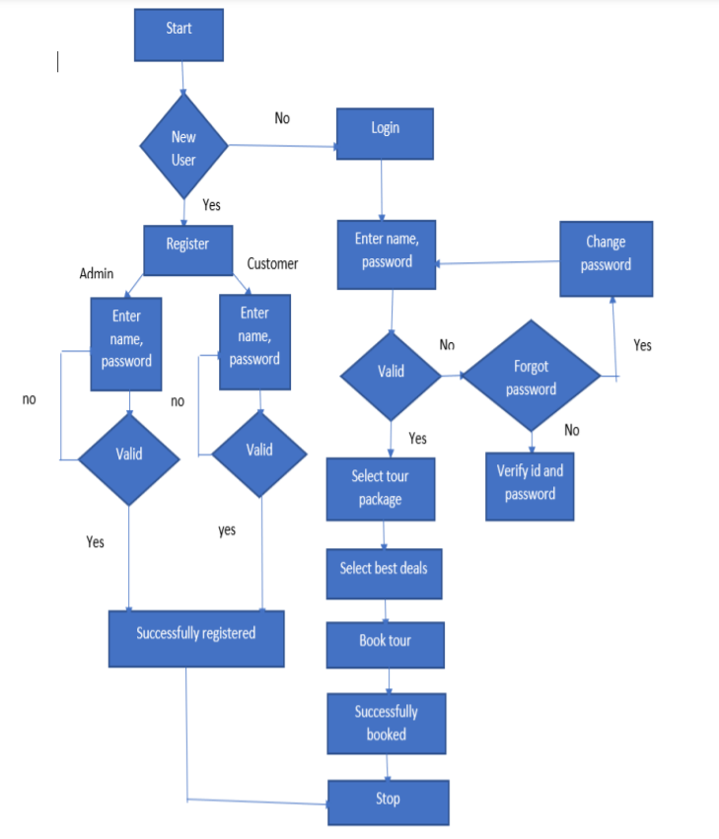

Implementation details
Hardware requirements:
Processor (2.0 GHZ)
Ram(2GB)
Software Requirements:
Windows10/Mac/Linux Operating system
BackEnd (MySQL)
Front-End (PHP,HTML,CSS,Javascript)
Web browser(google chrome.firefox)

Schedule and timelines

Serial | Development procedure | 1st week | 2nd week | 3rd week | 4th week | 5th week | 6th week | 7th week
1 | Project proposal
2 | Requirements specification
3 | Requirements validation
4 | designing
 | Implementation and coding
5 | Validity testing and testing
6 | Submitting project

Conclusion
This project will help Maple automate its business process; bookings and reservation will be done online, customer support via feedback mechanism in the website, vehicle and destination selection, and travel package offers by the organization. In this case, a customer chooses a trip package for a certain location based on the suggestions of prior customers who have used the package. The website allows the user to choose the transport vehicle of their choice, make inquiries, get an overview of the destination journey, and quickly select the best destination based on other people’s review who has visited same destination. Since a client may cancel a reservation anytime necessary, the project will be efficient and effective in terms of cost and money.

References
obokash. (2022). OBOKASH TRAVEL AGENCY. https://www.obokash.com/. https://www.obokash.com/

