Searching Via Divide and Conquer
Student’s Name
Institutional Affiliation

Searching Via Divide and Conquer
Part 1
#include <iostream>
using namespace std;
int main ()
{
//variables and array declarations
int songs, i, myArray[30], number, top, bottom, centre;
cout<<"Enter the number of songs in the list:";
cin>>songs;
// input of the number of elements

for (i=0; i<songs; i++)
{
cout<<"Enter song number "<<(i+1)<<"=";
cin>>myArray[i];
//input of the songs via the loop.
}
cout<<"Which song number do you want to search:";
cin>>number;
// this allows you to input the song from the list to be searched within the array
top = 0;
bottom = songs 1;
centre = (top+bottom)/2;
// initialization and dividing the array into 2 sections for searching purposes
while (top <= bottom)
{
if(myArray[centre] < number)
{
top = centre + 1;
// this section searches the first part of the array
}
else if(myArray[centre] == number)
{
cout<<"The song number:"<<number<<" found in the Song List at the location "<<centre + 1<<"\n";
//if the song to be searched is in the first section, then it will display a message on the screen that the song has been found
break;
}
else {
bottom = centre - 1;
// this searches the last section of the array to find if the song is in the second part
}
centre = (top + bottom)/2;
}
if(top > bottom)
{
cout<<"The song number:"<<number<<" not found in the Song List";
}
return 0;
}
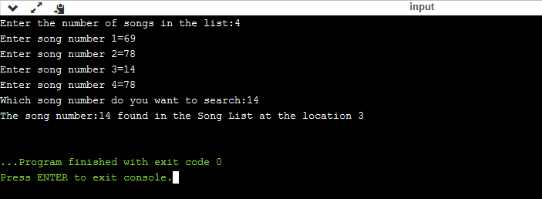
Screenshot of the Results

Part 2
1st step = Time (n) = Time (n / 2) + 1
2nd step = Time (n / 2) =Time (n/4) + 1-----(T (n / 4) = Time (n / 2 ^ 2)
3rd step = Time(n/4) =Time (n / 8) + 1------[ T(n/8) = T(n/2^3)
k^{th} step = Time (n / 2 ^ k-1)=Time (n / 2 ^ k) + 1x(k times)
When we add all the equations, we obtain Time (n) = Time (n / 2 ^ k) + k times 1
= n /2 ^ k= 1 (So how many times we need to divide by 2 until we have only one element remaining)
=> n=2 ^ k
=> log n=k [(taken log (base 2) on both sides)
Put k= log n in e.q. [final]
Time (n) = Time (1) + log n
This algorithm uses is in worst case just like it is the case of binary search algorithm in which its time complexity is at worst logarithmic time, making O (log n) comparisons, where n is the number of elements in the array, the O is Big O notation, and log is the logarithm. Its derivation can be described in the section above.

