Recommended Network Infrastructure for SNHUEnergy Inc
Student’s Name
Institutional Affiliation

Recommended Network Infrastructure for SNHUEnergy Inc
Introduction
Network infrastructures are very paramount in the organizations, as they provide a platform for compunction within and outside organizations. Companies especially with several departments, offices and branches, require a top notch network infrastructure, built in with the required network security frameworks. Understandably, efficient and secure computer network in the organizations play a critical role in promoting the competitive advantage as well as creating a proper platform for communication within the company and to the customers. In this report, the goal is to evaluate the current network architecture for SNHUEnergy Inc, which is a medium-sized company, which is focused on drilling of oil-based products. The headquarter of this company is in Dallas, Texas. This paper also aims at providing a plan for expanding the current network infrastructure to accommodate more branches in Kansas City and Houston. Additionally, this paper provides recommendations of high level design for future growth of the company.
Evaluation of the Current Network Architecture.
Based on the current network architecture of SNHUEnergy Inc, it is designed to accommodate two branches, which are Dallas office and Memphis office. The connection of the two offices is via WLAN, which is protected using the firewall. The current capacity of the network users is 120 employees from the two branches. The current network can support services such as VoIP phone system and video conferencing, which has been crucial especially when the management from the two branches are having online meetings. The networking devices used in the current network set up include routers, switches and firewall to enhance the network security between the two branches. The challenge with the current network design is that it require expansion to cater for the rising needs of the organizations, as well to facilitate the additional branches. Additionally, security of the current network design require to be uplifted, since it is only relying on one firewall.
As per the valuation of the current network design, key changes need to be implemented to help the company to meet its objectives effectively. One of the key changes that need to be made, is to expand the network to accommodate the two branches and more employees. Additionally, changes relating to the devices used the current network design need to be made, to accommodate the use of more sophisticated devices that would easily facilitate the communication in a secure manner. In ensuring that the networking technology is complete, implementation of four key layers is paramount. Such layers include the telecommunication infrastructure, which provides the physical environment of the network, using devices such as mobile on satellite, network on cable ISDN and relay centers (Bonaventure, 2011). The second layer is intermediate of network services provided, which has components such as teleconferencing and video conferencing. The third layer in the network technology is the intelligent terminals of the network, which include data terminal equipment. The last and fourth layer is specific applications, which may include an information service or electronic mail application.
Future Communication Needs of the Organization
Due to the anticipated company growth via expansion of the SNHUEnergy Inc, the future needs of the company will rise. The organization will require a modern and responsive network infrastructure, which will require the company having a virtualized data centers for communication purposes. With the expansion of the company, it will require to have a top-notch security platforms to ensure the communication remain protected and secured within all the branches owned. Network security is a big concern for the company, as new devices will be introduced to the network, and as this organization will extend its network connection to other branches.
The future communication needs of the organization under consideration requires network design using virtual private network and various devices, which will facilitate sharing of information and other resources. The network requirement of the enterprise is one of the most important element to consider in future when planning for a network design for an organization. Additionally, the future communication will require considering other factors as listed and aligning the network infrastructure to both business goals and technical goals of the organization. Below are the goals relating to future network design for SNHUEnergy Inc, which will be as a result of the anticipated expansion of network.
- Designing a network that is secure to protect the applications and data.
Since the company transact many financial and other sensitive transactions on daily basis, the goal is to provide a secure network, by ensure that both the company and client data is protected. The priority will focus on designing a secure network for the organization. It can be noted that currently there are several attacks imposed by the attackers and hackers, with an intention of gaining sensitive information for the company as well for the customers (AbuSamra & Alnaji. This is very risky indeed, and that is why the goal is to ensure the design of the network under consideration is geared towards implementation of security mechanisms.
- To design network that will guarantee availability
Uptime of network throughout is essential since it can allow the organization to access the needed information, at any time. If the information needed cannot be accessed when needed, then it means that availability of such a network cannot be guaranteed. With the proposed network design the idea is to guarantee 99% availability, if not 100%.
- To design network that will support higher network bandwidths.
Network bandwidth represent the network speed, which is an important aspect of the implementation. The idea is to design a top-notch network to ensure there is no downtime during the communication. Additionally, higher network bandwidths support an optimal network performance (Offor et al., n.d). With this, the network throughput is expected to be high, which will ensure no packet loss as well as delays during the transmissions.
Recommended Network Infrastructure for the Company
Since the idea is to provide a reliable and secure network design for the company within all the branches of SNHUEnergy Inc, some considerations need to be made to achieve this objective. The ideal solution recommended for this company is designing enterprise branch architecture, which takes into account the services that the customers may want to be deployed, at their endpoints, regardless of how they are connected. Other recommendations are based on the use of Cisco ISR G2 innovations which aims at delivering video ready branch office for supporting high-tech customers experience (Wilkins, 2011). This is supported by bandwidth that is optimized with scalable video and teleconferencing services. To facilitate high-speed communication, the recommended options include use of higher density external access switch is paramount. Additionally, the use of ISR module that can support switched access ports to facilitate the redundancy within the connection to the access switches via Ether-Channel. In ensuring that the network design for the organizations are met, the connection should need to be high speed. Therefore, this paper proposes the use of ISP fiber backbone, provided by Mercantile Communication Network Company. In addition to this, there need to be the use of Demilitarized Zone (DMZ), with an aim of buffering zone between public and private networks (Rababah, Zhou & Bader, 2018). Deploying the DMZ besides the firewall, means that in-bounds packets are filtered using firewall, before arriving at the server hosted by the organization in DMZ.
The recommended network design for the organization with all its branches will as shown in the diagram below. Notably, as per the recommended network architecture presented in this paper, it is aligned with the goals of the organization. Hence, it is meant to support the ultimate growth of the organization in a secure and reliable manner. It is important to note that this is as per the redesign of the current network infrastructure, to meet the future communication need, as well as accommodating more branches due to the expansion of the company.
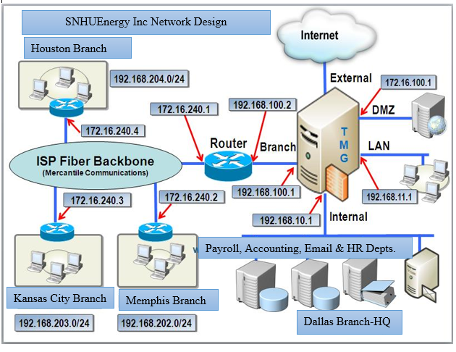

References
AbuSamra, A.A. and Alnaji, K.W., 2017. Developing A Security Model for Enterprise Networks (SMEN). Developing A Security Model for Enterprise Networks (SMEN), 4(1).
Kumatani, K., Takahashi, E., & Kato, T. (2013). Current and future infrastructure networks aimed at resolving issues related to the changing and diversifying activities in society. Fujitsu Sci. Tech. J., 49(3), 271-279.
Offor, K.J., Obi, P.I., Nwadike Kenny, T. and Okonkwo, I.I., Structured Network Design and Implementation for a Small Office Home Office–Tutorial/Report.
Rababah, B., Zhou, S., & Bader, M. (2018). Evaluation the Performance of DMZ. Assoc. Mod. Educ. Comput. Sci, 0-13.
Wilkins, S. (2011). CCDA DESGN 640-864: Designing Remote Connectivity. Retrieved from https://www.ciscopress.com/articles/article.asp?p=1743279&seqNum=3

