Coronavirus Detecting Drone
Yuval Zamir
SCE

Table of Contents
Introduction 3
Problem Statement 3
Objectives 4
Research Questions 4
Functional Requirements 5
Non-Functional Requirements 6
Input and Output of the System 6
Information to be Loaded to the System 7
Action Logic of the System 7
Software Requirements 8
Use Case Diagrams 8
Drone Processes Use Case Diagram 9
Drone Control System Use Case Diagram 10
Drone Control Station Sequence Diagram 11
Conclusion 12
References 13

Coronavirus Detecting Drone

Introduction
With the increased number of cases of COVID-19, the use of technology has taken the center stage in analyzing and detecting people infected with Coronavirus. The idea of implementing the Coronavirus detecting drone is to reduce human to human and object contact, which escalates the spread of the deadly virus. With such drones, they can detect body temperature, cough, and heart rate. Technologies that can identify if people are keeping social distancing, not wearing masks, not adhering to the guidelines set by the governments are paramount as they will reduce the human to human contacts, thus limiting the spread of Coronavirus disease. This paper aims to provide system requirement specification for Coronavirus detecting drone.

Problem Statement
With the rapid increase in the number of cases of those infected with the novel Coronavirus, it can be noted human to human contact is the major spread of the disease. Most of the cases reported are through contact and respiratory droplets. Due to human contact, the rapid widespread of the disease has led to increased fatalities and affecting people with pre-existing conditions. This appears to be a major problem that is instigating the rising curve if the virus. In ensuring that this problem is fully resolved, the use of technology is paramount. One of the best and proposed technologies that can be applied is by designing drones that can trace, analyze, and detect people who are infected with the virus. The drone should have sensors to analyze body temperature, respiratory conditions such as coughing, and heart conditions. The development of the proposed drone system will provide the solution to the problem by detecting people who are not observing social distancing measures, gatherings of more than 20 people, not adhering to the self-isolation guidelines, among other measures.

Objectives
- The primary goal of this paper is to implement the Coronavirus detecting drone.
- To research on the technologies that can be used to implement a Coronavirus detecting drone.
- To propose an AI-based system that gathers information from the drones, perform analysis, and provide the necessary security measures.
- To simulate the drone-based system for Coronavirus, which include operations such as monitoring, sanitization, thermal imaging, and data analytics
- To perform system analysis for the proposed Coronavirus detecting drone.
- To perform system design for the proposed Coronavirus detecting drone

Research Questions
- What techniques can be used to develop and implement secure Coronavirus detecting drone?
- What are the available technologies that can be used in the implementation of Coronavirus detecting drone?
- What are the mechanisms of implementing a multi-layered architecture that gather information from the drones and exchange it with the server for analytical purposes?

Functional Requirements

- The system should broadcast useful information to the headquarters where servers are residing.
- The system should perform audio broadcasting to encourage social distancing and staying at home.
- The system should use sensors to do surveillance to enhance situational awareness, the sensors should analyze and inform the operator or police.
- The system should have the ability to do the aerial mapping to understand the vulnerability of the virus in different locations. Aerial mapping involves checking the locations of the maps and setting and getting the required measurement
- The system should measure the body temperature through automated scanning.
- The system should be able to check if the gathering has more than 20 people.
- The system should check if the distance of 2 meters is maintained by the people.
- The system should check if people are wearing masks.
- The system using cameras should perform face recognition.
- The system should check if people have moved >1 km from their home.
- The system should allow users to use QR Codes in their smartphones, to monitor the population movement, and to trace the risk levels. QR codes are generated from the smartphones of the people through the use of sensors or manual recording in the control station.
- The system should use be incorporated with a megaphone, to notify about the violations and threaten them about the fines if guidelines are not adhered. It used also to encourage social distancing and staying at home.
- …..

Non-Functional Requirements

- Security: The system should provide a high level of security to the personal information collected by the drone.
- Reliability: The system should be highly reliable in terms of performance and should provide the expected results.
- Maintainability: the system should accommodate continuous refinement to make it better as the technology advances. In addition, the system must be flexible to changes of the restrictions relating to quarantine.
- Scalability: the system can handle the growing amount of work by adding the required resources. Coronavirus detecting drone system will be developed in a way that it will accommodate the future growth to make it better.

Input and Output of the System
Use of QR Codes are generated from the smartphones using sensors or manual recording to track the movement the people. Inputs will include scanning of the QR codes, scanning of the location maps, getting the location measurements, scanning the temperature through thermal imaging. These inputs will not be manually entered but will be gathered by the drone system automatically using the sensor. In terms of the output, the system will provide the results in terms of data analytics. Such data will include all the locations visited by the drone, the number of people analyzed, the number of people with Coronavirus symptoms, photos and videos of the cases, etc.

Information to be Loaded to the System
For the system to work effectively, it needs to be loaded with some information, which includes all the locations as per the map. The locations maps will be fed manually to the system or automatically using the sensor, which will involve setting the longitude and latitude. This will enable the trade to target such locations, analyze and detect people with symptoms like those of the Coronavirus. Additionally, the system will require to be loaded with QR codes of the smartphones of all users to trace the movements in all the locations. With QR codes, GPS can be integrated to navigate, and relay detects and analyzes the required information from the public.

Action Logic of the System
The system is based on some logic which includes the following operations
Get measurements- (location measurements)
Set Angle/ WP Control- (target location)
Get Gimbal Control- (target location)
Set Measurements- (for the target location)
Get Angle/ WP Control- (For the target location)
Calculate Controls (MPC)
If gathering exceed more than 20 people, then inform the police
If the distance of 2 meters is not maintained, then inform the police
Perform face recognition to know the location of residence of the people
If a person moves>1 km from home, then inform the police
If the person detected has sighs of illness such as coughing, flattening on the floor, sneezing, high temperature, then inform the operator
If in isolation and not adhering to the set rules, then alert the police

Software Requirements
Software requirements, in this case, describe the software tools to be used in the design and development of Coronavirus detecting drone system.
In system analysis and design, the software to be used is Star UML 5.0, which will be used to draw use case diagrams, activity diagram, sequence diagram, and class diagram. Implementation will require the use of Arduino IDE. The system will also require the use of Prolog programming language, which will be used to implement the logic side along with Arduino. This will be important as the system will use artificial intelligence to be implemented and for it to work accordingly.

Use Case Diagrams
The primary goal of use case diagrams is to model the system or a subsystem and show the relationship between various actors in a system. Use case diagrams comprise of actors, use cases, and their respective relationship. The use case diagram below depicts the scenario of implementing Coronavirus detecting drone.

Drone Processes Use Case Diagram
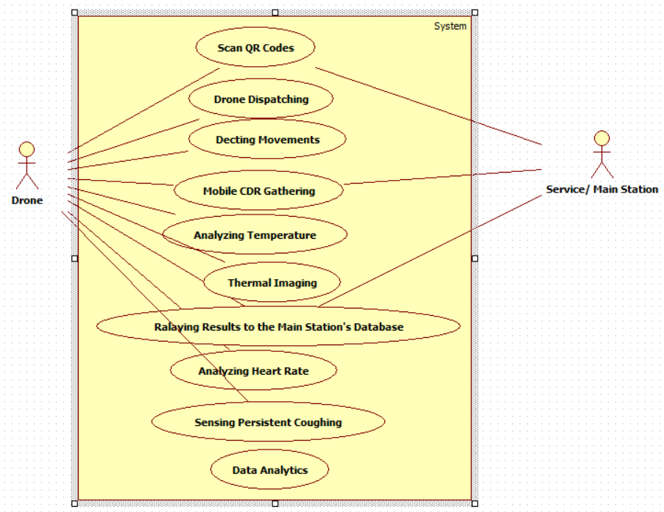
Figure 1: Drone Processes Use Case Diagram
As shown in the above use case diagram, there are 2 main actors, namely Drone and service/ main station, each of the 2 actors has its corresponding use cases, that are used to map their relationship. QR codes from the smartphone of the user can be scanned by the drone and mapped to the service/main/ control station. Drone dispatching as captured in the above diagram will automate and triggered from the control station. In the detecting movements use case, the drone will use the location map to analyze and detect the movement of people and their interactions. For the case of mobile (Call Detail Record) CDR gathering use case, the drone analyzes the location by assessing and interaction of people through CDR data set, which will be obtained easily through the use of the sensor.
Other operations that the drone will be able to perform as provided in the use case diagram include analyzing temperature of the people through thermal imaging, relaying the results to the main/ control station database, analyzing heart rate, sensing persistent coughing, and data analytics. With the data analytics, the drone system will provide reports based on the analysis and detection of those with symptoms like of the Coronavirus disease. Those with temperature far above the normal, persistent coughing and have a high heart rate. Difficulty in breathing will be isolated from the public.

Drone Control System Use Case Diagram
Ideally, this use case diagram provides a visualization of the abstract operations in the control station. Drone control stations have system components with high-powerful sensors that will get the location map and provide direction to the drone. Additionally, the control station will provide the actual measurements of the location and set the appropriate angle of control for the drone to analyze and detect people with the symptoms like those of Coronavirus. In terms of the use cases associated with the drone as far as drone control station is concerned, set measurements will be triggered by the drone after the identification of the location/ getting of the measurements by the control station. The drone will also set the gimbal control and set angle WO control. Understandably, gimbal control is used in drone systems and it is developed using Payload SDK, to support users to set the smooth control coefficients. The settings allow the drone to rotate at a certain angle within the specified time.
The drone control system also has Calculate Code MPC, which comprises of microcontrollers with high computing capabilities and related memory demands of the algorithms. According to Currie (2012), MPC (Model Predictive Control) is known to be a successful control and complex algorithm that is in use in modern technology. The goal of implementing MPC in the drone control station is due to its ability to handle multivariable systems (Vidyadharan et al.,2017). The diagram below shows the Coronavirus detecting drown control station
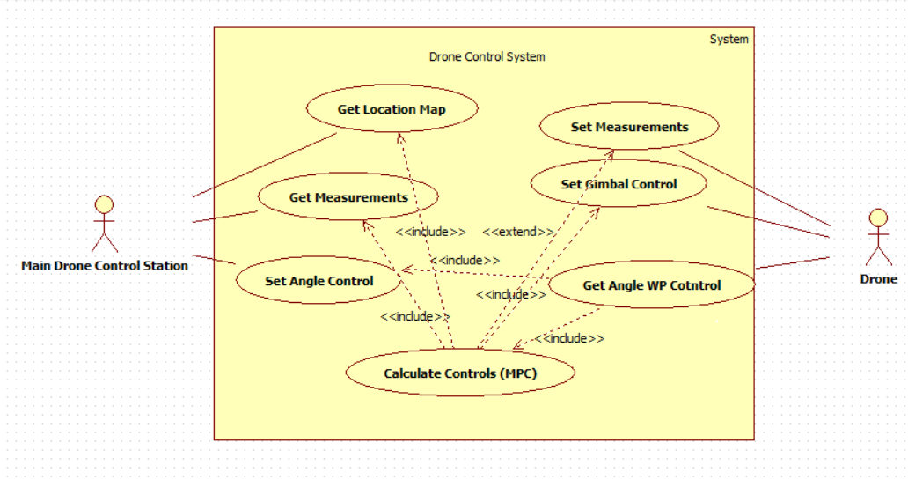
Figure 2: Drone Control System Use Case Diagram

Drone Control Station Sequence Diagram
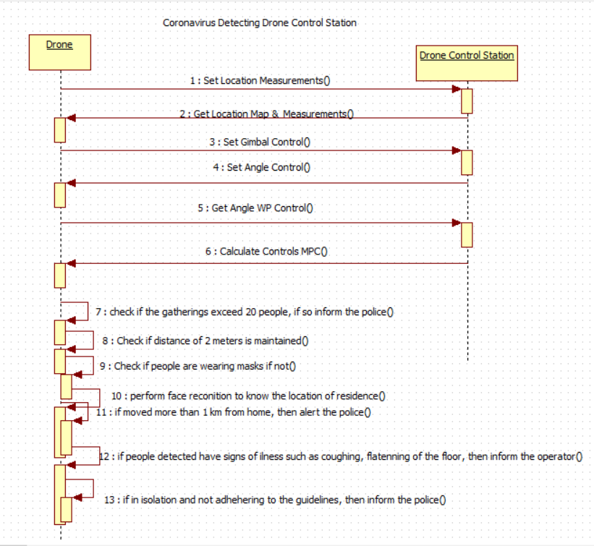
The above scenario that involves the control station and the drone can be represented through the sequence diagram as shown in the diagram below.

Figure 3: Drone Control Station Sequence Diagram.

Conclusion
The Coronavirus detecting drone is a system with advanced features to allow the agents concerned to detect citizens with symptoms that resemble those of the Coronavirus, such as coughing, breathing problems, flattening on the floor, among others. The systems will use sensors for detection purposes and will have in-built arithmetic logic for computation and making a decision depending on the measurements done. This system aims to reduce human to human contact, which can easily lead to the spread of this disease. Once cases are detected, the people concerned will be alerted to take the measures and ensuring that the guidelines set are adhered to.

References
Coronavirus-Detecting Drones Stir Privacy Concerns (2017). Retrieved from https://www.youtube.com/watch?v=mmryPT7PXn4&ab_channel=TODAY
Currie, J., Prince-Pike, A., & Wilson, D. I. (2012, November). Auto-code generation for fast embedded model predictive controllers. In 2012 19th International Conference on Mechatronics and Machine Vision in Practice (M2VIP) (pp. 116-122). IEEE.
Deedee. S. (2020). Drones Detecting Body Temperature Being Used in COVID-19 Response. Retrieved from https://www.kiro7.com/news/local/drones-detecting-body-temperature-being-used-covid-19-response/CAGP3UM2IRCI7HMXPZMOL7OOXY/ https://blog.werobotics.org/2020/04/09/drones-coronavirus-no-sense/1
Vidyadharan, A., Philpott, R., Kwasa, B. J., & Bloebaum, C. L. (2017). Analysis of autonomous unmanned aerial systems based on operational scenarios using value modelling. Drones, 1(1), 5.

