KATZ OFFICE FITOUTS PROJECT
Student’s Name
Course
Professor
Institutional Affiliation
Date

Table of Contents
Executive Summary 4
Introduction 4
Discussion of the Key Elements 5
Budget Review 5
Original Project Schedule 6
Execution of the Project/ Project Plan 7
Brief Summary of the Project Status 8
Cost and Schedule Variance 8
Additional Information 10
Overview of the Leadership Behavior 11
Overview of Existing Team Environment 11
Summary of Recommendations and Conclusions. 12
Appendices. 13
Appendix 1: Student Group Reflection. 13
Reference List 14

Executive Summary
Project management concepts for the construction of medium-size IT office building for Katz Office Fitouts is the core subject of this paper. An introductory statement has been provided in this paper to outline the primary goal of this report. The report also covers other important aspects that revolve around the key elements of the projects, such as review of the project in terms of the projected cost, the discussion about the original project schedule based on the case study provided in this report. Status report based on the information provided has also been deduced by discussing the elements of the project plan, which are core in the implementation of this projects. Other items under consideration in this project include brief summary of the project status, that looks at cost and schedule variance. The attention has also been paid to the overview of the leadership behavior based on the Organization Zoo model, overview of existing team environment, and lastly summary of the recommendations and conclusions based on the findings of this report

Introduction
Project management role in any organization is paramount in ensuring that the implementation of specific projects by the organization. Katz organization is very keen in ensuring that the fitout of a medium -rise information technology office building has been done successfully. The fundamental goal of this report is to provide an investigation report on the current status of the project, which was initiated on 1st March 2020, and is currently underway. The second objective is to provide the recommendations board of Katz Office Fitouts, which is part of the advice. The report is also meant to provide to present summary of the findings in terms of the cost and schedule variance as per the plan. Other goals to be achieved in this report include is to provide an overview of the project and the working team and the environment within which the project is been implemented.

Discussion of the Key Elements
As per this report, the key elements in this project include the review of the budget allocated for the completion of the project, original schedule that capture the project start date and completion date. In the original schedule, the review will include the progress of the work completed and what is remaining, and whether it can be completed within the provide timeline. The third key element is based on the execution of the project from the perspective of the work done and other aspects of leadership. The fourth element entails the project plan for the implementation of the construction of medium-rise IT office building for the Katz company.

Budget Review
Budget allocation is one of the paramount resources for facilitating the completion of any given project. In assessing the work of Kwon & Kang (2019, p.1), project cost estimation is the most critical parameter that can determine the successful implementation of a project. Based on this project the allocated funds for the completion of the fitouts is $1.2 million, which is sufficient for the completion of the project. However, as per the assessment, the work done, and the cost incurred up to May 1st is to high that the remaining work might not be sustained by the remaining cash. It can be noted that the that the amount of money spent so far is $675K; hence, the amount remaining is $525K, which is to facilitate the remaining work.
In pursuant to the budget plan put in place for the implementation of the project as per the allocation by the previous project manager, can be deduced as follows.
Activity/ Item | Budget Amount
Construction of the IT office Building | $850,000
Furnishings | $55,000
Plumbing | $62,000
Electrical and Data Cable Installations | $40,000
Telecom Infrastructure | $125,000
Miscellaneous expenses | $68,000
Total | $1,200,000
Table 1: Budget Review

Original Project Schedule
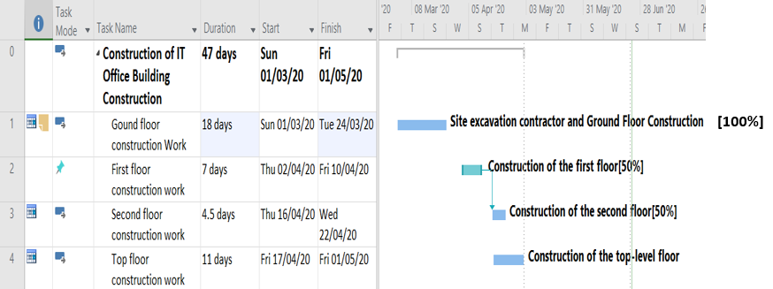
As per the original schedule of the project provided, the project was purposed to start on 1st May 2020 to 30th June 2020. In assessing the work of Hessami et al. (2017, p.), accurate definition of the project work, cost estimate and schedule are the primary focus of any given project and should be clearly defined in accordance with the project scope. As per the schedule, it states that the completion of the work on the ground floor by 1st May, need to be completed, first floor to be completed by 50% and second floor to be completed by 50% by the said date. Additionally, the schedule the stipulate that by 1st May, the top floor is not yet due to commence. Though this schedule does not correlate the with the with the findings on the investigation, the following figure present the actual project schedule as per the time of investigation. The schedule has been prepared using Microsoft Project Management tool.

Figure 1: Original Project Schedule

Execution of the Project/ Project Plan
The execution of the project entails various aspects, which include the project team, working environment, and whether the execution was in accordance to the project schedule. Heldman & Baca (2009, p.259-261) affirms that approval of the project plan is important decision, since it implies that the work will be executed as outlined by the plan. Additionally, the study asserts that the management of execution requires the allocated project time to be expedited accordingly. Based on a look of the project plan, it is clear the execution has not been well established. Similarly, it is a good practice in construction to move as per the schedule.
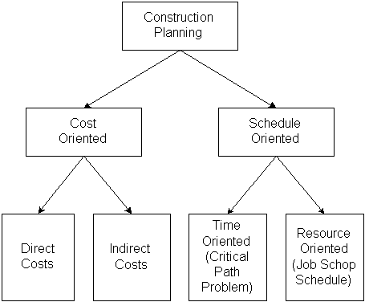
Accordingly, the actual execution or project plan for the construction projects require various aspects to be factored in, which include project scheduling, project execution through critical path method. Creation of work breakdown structure (WBS), etc. According to Abdulkareem (2020, p. 2-3), proper project planning and scheduling, ensures that all the resources have been put in place to facilitate the construction process. Notably, various methods can be put in place by the project managers, to estimate the duration that can be taken for the execution of the project. For the successful completion of this project, and in accordance with the investigation undertaken, the project plan can be presented in by showing in a diagram, the alternative emphasis in construction planning as shown below, as well as using work breakdown structure.
Figure 2: Alternative Emphasis on Construction Planning.
The whole idea can also be presented in WBS, whereby this plan entails site preparation, which involves mobilization, exaction. The second fundamental item in the project plan is construction of floor slab, which is all about sub-base and blinding, and formwork and concrete. Other items to capture in the WBS include furnishings, plumbing, electrical and data and telecom. As per the project plan, the duration foe implementing the said project plan is within 4 months.

Brief Summary of the Project Status

Cost and Schedule Variance
In this section, it covers various aspects of the project in terms of the cost variance, and the schedule variance. Cost variance is the difference between the actual cost and the budgeted cost of the projected (Prasanth, 2014, p.2) It is important to note that the cost as per the initial budget was $ 1.2 million. On the other hand, schedule variance is an indicator on whether the project is ahead or behind the schedule. As per this project, there seems to be both cost and schedule variance. First, the as alluded earlier in this report, the budget cost for the project was $1.2 million, which has been provided as a breakdown under the budget review section in this report. However, based on the actual cost used so far and the remaining cost for the work to be done, the project cost seems to vary. As a matter of fact, and as stated, cost and the proportion of the work completed is not proportion, there seems to be an under estimation. A comprehensive of the budgeted cost versus the actual cost can be illustrated using the table below.
Activity/ Item | Budget Amount | Account Amount
Construction of the IT office Building | $850,000 | $950,000
Furnishings | $55,000 | $100,000
Plumbing | $62,000 | $60,000
Electrical and Data Cable Installations | $40,000 | $75,000
Telecom Infrastructure | $125,000 | $140,000
Miscellaneous expenses | $68,000 | $80,000
Total | $1,200,000 | 1,405,000
Table 2: Cost Variance
Cost Variance =$1,405,000-$1,200,000=$205,000
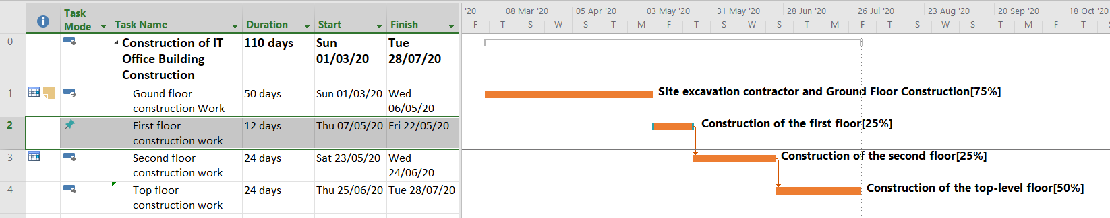
In terms of the schedule variance, it is evident that the project cannot be completed within the stipulated timeline, which can be confirmed based on the work completed by 1st May. With the 75% completion of ground floor, which ought to have been completed by the said date, with 25% completion of first and second floor, which ought to have reached 50% by the said date so unrealistic projected schedule. Lastly, the top-level floor ought not to have started, and it is already done 50%, the project cannot be completed as per the defined timeline in the schedule. The actual completion of the said project can be depicted as shown in the schedule below in the actual project schedule.
Figure 3: Actual Project Schedule
As per this diagram capturing actual project schedule, and in comparison, with the projected schedule, there seems to be a variance, resulting to time underestimation in every project activity. This has been captured clearly in the above diagram. It is worth noting that time underestimation may lead to project being delivered in partiality.

Additional Information
Project manager will require to source additional information to have a clear understanding of this project. Such information will entail the project team selected by the previous project manager, their competence and qualification. Project deliverables issued to the stakeholders about the project, communications made regarding the projects, will also be of great importance to be sourced by the project manager, and lastly the scope of the project. Lastly, the incoming project manager will be required to meet the project team to have a clear understanding on how the project has been running and executed. This will form the basis of generating a comprehensive status report about the project.

Overview of the Leadership Behavior
Leadership behavior in project management is an important element in project management. According to Neuhauser (2007, p.21), effective project managers must show and support transformative leadership behaviors in project management. With reference to Organizational Zoo model on leadership behavior, a top person in the organization may be a poor leader, and may also command decisions, which does not mean that they are good leaders (Shelly, 2011, p.278-279). Borrowing this model to the case of Tony Faultier, the party has shown not to be a good leader, for not making arrangements to provide training to the contract staff, thus derailing the implementation of this project. Addition, lack of knowledge to the team members on the orderly execution of the work shows that Tony Faultier as an autocratic leader. Since the kind of leadership behavior displayed by Tony is not good leadership, the good leadership that can be recommended is democratic form of leadership, where all the team members are allowed to participate.

Overview of Existing Team Environment
With reference to the information provided, there seems to be a hostile team environment during the reign of Tony Faultier, which does not allow them to participate in decision making, as well as empowering them though several avenues such as trainings. Therefore, one of the recommendations is to have a platform where there is synergy between the project manager and the team members, this will facilitate cooperation and smooth running of the project activities. Additionally, good team environment, this would allow the team to undergo training, and hence they are able to focus on the project work at hand

Summary of Recommendations and Conclusions.
As guided by the case study, and for the purpose of this report, several recommendations can be deduced such as having a comprehensive plan before undertaking any project. Similarly, project team must be trained adequately, to be in line to allow the team focus on the project at hand. Additionally, delivering project milestones is also necessary, since this will be able to tell if the project will be delivered on time or not. In conclusion, it can be affirmed that implementation of this project is marred with many challenges resulting from the leadership. Hence, with improper project management skills and responsibilities, implementation of this kind of project may end up failing.

Appendices.

Appendix 1: Student Group Reflection.
In this report, it provides reflections and many lessons learned from the student perspectives. One of the key lessons is on the project management skills. Additionally, reflecting on the leadership provided by Tony Faultier, students are made to understand that autocratic leadership that follows which can be closely associated to Organizational Zoo model, may not work in favor of the organization. Hence, this may lead to a downfall projects being undertaken, by any organization. Another reflection is based on scheduling and budgeting of the project., it seems that the original budgeted cost for this project seems to be unrealistic, which seems to negatively affect the execution of the project. Hence, it can it provides the students with a lesson to learn on budget and cost management skills, Lastly, the students also learn about project management tools, such as use of project management tools to develop project schedule, and track on the progress of the project, as it has been stipulated in the project.

Reference List
Abdulkareem, S. 2020. Methods of Project Planning for Constuction Projects. Engineering Department, the American University of Iraq Sulaimani
Heldman, K. and Baca, C., 2009. Pmp-Project Management Professional Study Guide (With Cd). John Wiley & Sons.
Hessami, A.R., Sun, D., Odreman, G.J., Nejat, A. and Saeedi, M., 2017. Project Scoping Guidebook for Metropolitan Planning Organization Transportation Projects (No. 0-6929-P1). Texas A & M University.
Kwon, H., & Kang, C. W. 2019. Improving project budget estimation accuracy and precision by analyzing reserves for both identified and unidentified risks. Project Management Journal, 50(1), 86-100.
Neuhauser, C., 2007. Project manager leadership behaviors and frequency of use by female project managers. Project Management Journal, 38(1), pp.21-31.
Prasanth, A., 2014. Analysis of cost and schedule performance of Residential Building Projects by EVM Technique. Journal of Construction Engineering, Technology & Management, 4(1), pp.1-7.

