Narrowband Wireless Communication
Student’s Name
Institutional Affiliation

Narrowband Wireless Communication
Question 1
- Describe 5 internetworking connecting devices
- Routers: This device is useful in transmitting packets from the source to their destinations via the interconnected networking devices. Routers are considered to be the most intelligent devices and they store information about the network connections. Such a device can be used to divide networks into two or more subnetworks. Routers normally operate at the network layer of OSI model.
- Switches: A switch is a multi-port device that is critical in improving network efficiency. Ideally, one of the key roles of the switch is to maintain is to maintain routing information relating to the nodes (Melnick, 2019). A switch ca work either at the Data Link layer or Network layer of the OSI reference model. The information maintained by switch is limited.
- Bridge: The main role of a bridge is to connect two or more network segments or hosts. Ideally, bridges are also used are also used in to store and forward frames between different network segments connected by the bridge. Bridge mostly rely on MAC address to transfer frames between different network segments. Additionally, bridges are useful in connecting two physical local area networks into larger logical LAN. A bridge is mostly found in the data link layer and physical layer of OSI refence model
- Hub: The role of this device is to link multiple computer networking devices together, Similarly, this device also acts like repeater by amplifying signals travelling over a long distance via a cable. Hubs mostly operate at the physical layer of OSI reference model
- Gateway: Gateway is operating at transport and session layers of the OSI. Gateway is used to handle networking protocols of different family for the communication to be effective and efficient. Additionally, gateway provides translation between networks of different families such as OSI model and TCP/IP
- Fill out the following table according to features of the named connecting devices
 | Repeater | Bridge | Router | Gateway | Switch
Operating Layer | Physical Layer | Data Link Layer | Network Layer | Network/ Transport layer | Data link/ Network layer
Create Separate Segments | Create multiple ethernet segments and join them together | Segments network logically | Pass data from different created segments | Connects flowing from the same LAN segment | Separates different network segments
Connects different protocols networks | Use different protocols | Interconnect 2 LANS using same protocols | Connects different network using different network protocols | Connects different networks together using different protocols | Connects devices on computers via packet switching for receiving information and forwarding to the destination
Maximum number of ports | 2 ports | 2 ports | 65535 ports | 65536 ports | 52 ports

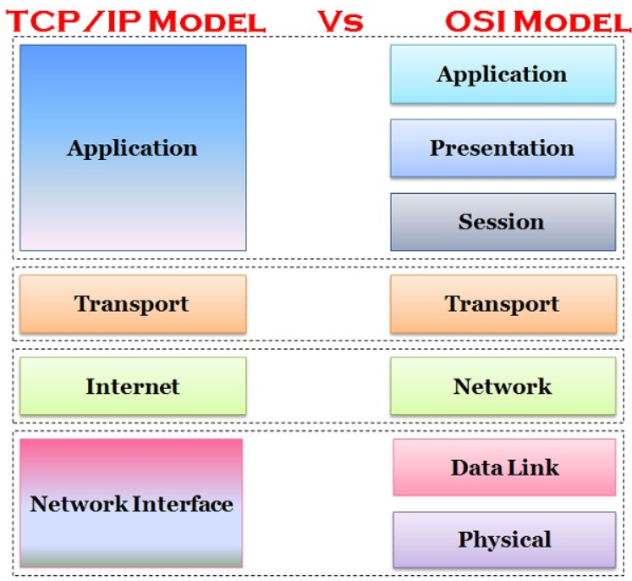
Question 2: Differences between TCP/IP and OSI Model

- TCP/IP model provides standard for the development of internet while OSI model provides guidelines on the mechanism for which communication needs to be done.
- TCP model is based on a client server model for data transmission over the network while OSI model is based on a theoretical model for computing systems (Alani, 2014).
- OSI model is based on four layers, which include application, transport, internet and network interface. On the other hand, OSI model is based on 7 layers, which include application, presentation, session, transport, network, data link and physical layer.
- OSI model is mostly distinguished based on 3 main concepts, which include services, protocols and interfaces, while TCP/ Model is do not have a clear distinction between the 3 concepts.
Question 3:

Host a successfully deliver can use method getData to extract it and performs type conversion to convert array of bytes being transmitted from a message. Importantly, getData method returns the data received from host A to other hosts or the data to be sent to host A or another host. With connection-oriented protocol it provides a guarantee for successful delivery of data to the receiving host. Understandably, TCP protocols receives/ captures the stream of data via rlogin command. In the connection-oriented that applies use of datagram packet, information indicating the data to be sent, its size and IP address for the remote host must be well captured (Mamidala et al., 2007). The connect method is called allow initiating the connection for the sending of the message (data packets) from host A to the destination. The connect method is paramount in this case in connecting the socket to a remote address for the specific socket. Once the socket is connected to a remote address, packets can only be sent or received via that address alone.

If host A tried B and does not responds, it means at there is an issue with the connection socket, which is initiated via the connect method. Notably, the message will be dropped teal the establishment of the connection from the source host (host A) to the destination host (host B) because packets cannot be sent, received or transmitted via the remote address that is not established. It is important to note that the connection must be established and be kept in the routers that performs multi-casting of the packets sent between the hosts. This requires signaling and routing protocols especially when the connection method is established, and both sendData() and receiveData() are ready to perform their respective operations of sending and receiving messages. Once the message id received by host B, which is the destination host, acknowledgement will be sent to host A, and then close ()-method will be initiated. If the connection is not readily available, A will drop the message to the message center host, till the establishment of the connection via the network connection socket. It is worth noting that a sending method/ process is bestowed in creating and sending messages into the network, whereby a receiving process receive such message and responds by sending an acknowledgement receipt. In this case, a process socket is important and checking if the connection is available for the connection to be established or not. With a process socket sends the message can help on sending the message into and receive message from another process in another host. TCP protocol or UDP protocols could be used in the connection-oriented and transmission of messages from source to destination.

References
Alani, M. M. (2014). Guide to OSI and TCP/IP models.
Melnick, J. (2019). Networking Devices Explained. Retrieved from https://blog.netwrix.com/2019/01/08/network-devices-explained/
Mamidala, A. R., Narravula, S., Vishnu, A., Santhanaraman, G., & Panda, D. K. (2007, March). On using connection-oriented vs. connection-less transport for performance and scalability of collective and one-sided operations: trade-offs and impact. In Proceedings of the 12th ACM SIGPLAN symposium on Principles and practice of parallel programming (pp. 46-54).

