Thunderpost Company Network Infrastructure
Name
Institutional Affiliation

Table of Contents
Introduction of the Company 3
Background 3
Business Operation 3
The Network need of the Company 4
Local Area Network Infrastructure of the Company Headquarters-Thunderpost 4
Network Devices 4
Topology 5
Communication Media 5
WAN Network Infrastructure of the company 6
Network Devices 6
Connections 6
Network Services 7
IP Addresses Scheme Using Subnets in the Company’s Headquarters (Ground Floor to Fourth Floor) 7
Detailed Calculations of the IP Subnets 8
Ground Floor Subnetting 8
First Floor 9
Second Floor 10
Third Floor 10
Fourth Floor 11
Description of the Network Software Diagram Software 11
Explanation of the Network Tool Diagram and Screenshots 12
Detailed Network Diagram for the Company Headquarters and all its Stations 13
Network Diagrams 14
Network Architecture For Company’s Headquarters (Five Floors) 14
References 15

Thunderpost Company Network Infrastructure

Introduction of the Company

Background
Thunderpost is a company that deals with different services such as parcel, express mail services, and courier services delivery to national and international destinations. It delivers market value to clients through a combination of excellence method, quality network, and service delivery innovation. The company is known to offer the highest network coverage where all booking is done online where the parcel can be delivered within one to five days and areas within Malaysia enjoy working daily deliveries for affordable rates. The rates are calculated based on the state to state and the weight. The Thunderpost Company manages cost delivery, network operations, and transactions done by the clients, and pick up of the parcels. Owing to a rise in the number of customers, the business began in Malaysia in the 1990s and has grown to have two headquarters branches in West Malaysia, East Malaysia, and Selangor. Apart from the two listed cities, the company operates in a total of 16 locations. Thunderpost headquarters are located in the West Malaysia branch. This paper aims to discuss the overview of networking for Thunderpost limited.

Business Operation
Businesses operation varies daily across the industries to make profits and to increase the value of the business. Thunderpost enterprise offers full support to the branches and remote working stations to allow branches to operate in real-time mode. It ensures that customer signature is present before the product is delivered to the customer to minimize complaints. The organization provides a supply chain management that delivery of goods and parcels from wholesalers to retail directly. The setup of postal services links businesses to customers to engage in communication of time and date the delivery can be processed and how to make payments online. Since different customers have different requirements the company offers multiple pricing packages based on size and delivery speed from which the customer chooses the use of route-optimization and real-time tracking provides efficient packaging delivery. Enterprise reports are done and merged from the branches and transferred to the headquarters. Additionally, the company offers the best services to attract and keep its customers.

The Network need of the Company
The business requires an online network to keep connections and interaction with customers for awareness of any changes of deliveries, promoting goods and services, and responding to consumer questions and concerns. Delivery management platforms have successfully reduced difficulties between companies and customers. The use of a strong communication network has significantly improved the sharing of business services and the ability to keep track of package delivery to the customers. The introduction of these networks to the business has enhanced effective and fast services and products deliveries to the customers globally. Additionally, an expert's involvement accomplishes the exchange of information and ideas of a specific industry. The network will require the customer to enter personal details such as the name, email address, date, and time received the product.

Local Area Network Infrastructure of the Company Headquarters-Thunderpost

Network Devices
Corporate Local area network facilitates communication and data sharing within a company. Hardware and software resources of the entire network empower network connectivity, operation, services, and business management between customers and company headquarters. These network devices prevent data from other different networks and also transmit and receive data fast from computers, printers, and other machines. In order for this company headquarters to connect five floors and branches around the country with a network, it will use devices such as a network router, switch, bridge, gateway, and AP. This connection will ensure effective communication between various network hosts within the headquarters and transferring data from one network to another. After configuring the network, the data will be processed to all connected device ports. A network router is a device that links two local area networks (LANs) and an internet service provider (ISP) to improve signals before sending and receiving data in the form of packets. In LAN, the network is connected to other different networks through the gateway. Notably, the bridge connects two networks by allowing only packets that are needed to the network. Once the data packets are received from the network, they are sent directly to the recipient to checks errors before acknowledging the data. An access point (AP) is a wireless interface that links points between WLANs and Ethernet LANs using network infrastructure. It has several ports that can expand the network to allow additional clients in a company. Additionally, the gateway provides translation between network technologies such as OSI and TCP/IP.

Topology
Network topology involves arranging links and nodes of the network to relate to each other through connection line. To link to the headquarters’ central hub, Thunder will use a bus, ring, and star topology network. Star topology allows direct communication between devices through the hub. Every computer in this network is connected to the switch directly and indirectly to the other network nodes. Data is transmitted over the main cable in a bus topology because all devices are connected to it via a drop line. Additionally, ring topology devices are connected in a network. If the company wants to send data from headquarters to the other branches of the company, the data is sent directly into one direction and if the received data is intended for another device the repeater forwards it until it is received on the intended device. When the company headquarters needs to add another device it will not affect the network.

Communication Media
Communication media in the company gives a path for data, information, and files to be transferred from one headquarters to other branches of the company. They are categorized into two types which are: guided and unguided transmission media. In guided transmission media, data signals are transmitted from source to destination through a cable. A coaxial cable connects a computer antenna with a computer set to transmit data, voice, and video signals of the company with the branches. Fiber optic cables transmit data signals from one point to another using light. Since it is convenient for long distances and fast transmission media, headquarters can communicate and send data to various branches of the company through this media. UTP cable consists of two insulated copper wires that are covered by permanent virtual circuits (PVC) and twisted to reduce electromagnetic inference. It contains high-speed capacity and attenuation to transmit data signals. Additionally, shield twisted pair cable (STP) transmits both data and voice signals. It eliminates crosstalk and performs adequately compared to unshielded twisted pair cable.

WAN Network Infrastructure of the company

Network Devices
A wide area network is geographically distributed to a telecommunication network that interconnects multiple local area networks. In a corporation, WAN can include connections to the company's headquarters and branches for customer service. To link these networks, a core router and Layer3 switch are ideal. Layer 3 switch acts as a switch to connect to devices that are on the same subnet or Virtual LAN to combine functionality between the router with an IP routing. L3 switch supports routing protocols and decisions for incoming packets based on source and destination address. A core router is a router that operates in the internet core that supports multiple telecommunication interfaces at high speed and forwards the packets to a computer host within the network.

Connections
The connection allows devices in a network to communicate, share information and resources. An MPLS connection enables the IP network to run over the Ethernet. The IP router forward packets are based on the label where the MPLS header is sandwiched between the IP header and the LLC header. When the packets arrive in the label switched router (LSR) the header is cross-referenced and packets are switched to the destination output port. ATM connection uses time-division multiplexing (TDM) for data communication. ATM networks are connection-oriented networks for cell relays that support voice and video signals of data. SONET is a transport technology that provides businesses with automatic network recovery caused by fiber optic cables cut or loss of signals. Additionally, X.25 connection defines the protocol of access to packet data subnetwork. It allows the users to establish virtual circuits to send packets to the delivery destination.

Network Services
Internet connectivity in a company allows effective communication between customers and staff. Beyond giving internet access to company internet connection also gives employees access to the business network from remote locations through VPN. A redundant network creates a fast and reliable experience of operations to staff and customers. It puts together the fallback plans in place to ensure that data and hardware are recovered in event of an emergency and the company stays in operation no matter the situation. Additionally, data services such as email, web surfing, and cellular wireless have improved way of communication to customers while at home.

IP Addresses Scheme Using Subnets in the Company’s Headquarters (Ground Floor to Fourth Floor)
The issue of IP address in a computer network is to uniquely identify each device. Assigning of IP addresses can be a cumbersome process is not well looked at. Ideally, IP addressing consists of a network of foundation services, which is paramount in preparing for the network support for cohesive communication within the computer network of the organization under consideration.
Configurations of address scheme is paramount and a critical requirement that facilitate network communication. Moreover, with an address scheme for the company’s headquarter, forwarding of packets is made easier from one location to another. For the purpose of the company’s headquarters and based on the address scheme guidelines, the address structure for this network must be divided into two parts, that is the network ID and host ID. Network ID identifies the network segment to which the host belongs, while hos ID identifies the individual host on specific network segment
As per the whole concept subnet addressing and masking, for the company’s computer network, it is worth noting that it is helpful in handling the challenges associated with overcoming the issue of IP addressing. Additionally, since the company’s network is subjected to growth in the near future, managing such number of hosts might become enormous task. For instance, if the company’s network address scheme can support up large number of hosts in the three computer network classes
The global IPV4 address consist of two main parts, which include Subnet ID and Interface ID, which forms part of networking computation. Based on a unicast address, it captures a single interface. Additionally, the packets being addressed to unicast addresses are delivered via a specific network interface. The network architecture of Thunderpost Company can be explained further using the following subnetting information.

Detailed Calculations of the IP Subnets

Ground Floor Subnetting
This network is in class A and it covers Ground floor of the main building in the Company’s headquarter. The details below represent the description of subnetting within the ground floor of Thunderpost Company at the headquarters branch.
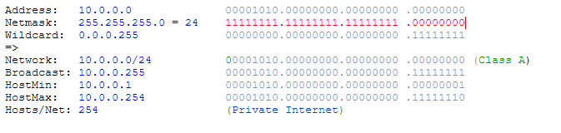

First Floor
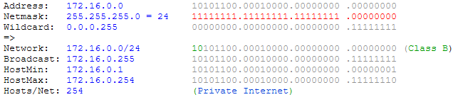
The network addressing in the first floor follows within class B of computer networks. The primary assigned IP Address is 172.16.0.0. The whole concept of subnetting can be described as shown in the screenshot below.

Second Floor
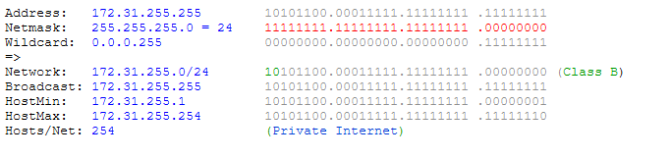
From the subnetting of second floor, the computer network falls in class B with the assigned IP Address of 172.31.255.255. In this floor, the connection will span several rooms with several computer devices linked together. The table below represent the whole scenario of subnetting.

.

Third Floor
In the third floor, there is interconnection of several devices in several rooms that are in this floor. The primary IP address is 192.168.0.0, which is in class B of the computer network. The table below represents an overview of subnetting within this floor of Thunderpost Company, which is based on the calculation
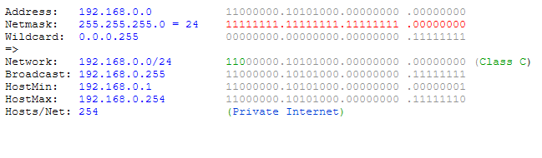

Fourth Floor
This network is in class Based on the network architecture of Thunderpost Company The fourth floor is the last floor that is owned by the company, where various operations for the company are undertaken. This floor has some offices which are interconnected using computer networks to facilitate communication and other. Just like other floors that we have discussed, the main network connection to this from will be from the edge router/ access point, which will supply network connections to other rooms of the building. IP address for the edge router as far as subnetting calculations are done is 192.168.255.255The whole computation of subnetting can be described as shown in the screenshot below.
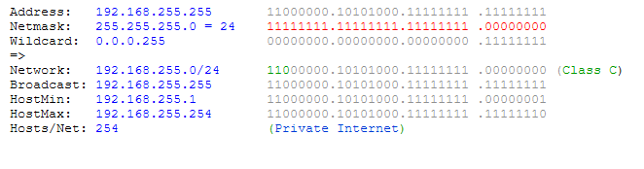

Description of the Network Software Diagram Software
In this assignment, the network diagram tool used is Visual Paradigm, which consist of various tools that can be used to draw network diagram. Such tools include ring bus topology used firewall tool, webserver, router, switch, bridge, gateway, hub, wireless modem, among others. The tool also have an option to import other symbols for incorporating in the network diagrams network or internet, work stations, clients, or nodes, servers, routers, among others.
Explanation of the Network Tool Diagram and Screenshots
For the purposes of drawing network diagrams for Thunderpost, Visual Paradigm tool was used. Visual paradigm is an online tool for creating an impressive suite of lightweight diagram tools that provides support for wide range of visualization needs. The following steps were used in creating network diagram using Visual Paradigm.
- Register an online visual paradigm account
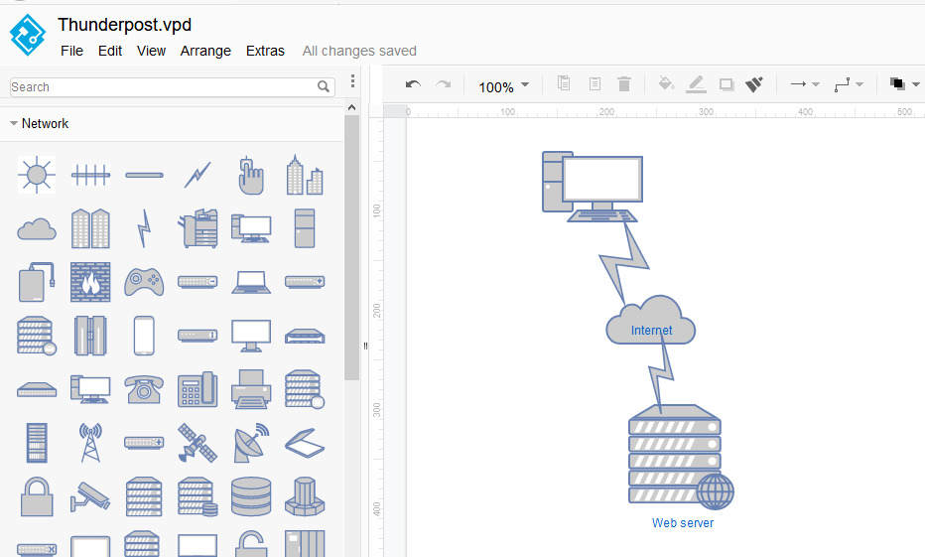
- Select network diagram option and identify the appropriate tools to use when drawing network diagram as shown below.

- After drawing the wholde diagram, save your diagram in any of the available location such as VP Online, Google Drive, Device, or Browser.

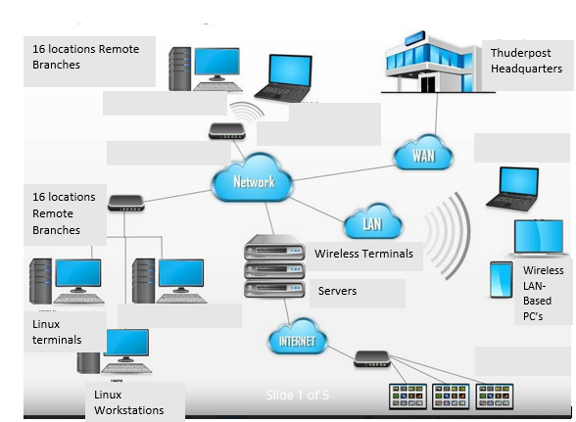
Detailed Network Diagram for the Company Headquarters and all its Stations

Network Diagrams

Network Architecture For Company’s Headquarters (Five Floors)
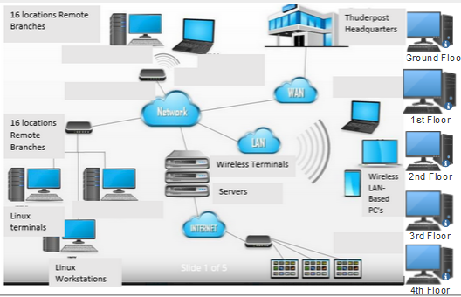

.

References
Bolun, I., & Ciumac, A. (2002). Configuration of local area network set of servers. Computer Science Journal of Moldova, 10(2), 29.
Bordetsky, A., Thiry, J., & Johnson, S. (2005). Concept of Deployable Network Operations Center (DNOC). NAVAL POSTGRADUATE SCHOOL MONTEREY CA DEPT OF INFORMATIONAL SCIENCES.
Saha, D., Mukherjee, A., & Bandyopadhyay, S. (2011). Networking infrastructure for pervasive computing: enabling technologies and systems. Springer Science & Business Media.
Saravanan, K., Anusuya, E., & Kumar, R. (2018). Real-time water quality monitoring using Internet of Things in SCADA. Environmental monitoring and assessment, 190(9), 1-16.
Sisat, S. N., Bhopale, P. S., & Barbudhe, V. K. (2012). IP Subnetting. International Journal of Electronics, Communication and Soft Computing Science & Engineering (IJECSCSE), 2(5), 5.

