National Gallery Incident-Forensic Investigation
Name
Institutional Affiliation

National Gallery Incident-Forensic Investigation
Overview of the Scenario
Based on the 2012 Nationally Gallery DC Scenario, which revolves around an employee of the National Gallery DC Art Gallery. Tracy who works as supervisor at National Gallery is an acquaintance of Carry. In the process there is money transfer between Carry and Terry, which becomes suspicious, especially on the issue of items transferred, though not outright illegal The whole scenario depict the criminal plans for both theft and despoilment, and this attracts performing investigation
Introduction
Forensic extraction and evidence examination on the mobile device may differ on each mobile device. Nevertheless, with a consistent examination process to be followed will be critical in assisting the examiner and ensuring the evidence extracted from each phone is well documented and that the outcomes are repeatable and defendable. Ideally, there is no well-established standards process that is meant for mobile forensics (Phillips et al., 2013). Nevertheless, mobile phone evidence extraction process can follow various defined steps, which include intake, identification, preparation, isolation, processing, verification, documentation/ reporting, presentation, and archiving. All methods applied in the data extraction from the mobile devices should be properly validated as well as documented. In this assignment, it aims at extracting evidence from Carry’s Phone through a forensic image of the Samsung GSM GT-I9020a Nexus S (Android) that was collected on 13th January, 2016.
Based on the evidence intake phase this involves request forms and paperwork in documenting ownership information and the kind of incident that mobile device was involved in, and outlining the type of data the requester is looking for. . Additionally, developing specific objectives of the preliminary evidence extracted from Carry’s phone must take place. Such details that are part of the incidences revolves around Samsung mobile phone, which is Nexus 5, which uses Android 2.3.4. In the identification phase forensic examiner should focus on identifying the following details of examination of the mobile device, which include: the legal authority-in this case the forensic expert, examination goals, removal and external storage, and other potential evidence sources.
Forensic Methodology
The forensic investigation adopted digital forensic analysis methodology. Digital forensic analysis methodology is an approach that apply scientifically derived and proven approaches in the preservation, collection, validation, identifying, analyzing, documenting, and presenting digital evidence deduced from the digital sources with the aim of furthering the reconstruction of events found to be crime-related. Understandably, digital forensic analysis methodology is based on various key elements, which include the use of scientific methods, collection and preservation of data and digital evidence, validation, identification, analysis and interpretation, and documentation and presentation (Delp et al., 2009). Based on this methodology, its process overview comprises of various steps, which include obtaining and imaging forensic data, forensic investigation, preparation/ extraction, identification, analysis, forensic reporting, and case level analysis. Based on the case under consideration, the investigator and forensic examiner must decide how much of the process is to be completed in every stage. Ideally, the whole process is iterative in nature hence the investigator and examiner must put this into consideration and decide how many times to repeat this process.
Types of Evidences Files Provided
Generally, in mobile forensics process steps that are important in obtaining different types of evidence. Based on the scenario in hand, the three main steps that are highly important include seizure; in this case, digital. Forensics operates on the principle that the evidence should be adequately preserved, processed and admissible (Catanese et al., 2013). Regarding the types of mobile forensics to be considered in this scenario, the following parameters will be used:
- Assessing the type of the phone (Make, Model, and Manufacture)
- Analyzing the operating system of the mobile device
- Assessing the encryption level of the device
- Assessing the availability of passcode/ pin code/ pattern
Based on the manual way of starting off with the forensic, the device must be browsed manually by forensic expert. The data on the phone can be directly seen or retrieved. This is a quick method since the examiner is well aware on the type of data to browse (Curran et al., 2012). Another approach is known as logical approach, which is a quick way of evidence extraction from the user files. In this case, data is extracted from flash memory. Other types of evidence that can be extracted can be derived from the file system of operating system-Android. Since it is the operating system that stores information relating to deleted files within the file system, the application of Digital forensic tool such as Autospy can be helpful in this case.
Description of the Analysis of Each Type of file
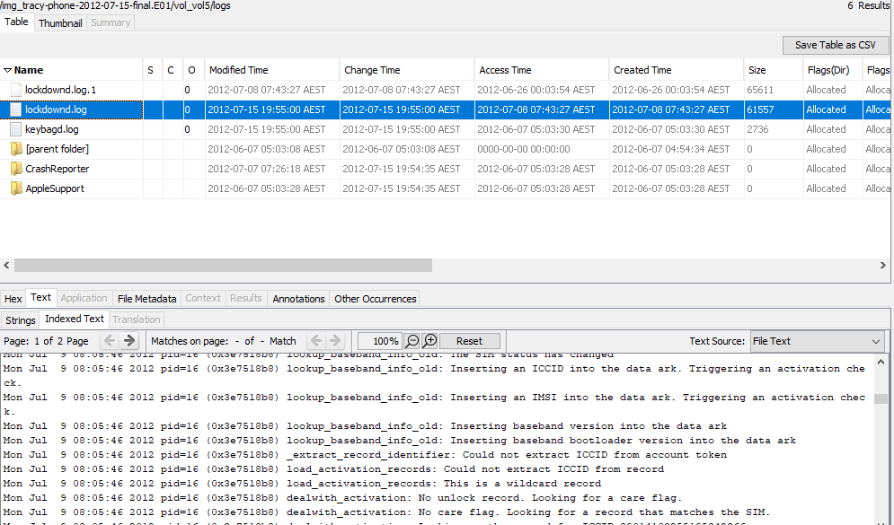
This assignment involves analysis of different fines that could provide evidence on the criminal liability of the suspects, who are Alex, Carry, and Terry. Additionally the analysis involves assessing image files for the Samsung GSM GT-I9020a. Some of the files assessed include email file with email conversation, images files, network traffic file, and various log files. Below is a PCAP log file which provides packet over the network.
Figure 1.
The above file has been captured using Autospy application and it searches for record identifies and data packets
Below is additional PCAP file that analyze packet, which indeed is meant to show communication between different devices. As per now there is no evidence presented of any criminal operations or communication between Terry, Alex, Carry, among others

Figure 2
Email Addresses and Associated Passwords
In assessing email addresses used to do any communication between different participants, log files and email conversation must be assessed. This is critical in assessing email used in any communication. Assessing email log files play a critical role in analyzing any conversation between any parties. This section will be analyzed using both Autospy and Wireshark.

Tracy Phone Analysis
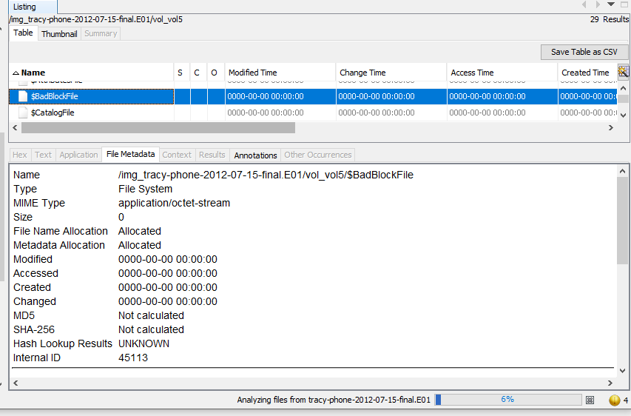
The analysis below based on the file system of Android operating system of the Samsung phone. This file is ran for investigation purposes and check on the status and type of file system. The screenshot below provides an overview on the same
Figure 3
User Pat
Pat is Tracy’s bother based on the description given, and he is subject in this investigation. Even though he is not considered as an outright criminal, the details provided affirm that he walks the line so closely. Based on this analysis, the kind of information regarding Pat as retrieved via Autospy does not show any criminal liability. This can be affirmed through the files retrieved such as Noise_Impact_Assessment_Spreadsheet.xls, BusinessPro.xls, among others. The diagram below present the analysis carried out.
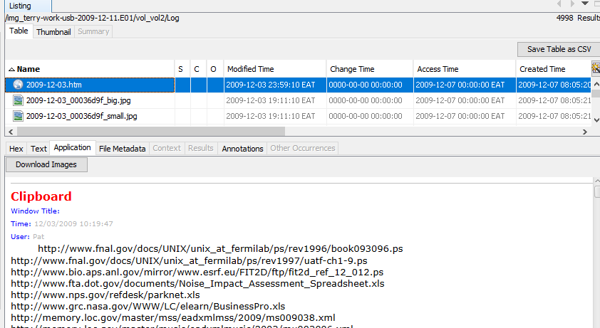
Figure 4

References
Catanese, S., Ferrara, E., & Fiumara, G. (2013). Forensic analysis of phone call networks. Social Network Analysis and Mining, 3(1), 15-33.
Curran, K., Robinson, A., Peacocke, S., & Cassidy, S. (2012). Mobile phone forensic analysis. In Crime Prevention Technologies and Applications for Advancing Criminal Investigation (pp. 250-262). IGI Global.
Delp, E., Memon, N., & Wu, M. (2009). Digital forensics. IEEE Signal Processing Magazine, 26(2), 14-15.
Phillips, A., Godfrey, R., Steuart, C., & Brown, C. (2013). E-discovery: an introduction to digital evidence. Cengage Learning.

