MS Project Analysis Part A
Name
Institutional Affiliation

MS Project Analysis Part A
Based on the proposed online store project, the question on whether the project will be completed in time can be easily be identified by determining the length of the project. Chris Johnson who is a new CEO can easily understand this by looking at MS project files, and assess the critical path, which comprises of a series of tasks that show the finish date of the project. In this project, the project finish date 17th April 2019. This date highlighted here is based on a number of assumptions made when creating Ms Project File, such as the project start date, among others.
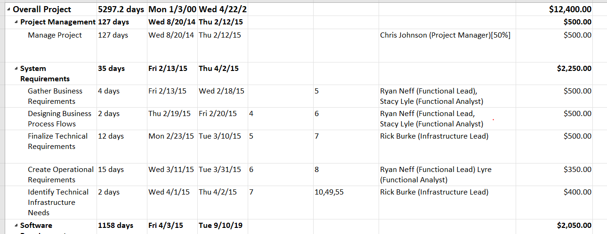
Regarding the total cost for the implementation of this project, as per MS Project Management Tool and based on the assumptions made for this project, the total cost is $812,400 as shown on the screenshot below. The total cost that goes to capital is assumed to be 10% and for labor 8%. Therefore, total cost on capital will be $1240, and for labor is $9,920

On the question of how to manage the level of risk on this project, this would entail first of all identifying the potential risks, then secondly determine the probability that such risk(s) will occur, determining its impact, and lastly devising strategies for mitigating such risks. Lastly, pertaining my opinion on whether this project will be completed on time, yes there is high potential and likelihood looking at the critical paths, there are no activities appearing to cause delays for such project completion.

References
Bonnie, E. (2018 November, 5). Project Assessment (Ultimate Guide to Project Risk, Part 1. Retrieved from https://www.wrike.com/blog/ultimate-guide-to-project-risk-part-1-risk-assessment/

