LexAR Mobile-Based Application
Student’s Name
Institutional Affiliation

Table of Contents
Abstract 3
Introduction 3
Design 4
Agile Design Methodology Architectural Pattern 4
Description of Diagrams 5
Class diagram 5
Package Diagram 6
Interaction Diagram 7
Development 8
Development Tools and Programming Languages 9
Testing Techniques 10
Discussion/ Reflection 10
References 12

Abstract
Multilingual translation of terminologies is important especially in the interaction of people with diverse linguistic backgrounds. Similarly, translation of English to Arabic terms and vice versa is paramount. Terminological terms for the Arabic language are difficult to understand and transfer them to other languages as there are no extensive encyclopaedia, dictionary or systems to translate from one language to another. In this paper, the idea id to design and develop LexAR mobile-based application that would facilitate translation of terms from English to Arabic and vise versa, thus facilitating the communication between people from the two linguistic backgrounds. In the development of this software application, the software development methodology to be adopted will be agile. This project provide in details the design of class diagrams, interface diagrams and interactions diagrams to facilitate the development of this system. This paper also provides a discussion/ reflection of the problems/ challenges involved in the design and development of this system.

Introduction
The design and implementation of LexAR mobile-based application will serve as a great deal in facilitating the translation of Arabic terminologies. Ideally, such a system makes it easier to learn and communicate to people with English and Arabic linguistic background. Baydan (2016) argues that translation of terms is regarded as interdisciplinary that is closely associated to other disciplines like linguistics, which results to contact zones between people from different cultures. The main objective of this paper is to capture the design and development of LexAR system to help in breaking down of the terminological terms and translating them in Arabic. In this paper, design of LexAR system with functionalities such as creation and entry, advance search of dictionary entries, inclusion of semantic attributes, and exchange facilities will be achieved. Importantly, this paper discusses the application of agile and object-oriented methodology in the implementation of LexAR mobile-based application.

Design
Design involves designing system elements such as modules architecture, interactions components and their interfaces. Ideally, system design comprises of the basic architecture, modules and interfaces to be implemented by the development team (Fleming, 2016). The chosen software analysis and design methodology in the design and development of LexAR system is agile methodology which is based on the four values, which include individuals and interactions, working software, customer collaboration, and responsiveness to changes. The reason for choosing agile in this case is due to its ability to enhance collaboration among the development team and ensuring a speedy development approach in software development. Additionally, with agile development the idea is to focus on detailed design and development paying close attention to the systems requirements.

Agile Design Methodology Architectural Pattern
Agile being an iterative method, people-oriented and time-boxed approach focuses software delivery that aims at building software incrementally from the beginning of a project rather than delivering it at the end of the project. Additionally, this methodology is aligned with the values and principles as demonstrated in Agile Manifesto for Software Development. As per this principle, requirements, plans, and results are evaluated constantly; teams have natural approach for responding to changes quicky (Will, 2016). The rationale for adopting agile methodology in development of LexAR mobile-based application is because it focuses on the customer and result. Moreover, in agile methodology customers are always in the whole process for them to get updates for their products and ensure that they have met all the requirements. The diagram below shows the architectural pattern in the application of Agile methodology in the design and development of LexAR mobile-based application .
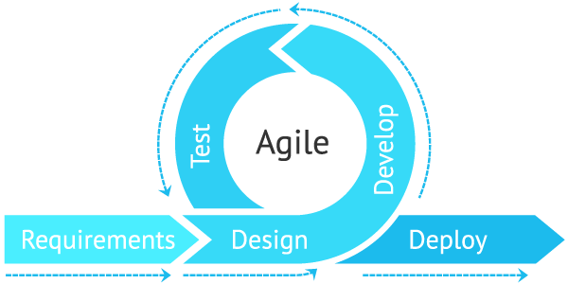

Figure 1: Agile Methodology Architectural Pattern.

Description of Diagrams

Class diagram
Class diagrams forms part of the object-oriented modelling building block. It is applied for general conceptual modelling of the application structure. In the case of implementation of LexAR mobile-based application , modelling of class diagram involves 6 main classes with their respective attributes, which provide different associations. Such classes include voluntee

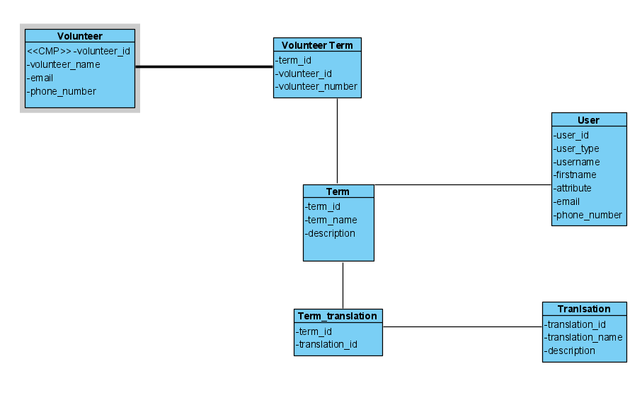
Figure 2: Class Diagram

Package Diagram
Package diagrams are meant to provide description of hierarchical relationships between different packages or objects within a system. With a package diagram, it is easier to simplify complex class diagram into packages. The diagram below represents package diagram for the implementation of LexAR mobile-based application .
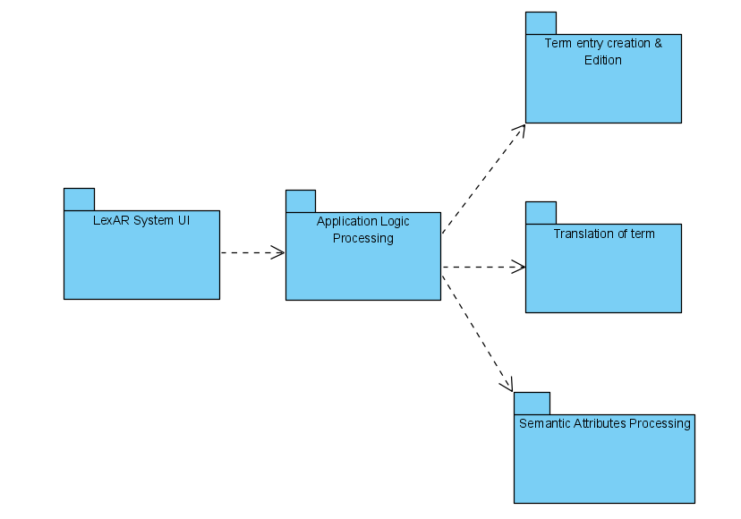
Figure 3: Package Diagram

Interaction Diagram
Interaction diagrams are used to show how one or more objects are applied to communicate with each other. With interaction diagrams, the idea is to dynamic nature of a system by depicting the context of interactions between two or more lifelines within a system. The diagram below represents interaction diagram in the implementation of LexAR mobile-based application .

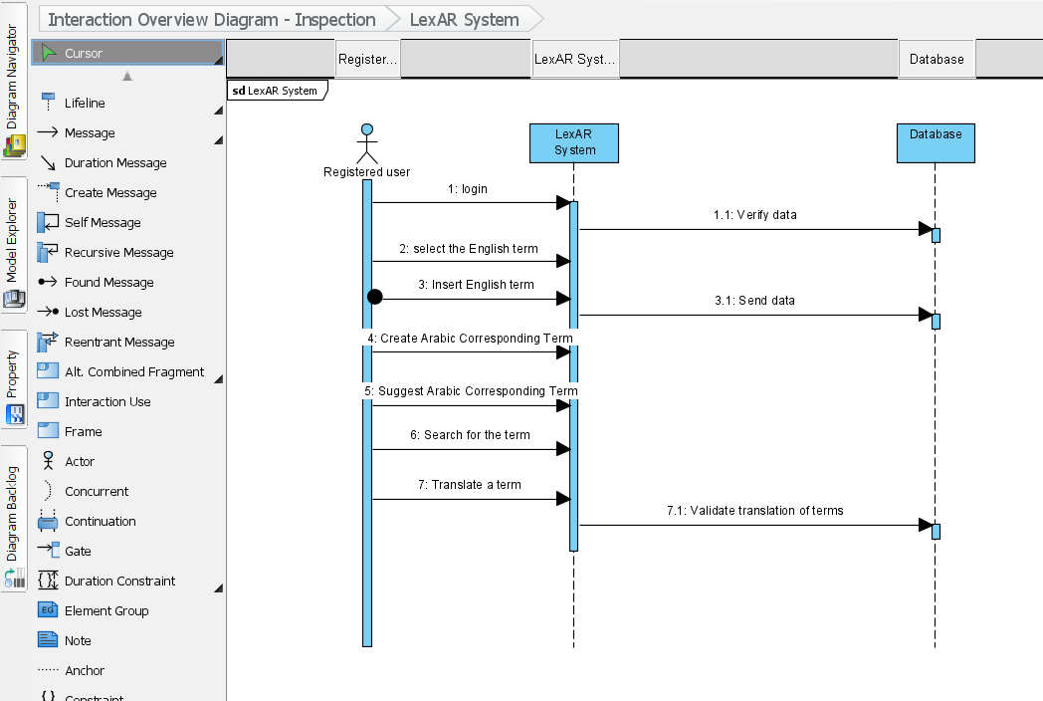

Development
Software development encompasses set of computer-based activities relating to the process of creating, designing, deploying and proving support to the software. With Agile software development, it is geared towards the concept of iterative development where requirements keep on evolving via collaboration between cross-functional teams. Development and implementation of LexAR system is solely based on Agile Software development methodology. Development of LexAR system will be done in stages before delivering the final product.
Agile software development methodology put emphasis on the four main core values, as outlined below.
- Interaction between individual and software development team over tools and processes.
- Working software over comprehensive system’s documentations.
- Customer collaboration over negotiation of contract.
- Response to change over following specified plan.

Development Tools and Programming Languages
In terms of the tools required to complete the development of this software, they include Lexicala Mobile API, Laravel framework, MariaDB, and Ubuntu 16.04. With Lexicala Mobile API, its purpose is to provide access to dictionaries quality for cross-multilingual data resources. Notably, this API will help in facilitating flexible search options and returns through JSON responses. This will be crucial in featuring the semantic information from the database thus allowing easier and quick translations of terms via the system. For the Laravel framework, the reason for its choice is because of the ability to integrate with tools for making mobile application to be faster. Authentication and authorization systems, integration with mailing services, and ease of fixing common and technical vulnerabilities. MariaDB in the development of LexAR system is because of its advancement features from MYSQL such as better storage engines and its ability to handle big data. Since the goal is to use Linux-based server to host LexAR mobile system for security reasons, Ubuntu 16.04 will be best suited to achieve this as it is consistent OS across all the platforms. Arguably, the greatest advantage of developing with Ubuntu is that it allows users to work with the same underlying operating system via their desktop as they do in their servers. Other advantages of developing with Ubuntu extensive support from canonical, availability of essential packages for free, among others. The suitable programming languages include Swift programming language, PHP 7.3 and above, JavaScript, Python, CSS, and HTML5.

Testing Techniques
Software testing is a process of investigating and evaluating the functionality software application with an intention of ensuring no bugs are available and that the software has been developed as per user’s requirements. Since the development of LexAR will be based on the application of agile software development methodology, which is incremental, testing will take similar approach. Ideally, LexAR system will be tested using four main testing levels i.e. unit testing to test whether individual modules are working accordingly, integration testing will be done by integrating different software modules and testing if they are working accordingly. System testing is the third level of software testing to be undertaken in LexAR system, which will look at the whole system from end to end to ensure that the whole applin works as intended. Lastly, acceptance testing will be geared towards to obtain customer sign-off by approving the developed system.

Discussion/ Reflection
In the design and development of LexAR mobile-based application , basically there are several problems involved including taking time to learn on integration of Lexicala Mobile API to integrate into the system, how to code using various programming languages like Swift. Additionally, developing the whole system required a lot of research on implementation of different functionalities such as term translation, among others. Another challenge is relating to the project timeline, development of this application required to be implemented within a tight project deadline. Due to this, the system would require to be upgraded in future and have advanced features due to the advancement in technology.
Design and development of LexAR mobile-based application requires software security aspects considerations to ensure the information of the users who have registered with the system remains secure and protected. Security implementation like cryptographic techniques, two-factor authentication, and encryption algorithms are necessary. However, implementation of these and more security techniques is a real challenge that requires extensive research and timeline. Undoubtedly, software development is always vulnerable to attacks due to increase in complexity (Ahmed, 2007). Before completing this project, there are some areas that the development and project team need to study to solve some of these challenges. Such areas include integration of Lexicala Mobile API in Swift development. Other areas include implementation of software security and interface design principles to ensure development of user-friendly application.

References
Ahmed, S. R. (2007). Secure Software Development: Identification of Security Activities and Their Integration in Software Development Lifecycle.
Baydan, E. B. (2016). Translating terms and concepts in the texts of translation studies. International Journal of Comparative Literature and Translation Studies, 4(2), 18-23.
Fleming, I. (2016). Defining software quality characteristics to facilitate software quality control and software process improvement. In Software Quality Assurance (pp. 47-61). Morgan Kaufmann.
Will, B. (2016). Agile Assessments – How to Assess and Evaluate Agile / Scrum Projects. Retrieved from https://www.linkedin.com/pulse/agile-assessments-how-assess-evaluate-scrum-projects-brian-will

