Heathwick Airport Construction Project
Student’s Name
Institutional Affiliation

Table of Contents
Project Details 3
Introduction 3
Mission Statement 4
Relationship and Role of Each Stakeholders 4
Resource Scheduling and Costs 4
Project Controls 7
References 9
Appendices 10

Heathwick Airport Construction Project

Project Details

Introduction
A radical plan regarding the construction of new Heathwick airport hub, featuring 5 billion pounds, high-speed railway line between Heathrow and Gatwick has been considered to be a key agenda for implementation. The idea of this airport was put forward by as a way to the politically inedible expansion of Heathwick after being examined by the minister who were under pressure to increase the capacity of the airport. With the expansion of this airport, the goal is to increase the capacity of the airport. This proposal is believed to increase the capacity around London and other nearby areas. In this paper, the goal is to provide comprehensive requirements for this project from the project management point of view, resource scheduling and costs, project controls, among other issues.
The structure of the whole project is based on the original scheme presented at public enquiry, which envisaged the construction of a core terminal block 40 metres (130 feet) high (1,300 feet) long and 176 metres (575 feet). The terminal master plan consist of hierarchy of elements which are geared towards providing flexibility, thus facilitating the construction of the building and airport with the aim of responding to changes in requirement and making adjustments to include information in a dynamic planning process. Additionally, the construction of the proposed airport construction will start with complying with the general construction conditions, long lead procurements of items that will be used in the construction process, mobilization of site, sit e grading and utilities, building foundation for the construction and expansion of the airport to kick start (CAPA, 2019). Other work to be involved in this construction of the airport project will include masonry work, roofing, plumbing, airport lane preparations and marking, division of terminals, building emergency centers, and finally completing final inspections of the project.

Mission Statement
The mission key mission of this project is to apply project management techniques in the construction and expansion of the proposed Heathrow airport with the aim of giving passengers the best airport service in the world.

Relationship and Role of Each Stakeholders
Construction of this project will involve various stakeholders, who will include relevant government agencies, who will facilitate for the construction in terms of the finances. Another key stakeholder will be ministry of construction and public works, who will ensure that the construction meets the required threshold. Additionally, Turner Construction Co is the firm given contract to construct and do expansion of the proposed airport. Lastly, ministry of health will be involved in ensuring that health guidelines have been preserved such as ensuring that no pollution of emission during the construction process (Turner, 2016). Turner Construction Co being the key in the construction of this project, will have the project manager taking the lead, construction engineer, site surveyor, among other personnel. All the stakeholders highlighted in the above section will have a direct relationship in ensuring that the construction Heathwick Airport has been completed promptly.

Resource Scheduling and Costs
Resource scheduling is key in determining when work elements are to be completed, milestones achieved, and completion of the whole project. Ideally, the budget is also key in determining how much each element should cost as well as the cost of each level of the WBS and the total cost of the project. The estimated cost for the construction of Heathrow airport is £ 2.8 billion. This cost include purchasing of the adequate space for the construction, procurement of the construction materials for the building as well as for the port, labour costs, construction of airport signage, parking lot, installation of visual system, perimeter fencing, improvement of runaway safety area, security access systems.
The table below presents overview of cost breakdown for the construction and expansion of the proposed airport.
Cost Item | Amount | Expected Duration
Land Purchase | £ 800 million | 4 weeks
Procurement of construction materials | £ 250 million | 3 weeks
Construction of airport signage | £ 150 million | 8 weeks
Construction of the parking lot | £ 50 million | 6 weeks
Construction of the waiting room (terminal) | £ 150 million | 8 weeks
Installation of the visual system | £ 150 million | 4 weeks
Perimeter fencing | £50 million | 4 weeks
Construction of runaway safety area | £ 148 million | 7 weeks
Installation of security access systems | £ 60 million | 6 weeks
Demarcation of airplane lanes | £ 2 million | 2 weeks
Labour cost | £ 300 million | n/a
Miscellaneous Expense | £ 200 million | n/a
Total | £ 2 Billion | 52 Weeks
The above table present resource scheduling in terms of the budget and duration that each will take to complete the construction process. Below is the Work Breakdown Structure (WBS) for the construction of Hethwick Airport
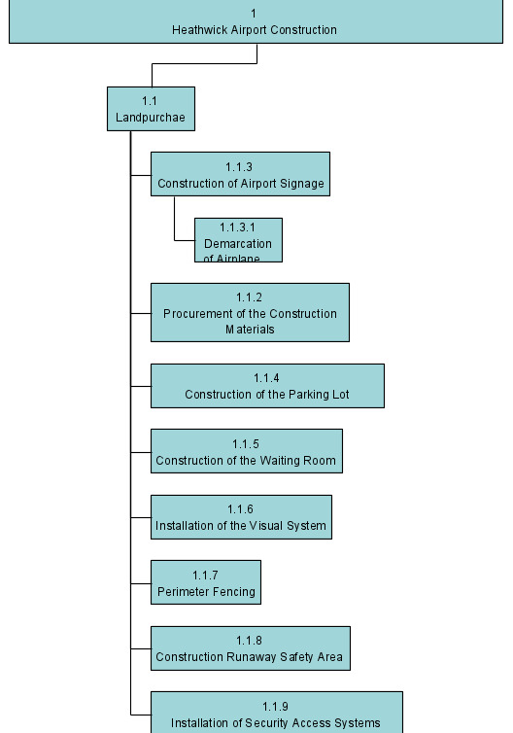

Project Controls
In managing and controlling the construction projects, especially airport construction, there are a lot of challenges involved. Consequently, various bodies are also interested in ensuring that safety and construction procedures have been followed up promptly (Alnasseri, 2015). For the case of the construction of Heathwick airport, there are various controls that must be put in place to ensure the success of this project. The project controls put in place, must be geared towards ensuring there are comprehensive project management strategies as well as human-related competencies in the implementation process. Ideally, the construction works play a paramount role in the economic development; therefore, the whole process must be completed in an effective and efficient way.
In ensuring the proper management and control of this project, the roles and responsibilities of each project team must be well defined to ensure the project will be completed and controlled accordingly. In this case, the project manager will be the lead in this project, especially in planning, executing, controlling and controlling of the projects. Additionally, other team members will report directly to the project manager, who will be responsible in handling of ensures, and ensuring that the available resources have been allocated accordingly. Other stakeholders such as construction engineer, site surveyor, civil engineer, will report direct to the project manager. Construction engineer will be responsible in managing and of this construct project by carefully inspecting all the drawings of the airport construction. Civil engineer will be responsible planning, designing, and overseeing construction, and maintenance of the airport structures. Finally, site surveyor will be solely responsible in measuring land features and examining land records. Additionally, site surveyor will be responsible in preparing the maps and related records.
The construction will undergo and approved by the quality assurance department, to ensure that quality procedures have been followed to the latter. Quality assurance by approved bodies will be responsible in ensuring that all the required standards and compliances have been followed, and no environmental issues exist. The whole project will comply airport construction standard (AC150/5370-10). Based on the Cost Benefit analysis (CBA), it is worthwhile to undertake as it have financial implications. It is anticipated that the project will payback its initial cost outlay in 5 year; hence feasible.
The introduction of this project will bring about change in terms of the product under consideration. Quality of work will be guaranteed because in each month, walkthrough testing will be done and quality analysis by the qualified personnel and government agencies. In terms of project risks, it is important to note that every project is associated with the risks, in this project the key risk is financial risk committed to this project. The budget for the implementation of this project might end up changing due to the prevailing market conditions in terms of materials and other unforeseeable events.

References
Alnasseri, N. (2015). Managing and controlling airport construction projects: a strategic management framework for operators (Doctoral dissertation, Northumbria University).
Turner, T. (2016). Heathrow Airport Expansion, London. Retrieved from https://www.turnerandtownsend.com/en/projects/heathrow-airport-expansion-london/
Mahamood, T. A., & Waghmare, A. P. (2019). Construction Planning and Management of Airport: A Case Study of Purandar Airport.`
CAPA (2019 December, 6). Airport Construction: Overall Expenditure on New Existing Airports is not Increasing. Retrieving from https://centreforaviation.com/analysis/airline-leader/airport-construction-overall-expenditure-on-new-and-existing-airports-is-not-increasing-503759

Appendices
The expansion and construction of Heathwick airport will be a great deal in increasing the capacity. Additionally, this construction is deemed important in bringing the connectivity, trade and movement of people who are considered to be the cornerstone for business. To ensure successful completion of the construction process, Heathwick airport management will appoint Turner and Townsend Company, to complete the whole process. This company is also meant to provide strategic support for Heathwick in its expansion and construction. The primary goal goal in the project management of this initiative is to ensure that this programme achieve quality and cost management in this project. The costing of this project has been achieved using complex cost estimation modelling technique and balance in ensuring that Heathwick achieves the right balance and best outcomes from this project. Additionally, the contractor is keen in helping Heathwick to achieve its strategic objectives. Having implemented several other projects that are similar to this one in many years, it has been noted

