DATABASE ADMINISTRATION ASSIGNMENT
Student’s Name

Class Name
Professor’s Name
Institutional Affiliation
City and State
Date

Database Administration Assignment
- Client-Server Environment in a Hypermarket
The database in a client-server environment involves a distributed application structure that divides tasks between the providers of the resources known as servers and the requesters of the services known as clients. With the client-server architecture sharing of the data processing chores between the server, usually a high-end workstation and a client, which is usually personal computers. In this kind of environment, the applications programs are stored, and execution is done on personal computers. Additionally, network traffic is minimized the data manipulation operations and requests from the computer to the database server, and what is returned as a result of this request is the raw data. The client-server environment in a hypermarket is not that different from other environments. On the client’s side, the applications run on the computers, depend on the servers for file execution, devices, as well as processing power. From the server end, it comprises of high-end workstations that process and manage the network resources within this environment.
When establishing a connection between a database server and the clients within the client-server environment in a hypermarket, there are several processes that must be followed to the latter. First, it requires setting up the computers that will act as clients and then the one that will act as a server. The role of the client machine within this environment is an interface for allowing computer users to request for services such as scanning the products via the barcode reader, generating receipts, allow modifications of the product items, feeding the codes of the products to the database, among others (Özsu and Valduriez, 2014, p.2-4). All computers acting as clients within the hypermarket requires to have a network, which must be installed to facilitate the communication or requesting of services from the database server. Additionally, client machines require to have a Point of Sale (POS), which needs to be configured in all the computers serving as clients. Clients are located on personal computers. From the database server end, it must be set up in very powerful workstations, which can process the requests of all the client computers within the hypermarket environment. The database server will have the application(s) that will control the client's computers. With roles such as processing and storing the barcodes of the products, allowing modifications of the products, creating, and deleting the products, among other important operations.
Having a clear understanding of important concepts that revolve around the connection between the client and clients and database servers within the hypermarket environment, it is important to note that various operations occur when the clients pick up the products from the shelves to the counter to purchase the product. The first operation that is involved after presenting the product to the counter is scanning of the product via the barcode reader. Barcodes of all items are stored in the database server; therefore, when scanning the products via the barcode reader, the client computer must request for the code from the server to be availed, which is stored together with the details of the products purchased by the customer. Once the products purchased by the customer have been fetched by the client form the database server, the client computer generates the receipt, when such action has been triggered. The database server, which is centralized in nature, communicates with the terminals whenever information of the items is requested.
In hypermarket data processing, a client computer can be running an application program for scanning the details of the products, while the database server or server computer manages the information that is permanently stored. Different client computers can access the server's information concurrently, and at the same time, the client can perform other operations such as sending the product details, emails, etc. With the client computers within the hypermarket, if one fails to work at the time of purchase, the next available client computer can be used because the product details are never stored in the database server. However, if the database server where all information on the products is stored fails to work, at the time of purchasing the product, purchasing of the products may fail since the client's computers do not have any processing power.
In the client-server architecture, the existence of the network is critical in ensuring that the communication between the client and the database server within the hypermarket is enhanced. The client computer can request for any service to be availed via the network, and then the server will either grant the request or decline such requests. Importantly, the database server allows creation, altering, inserting, updating, deletion, and retrieval of the product information—for instance, all the products purchased by the customers via the counters within a certain period of time. Additionally, the database server through the database administrator in a hypermarket is the one bestowed with manipulation of the products that are available in the database. All the information about the sales made, products sold, and all the items in the hypermarket are stored in the database server. In simple terms, the role of the client’s computers and the database server is separated from each other, and clients' computers can only request for the services, while the server is meant to process such requests. The client server architecture allows inter-process communication in the network.
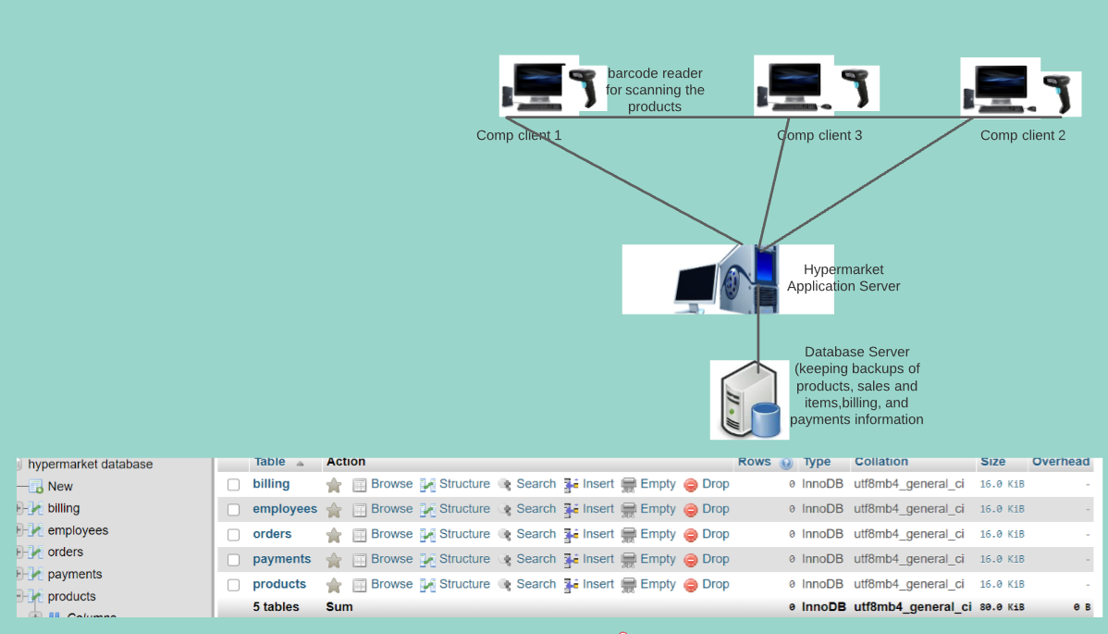
The connection established between the client and server uses SQL connection in the hypermarket environment. In this case, client application allows client computers to connect to an instance of SQL server on the network. The client is known the services offered by the SQL server database engine. Notably, client connect to one or more remote servers over a computer network. SQL server include the use the command SQL command prompt utility, and clients written to database library. In terms of SQL Server configuration manager in the hypermarket environment, it is used to manage both client and server network components. It combines SQL Server Network utility, service manager and SQL Server Client utility. Such components are useful in establish the link or connection between the client application and the server. The database server setup requires installing the required components on the client machine, then individual network can be enabled or disabled when setting up has been started or during setup from the command prompt. The SQL client-server architecture is paramount in allowing management of multiple clients and server within the network. Client-server architecture in a hypermarket scenario can be represented using the diagram below.
The code for the main database tables can be represented as shown below
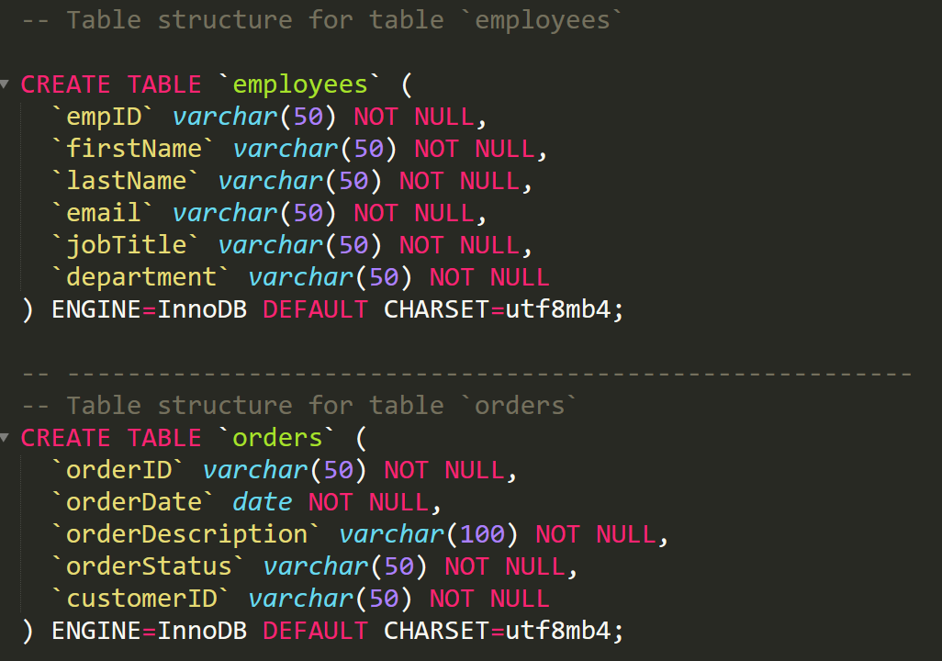
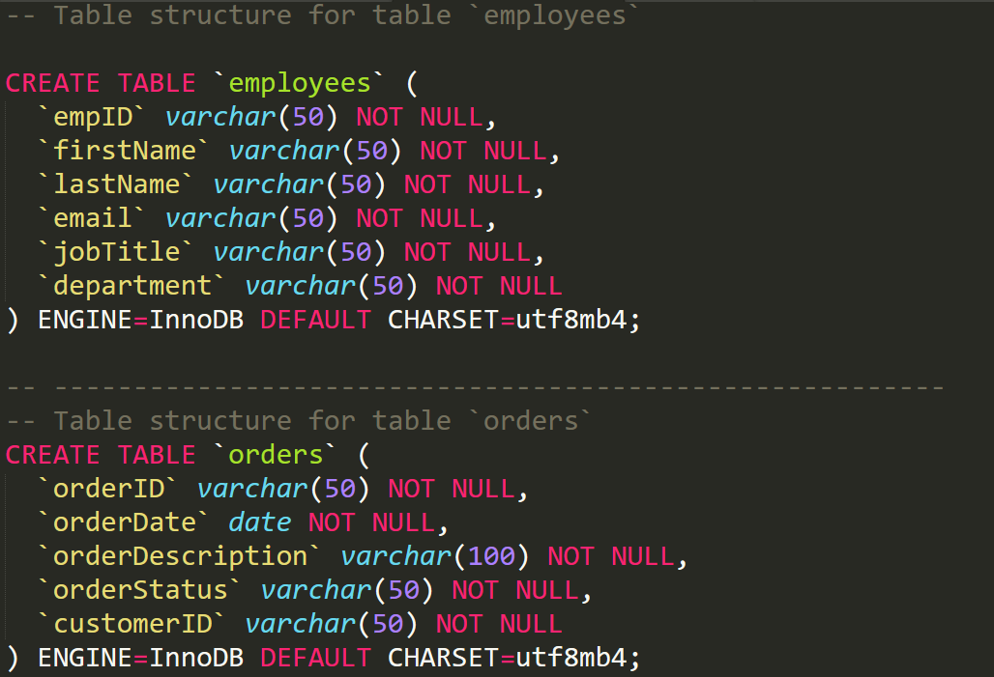
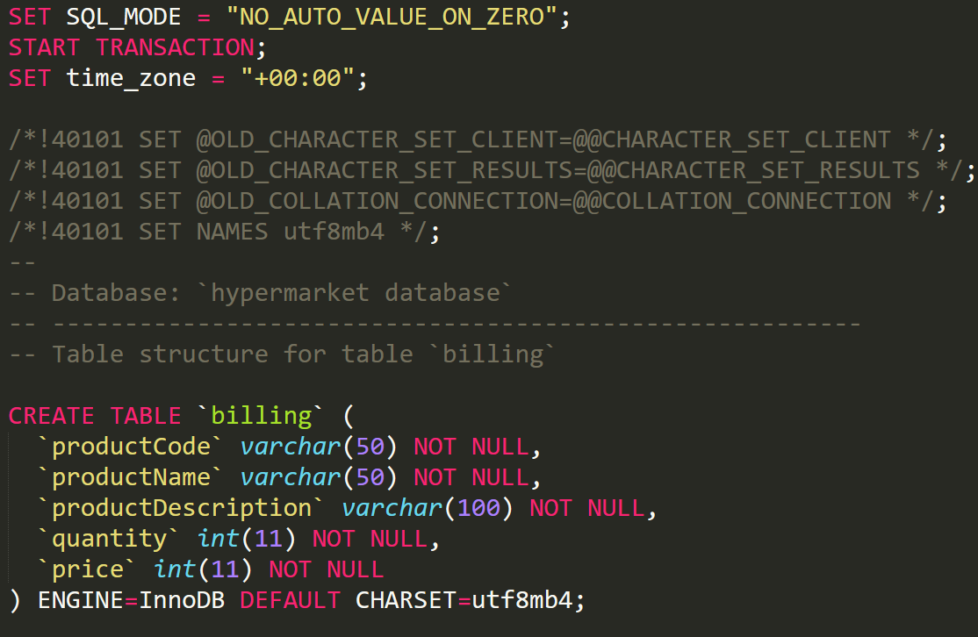
‘

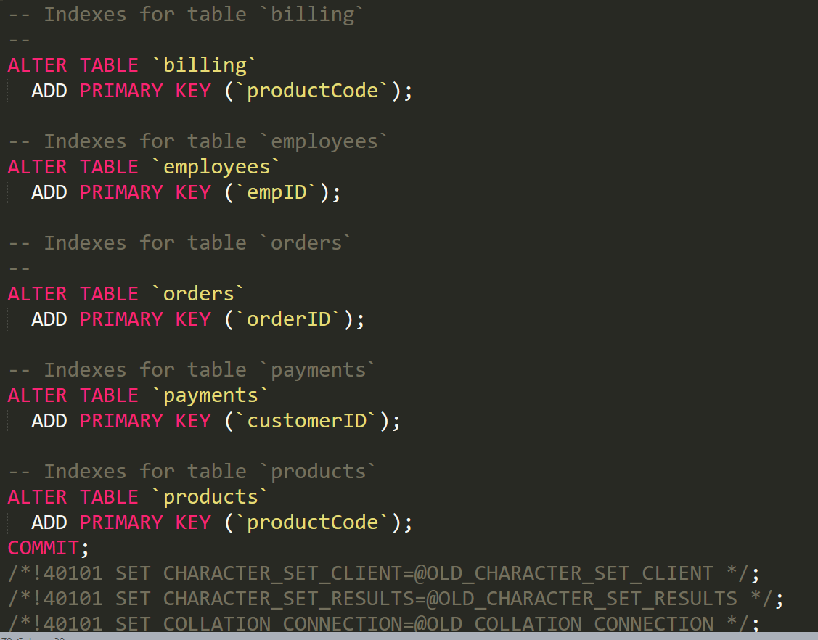
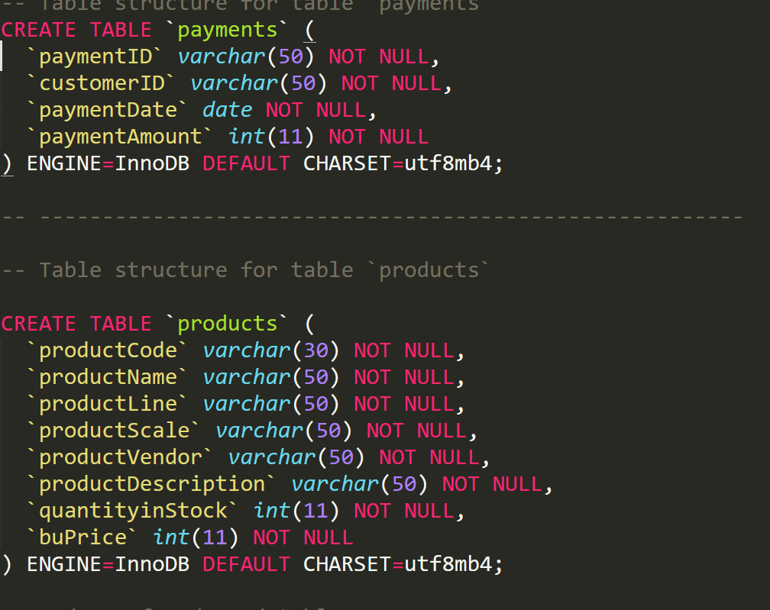

- Diagram of a Database Client-Server Architecture in a Hypermarket Environment-Database Replication
The diagram below represents the client-server database architecture within the hypermarket environment.
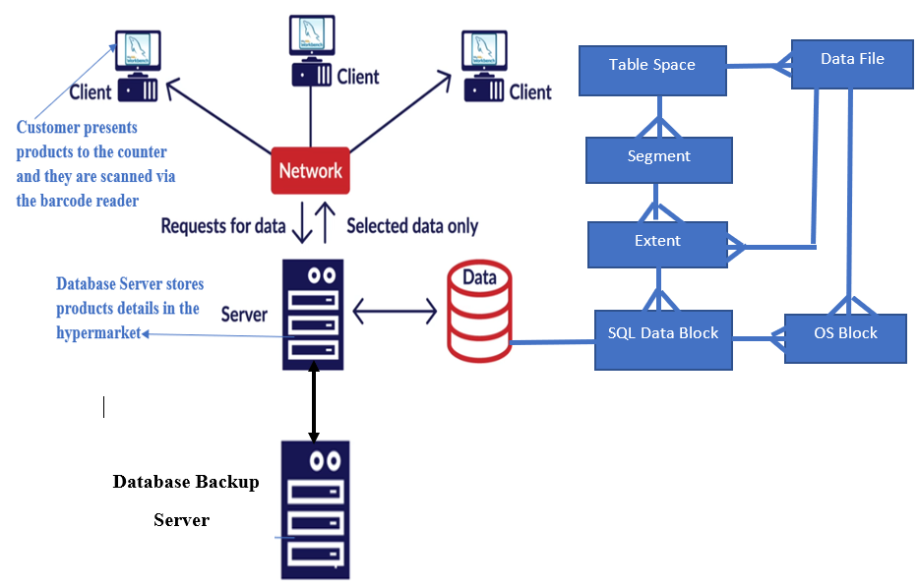
Figure 1: Client-Server Database Architecture
As shown in the above diagram, it captures the client-server database architecture in the hypermarket, where the customer presents the products to purchase to the counter. At the counter, there are client computers, which are basically used to scan the products using the barcode readers and provides the total bill that the customer is required to purchase. For the client to capture all the product details of the product on the client computer, the request is sent to the server. If the product code is available, the server will process the details of the item and then be accessed via the client computer. If the products are not available, the products code will have to be entered manually, which can be added either via the client machine, but be processed by the server, or be entered directly via the server.
(a) Explanations and Block Diagrams in Homogeneous Environment.
A distributed database involves a set of databases stored in multiple machines that normally appears as if it is a single database to the applications. Accordingly, an application can concurrently access and modify the data in different databases over a network (Ezechiel & Agarwal, 2019). In a homogeneous environment, database systems involve a network of two or more databases that exist in one or more machines. For the case of Al-Fajrpolyclinic that has different branches, each database is distinct from the other databases but has its own global database name that resides in the company's headquarter. Additionally, the computer managing the headquarter database act as a database server. Other branches will have their own databases which are independent but must adhere to some conditions for them to be homogeneous database within the distributed environment (Prenhall, n.d, p.5). The first condition that must satisfy is that the data structures in each branch must be the same and compatible throughout. The second condition requires a database application(s)at each branch to be the same and compatible. For the client/ branch application, the location, and the platform, all databases are always transparent.
Linking all the databases within the distributed environment of the company under consideration requires several conditions to be met. The first condition is the distribution and autonomy of the business units, where every unit or branch can create its own information systems, then other branches can still have control of this environment. The second condition is data sharing, which requires the sharing of data across all the branches; to make it convenient and easier to consolidate data across the local databases when needed. Linking of independent databases also requires a replication mechanism.i.e. database recovery whenever the database is damaged, which makes it easier to recover. This makes it easier for the users to access data even when the recovery process is still in progress. Replication of data in databases in all branches is a natural form of a distributed database.
The distributed database concept of the organization can be view as homogeneous because the environment seems to have the data that is distributed across all nodes in all branches. Secondly, the homogeneous nature is due to the use of a similar database management system (DBMS) in each independent branch (location). Thirdly, all data is managed by the distributed DBMS, meaning that there is nod exclusively local data. Additionally, within this environment, it is structured in a way that all users can access the database via one global database schema. The whole scenario of the distributed environment for Al-Fajrpolyclinic is captured in the diagram below. The diagram shows that each branch, including the headquarter, has its own independent database, and the information stored in the database is homogeneous and can be availed in any of the four branches within the organization.
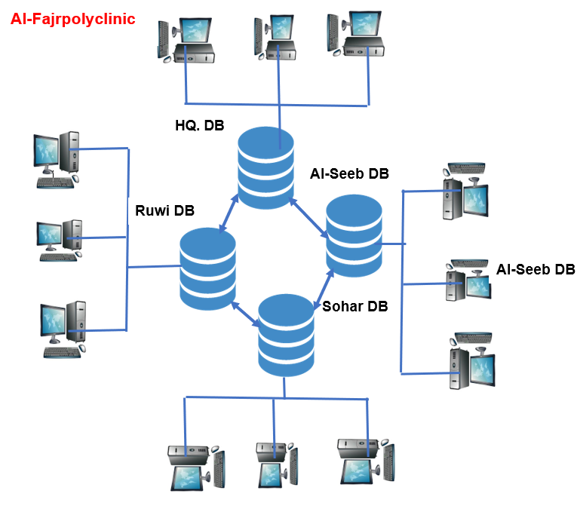
Figure 2: A distributed environment for Al-Fajrpolyclinic
(b). SQL Code and Database Link
The fundamental concept within the distributed database environment is the database link, which is a connection between physical database servers to allow access as one logical database. For the Al-Fajrpolyclinic, database link between the database server defines a one-way communication from one server to the other. With a link, a database link connection plays an important role in allowing local database users to access data from the remote database. Such links are basically transparent to the database users because the name of the database is similar to the global database name. The SQL code below is to establish the link between the two databases within the case study provided.
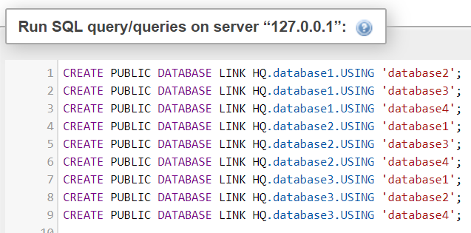

Reference List
Ezechiel, K. K., & Agarwal, S. K. R. (2019). A systematic review of distributed database systems and their techniques. Journal of Theoretical and Applied Information Technology, 96(1), 236-266.
Oluwatosin, H.S., 2014. Client-server model. IOSR J Comput Eng (IOSR-JCE), 16(1), p.67.
Özsu, M.T., and Valduriez, P., 2014. Distributed and Parallel Database Systems.
Penhall. (n.d). Distributed Databases: Chapter 13. Retrieved from https://wps.prenhall.com/wps/media/objects/3310/3390076/hoffer_ch13.pdf

