Curriculum Information Repository

Business Process Mapping
Version: 1.3

Version Control

Version | Date | Revision Description | Author
0.1 | 29/10/19 | First Draft 0.1 | Regan Kowald
1.0 | 11/12/19 | Final Version | Regan Kowald
1.1 | 09/01/20 | Amended 15.0 Program Business Case Approval  Amended 16.0 New Double Degree Program Approval | Regan Kowald
1.2 | 14/01/20 | Addition of 17.0 Program Approval to Market | Regan Kowald
1.3 | 10/02/20 | Amended 9.0 New Course to include changes for Course Synopsis | Regan Kowald

Contributors

Name | Position
Julieann Smith | Learning and Teaching Business Analyst
Joyce Vlahopoulos | Curriculum Support Officer – C-SALT

Project Contact List

Name | Position | Contact Details
Shayne Simpson | Project Manager | Ssimpso2@usc.edu.au
Jon Dickins | Project Lead | JDickins@usc.edu.au
Julieann Smith | Business Analyst | jsmith6@usc.edu.au
Joyce Vlahopoulos | Business Expert | jvlahopo@usc.edu.au
Allison Vial | Business Analyst | avial@usc.edu.au
Regan Kowald | Business Analyst | rkowald@usc.edu.au

Document Distribution

Name | Title | Date | Version | Distribution Type
Shayne Simpson | Manager – Student Information Systems | 19/11/19 | 1.0 | Approve
Jon Dickins | Curriculum Quality Manager – C-SALT | 19/11/19 | 1.0 | Approve

Acronyms/Abbreviations

Acronym / Abbreviation | Description
AB | Academic Board
CIR | Curriculum Information Repository
C-SALT | Centre for Support and Advancement of Learning and Teaching
CSO | Curriculum Support Officer
CSU | Curriculum Support Unit - refers to the relevant staff within the Centre for Support and Advancement of Learning and Teaching (C-SALT) who are responsible for supporting and facilitating the program accreditation and course approval process.
DVC(A) | Deputy Vice Chancellor - Academics
HoS | Head of School (the role)
PACC | Program And Course Committee
PVC (Students) | Pro Vice-Chancellor (Students)
SAO | Student Administration Officer
SIAU | Strategic Information and Analysis Unit
USC | University of the Sunshine Coast
USC IT | The USC Department of Information Technology
VCP | Vice Chancellor and President

Glossary

Term | Definition
Course | A discrete element of a program, normally undertaken over a single teaching session, in which the student enrols, and on completion of which the student is awarded a grade.
Course outline | The document that represents the statement of course requirements that are authoritative for both the University and the students undertaking the course. It is prepared in accordance with the requirements specified in the Program Accreditation and Course Approval Procedures and includes: graduate attributes, learning outcomes, details of assessment tasks, details of the minimum essential requirements necessary to pass the course, and any required attendance and/or participation.
Program | A set of coherently scoped, sequenced and structured studies or courses undertaken by the student in order to meet the requirements for award of a qualification, including a program of study with a major research component.
School | A designated academic unit, usually based on discipline groupings, including the Thompson Institute.
Semester, Trimester and Session | Named teaching periods within Study Period 1 and 2, consisting of a variable number of weeks of teaching.
ServiceNow | IT Help Desk solution used by USC to facilitate the creation and management of requests (tickets) related to USC applications and ICT infrastructure.
Study component | A coherent set of courses that develop a particular academic theme which is formally recognised on the Official Statement of Academic Record. This includes Majors, Extended Majors, Minors, Specialisations and Dean’s Scholars.
Study period | The academic year is organised into two study periods, each spanning half a calendar year. Study Period 1 covers the period 1 January – 30 June; Study Period 2 covers the period 1 July – 31 December.

Table of Contents
Document Detail 6
Purpose 6
Structure 6
1.0 BPMN Hieararchy 6
2.0 Process Map Legend 7
Business Process Mapping 8
Context Diagram 8
Program Entity 9
1.0 CIR New Program 9
2.0 CIR Program Change 20
3.0 CIR Program Suspension 28
4.0 CIR Program Discontinuation 34
15.0 Program Business Case Approval 44
16.0 New Double Degree Program Approval 49
Study Component Entity 53
5.0 CIR New Study Component 53
6.0 CIR Study Component Change 59
7.0 CIR Study Component Suspension 65
8.0 CIR Study Component Discontinuation 71
Course Entity 77
9.0 CIR New Course 77
12.0 CIR Course Change 87
13.0 CIR Course Discontinuation 94
Appendix 100

Document Detail

Purpose

The purpose of this document is to provide a central resource for all the business process maps associated with the use of the Curriculum Information Repository (CIR).

Structure
The context diagram defines the scope and context of the business process maps within this document. Each individual business process map uses a numeric prefix to identify the process in terms of the context diagram and in terms of its hierarchical position relevant to other process maps and process tasks.

BPMN Hieararchy
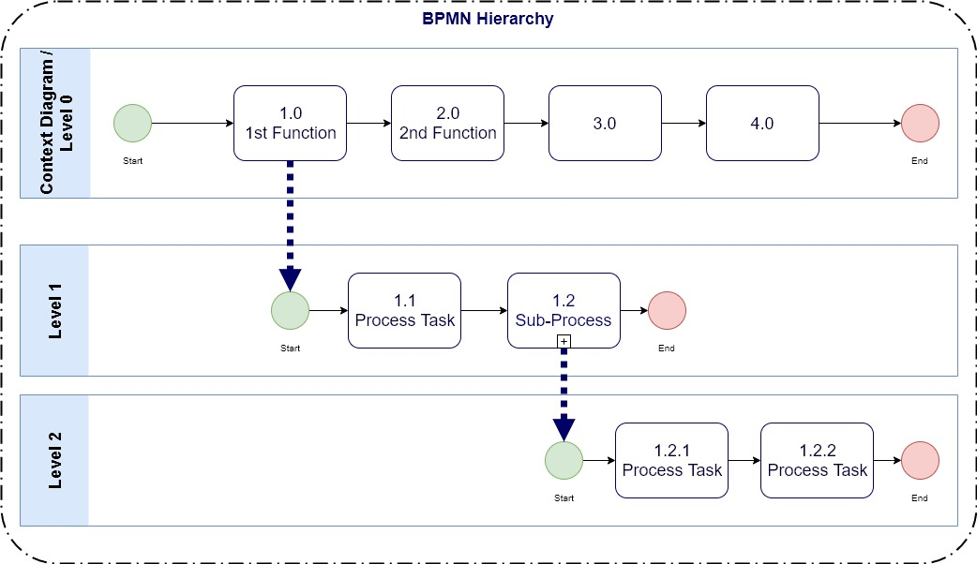

Process Map Legend

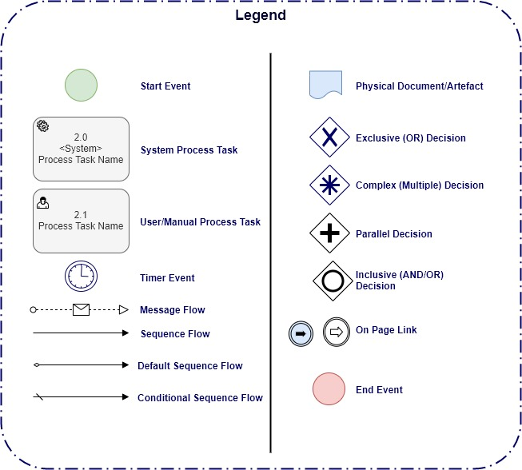

Business Process Mapping

Context Diagram

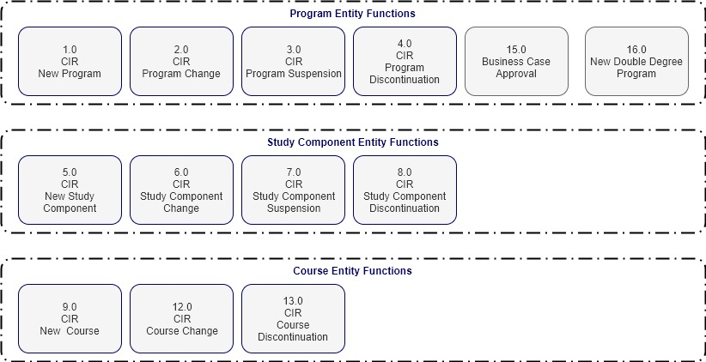

Program Entity

1.0 CIR New Program
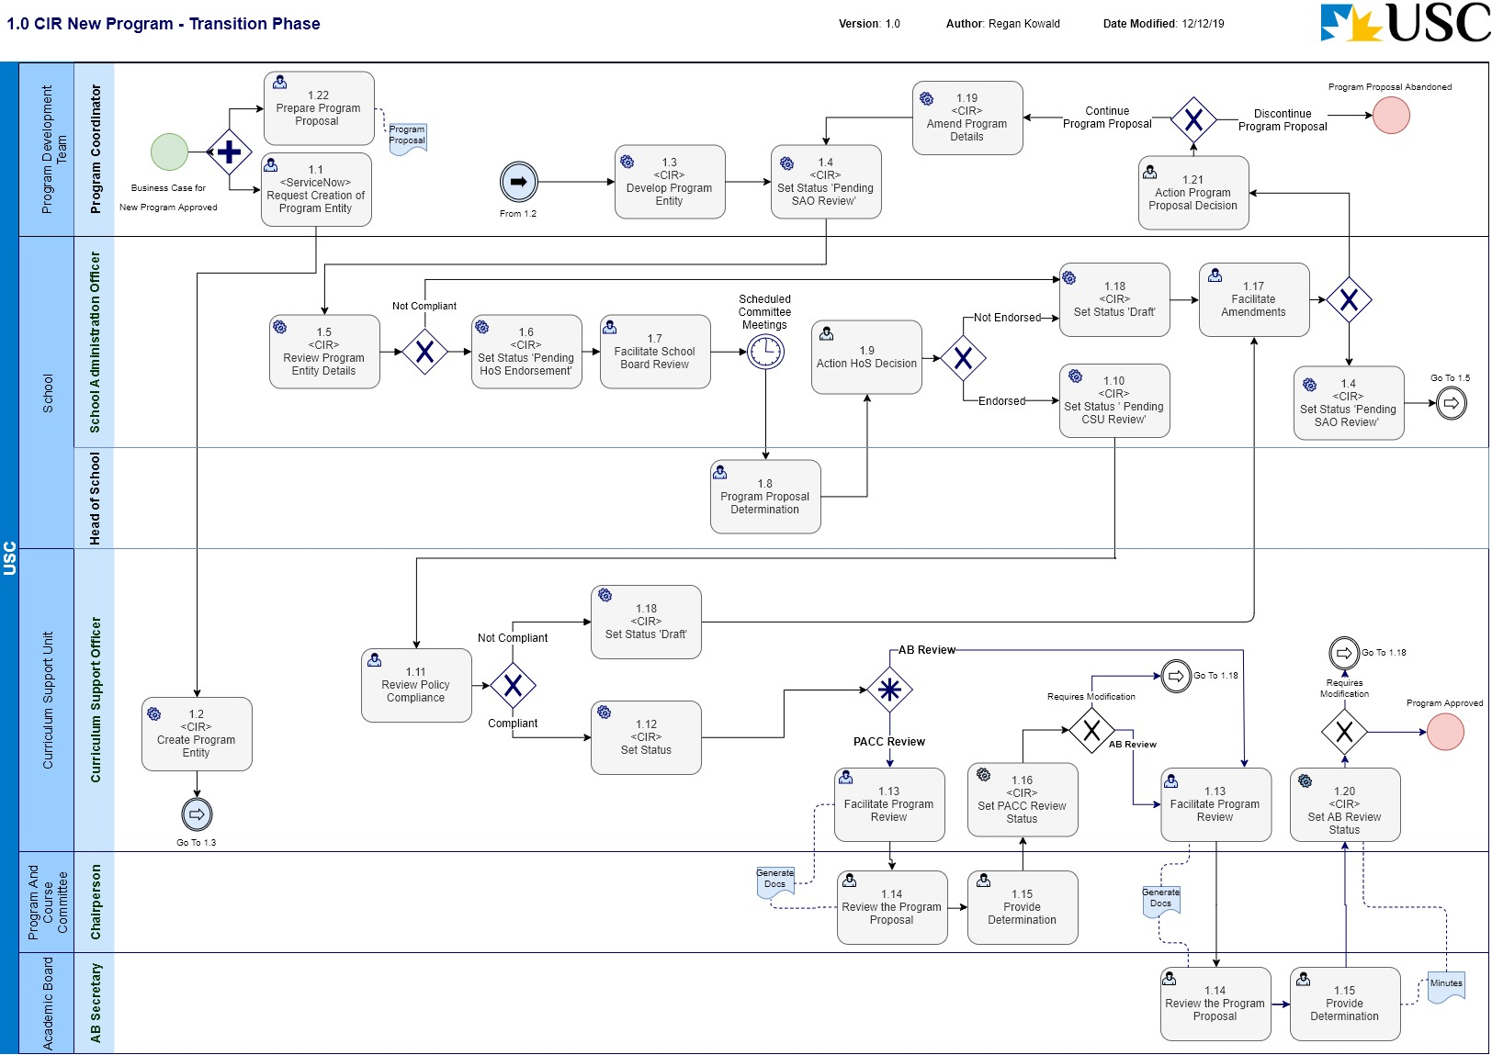
Business Process Name: | 1.0 CIR New Program
Description | This is the process required to initiate a new Program in CIR and manage the request through the formal review and approval business process.
Roles | - Program Coordinator – Program Development Team  - School Administration Officer - School  - Curriculum Support Officer – C-SALT  - Head of School - School  - PACC Secretary – Program and Course Committee  - AB Secretary – Academic Board
Triggers | - A Program Coordinator initiates the request for a new Program to be created.  - 15.0 Program Business Case Approval process has completed with a Post Condition of Business Case Approved;  - If the Program is to be a Double Degree, 16.0 New Double Degree Program Approval process has completed with a Post Condition of Double Degree Program Approved.
Pre-Conditions | - The Program to be created does not already exist in CIR;  - The business case for the creation of the Program has been endorsed and approved;  - The ‘Program Proposal’ document has been created.
Process Task Description | - <ServiceNow> Request Creation of Program Entity  The Program Coordinator will request the creation of a Program entity in CIR by raising a ticket in ServiceNow.
- <CIR> Create Program Entity
The CSO will access CIR, and enter the minimum amount of information required to create a new Program entity in CIR.
Note: It is anticipated that codes and reporting fields required by SIAU will be entered by the CSO.
Note: by default, the status is ‘Draft’ when creating a new entity, which allows the Program Coordinator and SAO to edit the Program details.
The Program Coordinator will be facilitating the development of the ‘Program Proposal’ document at this time.
- <CIR> Develop Program Entity
The Program Coordinator will facilitate the development of the Program information in CIR to the point where it is ready for SAO review.
Note: A link will be created in CIR to the Program Proposal as an attachment.
- <CIR> Set Status ‘Pending SAO Review’
The status of the Program will be set to ‘Pending SAO Review’.
Note: This puts the entity into a state of ‘read only’ and changes cannot be made.
- <CIR> Review Program Entity Details
The SAO upon receiving email notification (which is generated by the CIR workflow), will review the details of the Program to determine if the information is complete and compliant. If the current information is not compliant, the Program Coordinator will be notified, and the status of the Program change will be set back to ‘Draft’ for modification.
The SAO will also review the ‘Program Proposal’ documentation in parallel with this process task.
- <CIR> Set Status ‘Pending HoS Endorsement’
The SAO will set the workflow status to ‘Pending HoS Endorsement’. This task requires the SAO to provide a comment/s supporting the status change.
- Facilitate School Board Review
The SAO will compile the relevant documentation for the Head of School to seek informed advice from the School Board.
Prior to the HoS consideration the SAO will complete a request to the Student Services and Engagement for: the allocation of a Program Code; the allocation of Study Components codes for any new Study Components; and the allocation of Course codes for any new Courses.
The SAO will update the Accreditation documentation and the Resource Impact Statements.
The Head of School will consider the merit of the proposed program on the basis of the Accreditation documentation and the advice from the School Board and make a determination on the approval of the new Program.
- Program Proposal Determination
The Head of School will consider the merit of the proposed program on the basis of the Accreditation documentation and the advice from the School Board and make a determination on the approval of the new Program.
- Action HoS Decision
The SAO will determine what action is required of the HoS decision for the proposed new Program. If the proposal is not endorsed, the SAO will return the proposal to the Program Coordinator (Program Development Team) for modification based on the HoS recommendations. If the change is endorsed, the SAO will progress the process.
Note: If the proposal is not endorsed, the SAO will set the status of the Program entity to ‘Draft’ to allow editing of the information.
- Set Status ‘Pending CSU Review’
If the HoS endorses the proposal, the SAO will set the workflow status to ‘Pending CSU Review’. This task requires the SAO to provide supporting comment/s with the status change.
- Review Policy Compliance
The CSO reviews the Program details for policy compliance (University and external reference points), data quality and completeness. If the information is not compliant, the SAO will be notified.
Note: If the proposal is not compliant, the CSO will set the status of the Program entity to ‘Draft’ to allow editing of the information.
- <CIR> Set Status
The CSO will set the status to be ‘Pending PACC Endorsement’ if the Program is still to be endorsed by PACC; or
The CSO will set the status to be ‘Pending AB Approval’ once the Program has been endorsed by PACC.
- Facilitate Program Review
This task is relevant for all the endorsement/approval workflows (PACC, AB).
The CSO will export the information out of CIR in PDF format (accreditation documentation) and be distributed using a collaboration space (SharePoint). The CSO will then monitor the progress for a response.
- Review the Program Proposal
This task is relevant for the: PACC Secretary or the AB Secretary.
The PACC Secretary will receive the submitted documentation from CSU and facilitate the deliberation of the PACC to enable the PACC Chairperson to provide a recommendation to the Academic Board.
The AB Secretary will receive the submitted documentation from CSU and facilitate the deliberation of the Academic Board to enable the Chair of the Academic Board to determine if the Program will be accredited.
- Provide Determination
This task is relevant for the: PACC Secretary or AB Secretary.
The PACC or AB representative will send the decision of endorsement or approval back to the CSO via the committee meeting minutes.
- <CIR> Set PACC Review Status
The CSO will set the status determined by the PACC decision:
If the decision is that the new Program needs to be modified, the CSO will set the status ‘Draft’.
If the decision is that the new Program should be accredited (i.e. PACC have endorsed the change), the CSO will set the status ‘Pending AB Approval’.
- Facilitate Amendments
The SAO will receive notification and commentary with the status change ‘Draft’ outlining the returning authority’s recommendation required to accredit the Program. The SAO will either make the required administrative updates and refer back to the Head of School for review or initiate the process to amend the Program accreditation documentation with the Program Coordinator.
- <CIR> Set Status ‘Draft’
The workflow status of the Program entity will be set to ‘Draft’ to enable editing of the Program information in CIR.
- <CIR> Amend Program Details
With the status of the Program entity as ‘Draft’, the Program Coordinator will make any the changes to the Program (accreditation) information in CIR to meet the approval requirements.
- <CIR> Set AB Review Status
The CSO will set the status determined by the AB decision:
If the decision is that the proposed Program needs to be modified, the CSO will set the status ‘Draft’ and notify the SAO.
If the decision is that the proposed Program will be accredited, the CSO will set the status ‘ Approved’ and notify the School.
- Action Program Proposal Decision
The Program Coordinator will review and action the required changes of the Program proposal. This may require amendments to be made to the proposal or in fact abandon the creation of the new Program.
- Prepare Program Proposal
The Program Coordinator will initiate the creation of a ‘Program Proposal’. This document will be required to support the CIR generated information for the approval workflow process.
Post-Conditions | - The new Program is accredited and has a CIR status of ‘Approved’; or  - The process to accredit the proposed Program is discontinued.
Supporting Applications/Tools | - Curriculum Information Repository  - ServiceNow
Forms/Templates | - Business Case for a New Program  - Proposal for a New Program
Related Documentation | - USC Program Accreditation, Change and Discontinuation – Procedures.  - Program Accreditation and Course Approval - Governing Policy  - Program Review - Procedures  - Australian Qualifications Framework  - Higher Education Standards Framework.
Business Rules | - Accreditation of a new Program is the responsibility of Academic Board.  - A2.2 The following deadlines have been established for the accreditation of programs: Study Period 1 offering – accredited by 31 August for the following academic year; Study Period 2 offering – accredited by 30 November for the following academic year.  - A2.4 Expedited Pathway  A2.4.1 In exceptional circumstances, approval to expedite the accreditation/approval of a program can be given by the Deputy Vice Chancellor (Academic).  A2.4.2 An expedited option allows for the Chairperson of Academic Board or the Program and Course Committee, to act on behalf of the relevant Committee in considering a proposal for program accreditation or program change. The Chairperson has the option to consult with members of the committee before making a decision on an expedited proposal.  A2.4.2 An application to expedite can be made by the Head of School to the Deputy Vice-Chancellor (Academic), through the Curriculum Support Unit, C-SALT, for approval to expedite. The written request outlines: the reasons for requesting expedition; the consequences if the expedited process were not followed; and the anticipated accreditation/approval date.  A2.4.3 The Curriculum Support Unit, C-SALT informs the relevant School of the decision of the Deputy Vice Chancellor (Academic).  A2.4.4 The Chairperson of the relevant committee reports to the ensuing meeting of the committee on any actions taken on the committee’s behalf.  - B3.3 Double degree proposal  B3.3.1 Where a new double degree using existing programs is proposed, the Head of School investigates the proposed double degree’s contribution to the University’s strategic direction and financial sustainability, and the Deputy Vice-Chancellor (Academic) (as delegate of the Vice- Chancellor and President) must be satisfied that the proposed combination will not compromise the academic integrity of either University program.  B3.3.2 The Deputy Vice-Chancellor (Academic) (as delegate of the Vice-Chancellor and President) considers the Program Brief (New Double Degree) and decides to approve or not approve the new double degree program for development and for offering at the nominated locations.  B3.3.3 The Curriculum Support Unit, C-SALT, informs the relevant School of the decision of the Deputy Vice Chancellor (Academic).  - B7 Program Development  B7.1 The program development team develops the proposed program ensuring that:  (a) consultations are held with all relevant parties:  (i) with a legitimate interest in the proposed program, including for example other Schools and service areas of the University, potential employers, professional and registration bodies, and the relevant advisory committee;  (ii) for whom there may be resource, legal or administrative implications with the proposed program, including for example USC International, Information Technology Services, Information Services, Student Services and Engagement, and Marketing and External Engagement; and  (b) input is sought from other appropriate sources with expertise relevant to development of the program, for example, the school’s curriculum body, academic developers within the Centre for Support and Advancement of Learning and Teaching (C-SALT), Governance and Risk Management and the Curriculum Support Unit, C-SALT for alignment with University policies and procedures and the external requirements listed in B7.2;  B7.2 The program is designed and developed consistent with: the Australian Qualifications Framework and associated guidelines and principles; the Higher Education Standards Framework; any standards for external recognition, registration or accreditation of the proposed program or for potential graduates.  B7.3 The program is in line with the University’s values and relevant policies procedures and good practice in program design and learning and teaching.  B7.4 The program development team documents the proposed new program using templates identified in the next section.  B7.5 In the case of a proposal to develop a jointly conferred award, the development of the legal agreement with the partner institution(s) should occur in parallel with the program development and accreditation process, but the formal legal agreement cannot be signed until the program itself has been approved by both the University’s Academic Board and an appropriate authority at the partner institution(s). The legal agreement is, in effect, the implementation plan specifying how the jointly conferred coursework program is to be delivered, administered, completed and reviewed. This agreement documents the understandings and obligations of all parties, to ensure that the academic aspirations and standards embodied in the jointly conferred coursework program are met.  - B8 Accreditation Documentation  B8.1 The program development team documents the proposed new program using: the Program Proposal template; and the Program Outline template (including Study Component and Course Outlines and Resource Impact Statements for new curriculum).  B8.2 Program Proposal  The Program Proposal provides information on the academic rationale for the introduction of the program and the design and development process, including the consultation undertaken in support of the proposed program.  B8.3 Program Outline  The Program Outline is the detailed description of the proposed new program that is used to assess the academic integrity of that program and forms the basis for provision of information to students, prospective students, the University community and the broader community concerning the program.  B8.3.1 Study Component Outline  All proposed new study components in the program should be documented using the Study Component Outline template and added to the Program Outline as appendices.  B8.3.2 Course Outlines  All proposed new courses in the program should be documented using the Course Outline template and added to the Program Outline as appendices, except where the program is proposed to be approved subject to further documentation (refer to B8.3.3).  B8.3.3 Course Synopses  In some circumstances, full development and documentation of new courses to be undertaken in the second or subsequent years of offer of a proposed new program may not be possible. In these cases, a Course Synopsis can be substituted for the relevant Course Outline when documenting the new program. Refer to Section B4.5 of the Course Approval, Change and Discontinuation – Procedures for details.  - B9 Consideration of the accreditation documentation by the Head of School  B9.1 Before consideration by the Head of School, the documentation is deliberated by the School Board, the Board would provide advice to the Head of School on the merit and quality of the proposed program and required documentation.  B9.2 Following endorsement from the School Board and before consideration of the proposal by the Head of School, the School Administration Officer completes a template to request from Student Services and Engagement the:  (a) allocation of a Program code;  (b) allocation of Study Component codes for any new study components; and  (c) allocation of Course Codes for any new courses.  B9.3 The School Administration Officer requests the creation of any new files required for the University’s records management system.  B9.4 The School Administration Officer updates the accreditation documentation and Resource Impact Statements to include program and course codes and file numbers, and then provides a copy to Student Services and Engagement (Timetabling Unit), Asset Management Services, Information Services and Information Technology Services.  B9.5 The Head of School considers the merit of the proposed program on the basis of the accreditation documentation and advice of the School Board and approves the proposal.  B9.6 The School Administration Officer arranges for the signed accreditation documentation to be submitted to the Curriculum Support Unit, C-SALT and captures the accreditation documentation on the relevant program and course files in the University’s records management system.  B8.3.4 Resource Impact Statements  Resource Impact Statements detail the resource needs and implications of the component courses in the proposed program for provision of support and services by Student Services and Engagement, Information Services and Information Technology Services.  - B10 Consideration of the accreditation documentation by Program and Course Committee  B10.1 The Curriculum Support Unit, C-SALT checks the accreditation documentation for completeness and clarity, accuracy, internal consistency and compliance with relevant University and external reference points and liaises with the relevant School so that action and/or amended documentation can be submitted to the secretary, Program and Course Committee via the Curriculum Support Unit, C-SALT as required.  B10.2 The Chairperson, Program and Course Committee can determine that the accreditation documentation is incomplete or under-developed and delay the consideration of the proposal by the Program and Course Committee until such time as the School has responded to the Chairperson’s concerns regarding the completeness of the accreditation documentation.  B10.3 The Program and Course Committee considers the academic merit of the program on the basis of the accreditation and related documentation and: (a) resolves to recommend to Academic Board that the proposed new program as documented be accredited; or (b) resolves to recommend to Academic Board that the proposed new program as documented be accredited, subject to identified amendments being made; or (c) makes such other resolutions as may be appropriate.  B10.4 If (a), the resolution is to recommend unqualified accreditation, then the Secretary, Program and Course Committee refers the accreditation documentation to the Academic Board for consideration.  B10.5 If (b), the resolution is to recommend accreditation subject to amendments, then: (i) the relevant parties are advised to make the amendments and resubmit to the Chairperson of the Program and Course Committee, through the committee secretary via the Curriculum Support Unit, C-SALT, the amended documentation together with a written response to the matters identified, including a statement detailing the changes made to the documentation (with page references); (ii) the School resubmits the amended accreditation documentation for reconsideration vis the Curriculum Support Unit, C-SALT to the Secretary, Program and Course Committee; and (ii) the Chairperson of the Committee reviews the amended documentation and if satisfied that the required amendments have been made, the Secretary, Program and Course Committee forwards the revised accreditation documentation to the Secretary, Academic Board.  B10.6 Courses and Study Components  B10.6.1 The Program and Course Committee considers the academic merit of the proposed new courses and study components on the basis of the accreditation and related documentation; and  (a) resolves to approve the proposed new courses and study components as documented; or  (b) resolves to approve that the proposed new courses and study components as documented be approved subject to identified amendments being made; or  (c) makes such other resolutions as may be appropriate.  B10.6.2 If approval is recommended subject to amendments being made then:  (i) the relevant School is advised to make the amendments and submit to the Chair of the Committee, through the Secretary, Program and Course Committee via the Curriculum Support Unit, C-SALT, the amended documentation together with a written response to the matters identified, including a statement detailing the changes made to the documentation;  (ii) the School resubmits the amended accreditation documentation for reconsideration vis the Curriculum Support Unit, C-SALT to the Secretary, Program and Course Committee; and  (iii) the Chairperson, Program and Course Committee, reviews the amended documentation and if satisfied that the required amendments have been made approves the proposal.  B11.6.3 The Secretary, Program and Course Committee sends the relevant School/s the Committee minutes when they have been approved by the Chairperson. Any queries in relation to the accreditation documentation will be referred to the Curriculum Support Unit, C-SALT.  - B12 Consideration of the accreditation documentation by Academic Board  B12.1 Academic Board considers academic merit of the proposed program on the basis of the accreditation documentation, and:  (a) resolves to accredit the program subject to the standard conditions of accreditation as specified in the parent policy and any other conditions that the Academic Board may impose, confirming when the program will be offered for the first time; or  (b) resolves to accredit the program subject to identified amendments being made; or  (c) makes such other resolutions as may be appropriate, for example, for the proposal to be revised and brought back to a future meeting of Academic Board.  B12.2 Where accreditation is subject to any required amendments being made:  (i) the relevant School is advised to make the amendments and submit to the Chair of the Academic Board, through the Secretary, Academic Board via the Curriculum Support Unit, C-SALT, the amended documentation together with a written response to the matters identified, including a statement detailing the changes made to the documentation;  (ii) the School resubmits the amended accreditation documentation for reconsideration via the Curriculum Support Unit, C-SALT to the Secretary, Academic Board; and  (iii) the Chairperson, Academic Board, reviews the amended documentation and if satisfied that the required amendments have been made approves the proposal.  B12.3 The Secretary, Academic Board sends the relevant School/s the Committee minutes when they have been approved by the Chairperson. Any queries in relation to the accreditation documentation will be referred to the Curriculum Support Unit, C-SALT.
Issues | - The process for a Program Coordinator to request the creation of a new Program entity in CIR is still to be endorsed and approved.
Notes | - It is an assumption of this business process, that the IT Help Desk solution – ServiceNow will be used to facilitate the creation and management of requests for new entities to be created in CIR.  - It is an assumption of this business process, that with the introduction of CIR, Curriculum Bulletins will not be required to be prepared and submitted. The information contained in the Curriculum Bulletin will be available in CIR.  - This Process Map depicts the workflow expected for the initial implementation of CIR and should be considered a transitional phase. As the business outside of C-SALT become more familiar with the CIR, the CSO’s will take less of a role in facilitating the workflows through, and each role in the workflow will take the responsibility for progressing the status change through the workflow.

2.0 CIR Program Change
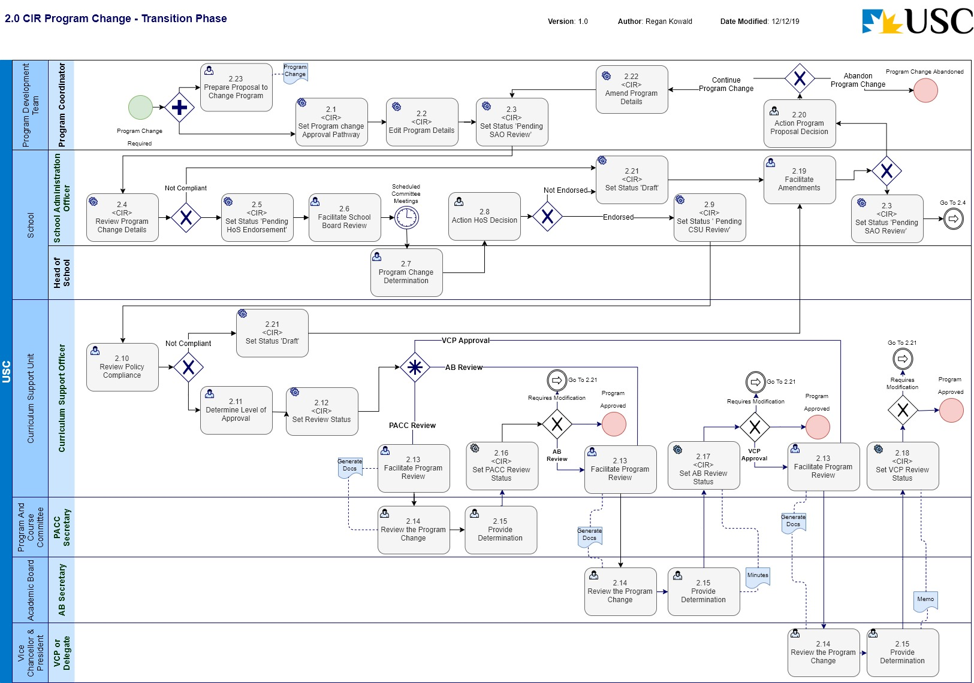
Business Process Name: | 2.0 CIR Program Change
Description | This is the process required to initiate a change to an existing Program in CIR and manage the change through the formal review and approval business process.
Roles | - Program Coordinator – Program Development Team  - School Administration Officer – School  - Head of School - School  - Curriculum Support Officer – C-SALT  - PACC Secretary – Program and Course Committee  - AB Secretary – Academic Board  - VCP or Delegate – Office of the Vice-Chancellor & President
Triggers | - A Program Coordinator initiates the request for a change to an existing Program.
Pre-Conditions | - The Program to be changed does exist in CIR;  - The Program Coordinator has received an approval from the Head of School to initiate the Program change.
Process Task Description | - <CIR> Set Program change Approval Pathway  The Program Coordinator will access CIR and select the ‘Program change’ Approval Pathway for the Program entity.  Note: This action will set the status of the Program entity to ‘Draft’.
- <CIR> Edit Program Details
The Program Coordinator will access CIR, and edit the relevant information required for the change to the Program.
The Program Coordinator will be facilitating the development of the ‘Proposal to Change Program’ document at this time.
- <CIR> Set Status ‘Pending SAO Review’
The status of the Program will be set to ‘Pending SAO Review’.
If this is the initial setting of this status, The Program Coordinator will also attach the ‘Proposal to Change a Program’.
Note: This puts the entity into a state of ‘read only’ and changes cannot be made.
- <CIR> Review Program Change Details
The SAO upon receiving email notification, will review the details of the Program change to determine if the details are compliant. If the current information is not compliant, the Program Coordinator will be notified, and the status of the Program change will be set back to ‘Draft’ for modification.
The SAO will also review the ‘Proposal to Change’ document template in parallel with this process task.
- <CIR> Set Status ‘Pending HoS Endorsement’
The SAO will set the workflow status to ‘Pending HoS Endorsement’. This task requires the SAO to provide a comment/s supporting the status change.
- Facilitate School Board Review
The SAO will compile the relevant documentation for the Head of School to seek informed advice from the School Board.
- Program Change Determination
The Head of School will consider the merit of the proposed program change on the basis of the documentation and the advice from the School Board and make a determination on the approval of the Program change.
- Action HoS Decision
The SAO will determine what action is required of the HoS decision for the requested Program change. If the change is not endorsed, the SAO will return the change request back to the Program Coordinator for review and modification based on the HoS recommendations. If the change is endorsed, the SAO will progress the process.
Note: If the change is not endorsed, the SAO will set the status of the Program entity to ‘Draft’ to allow editing of the information.
- Set Status ‘Pending CSU Review’
The SAO will set the workflow status to ‘Pending CSU Review’. This task requires the SAO to provide supporting comment/s with the status change.
- Review Policy Compliance
The CSO reviews the Program change details for policy compliance, data quality and completeness. If the information is not compliant, the SAO will be notified, and the Program change will be sent back for amendment.
Note: If the proposal is not compliant, the CSO will set the status of the Program entity to ‘Draft’ to allow editing of the information.
- Determine Level of Approval
If the Program change information is compliant, the CSO will determine the level of approval that is required and set the relevant workflow status. The CSO can initiate: a PACC endorsement and/or approval process; an AB endorsement and/or approval process; or a VCP approval process.
- <CIR> Set Status
The CSO can set the status of the workflow to be either:
‘Pending PACC Endorsement’ or
‘Pending PACC Approval’ or
‘Pending AB Approval’ or
‘Pending VCP Approval’.
All statuses will require the CSO to provide supporting comments for the status change.
- Facilitate Program Review
This task is relevant for all the endorsement/approval workflows (PACC, AB, VCP).
The CSO will export the information out of CIR in PDF format: for PACC and AB, the information will be distributed using a collaboration space (SharePoint); for VCP, the information will be emailed directly. The CSO will then monitor the progress for a response.
- Review the Program Change
This task is relevant for the: PACC Secretary; AB Secretary; VCP or Delegate.
The PACC Secretary and the AB Secretary will facilitate the review and determination of the Program change at the relevant committee meeting.
The VCP or Delegate will review and provide a determination of the Program change in direct response to the sent documentation.
- Provide Determination
This task is relevant for the: PACC Secretary; AB Secretary; VCP or Delegate.
The PACC, AB, or VCP representative will send the decision of endorsement or approval back to the CSO. PACC and AB will be via the committee meeting minutes, VCP will be via an emailed memo.
- <CIR> Set PACC Review Status
The CSO will set the status determined by the PACC decision:
If the decision is that the Program change needs to be modified, the CSO will set the status ‘Draft’ and notify the SAO.
If the decision is that the Program change is approved, the CSO will set the status ‘ Approved’ and notify the School.
If the level of approval requires further determination from AB (i.e. PACC have endorsed the change), the CSO will set the status ‘Pending AB Approval’.
- <CIR> Set AB Review Status
The CSO will set the status determined by the AB decision:
If the decision is that the Program change needs to be modified, the CSO will set the status ‘Draft’ and notify the SAO.
If the decision is that the Program change is approved, the CSO will set the status ‘ Approved’ and notify the School
If the level of approval requires further determination from VCP (i.e. PACC and AB have endorsed the change), the CSO will set the status ‘Pending VCP Approval’.
- <CIR> Set VCP Review Status
The CSO will set the status determined by the VCP decision:
If the decision is that the Program change needs to be modified, the CSO will set the status ‘Draft’ and notify the SAO.
If the decision is that the Program change is approved, the CSO will set the status ‘ Approved’ and notify the School.
- Facilitate Amendments
The SAO will receive notification and commentary with the status change ‘Draft’ outlining the returning authority’s recommendation required to change the Program. The SAO will either make the required administrative updates and refer back to the CSU for review or initiate the process to amend the Program change documentation with the Program Coordinator.
- Action Program Proposal Decision
The Program Coordinator will review and action the required changes of the Program proposal. This may require amendments to be made to the proposal or in fact abandon the changes to the Program.
- <CIR> Set Status ‘Draft’
The Program entity will be set to a status of ‘Draft’ to enable editing in CIR.
- <CIR> Amend Program Details
With the status of the Program as ‘Draft’, the Program Coordinator will make any the changes to the Program information in CIR to meet the approval requirements.
- Prepare Proposal to Change Program
The Program Coordinator will facilitate the creation of a ‘Proposal to Change Program’ document. This document will be required to support the CIR generated information for the approval workflow process.
Post-Conditions | - The Program change has been approved and is a legitimate curriculum entity for use; or  - The Program change has not been approved, and the change to the Program will not be progressed and the process will be discontinued.
Supporting Applications/Tools | - Curriculum Information Repository
Forms/Templates | - Request to Develop a Change Proposal Within the Three-Year Program Period  - Program Change Proposal requiring Committee(s) approval  - Program Change Proposal requiring VCP (or delegate) approval
Related Documentation | - USC Program Accreditation, Change and Discontinuation – Procedures.  - Program Accreditation and Course Approval - Governing Policy  - Program Review - Procedures  - Australian Qualifications Framework  - Higher Education Standards Framework.
Business Rules | - C1 Program change approval authorities  C1.1 Approval of changes to existing programs is the responsibility of either Academic Board, the Program and Course Committee or the Vice-Chancellor and President depending on the nature of the proposed changes.  C1.2 Any proposals for program changes that proceed to Program and Course Committee, or Academic Board or Vice-Chancellor and President (or delegate) for approval, would first be endorsed by the Head of School, giving due regard to resourcing and the program’s continued financial viability.  C1.3 Proposed program changes requiring Program and Course Committee, or Academic Board approval are presented on the same template. A separate template is used for changes requiring Vice-Chancellor and President approval.  - C2 Changes approved by Program and Course Committee  C2.1 Following endorsement by the Head of School, Program and Course Committee will consider and approve the following program changes: (a) alterations to the requirements for completion of a program, including the addition or removal of exit and entry points; the creation, alteration and removal of study components; and/or changes to the number of required courses. (b) minor changes to the learning outcomes of the program; (c) minor alterations to the entry requirements (including English language requirements); and (d) any other program changes not requiring Academic Board or Vice-Chancellor and President approval.  - C3 Changes approved by Academic Board  C3.1 Following consideration by Program and Course Committee, Academic Board will consider and approve: (a) a significant re-visioning of the learning outcomes and any consequential structural changes; (b) a change to the award title (requires a new program code); (c) a change to the total unit value of a currently accredited program (requires a new program code); (d) a change to the duration (standard completion time) of an accredited program; and (e) a significant alteration to the entry requirements.  - C4 Program management changes approved by the Vice-Chancellor and President or delegate  C4.1 The following types of proposed program changes will be documented by the Head of School, for the approval of the Deputy Vice-Chancellor (Academic) (as delegate of the Vice-Chancellor and President): (a) the addition or removal of a program offering at a location; (b) changing the funding arrangement (for example changing from CGS funded to full-fee) for an existing program; (c) the offering of an existing program at an additional calendar entry point; and (d) a change to a program that has significant resource impact outside the proposing school or for the University.  - C6 Restrictions on program change  C6.1 A program (including study components “owned” by a program) may only be changed once in a three-year period (Program Period). The commencement date of the Program Period is determined from the date that any previous program changes were approved or from the date that the program was introduced by the University.  C6.2 Notwithstanding C6.1, a program may be changed independently of a Program Period as follows:  (a) The Head of School may request that the Chair, Program and Courses Committee via the Curriculum Support Unit, C-SALT to the Secretary, Program and Course Committee, consider a program change within the Program Period. The grounds for approving consideration of a program change within the Program Period include changes: in response to recommendations related to program structural change from professional accreditation reviews; in response to significant issues raised in curriculum evaluations, including University program reviews; that would demonstrably increase student demand for the program, for example introduction of a new topical study component; and resulting from changes approved to another program that impact directly on the program’s structure. For the avoidance of doubt, if the Chair, Program and Courses Committee, approves a program change within the Program Period, a new Program Period commences from the date of the approval of the program change.  (b) The Deputy Vice-Chancellor (Academic) may determine that there are changes to the University’s curriculum that result in a program change. Such changes may be implemented independently of the Program Period and will not affect the commencement date of the Program Period.
Issues
Notes | - It is an assumption of this business process, that with the introduction of CIR, Curriculum Bulletins will not be required to be prepared and submitted. The information contained in the Curriculum Bulletin will be available in CIR.  - This Process Map depicts the workflow expected for the initial implementation of CIR and should be considered a transitional phase. As the business outside of C-SALT become more familiar with the CIR, the CSO’s will take less of a role in facilitating the workflows through, and each role in the workflow will take the responsibility for progressing the status change through the workflow.

3.0 CIR Program Suspension
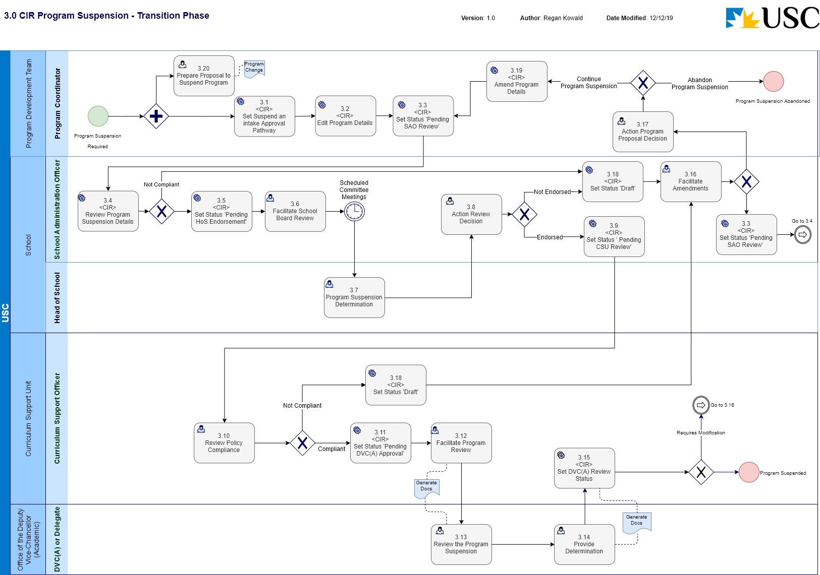
Business Process Name: | 3.0 CIR Program Suspension
Description | This is the process required to initiate the suspension of intake to a Program in CIR and manage the request through the formal approval business process.
Roles | - Program Coordinator – Program Development Team  - School Administration Officer – School  - Head of School - School  - Curriculum Support Officer – C-SALT  - PACC Secretary – Program and Course Committee  - AB Secretary – Academic Board
Triggers | - A Program Coordinator initiates the request for a Program to be suspended.
Pre-Conditions | - The Program to be suspended already exists in CIR.
Process Task Description | - <CIR> Set Suspend an intake Approval Pathway  The Program Coordinator will access CIR and select the ‘Suspend an intake (study component/program only)’ Approval Pathway for the Program entity.  Note: This action will set the status of the Program entity to ‘Draft’.
- <CIR> Edit Program Details
The Program Coordinator will access CIR, and edit the relevant information required to initiate the suspension to a Program.
The Program Coordinator will be facilitating the development of the ‘Proposal to Change Program’ document at this time.
- <CIR> Set Status ‘Pending SAO Review’
The status of the Program will be set to ‘Pending SAO Review’.
If this is the initial setting of this status, The Program Coordinator will also attach the ‘Proposal to Change a Program’.
Note: This puts the entity into a state of ‘read only’ and changes cannot be made.
- <CIR> Review Program Suspension Details
The SAO upon receiving email notification, will review the details of the Program suspension to determine if the details are compliant. If the current information is not compliant, the Program Coordinator will be notified, and the status of the Program change will be set back to ‘Draft’ for modification.
The SAO will also review the ‘Proposal to Change’ document template in parallel with this process task.
- <CIR> Set Status ‘Pending HoS Endorsement’
The SAO will set the workflow status to ‘Pending HoS Endorsement’. This task requires the SAO to provide a comment/s supporting the status change.
- Facilitate School Board Review
The SAO will compile the relevant documentation for the Head of School to seek informed advice from the School Board. The Head of School will consider the merit of the proposed suspension of intake on the basis of the documentation and the advice from the School Board and make a determination.
- Program Suspension Determination
The Head of School will consider the merit of the proposed program suspension on the basis of the documentation and the advice from the School Board and make a determination on the approval of the Program suspension.
- Action Review Decision
The SAO will determine what action is required of the HoS decision for the requested Program suspension. If the suspension is not endorsed, the SAO will return the request back to the Program Coordinator (Program Development Team) for review and modification based on the HoS recommendations. If the change is endorsed, the SAO will progress the process.
Note: If the change is not endorsed, the SAO will set the status of the Program entity to ‘Draft’ to allow editing of the information.
- Set Status ‘Pending CSU Review’
The SAO will set the workflow status to ‘Pending CSU Review’. This task requires the SAO to provide supporting comment/s with the status change.
- Review Policy Compliance
The CSO reviews the suspension of intake to a Program details for policy compliance (University and external reference points), data quality and completeness. If the information is not compliant, the SAO will be notified, and the Program request will be sent back for amendment.
Note: If the proposal is not compliant, the CSO will set the status of the Program entity to ‘Draft’ to allow editing of the information.
- <CIR> Set Status ‘Pending DVC(A) Approval’
The CSU will set the workflow status to be ‘Pending DVC(A) Approval’.
- Facilitate Program Review
The CSO will export the information out of CIR in PDF format and facilitate the distribution to the Office of the DVC(A). The CSO will then monitor the progress for a response.
- Review the Program Suspension
The DVC(A) or Delegate will receive the submitted documentation from CSU and facilitate any discussions with relevant parties to provide a decision to the School.
- Provide Determination
The DVC(A) or Delegate will make a determination on whether to approve the suspension of intake to a Program or not and notify CSU.
- <CIR> Set DVC(A) Review Status
The CSO will set the status for the workflow dependant on the determination by the DVC(A):
If the decision is that the request for suspension of intake to a Program needs to be modified, the CSO will set the status ‘Draft’ and notify the SAO.
If the decision is that the request for the suspension of intake to a Program is approved the CSO will set the status ‘Approved’ and then set the action ‘Suspend an intake’ and notify the School.
The CSO will also add the ‘to and from’ dates for the period the suspension is valid for into CIR.
- Facilitate Amendments
The SAO will receive notification and commentary with the status change ‘Draft’ from the CSO outlining the returning authority’s recommendation required to change the Program. The SAO will either make the required administrative updates and refer back to the CSU for review or initiate the process to amend the Program suspension documentation with the Program Coordinator.
- Action Program Proposal Decision
The Program Coordinator will review and action the required changes of the Program proposal. This may require amendments to be made to the proposal or in fact abandon the suspension of the Program.
- <CIR> Set Status ‘Draft’
The Program entity will be set to a status of ‘Draft’ to enable editing in CIR.
- <CIR> Amend Program Details
With the status of the Program entity as ‘Draft’, the Program Coordinator will make any the changes to the Program information in CIR to meet the approval requirements.
- Prepare Proposal for Change to Program
The Program Coordinator will initiate the creation of a ‘Proposal to Change Program’ document. This document will be required to support the CIR generated information for the approval workflow process.
Post-Conditions | - The suspension of intake to a Program is approved and has a CIR status of ‘Suspend an intake’; or  - The process to suspend an intake to a Program is discontinued.
Supporting Applications/Tools | - Curriculum Information Repository
Forms/Templates | - Proposal to Suspend an Intake to a Program
Related Documentation | - USC Program Accreditation, Change and Discontinuation – Procedures.  - Program Accreditation and Course Approval - Governing Policy  - Program Review - Procedures  - Australian Qualifications Framework  - Higher Education Standards Framework.
Business Rules | - No changes will be made to the Program Entity in CIR while it is in a suspended state (i.e. status is ‘Suspend an intake’)  - E1 Suspension of intake approval authority  Suspension of intake is a management decision made by the Deputy Vice-Chancellor (Academic) that there will be no intake of students for a particular program in a specified period. A suspension of intake is temporary and may or may not lead to discontinuation of a program.  - E2 Timeframes and consultations  If it is proposed that there be a temporary suspension of intake into a program, the Head of School initiates the process for approval to suspend intake and consults all interested parties as soon as possible.  - E4 Proposal to Suspend an Intake  E.4.1 After the closing date for submissions in response to the Curriculum Bulletin (Program Suspension), the Head of School completes a Proposal to Suspend an Intake, using the relevant template and forwards it to Curriculum Support Unit, C-SALT. Curriculum Support Unit, C-SALT refers the proposal to the Deputy Vice-Chancellor (Academic).  E.4.2 The Deputy Vice-Chancellor (Academic) decides whether to approve the suspension of intake and signs the relevant section of the proposal.  E5.1 Curriculum Support Unit, C-SALT provides written advice to the School Administration of the Deputy Vice-Chancellor (Academic) decision concerning the proposal for suspension of intake.  E5.2 Following notification of approval, the School Administration Officer arranges for: the notification of the relevant Program Coordinator; (b) the approved documentation to be recorded and registered in the University’s records management system; and (c) requesting action from the relevant University’s administration units in regard to admission (informing QTAC), updating curriculum Web pages, and system data changes (Peoplesoft).
Issues | - CIR does not currently have functionality to capture the period a suspension of intake to a Program is valid for.
Notes | - It is an assumption of this business process, that with the introduction of CIR, Curriculum Bulletins will not be required to be prepared and submitted. The information contained in the Curriculum Bulletin will be available in CIR.  - This Process Map depicts the workflow expected for the initial implementation of CIR and should be considered a transitional phase. As the business outside of C-SALT become more familiar with the CIR, the CSO’s will take less of a role in facilitating the workflows through, and each role in the workflow will take the responsibility for progressing the status change through the workflow.

4.0 CIR Program Discontinuation
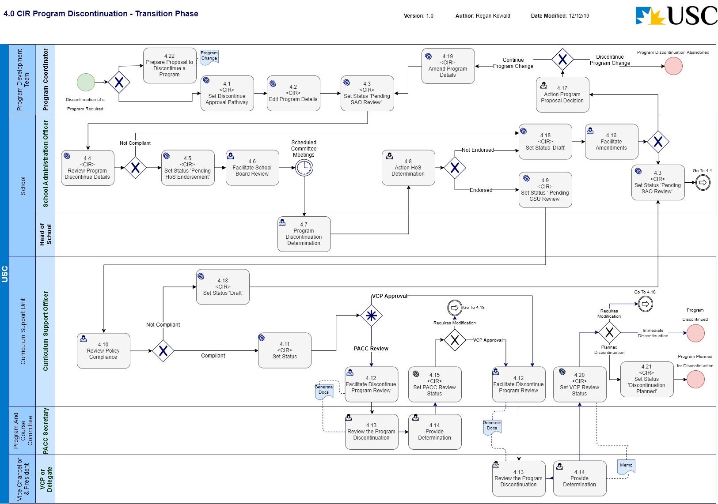
Business Process Name: | 4.0 CIR Program Discontinuation
Description | This is the process required to initiate a discontinuation of an existing Program in CIR and manage the change through the formal review and approval business process.
Roles | - Program Coordinator – Program Development Team  - School Administration Officer – School  - Head of School - School  - Curriculum Support Officer – C-SALT  - PACC Secretary – Program and Course Committee  - AB Secretary – Academic Board  - VCP or Delegate – Office of the Vice-Chancellor & President
Triggers | - A Program Coordinator initiates the request for a discontinuation of an existing Program.
Pre-Conditions | - The Program to be discontinued does exist in CIR;  - The Program Coordinator has received an approval from the Head of School to initiate the Program change.
Process Task Description | - <CIR> Set Discontinue Approval Pathway  The Program Coordinator will access CIR and select the ‘Discontinue’ Approval Pathway for the Program entity.  Note: This action will set the status of the Program entity to ‘Draft’.
- <CIR> Edit Program Details
The Program Coordinator will access CIR, and edit the relevant information required for the discontinuation of the Program.
The Program Coordinator will facilitate the creation of the ‘Proposal to Discontinue a Program’ document at this time.
- <CIR> Set Status ‘Pending SAO Review’
The status of the Program will be set to ‘Pending SAO Review’.
If this is the initial setting of this status, The Program Coordinator will also attach the ‘Proposal to Discontinue a Program’.
Note: This puts the entity into a state of ‘read only’ and changes cannot be made.
- <CIR> Review Program Discontinue Details
The SAO upon receiving email notification, will review the details of the Program discontinuation to determine if the details are compliant. If the current information is not compliant, the Program Coordinator will be notified, and the status of the Program will be set back to ‘Draft’ for modification.
The SAO will also review the ‘Proposal to Discontinue a Program’ document in parallel with this process task.
- <CIR> Set Status ‘Pending HoS Endorsement’
The SAO will set the workflow status to ‘Pending HoS Endorsement’. This task requires the SAO to provide a comment/s supporting the status change.
- Facilitate School Board Review
The SAO will compile the relevant documentation for the Head of School to seek informed advice from the School Board. The Head of School will consider the merit of the proposed discontinuation of the Program on the basis of the documentation and the advice from the School Board and make a determination.
- Program Discontinuation Determination
The Head of School will consider the merit of the proposed program discontinuation on the basis of the documentation and the advice from the School Board and make a determination on the approval of the Program discontinuation.
- Action HoS Determination
The SAO will determine what action is required of the HoS decision for the requested Program discontinuation. If the request is not endorsed, the SAO will return the request back to the Program Coordinator for review and modification based on the HoS recommendations. If the change is endorsed, the SAO will progress the process.
Note: If the change is not endorsed, the SAO will set the status of the Program entity to ‘Draft’ to allow editing of the information.
- Set Status ‘Pending CSU Review’
The SAO will set the workflow status to ‘Pending CSU Review’. This task requires the SAO to provide supporting comment/s with the status change.
- Review Policy Compliance
The CSO reviews the Program discontinuation details for policy compliance, data quality and completeness. If the information is not compliant, the SAO will be notified, and the request will be sent back for amendment.
Note: If the proposal is not compliant, the CSO will set the status of the Program entity to ‘Draft’ to allow editing of the information.
- <CIR> Set Status
The CSO can set the status of the workflow to be either:
‘Pending PACC Endorsement’ or
‘Pending VCP Approval’.
Both statuses will require the CSO to provide supporting comments for the status change.
- Facilitate Discontinue Program Review
This task is relevant for all the endorsement/approval workflows (PACC, VCP).
The CSO will export the information out of CIR in PDF format: for PACC, the information will be distributed using a collaboration space (SharePoint); for VCP, the information will be emailed directly. The CSO will then monitor the progress for a response.
- Review the Program Discontinuation
This task is relevant for the: PACC Secretary; VCP or Delegate.
The PACC Secretary will facilitate the review and endorsement of the Program discontinuation at the relevant committee meeting. The committee will consider the proposal, with attention to the impact on the student experience and the quality of the teach-out arrangements.
The VCP or Delegate will consider the information and recommendations from PACC provided for the discontinuation of the Program and make a decision.
- Provide Determination
This task is relevant for the: PACC Secretary; VCP or Delegate.
The PACC, and VCP representative will send the decision of endorsement or approval back to the CSO. PACC will be via the committee meeting minutes, VCP will be via an emailed memo.
- <CIR> Set PACC Review Status
The CSO will set the status determined by the PACC recommendation:
If the decision is that the Program discontinuation request needs to be modified, the CSO will set the status ‘Draft’ and notify the SAO.
If the decision is that the Program discontinuation is endorsed, the CSO will set the status ‘ Pending VCP Approval’.
- Facilitate Amendments
The SAO will receive notification and commentary with the status change ‘Draft’ from the CSO outlining the amendments required to make the Program discontinuation compliant. The SAO will either make the required amendments and refer back to the CSU for review or initiate the process to amend the Program discontinuation with the Program Coordinator.
- Action Program Proposal Decision
The Program Coordinator will review and action the required changes of the Program proposal. This may require amendments to be made to the proposal or in fact abandon the discontinuation of the Program.
- <CIR> Set Status ‘Draft’
The Program entity will be set to a status of ‘Draft’ to enable editing in CIR.
- <CIR> Amend Program Details
With the status of the Program as ‘Draft’, the Program Coordinator will make any the changes to the Program information in CIR to meet the approval requirements.
- <CIR> Set VCP Review Status
The CSO will set the status determined by the VCP decision:
If the decision is that the Program discontinuation needs to be modified, the CSO will set the status ‘Draft’ and notify the SAO.
If the decision is that the Program discontinuation has been approved for immediate discontinuation, the CSO will set the status ‘ Approved’ then set the Status ‘Discontinued’ and notify the School.
- <CIR> Set Status ‘Planned Discontinuation’
If the decision of the VCP is that the Program has been approved for a planned (future dated) discontinuation, the CSO will set the status ‘Approved’ and then set the status ‘Discontinuation Planned’. The CSO will also enter in a date for the planned discontinuation (‘final study period of offer’).
- Prepare Proposal to Discontinue a Program
The Program Coordinator will initiate the creation of a ‘Proposal to Discontinue a Program’ document. This document will be required to support the CIR generated information for the approval workflow process.
Post-Conditions | - The discontinuation of the Program is approved and has a CIR status of ‘Discontinued’; or  - The planned discontinuation of the Program is approved, has a CIR status of ‘Discontinuation Planned’ and the planned date for discontinuation has been recorded; or  - The process to discontinue the Program is abandoned.
Supporting Applications/Tools | - Curriculum Information Repository
Forms/Templates | - Request to Develop a Change Proposal Within the Three-Year Program Period  - Program Change Proposal requiring Committee(s) approval  - Program Change Proposal requiring VCP (or delegate) approval
Related Documentation | - USC Program Accreditation, Change and Discontinuation – Procedures.  - Program Accreditation and Course Approval - Governing Policy  - Program Review - Procedures  - Australian Qualifications Framework  - Higher Education Standards Framework.
Business Rules | - The date associated with the ‘Planned for Discontinuation’ status will be the ‘final study period of offer’.  - D1 Discontinuation of a program approval authority  D1.1 Discontinuation of a program means that: (a) there can be no new intake of students into that program from a specified date; (b) the program can no longer be advertised or marketed as available to students; and (c) the program is to be eventually removed from the suite of programs available to students.  D1.2 Approval of the discontinuation of a program is the responsibility of the Deputy Vice-Chancellor (Academic) (as delegate of the Vice-Chancellor and President).  - D2 Timing of program discontinuation  D2.1 If it is proposed to discontinue a program, the School consults all interested parties and arranges for development of a timetable for the discontinuation from the proposed date from which there will be no new intake up to the proposed date of permanent removal of the program. The timetable and preliminary plan takes into account: (a) the requirements for transition and teach-out as identified in Section G of these procedures; (b) any courses or study components that are “owned” by the program also available in other programs; (c) the date of the most recent intake into the program (base year/semester); (d) prior offers of a place in the program that have been made to any international student (agreed commencement date for student plus maximum completion time); (e) any obligation of the University to continue to offer the program to a student who is currently enrolled in the program, or a student or intending student relevant to 3.1.1(b) or 3.1.1(c); (f) the need to provide timely information to the University community, relevant authorities, e.g. Queensland Tertiary Admissions Centre (QTAC), and the public concerning discontinuation of the program and any applicable transition arrangements; and (g) University timeframes for progressing proposals for discontinuation as outlined in guidelines prepared by the Curriculum Support Unit, C-SALT.  - D3 Seeking approval to commence the discontinuation of a program  D3.1 To commence the approval of the discontinuation of a program the relevant Head of School submits a Curriculum Bulletin (Program Discontinuation) to the Deputy Vice-Chancellor (Academic) through the Curriculum Support Unit, C-SALT.  D3.2 The Curriculum Support Unit, C-SALT forwards the Curriculum Bulletin to the Deputy Vice-Chancellor (Academic) for consideration, who discusses any issues related to the proposed discontinuation with the relevant parties and then advises the Curriculum Support Unit, C-SALT whether to release the Curriculum Bulletin.  - D4 Proposal to Discontinue a Program  D4.1 Incorporating any submissions received or issues raised in response to the Curriculum Bulletin (Program Discontinuation), the Program Coordinator completes the Proposal to Discontinue a Program template. The document is forwarded to the Head of School for consideration.  D4.2 If the Head of School decides that approval for discontinuation should be sought, they sign the relevant section of the proposal and submit the proposal to the Curriculum Support Unit, C-SALT.  - D5 Endorsement by the Program and Course Committee  D5.1 The Head of School completes a Proposal to Discontinue a Program, using the relevant template and forwards it to Curriculum Support Unit, C-SALT. Curriculum Support Unit, C-SALT refers the proposal to the secretary, Program and Course Committee.  D5.2 The Program and Course Committee considers the proposal, with particular attention to the impact on the student experience and the quality of the teach-out arrangements and decides whether to endorse the discontinuation of the program.  D5.3 The secretary, Program and Course Committee informs the Curriculum Support Unit, C-SALT of the outcomes of the consideration of the proposal at the Program and Course Committee.  - D6 Approval by the Vice-Chancellor and President or delegate  D6.1 The Curriculum Support Unit, C-SALT refers the proposal to the Deputy Vice-Chancellor (Academic).  D6.2 The Deputy Vice-Chancellor (Academic) (as delegate of the Vice-Chancellor and President) decides whether to approve the proposed program discontinuation and signs the relevant section of the proposal.  - G2 Program Discontinuation  G2.1 When discontinuing a program with active student enrolments, the following principles should inform the approach adopted for the transition and teach-out period: proposed arrangements allow students to meet the learning outcomes of the program being discontinued; courses substituted for required courses are delivered and assessed at the appropriate level; assessment processes are comparable and call on the knowledge and skills requirements of the program being discontinued; proposed arrangement do not disadvantage transitioning students (e.g. arrangements allow balanced study loads, part-time or full-time study options, completion of their program without delay); the level of service, resources and support to students should not be reduced as part of any teach out process.  G2.2 The School has the following options available: teach-out arrangements with a time limit; transfer arrangements to new or similar USC program; or a combination of teach-out or transfer for different student cohorts.  G2.3 As part of the documentation for approval for a program discontinuation, the School is responsible for including: (a) a study plan for each student cohort in the program and for all locations it is offered (or individual students); and (b) a communication plan for all students enrolled in the program.  G2.4 The development of (a) and (b) above should be done in consultation with the appropriate units in Student Services and Engagement and USC International with responsibility for providing student support and advice and communication with students. Student Services and Engagement and USC International must be supplied with the final full discontinuation documentation prior to delivery to students.  G2.5 The communication plan must ensure that all students including those that are currently on deferment, leave of absence and academic exclusion receive clear and accurate information regarding their options. Refer to the Admissions – Procedures and the Enrolments and Graduation – Procedures for the University’s obligations regarding students in these situations, noting that readmission is not automatic following exclusion or where a student’s enrolment was discontinued due to an absence without leave status.  G2.6 Students must be notified in writing within 21 days of the approval to discontinue a program so that they can gain advice as to the best course of action.  G2.7 International Students  G2.7.1 The School ensures that the transition arrangements enable international students to complete all requirements of the program within the duration of their existing student visa, providing the student is maintaining satisfactory progress.  G2.7.2 The impact of any transfer arrangements on international students must be determined in consultation with USC International.  - G.3 Teach-out  A teach-out is an arrangement that has been put in place to provide a reasonable opportunity for students to complete a discontinued program without disadvantage.  G3.1 Length of the Teach-Out period  G3.1.1 Where the University is offering a replacement program and a transfer is an option, then the teach-out period is fixed at two years.  G3.1.2 Where the discipline is being discontinued entirely at the University, with no replacement program available, then the length of the teach-out period for a program is determined by the amount of remaining studies, expressed in years which is then doubled. Example 1: a three year degree is approved for discontinuation and no alternative program in the discipline is available. The program had its last intake in the previous semester, therefore two and half year of the program is required to be offered – program length remaining = 2 ½ years, double this amount, the teach-out period would therefore be five years.  G3.1.3 The minimum teach-out period is two years regardless of the length of the program.  G3.1.4 The length of the teach-out is not extended for individual students who seek leave of absence during the teach-out period.  G3.1.5 At the end of the teach-out period, the School, based on the number of students remaining, makes a decision as to whether to extend the teach-out period or put into place other mechanisms to allow the remaining students to complete their studies.  G3.2 Courses and structure of the Teach-out  G3.2.1 The courses included in the teach-out arrangement, should be those that were included in the original structure. If different courses are offered, the School must ensure that all students completing the teach-out meet the identified learning outcomes of the discontinuing program on graduation. The level of service and support to students should not be reduced as part of any teach out process. Courses introduced in the new version of the program, that have the same content, learning outcomes and level (for example, a course code change) as existing courses can be substituted into the teach-out structure.  G3.2.2 A study plan should be developed for each entry cohort in the discontinued program to demonstrate the teach out arrangement for that cohort. Individualised study plans may be used to ensure that individual students are aware of the applicable study plan/enrolment pattern they need to follow to complete the program within the teach-out period.  G3.2.3 A student following a teach-out arrangement should not be required to complete more courses or units than was originally required (additional financial cost must not be incurred by the student) or be required to overload (undertake more than four 12 unit courses, or equivalent, in a teaching period).  G3.2.4 The teach-out arrangement must include details of: availability of study components (majors, minors, etc); changes to compulsory course requirements (if any); waiving or changing course prerequisite requirements; and changes to semester offerings or delivery mode(s) of courses.  G3.2.5 The teach-out arrangement should be continually available to students and must be updated by the School on an annual basis.  G3.3 Students not completing program requirements within the “teach-out” period  Students who do not complete the program requirements within the teach-out period will be managed on a case-by-case basis. Every effort will be made to accommodate such individuals, however the University cannot guarantee suitable options will be available and cross-institutional study may need to be considered to complete the original qualification from USC.
Issues | CIR does not currently have functionality to capture the date that the discontinuation of the Program has been planned for (planned discontinuation date).
Notes | This Process Map depicts the workflow expected for the initial implementation of CIR and should be considered a transitional phase. As the business outside of C-SALT become more familiar with the CIR, the CSO’s will take less of a role in facilitating the workflows through, and each role in the workflow will take the responsibility for progressing the status change through the workflow.

15.0 Program Business Case Approval
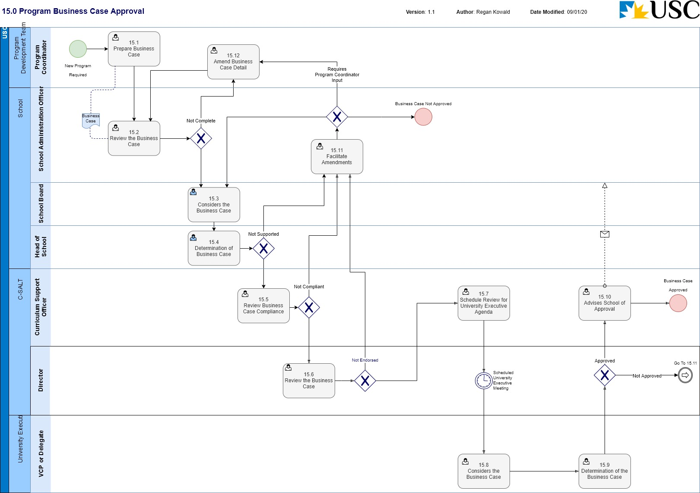
Business Process Name: | 15.0 Program Business Case Approval
Description | This process outlines the endorsement and approval tasks required for a new Program Business Case to be determined by all relevant stakeholders. The Business Case is considered the resource and planning component of the Program accreditation process.  Note: This does not include the process for Double Degree Programs. Refer 16.0 New Double Degree Program Approval.
Roles | - Program Coordinator – Program Development Team  - School Administration Officer – School  - School Board – School  - Head of School – School  - Director – C-SALT  - Curriculum Support Officer – C-SALT  - VCP or Delegate – University Executive/Office of the Vice-Chancellor & President
Triggers | - A new Program has been requested by the Program Development Team.
Pre-Conditions | - The Program does not currently exist in CIR;  - The Program Coordinator has had initial discussions with the Head of School to initiate the business case.
Process Task Description | - Prepare Business Case  The Program Coordinator will facilitate the creation and preparation of the business case for review by the Head of School. The business case is produced as a hard copy document.
- Review the Business Case
The SAO receiving the business case, will review the information to confirm the details are compliant and accurate.
If the current information is not compliant, the Program Coordinator will be notified, and the business case will be sent back for amendment.
If the business case is compliant, all relevant information will be collated and scheduled for consideration by the School Board.
- Consider the Business Case
The School Board will consider the business case and provide advice on the academic and financial merit of the proposed program and if the case meets relevant policy and procedural requirements.
- Determination of Business Case
The Head of School considers the merit of the proposed program on the basis of the documentation and advice of the School Board and will provide a recommendation of support for the University Executive through C-SALT.
If the Business Case requires changes (i.e. not supported), the document will be sent back to the School Administration Officer to facilitate the amendments.
- Review Business Case Compliance
The Curriculum Support Officer reviews the business case for compliance, data quality and completeness.
If the information is complete, the business case will be sent to the Director, C-SALT for review and endorsement.
If the business case is not compliant, the SAO will be notified, and sent back for amendment.
- Review Business Case
The Director, C-SALT will review the business case and provide feedback to the University Executive by way of endorsement to assist the determination of the business case.
If the business case is endorsed, the CSO will be notified.
If the business case is not endorsed, the SAO will be notified, and sent back for amendment.
- Schedule Review for University Executive Agenda
The CSO will schedule the business case as an agenda item for the next available University Executive meeting.
 | - The University Executive will meet to consider the business case and provide a recommendation to the VCP or delegate.
- Determination of the Business Case
The VCP or delegate will consider the recommendation of the University Executive and make a decision as to whether the Program will progress or not.
If the business case is approved, CSU will be notified to advise the School. The DVC(A) will also determine the nominated locations for the Program at this stage.
If the business case is not approved, and requires amendments, the School will be notified via the SAO.
- Advises School of Approval
The CSU will notify the School via the SAO that the Business Case has been approved. This will initiate the creation of the Program Proposal by the Program Development Team.
- Facilitate Amendments
The SAO will determine what changes are required and facilitate the amendments. The SAO may be able to effect the changes required or they may need to be resolved by the Program Development Team or the business case may not be approved and abandoned.
- Amend Business Case Detail
The Program Coordinator will facilitate resolving the issues or changes required of the business case by the approval groups.
Post-Conditions | - The Business Case has been approved and the Program can continue further development; or  - The Business Case has not been approved and the Program development will be discontinued.
Supporting Applications/Tools | - Curriculum Information Repository
Forms/Templates | - Business case for a New Program  - Proposal for a new program
Related Documentation | - USC Program Accreditation, Change and Discontinuation – Procedures.  - Program Accreditation and Course Approval - Governing Policy  - Program Review - Procedures  - Australian Qualifications Framework  - Higher Education Standards Framework.
Business Rules | - B3 Approval to develop a new program  B3.1 Approval to develop a new program proposal, and to offer a new program at nominated locations, is the responsibility of the Deputy Vice-Chancellor (Academic) as delegated by the Vice-Chancellor and President.  B3.2 For a new program (other than a new double degree using existing programs), the business case for a new program is the resource and planning component of the program accreditation process.  B3.2.1 The Business Case template is completed by the program development team to provide the case for the proposed new program’s contribution to the University’s strategic direction, financial viability, and all its resourcing requirements. In the case of a proposal to develop a jointly conferred award, in-principle approval, additionally addressing the Partner Institution Selection (Jointly Conferred Award) Guidelines, must be obtained before detailed planning and negotiations about collaboration arrangements with the potential partner institution/s occur and before any binding commitments are made.  B3.2.2 The program development team forwards the proposals to the relevant Head of School who considers the documentation.  B3.2.3 Before endorsement, the Head of School requests that the documentation is considered by the School Board, providing advice on the following: the academic and financial merit of the proposed program and benefit to the School; and whether the proposed program meets the requirements of relevant policies and procedures.  B3.2.4 The Head of School considers the merit of the proposed program on the basis of the documentation and advice of the School Board and recommends to the Deputy Vice-Chancellor (Academic) that the proposed program as documented be considered for development.  B3.2.5 The request to the Deputy Vice-Chancellor (Academic) is made through the Curriculum Support Unit, C-SALT.  B3.2.6 The Deputy Vice Chancellor (Academic) endorses the Business Case prior to consideration and comment by the Chief Financial Officer. Following the provision of comments by the Chief Financial Officer, the Deputy Vice Chancellor (Academic) arranges through the Curriculum Support Unit, C-SALT, for the Business Case to be scheduled on the University Executive agenda and provides the relevant documentation to the Secretary, University Executive.  B3.2.7 The University Executive considers the Business Case and makes a recommendation to the Deputy Vice-Chancellor (Academic) (as delegate of the Vice-Chancellor and President) who decides whether to approve or not approve the new program for development and to determine its offering at the nominated locations.  B3.2.8 The secretary, University Executive will advise the Curriculum Support Unit, C-SALT of the decision of the Deputy Vice Chancellor (Academic). The Curriculum Support Unit, C-SALT then informs the relevant School.
Issues
Notes

16.0 New Double Degree Program Approval
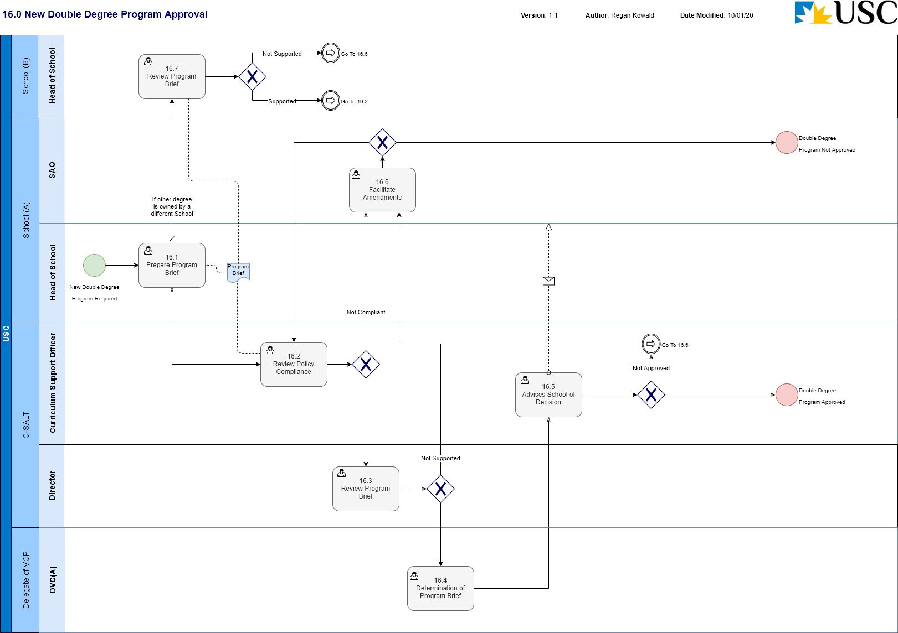
Business Process Name: | 16.0 Double Degree Program Approval
Description | This process outlines the endorsement and approval tasks required for a new Double Degree Program Business Case to be determined by all relevant stakeholders.
Roles | - Program Coordinator – Program Development Team  - School Administration Officer – School (A) indicates the School proposing the double degree  - Head of School – School (A)  - Head of School – School (B) indicates the School owning the other degree  - Curriculum Support Officer – C-SALT  - Director – C-SALT  - DVC(A) – Office of the Vice-Chancellor & President
Triggers | - The Head of School investigates the proposal for a new double degree.
Pre-Conditions | - The double degree must propose the use of two existing accredited programs.
Process Task Description | - Prepare Program Brief  The Head of School will prepare the Program Brief in support of the double degree. The Program Brief is created as a hard copy document.  If both degrees are ‘owned’ by the School, the brief is forwarded to the CSO.  If one of the degrees is ‘owned’ by another School, the brief is forwarded to the Head of School for endorsement.
- Review Policy Compliance
The Curriculum Support Officer reviews the Program Brief for policy compliance, data quality and completeness.
If the information is compliant, the Program Brief will be sent to the Director, C-SALT for review and endorsement.
If the information is not compliant, the School will be notified, and sent back for amendment.
- Review Program Brief
The Director, C-SALT will review the Program Brief and provide feedback to the DVC(A) by way of endorsement to assist the determination of the brief.
If the Program Brief is supported, the brief will be sent to the DVC(A) for determination.
If the Program Brief is not supported, the School will be notified and sent back for amendment.
- Determination of Program Brief
The DVC(A) as delegate of the VCP will consider the brief and make a determination on whether or not to approve the Double Degree proposal.
If the DVC(A) approves the brief, the nominated locations for the offering will be decided at this stage.
- Advises School of Decision
The CSU will advise the School of the DVC(A) decision.
If the Double Degree proposal is approved, the Program Development Team will initiate the preparation of the Program Proposal.
If the Double Degree proposal is not approved, the School will be advised of the amendments required or to abandon the proposal.
- Facilitate Amendments
The SAO will facilitate any changes or amendments required to progress the Program Brief through to DVC(A) approval or initiate the process to abandon the proposal.
- Review Program Brief
If one of the degrees proposed in the Double Degree proposal is ‘owned’ by another School, the Head of School will review the Program Brief and provide feedback to the DVC(A) by way of endorsement to assist the determination of the brief.
If the Program Brief is supported, the brief will be sent to C-SALT for review and endorsement.
If the Program Brief is not supported, the School will be notified and sent back for amendment.
Post-Conditions | - The Program Brief has been approved and the development of the Double Degree can be progressed; or  - The Program Brief has not been approved, and the progression of the Double Degree is discontinued.
Supporting Applications/Tools | - Curriculum Information Repository
Forms/Templates | - Program Brief (New Double Degree)  - Proposal for a New Double Degree
Related Documentation | - USC Program Accreditation, Change and Discontinuation – Procedures.  - Program Accreditation and Course Approval - Governing Policy  - Program Review - Procedures  - Australian Qualifications Framework  - Higher Education Standards Framework.
Business Rules | - B3.3 Double degree proposal  B3.3.1 Where a new double degree using existing programs is proposed, the Head of School investigates the proposed double degree’s contribution to the University’s strategic direction and financial sustainability, and the Deputy Vice-Chancellor (Academic) (as delegate of the Vice- Chancellor and President) must be satisfied that the proposed combination will not compromise the academic integrity of either University program.  B3.3.2 The Deputy Vice-Chancellor (Academic) (as delegate of the Vice-Chancellor and President) considers the Program Brief (New Double Degree) and decides to approve or not approve the new double degree program for development and for offering at the nominated locations.  B3.3.3 The Curriculum Support Unit, C-SALT, informs the relevant School of the decision of the Deputy Vice Chancellor (Academic).  - C7.2. Changes to Double Degrees  A structural change to a program that is also a component degree in a double degree, requires the School owner to consult with the other School involved in the double degree to ensure that requirements of both degrees are met in the revised structure. The consultation and outcomes should be included as part of the approval documentation.
Issues
Notes

Program Approval to Market
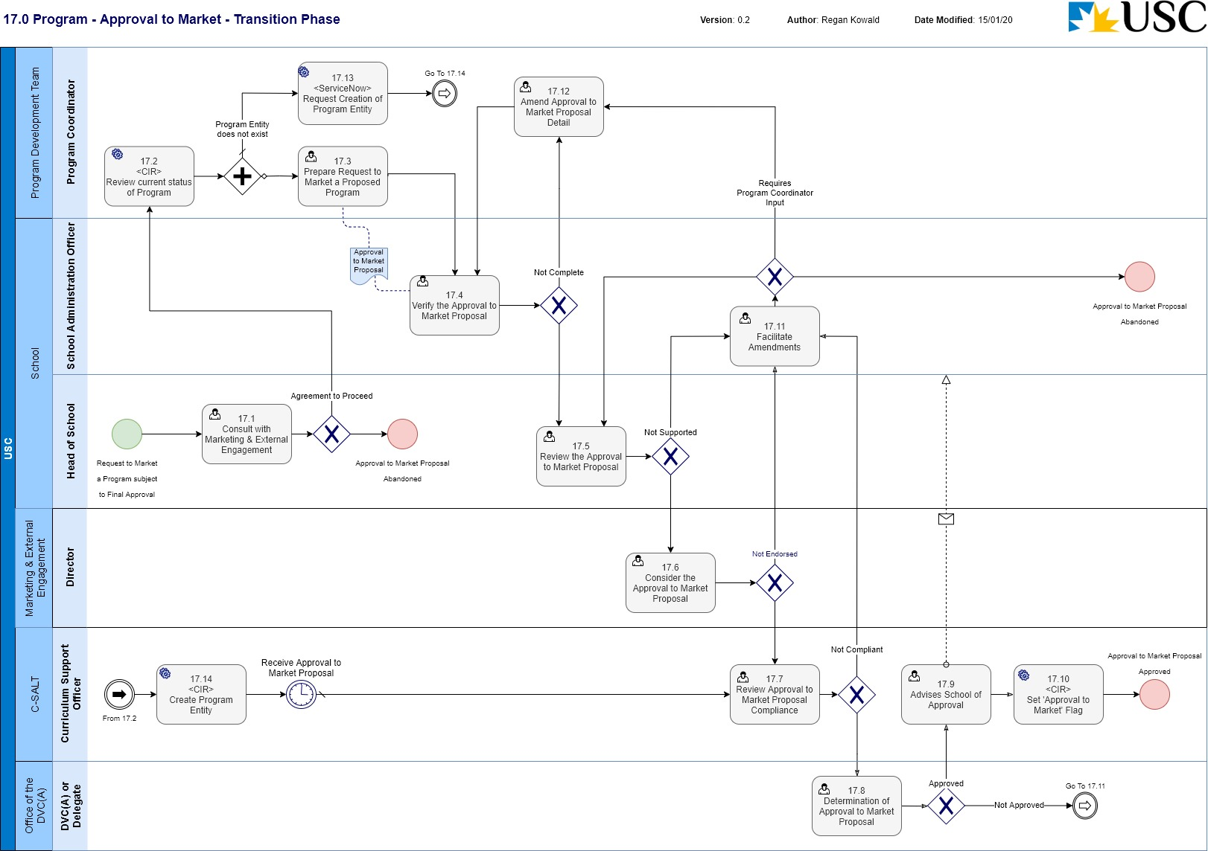
Business Process Name: | 17.0 Program Approval to Market
Description | This process outlines the endorsement and approval tasks required for all relevant stakeholders to progress a request to market a proposed Program subject to final approval.
Roles | - Program Coordinator – Program Development Team  - School Administration Officer – School  - Head of School – School  - Director – Marketing and External Engagement  - Curriculum Support Officer – C-SALT  - DVC(A) or Delegate – Office of the DVC(A)
Triggers | - A request to allow the marketing of a proposed Program (i.e. prior to the accreditation of the Program) has been initiated through the Head of School.
Pre-Conditions | - If the Program is already progressing through the accreditation process, a Program entity exists in CIR.
Process Task Description | - Consult with Marketing & External Engagement  The Head of School will consult with the Director, Marketing and External Engagement to gain support in principle for the request to market the Program subject to final approval.  If the Director, Marketing and External Engagement gives support in principle, the Program Coordinator will be contacted to facilitate the preparation of the ‘Request to Market a Proposed Program Subject to Final Approval’ document.  If the Director, Marketing and External Engagement does not give support in principle, the request will be abandoned.
- <CIR> Review current status of Program
The Program Coordinator will review CIR to determine if the Program exists and if so, at what status the Program is through the accreditation process.
If the Program does not exist in CIR, the Program Coordinator will raise a request with C-SALT to create the entity.
- Prepare Request to Market a Proposed Program
The Program Coordinator will facilitate the creation and preparation of the ‘Request to Market a Proposed Program Subject to Final Approval’ proposal for review by the Head of School.
If the Program has not yet started the accreditation process, the Program Coordinator will update the relevant CIR Program entity when available.
- Verify the Approval to Market Proposal
The SAO receiving the proposal, will review the information to confirm the details are compliant and accurate.
If the current information is not compliant, the Program Coordinator will be notified, and the proposal will be sent back for amendment.
If the proposal is compliant, all relevant information will be sent to the Head of School for consideration.
- Review the Approval to Market Proposed
The Head of School considers the merit of the proposal to market the Program prior to accreditation and will provide a recommendation of support for the DVC(A) through C-SALT.
If the proposal requires changes (i.e. not supported), the document will be sent back to the School Administration Officer to facilitate the amendments.
- Consider the Approval to Market Proposal
The Director, Marketing and External Engagement will review the proposal and provide feedback to the DVC(A) by way of endorsement to assist the determination of the proposal.
If the proposal is endorsed, the brief will be sent to the DVC(A) for determination through C-SALT.
If the proposal is not endorsed, the School will be notified and sent back for amendment.
- Review Approval to Market Proposal Compliance
The Curriculum Support Officer reviews the proposal for compliance, data quality and completeness. If the Program has not yet started the accreditation process (i.e. a new Program entity has been requested for this proposal), the CSO will also review the Program entity for compliance, data quality and completeness.
If the information is complete, the proposal will be sent to the DVC(A) for determination.
If the proposal is not compliant, the SAO will be notified, and sent back for amendment.
- Determination of Approval to Market Proposal
The DVC(A) or delegate will consider the endorsement from the Head of School and the Director, Marketing and External Engagement and make a decision as to whether the proposal to market the Program ‘subject to final approval’ will progress or not.
If the proposal is approved, CSU will be notified to advise the School.
If the proposal is not approved, and requires amendments, the School will be notified via the SAO.
- Advises School of Approval
The CSU will notify the School via the SAO that the proposal has been approved.
- <CIR> Set ‘Approval to Market’ flag
The CSO will set a flag/indicator in CIR to identify the Program entity has been approved to market (subject to final approval).
Note: This functionality is still TBD in CIR. Refer Issues section.
- Facilitate Amendments
The SAO will determine what changes are required and facilitate the amendments. The SAO may be able to effect the changes required or they may need to be resolved by the Program Development Team or the proposal may not be approved and abandoned.
- Amend Approval to Market Proposal Detail
The Program Coordinator will facilitate resolving the issues or changes required of the proposal by the approval groups.
- <ServiceNow> Request Creation of Program Entity
The Program Coordinator will request the creation of a Program entity in CIR by raising a ticket in ServiceNow.
- <CIR> Create Program Entity
The CSO will access CIR, and enter the minimum amount of information required to create a new Program entity in CIR.
Note: If the ‘Request to Market a Proposed Program Subject to Final Approval’ proposal is sent through with the request, it is anticipated that the CSO will update the Program entity with the relevant information.
Note: by default, the status is ‘Draft’ when creating a new entity, which allows the Program Coordinator and SAO to edit the Program details and/or initiate the accreditation process of the Program if required.
Post-Conditions | - The ‘Request to Market a Proposed Program Subject to Final Approval’ proposal has been approved and the Program entity can be consumed by downstream systems as an ‘Approved to Market Program’; or  - The ‘Request to Market a Proposed Program Subject to Final Approval’ proposal has not been approved and the proposal is abandoned.
Supporting Applications/Tools | - Curriculum Information Repository  - ServiceNow
Forms/Templates | - Request to Market a Proposed Program Subject to Final Approval
Related Documentation | - USC Program Accreditation, Change and Discontinuation – Procedures.  - Program Accreditation and Course Approval - Governing Policy  - Program Review - Procedures  - Australian Qualifications Framework  - Higher Education Standards Framework.
Business Rules | - B6 Approval to market a proposed program subject to final approval  B6.1 Following consultation with the Director, Marketing and External Engagement, the Head of School can make a case to the Deputy Vice-Chancellor (Academic) to market a proposed new program prior to it being accredited by the University.  B6.2. The Head of School completes a request to market a proposed program subject to final approval and submits it to the Deputy Vice-Chancellor (Academic) through the Curriculum Support Unit, C-SALT.  B6.3 The Deputy Vice-Chancellor (Academic) considers the request and decides to approve or not approve the proposal to market a new program “subject to final approval”.  B6.4 When making the decision to market a new program “subject to final approval”, the Deputy Vice-Chancellor (Academic) takes into consideration the potential risk and benefits to the University in advertising the program. To minimise risk, the decision of the Deputy Vice-Chancellor (Academic) may be based on the stage the program proposal has reached in the accreditation approval process.  B6.5 Following approval to market a new program “subject to final approval”, the Curriculum Support Unit, C-SALT informs the relevant School of the Deputy Vice-Chancellor (Academic) decision.  - CIR ‘Approval to Market’ indicator  When a program has been approved to market, this will be indicated in CIR and will be persistent for the life of the entity within CIR.  Program name  Owning school  Semester/Year of Implementation  Program duration  Intakes  Study mode  Location(s) of offer (1)  Student cohort availability  Study components  Professional body membership(s)  External accrediting body  Standard entry requirements  Pre-requisites  Recommended prior study  Special selection criteria  Program description (for Web and QTAC)  Career opportunities (for QTAC)  Double degrees and  Other information relevant to the marketing of the program (e.g. fixed application closing dates, only first year courses offered in 2020, first and second year courses offered in 2021, etc)
Issues | - Currently CIR does not have a way to identify that a Program entity has been ‘Approved to Market’. It is expected the resolution will involve a flag/indicator against the entity that is independent of the approval workflow, can be reported on, and can be used as a flag for downstream systems consuming CIR information. This issue is current as of 15/01/2020.
Notes | - It is expected that the Program entity ‘Approved to Market’ indicator will be persistent through the life of the entity i.e. CIR will always indicate that this entity was ‘Approved to Market’ regardless of the overall status of the Program (e.g. Suspended, Discontinued, Approved).  - This Process Map depicts the workflow expected for the initial implementation of CIR and should be considered a transitional phase. As the business outside of C-SALT become more familiar with the CIR, the CSO’s will take less of a role in facilitating the workflows through, and each role in the workflow will take the responsibility for progressing the status change through the workflow.

Study Component Entity

5.0 CIR New Study Component
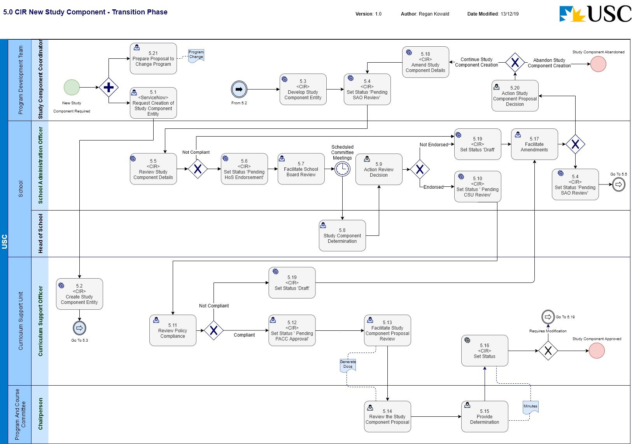
Business Process Name: | 5.0 CIR New Study Component
Description | This is the process required to initiate a new Study Component in CIR and manage the request through the formal review and approval business process.
Roles | - Study Component Coordinator – Program Development Team  - School Administration Officer – School  - Head of School - School  - Curriculum Support Officer – C-SALT  - PACC Chairperson – Program and Course Committee
Triggers | - A Study Component Coordinator initiates the request for a Study Component to be created.
Pre-Conditions | - The Study Component to be created does not exist in CIR.  - An Accredited (Approved) Program considered to be the ‘owning Program’ must exist in CIR
Process Task Description | - <ServiceNow> Request Creation of Study Component Entity  The Study Component Coordinator will request the creation of a Study Component entity in CIR by raising a ticket in ServiceNow.
- <CIR> Create Study Component Entity
The CSO will access CIR and enter the minimum amount of information required to create a new Study Component entity in CIR.
Note: It is anticipated that codes and reporting fields required by SIAU will be entered by the CSO.
Note: by default, the status is ‘Draft’ when creating a new entity, which allows the Study Component Coordinator and SAO to edit the Study Component details.
The Study Component Coordinator will be facilitating the development of the ‘Proposal to Change a Program’ document at this time.
- <CIR> Develop Study Component Entity
The Study Component Coordinator will facilitate the development of the Study Component information in CIR to the point where it is ready for SAO review.
Note: A link will be created in CIR to the Proposal to Change Program as an attachment.
- <CIR> Set Status ‘Pending SAO Review’
The status of the Study Component will be set to ‘Pending SAO Review’.
If this is the initial setting of this status, The Study Component Coordinator will also attach the ‘Proposal to Change a Program’.
Note: This puts the entity into a state of ‘read only’ and changes cannot be made.
- <CIR> Review Study Component Details
The SAO upon receiving email notification, will review the details of the Study Component creation to determine if the details are compliant. If the current information is not compliant, the Study Component Coordinator will be notified, and the status of the Study Component will be set back to ‘Draft’ for modification.
The SAO will also review the Proposal to Change Program in conjunction with the CIR information.
- <CIR> Set Status ‘Pending HoS Endorsement’
The SAO will set the workflow status to ‘Pending HoS Endorsement’. This task requires the SAO to provide a comment/s supporting the status change.
- Facilitate School Board Review
The SAO will compile the relevant documentation for the Head of School to seek informed advice from the School Board. The Head of School will consider the merit of the proposed Study Component on the basis of the documentation and the advice from the School Board and make a determination.
- Study Component Determination
The Head of School will consider the merit of the proposed Study Component on the basis of the documentation and the advice from the School Board and make a determination on the approval of the new Study Component.
- Action Review Decision
The SAO will determine what action is required of the Head of School decision for the requested Study Component. If the proposal is not endorsed, the SAO will return the request back to the Study Component Coordinator (Program Development Team) for modification based on the HoS recommendations. If the proposal is endorsed, the SAO will progress the process.
Note: If the proposal is not endorsed, the SAO will set the status of the Study Component entity to ‘Draft’ to allow editing of the information.
- Set Status ‘Pending CSU Review’
If the Head of School endorses the proposal, the SAO will set the workflow status to ‘Pending CSU Review’. This task requires the SAO to provide supporting comment/s with the status change.
- Review Policy Compliance
The CSO reviews the Study Component creation details for policy compliance (University and external reference points), data quality and completeness. If the information is not compliant, the SAO will be notified, and the Study Component request will be sent back for amendment.
Note: If the proposal is not endorsed, the SAO will set the status of the Program entity to ‘Draft’ to allow editing of the information.
- <CIR> Set Status ‘Pending PACC Approval’
The CSU will set the workflow status to be ‘Pending PACC Approval’.
- Facilitate Study Component Proposal Review
The CSO will export the information out of CIR in PDF format and facilitate the distribution to PACC. The CSO will then monitor the progress for a response.
- Review the Study Component Proposal
The PACC Chairperson or delegate will receive the submitted documentation from CSU and facilitate any discussions with relevant parties to provide a decision to the School.
- Provide Determination
The PACC Chairperson will decide on whether to approve the creation of the Study Component or not and notify CSU.
The CSU will be notified via the PACC Meeting Minutes.
- <CIR> Set Status
The CSO will set the status for the workflow dependant on the determination by the PACC:
If the decision is that the request for creation of a Study Component needs to be modified, the CSO will set the status ‘Draft’ and notify the SAO.
If the decision is that the request for creation of a Study Component is approved the CSO will set the status ‘Approved’ and notify the School.
- Facilitate Amendments
The SAO will receive notification and commentary with the status change ‘Draft’ outlining the returning authority’s recommendation required to approve the new Study Component. The SAO will either make the required administrative updates and refer back to the CSU for review or initiate the process to amend the Study Component documentation with the Study Component Coordinator.
- <CIR> Amend Study Component Details
With the status of the Study Component entity as ‘Draft’, the Study Component Coordinator will make any the changes to the Study Component information in CIR to meet the approval requirements.
- <CIR> Set Status ‘Draft’
The workflow status of the Study Component entity will be set to ‘Draft’ to enable editing of the Study Component information in CIR.
- Action Study Component Proposal Decision
The Study Component Coordinator will review and action the required changes of the Study Component proposal. This may require amendments to be made to the proposal or in fact abandon the creation of the new Study Component.
- Prepare Proposal for Change to Program
The Study Component Coordinator will initiate the creation of a ‘Proposal to Change Program’ document for the ‘owning Program’. This document will be required to support the CIR generated information for the approval workflow process.
Post-Conditions | - The creation of a new Study Component (and the change to the Program) is approved and has a CIR status of ‘Approved’; or  - The process to create a new Study Component is discontinued.
Supporting Applications/Tools | - Curriculum Information Repository  - ServiceNow
Forms/Templates | - Program Change Proposal requiring Committee(s) approval
Related Documentation | - USC Program Accreditation, Change and Discontinuation – Procedures.  - Program Accreditation and Course Approval - Governing Policy  - Program Review - Procedures  - Australian Qualifications Framework  - Higher Education Standards Framework.
Business Rules | - F1 Programs and study Components  F1.1 Study Components are approved as part of the accreditation of the “owning” program. A Study Component can be a requirement in multiple programs but only one program is identified as its “owner”.  F1.2 Study Components that have been identified as owned by a program in the accreditation process are modified or discontinued as a change to the owning program. The consultation process for any changes to a study component should ensure that all other programs requiring the study component are informed of the proposed changes.  F1.3 A program that proposes the inclusion of an existing study component as a new structural requirement will be required to make a program change to have that inclusion approved.  F1.4 The Program Coordinator may seek to have a study component offered at another institution recognised as part of their program’s structural requirements, the process is identified in Section F3 of these procedures.  - F2 Discontinuation of a study component  The discontinuation of a study component requires the approval of the Deputy Vice-Chancellor (Academic) (as delegate of the Vice-Chancellor and President).  - F3 Structural requirements for a Study Component  A Study Component Outline is required to be completed for any new or modified study component. The Study Component Outline should be included in the program accreditation/approval documentation.
Issues | - The process for a Program Coordinator to request the creation of a new Program entity in CIR is still to be endorsed and approved.
Notes | - Conceptually, this process will be run in conjunction with 2.0 CIR Program Change in that the request for a new Study Component will generate a change to the ‘owning Program’. Practically speaking, the processes are run separately, and the dependencies are managed with an informal communication process.  - It is an assumption of this business process, that with the introduction of CIR, Curriculum Bulletins will not be required to be prepared and submitted. The information contained in the Curriculum Bulletin will be available in CIR.  - It is an assumption of this business process that the ‘Study Component Outline’ as named in USC Policy and Procedure documents will be superseded by the introduction of CIR i.e. the information contained in the ‘Study Component Outline’ document will be available as the CIR Study Component entity.  - This Process Map depicts the workflow expected for the initial implementation of CIR and should be considered a transitional phase. As the business outside of C-SALT become more familiar with the CIR, the CSO’s will take less of a role in facilitating the workflows through, and each role in the workflow will take the responsibility for progressing the status change through the workflow.

6.0 CIR Study Component Change
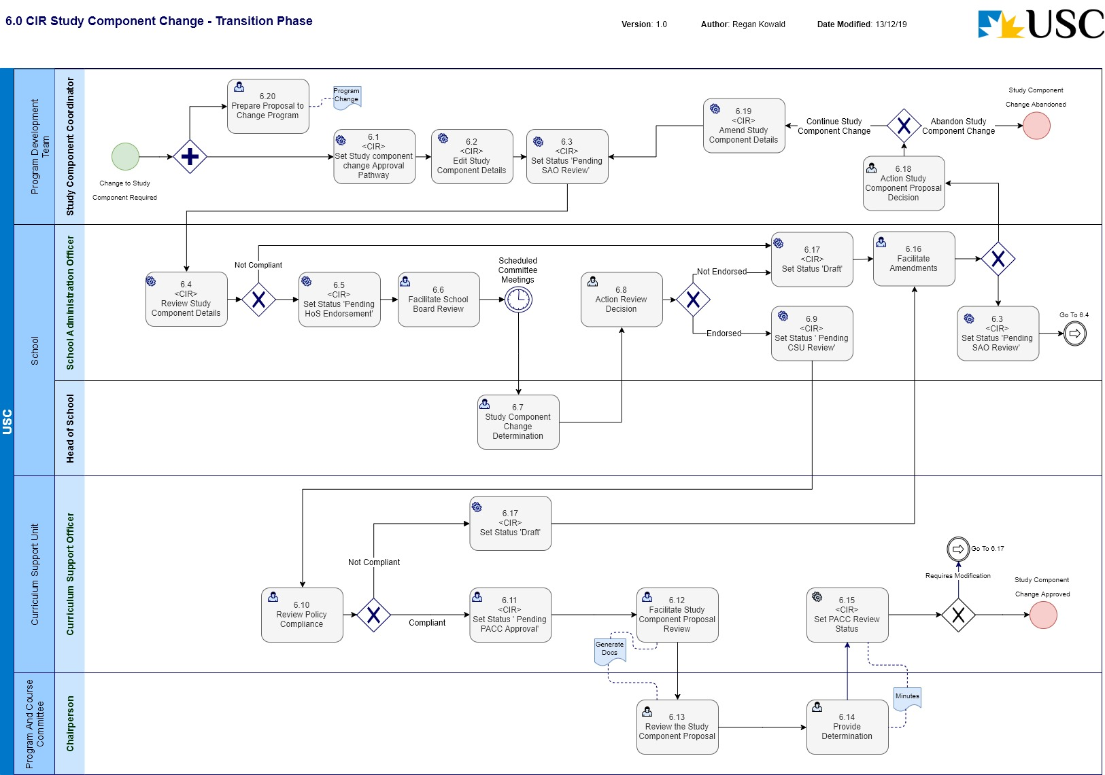
Business Process Name: | 6.0 CIR Study Component Change
Description | This is the process required to initiate a change to a Study Component in CIR and manage the request through the formal review and approval business process.
Roles | - Study Component Coordinator – Program Development Team  - School Administration Officer - School  - Curriculum Support Officer – C-SALT  - PACC Chairperson – Program and Course Committee
Triggers | - A Study Component Coordinator initiates the request for a change to be made to a Study Component.
Pre-Conditions | - The Study Component to be changed exists in CIR.  - An Accredited (Approved) Program considered to be the ‘owning Program’ must exist in CIR
Process Task Description | - <CIR> Set Study component change Approval Pathway  The Study Component Coordinator will access CIR and select the ‘Study component change’ Approval Pathway for the Study Component entity.  Note: This action will set the status of the Study Component entity to ‘Draft’.
- <CIR> Edit Study Component Details
The Study Component Coordinator will access CIR, and enter the relevant information required to change the Study Component.
The Study Component Coordinator will facilitate the creation of the Proposal to Change Program at this time. The proposal documentation will be sent to the SAO.
- <CIR> Set Status ‘Pending SAO Review’
The status of the Study Component will be set to ‘Pending SAO Review’.
If this is the initial setting of this status, The Study Component Coordinator will also attach the ‘Proposal to Change a Program’.
Note: This puts the entity into a state of ‘read only’ and changes cannot be made.
- <CIR> Review Study Component Details
The SAO upon receiving email notification, will review the details of the Study Component change to determine if the details are compliant. If the current information is not compliant, the Study Component Coordinator will be notified, and the status of the Study Component will be set back to ‘Draft’ for modification.
The SAO will also review the Proposal to Change Program in conjunction with the CIR information.
- <CIR> Set Status ‘Pending HoS Endorsement’
The SAO will set the workflow status to ‘Pending HoS Endorsement’. This task requires the SAO to provide a comment/s supporting the status change.
- Facilitate School Board Review
The SAO will compile the relevant documentation for the Head of School to seek informed advice from the School Board.
- Study Component Change Determination
The Head of School will consider the merit of the proposed study component change on the basis of the documentation and the advice from the School Board and make a determination on the approval of the Study Component change.
- Action Review Decision
The SAO will determine what action is required of the HoS decision for the requested Study Component. If the change is not endorsed, the SAO will return the request back to the Study Component Coordinator (Program Development Team) for review and modification based on the HoS recommendations. If the change is endorsed, the SAO will progress the process.
Note: If the change is not endorsed, the SAO will set the status of the Study Component entity to ‘Draft’ to allow editing of the information.
- Set Status ‘Pending CSU Review’
The SAO will set the workflow status to ‘Pending CSU Review’. This task requires the SAO to provide supporting comment/s with the status change.
- Review Policy Compliance
The CSO reviews the Study Component creation details for policy compliance (University and external reference points), data quality and completeness. If the information is not compliant, the SAO will be notified, and the Study Component request will be sent back for amendment.
Note: If the proposal is not compliant, the CSO will set the status of the Study Component entity to ‘Draft’ to allow editing of the information.
- <CIR> Set Status ‘Pending PACC Approval’
The CSU will set the workflow status to be ‘Pending PACC Approval’.
- Facilitate Study Component Proposal Review
The CSO will export the information out of CIR in PDF format and facilitate the distribution to PACC. The CSO will then monitor the progress for a response.
- Review the Study Component Proposal
The PACC Chairperson or delegate will receive the submitted documentation from CSU and facilitate any discussions with relevant parties to provide a decision to the School.
- Provide Determination
The PACC Chairperson will decide on whether to approve the change to the Study Component or not and notify CSU.
The CSU will be notified via the PACC Meeting Minutes.
- <CIR> Set PACC Review Status
The CSO will set the status for the workflow dependant on the determination by the PACC:
If the decision is that the request for change of a Study Component needs to be modified, the CSO will set the status ‘Draft’ and notify the SAO.
If the decision is that the request for change of a Study Component is approved the CSO will set the status ‘Approved’ and notify the School.
- Facilitate Amendments
The SAO will receive notification and commentary with the status change ‘Draft’ outlining the returning authority’s recommendation required to change the Study Component. The SAO will either make the required administrative updates and refer back to the CSU for review or initiate the process to amend the Study Component change documentation with the Study Component Coordinator.
- <CIR> Set Status ‘Draft’
The Study Component entity will be set to a status of ‘Draft’ to enable editing in CIR.
- Action Study Component Proposal Decision
The Study Component Coordinator will review and action the required changes of the Study Component proposal. This may require amendments to be made to the proposal or in fact abandon the changes to the Study Component.
- <CIR> Amend Study Component Details
With the status of the Study Component entity as ‘Draft’, the Study Component Coordinator will make any the changes to the Study Component information in CIR to meet the approval requirements.
- Prepare Proposal for Change to Program
The Study Component Coordinator will initiate the creation of a ‘Proposal to Change Program’ document for the ‘owning Program’. This document will be required to support the CIR generated information for the approval workflow process.
Post-Conditions | - The change to the Study Component (and the change to the Program) is approved and has a CIR status of ‘Approved’; or  - The process to change the Study Component is discontinued.
Supporting Applications/Tools | - Curriculum Information Repository
Forms/Templates | - Program Change Proposal requiring Committee(s) approval
Related Documentation | - USC Program Accreditation, Change and Discontinuation – Procedures.  - Program Accreditation and Course Approval - Governing Policy  - Program Review - Procedures  - Australian Qualifications Framework  - Higher Education Standards Framework.
Business Rules | - F1 Programs and study Components  F1.1 Study Components are approved as part of the accreditation of the “owning” program. A Study Component can be a requirement in multiple programs but only one program is identified as its “owner”.  F1.2 Study Components that have been identified as owned by a program in the accreditation process are modified or discontinued as a change to the owning program. The consultation process for any changes to a study component should ensure that all other programs requiring the study component are informed of the proposed changes.  F1.3 A program that proposes the inclusion of an existing study component as a new structural requirement will be required to make a program change to have that inclusion approved.  F1.4 The Program Coordinator may seek to have a study component offered at another institution recognised as part of their program’s structural requirements, the process is identified in Section F3 of these procedures.  - F2 Discontinuation of a study component  The discontinuation of a study component requires the approval of the Deputy Vice-Chancellor (Academic) (as delegate of the Vice-Chancellor and President).  - F3 Structural requirements for a Study Component  A Study Component Outline is required to be completed for any new or modified study component. The Study Component Outline should be included in the program accreditation/approval documentation.
Issues
Notes | - Conceptually, this process will be run in conjunction with 2.0 CIR Program Change in that the request for a new Study Component will generate a change to the ‘owning Program’. Practically speaking, the processes are run separately, and the dependencies are managed with an informal communication process.  - It is an assumption of this business process, that with the introduction of CIR, Curriculum Bulletins will not be required to be prepared and submitted. The information contained in the Curriculum Bulletin will be available in CIR.  - It is an assumption of this business process that the ‘Study Component Outline’ as named in USC Policy and Procedure documents will be superseded by the introduction of CIR i.e. the information contained in the ‘Study Component Outline’ document will be available as the CIR Study Component entity.  - This Process Map depicts the workflow expected for the initial implementation of CIR and should be considered a transitional phase. As the business outside of C-SALT become more familiar with the CIR, the CSO’s will take less of a role in facilitating the workflows through, and each role in the workflow will take the responsibility for progressing the status change through the workflow.

7.0 CIR Study Component Suspension
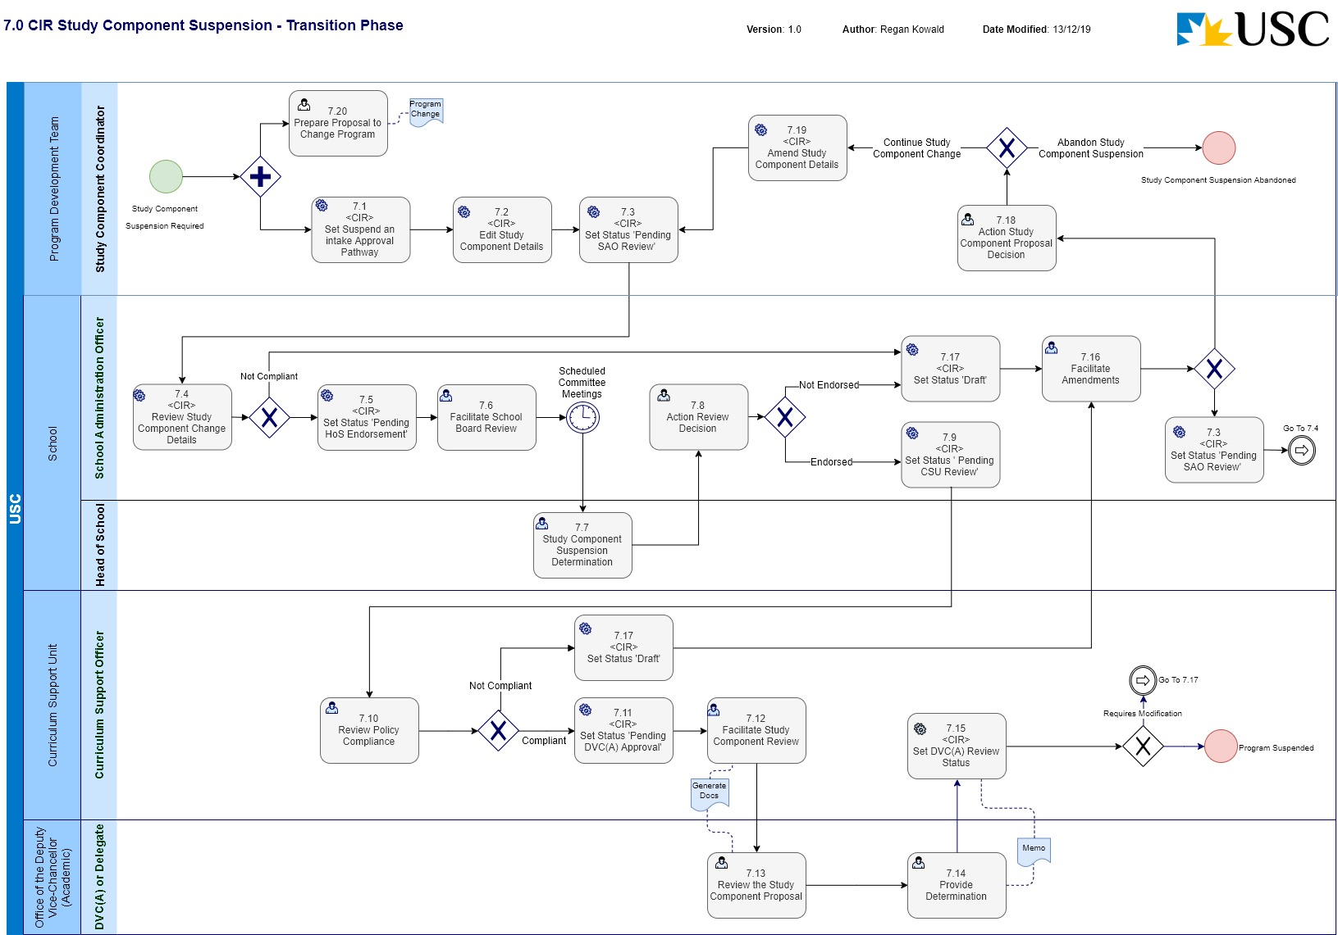
Business Process Name: | 7.0 CIR Study Component Suspension
Description | This is the process required to initiate a suspension of a Study Component in CIR and manage the request through the formal review and approval business process.
Roles | - Study Component Coordinator – Program Development Team  - School Administration Officer – School  - Head of School - School  - Curriculum Support Officer – C-SALT  - DVC(A) or Delegate – Office of the Deputy Vice-Chancellor (Academic)
Triggers | - A Study Component Coordinator initiates the request for a suspension of a Study Component.
Pre-Conditions | - The Study Component to be changed exists in CIR.  - An Accredited (Approved) Program considered to be the ‘owning Program’ must exist in CIR
Process Task Description | - <CIR> Set Suspend an intake Approval Pathway  The Study Component Coordinator will access CIR and select the ‘Suspend an intake (study component/program only)’ Approval Pathway for the Study Component entity.  Note: This action will set the status of the Study Component entity to ‘Draft’.
- <CIR> Edit Study Component Details
The Study Component Coordinator will access CIR, and enter the relevant information required to suspend the Study Component.
The Study Component Coordinator will facilitate the creation of the Proposal to Change Program at this time.
- <CIR> Set Status ‘Pending SAO Review’
The status of the Study Component will be set to ‘Pending SAO Review’.
If this is the initial setting of this status, The Study Component Coordinator will also attach the ‘Proposal to Change a Program’.
Note: This puts the entity into a state of ‘read only’ and changes cannot be made.
- <CIR> Review Study Component Details
The SAO upon receiving email notification, will review the details of the Study Component suspension to determine if the details are compliant. If the current information is not compliant, the Study Component Coordinator will be notified, and the status of the Study Component will be set back to ‘Draft’ for modification.
The SAO will also review the Proposal to Change Program in conjunction with the CIR information.
- <CIR> Set Status ‘Pending HoS Endorsement’
The SAO will set the workflow status to ‘Pending HoS Endorsement’. This task requires the SAO to provide a comment/s supporting the status change.
- Facilitate School Board Review
The SAO will compile the relevant documentation for the Head of School to seek informed advice from the School Board. The Head of School will consider the merit of the proposed Study Component on the basis of the documentation and the advice from the School Board and make a determination.
- Study Component Suspension Determination
The Head of School will consider the merit of the proposed study component suspension on the basis of the documentation and the advice from the School Board and make a determination on the approval of the Study Component suspension.
- Action Review Decision
The SAO will determine what action is required of the HoS decision for the requested Study Component. If the suspension is not endorsed, the SAO will return the request back to the Study Component Coordinator (Program Development Team) for review and modification based on the HoS recommendations. If the suspension is endorsed, the SAO will progress the process.
Note: If the change is not endorsed, the SAO will set the status of the Study Component entity to ‘Draft’ to allow editing of the information.
- Set Status ‘Pending CSU Review’
The SAO will set the workflow status to ‘Pending CSU Review’. This task requires the SAO to provide supporting comment/s with the status change.
- Review Policy Compliance
The CSO reviews the Study Component suspension details for policy compliance (University and external reference points), data quality and completeness. If the information is not compliant, the SAO will be notified, and the Study Component request will be sent back for amendment.
Note: If the change is not endorsed, the CSO will set the status of the Study Component entity to ‘Draft’ to allow editing of the information.
- <CIR> Set Status ‘Pending DVC(A) Approval’
The CSU will set the workflow status to be ‘Pending DVC(A) Approval’.
- Facilitate Study Component Review
The CSO will export the information out of CIR in PDF format and facilitate the distribution to the DVC(A). The CSO will then monitor the progress for a response.
- Review the Study Component Proposal
The DVC(A) or delegate will review the submitted documentation from CSU and facilitate any discussions with relevant parties to provide a decision to the School.
- Provide Determination
The DVC(A) or delegate will decide on whether to approve the suspension of the Study Component or not and notify CSU.
The CSU will be notified via a DVC(A) Memo.
- <CIR> Set DVC(A) Review Status
The CSO will set the status for the workflow dependant on the determination by the DVC(A):
If the decision is that the request for suspension of the Study Component needs to be modified, the CSO will set the status ‘Pending SAO Review’.
If the decision is that the request for suspension of the Study Component is approved the CSO will set the status ‘Suspend an intake’. The CSO will also add the ‘to and from’ dates for the period the suspension is valid for into CIR.
- Facilitate Amendments
The SAO will receive notification and commentary with the status change ‘Draft’ outlining the amendments required to make the Study Component suspension compliant. The SAO will either make the required amendments and refer back to the CSU for review or initiate the process to amend the Study Component suspension with the Study Component Coordinator.
- <CIR> Set Status ‘Draft’
The Study Component entity will be set to a status of ‘Draft’ to enable editing in CIR.
- Action Study Component Proposal Decision
The Study Component Coordinator will review and action the required changes of the Study Component proposal. This may require amendments to be made to the proposal or in fact abandon the suspension of the Study Component.
- <CIR> Amend Study Component Details
With the status of the Study Component entity as ‘Draft’, the Study Component Coordinator will make any the changes to the Study Component information in CIR to meet the approval requirements.
- Prepare Proposal for Change to Program
The Study Component Coordinator will initiate the creation of a ‘Proposal to Change Program’ document for the ‘owning Program’. This document will be required to support the CIR generated information for the approval workflow process.
Post-Conditions | - The suspension of the Study Component (and the change to the Program) is approved and has a CIR status of ‘Suspend an intake’; or  - The process to suspend the Study Component is discontinued.
Supporting Applications/Tools | - Curriculum Information Repository
Forms/Templates | - Program Change Proposal requiring Committee(s) approval
Related Documentation | - USC Program Accreditation, Change and Discontinuation – Procedures.  - Program Accreditation and Course Approval - Governing Policy  - Program Review - Procedures  - Australian Qualifications Framework  - Higher Education Standards Framework.
Business Rules | - F1 Programs and study Components  F1.1 Study Components are approved as part of the accreditation of the “owning” program. A Study Component can be a requirement in multiple programs but only one program is identified as its “owner”.  F1.2 Study Components that have been identified as owned by a program in the accreditation process are modified or discontinued as a change to the owning program. The consultation process for any changes to a study component should ensure that all other programs requiring the study component are informed of the proposed changes.  F1.3 A program that proposes the inclusion of an existing study component as a new structural requirement will be required to make a program change to have that inclusion approved.  F1.4 The Program Coordinator may seek to have a study component offered at another institution recognised as part of their program’s structural requirements, the process is identified in Section F3 of these procedures.  - F2 Discontinuation of a study component  The discontinuation of a study component requires the approval of the Deputy Vice-Chancellor (Academic) (as delegate of the Vice-Chancellor and President).  - F3 Structural requirements for a Study Component  A Study Component Outline is required to be completed for any new or modified study component. The Study Component Outline should be included in the program accreditation/approval documentation.
Issues | - CIR does not currently have functionality to capture the period a suspension of intake for a Study Component is valid for.
Notes | - Conceptually, this process will be run in conjunction with 2.0 CIR Program Change in that the request for a new Study Component will generate a change to the ‘owning Program’. Practically speaking, the processes are run separately, and the dependencies are managed with an informal communication process.  - It is an assumption of this business process, that with the introduction of CIR, Curriculum Bulletins will not be required to be prepared and submitted. The information contained in the Curriculum Bulletin will be available in CIR.  - It is an assumption of this business process that the ‘Study Component Outline’ as named in USC Policy and Procedure documents will be superseded by the introduction of CIR i.e. the information contained in the ‘Study Component Outline’ document will be available as the CIR Study Component entity.  - This Process Map depicts the workflow expected for the initial implementation of CIR and should be considered a transitional phase. As the business outside of C-SALT become more familiar with the CIR, the CSO’s will take less of a role in facilitating the workflows through, and each role in the workflow will take the responsibility for progressing the status change through the workflow.

8.0 CIR Study Component Discontinuation
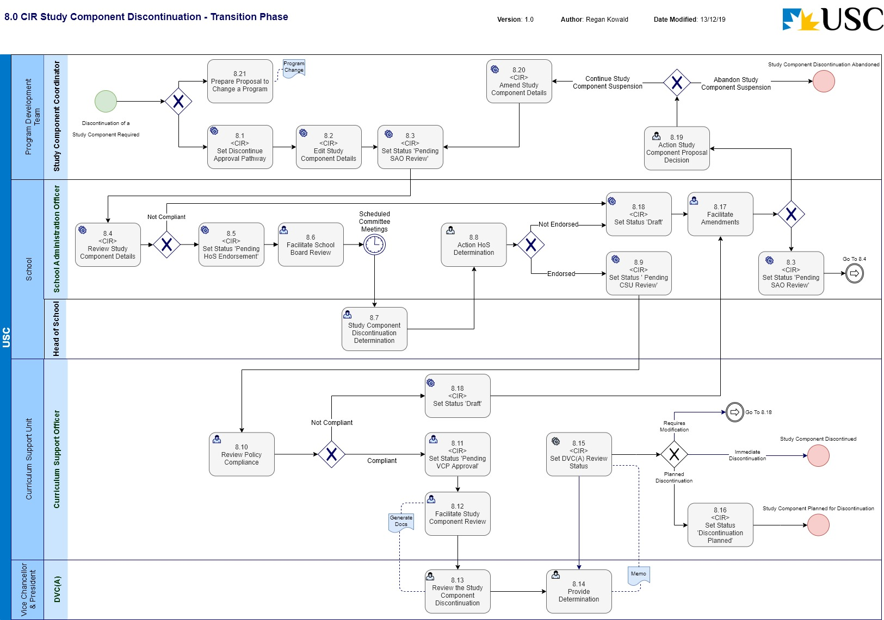
Business Process Name: | 8.0 CIR Study Component Discontinuation
Description | This is the process required to initiate a discontinuation of a Study Component in CIR and manage the request through the formal review and approval business process.
Roles | - Study Component Coordinator – Program Development Team  - School Administration Officer – School  - Head of School - School  - Curriculum Support Officer – C-SALT  - DVC(A) as delegate for the VCP – Office of the Vice-Chancellor & President
Triggers | - A Study Component Coordinator initiates the request for the discontinuation of a Study Component.
Pre-Conditions | - The Study Component to be changed exists in CIR.  - An Accredited (Approved) Program considered to be the ‘owning Program’ must exist in CIR
Process Task Description | - <CIR> Set Discontinue Approval Pathway  The Study Component Coordinator will access CIR and select the ‘Discontinue’ Approval Pathway for the Study Component entity.  Note: This action will set the status of the Study Component entity to ‘Draft’.
- <CIR> Edit Study Component Details
The Study Component Coordinator will access CIR, and enter the information required to discontinue the Study Component.
The Study Component Coordinator will facilitate the creation of the Proposal to Change Program at this time.
- <CIR> Set Status ‘Pending SAO Review’
The status of the Study Component will be set to ‘Pending SAO Review’.
If this is the initial setting of this status, The Study Component Coordinator will also attach the ‘Proposal to Change a Program’.
Note: This puts the entity into a state of ‘read only’ and changes cannot be made.
- <CIR> Review Study Component Details
The SAO upon receiving email notification, will review the details of the Study Component discontinuation to determine if the details are compliant. If the current information is not compliant, the Study Component Coordinator will be notified, and the status of the Study Component will be set back to ‘Draft’ for modification.
The SAO will also review the Proposal to Change Program in conjunction with the CIR information.
- <CIR> Set Status ‘Pending HoS Endorsement’
The SAO will set the workflow status to ‘Pending HoS Endorsement’. This task requires the SAO to provide a comment/s supporting the status change.
- Facilitate School Board Review
The SAO will compile the relevant documentation for the Head of School to seek informed advice from the School Board. The Head of School will consider the merit of the proposed Study Component on the basis of the documentation and the advice from the School Board and make a determination.
- Study Component Discontinuation Determination
The Head of School will consider the merit of the proposed study component discontinuation on the basis of the documentation and the advice from the School Board and make a determination on the approval of the Study Component discontinuation.
- Action HoS Determination
The SAO will action the tasks required of the HoS decision for the Study Component. If the discontinuation is not endorsed, the SAO will return the request back to the Study Component Coordinator (Program Development Team) for review and modification based on the HoS recommendations. If the discontinuation is endorsed, the SAO will progress the process.
Note: If the change is not endorsed, the SAO will set the status of the Study Component entity to ‘Draft’ to allow editing of the information.
- Set Status ‘Pending CSU Review’
The SAO will set the workflow status to ‘Pending CSU Review’. This task requires the SAO to provide supporting comment/s with the status change.
- Review Policy Compliance
The CSO reviews the Study Component discontinuation details for policy compliance (University and external reference points), data quality and completeness. If the information is not compliant, the SAO will be notified, and the Study Component request will be sent back for amendment.
Note: If the change is not endorsed, the CSO will set the status of the Study Component entity to ‘Draft’ to allow editing of the information.
- <CIR> Set Status ‘Pending VCP Approval’
The CSU will set the workflow status to be ‘Pending VCP Approval’.
- Facilitate Study Component Proposal Review
The CSO will export the information out of CIR in PDF format and facilitate the distribution to the DVC(A) as delegate for the VCP. The CSO will then monitor the progress for a response.
- Review the Study Component Proposal
The DVC(A) as delegate for the VCP will review the submitted documentation from CSU and facilitate any discussions with relevant parties to provide a decision to the School.
- Provide Determination
The DVC(A) will decide on whether to approve the suspension of the Study Component or not and notify CSU.
The CSU will be notified via a DVC(A) Memo.
- <CIR> Set DVC(A) Review Status
The CSO will set the status for the workflow dependant on the determination by the DVC(A):
If the decision is that the request for discontinuation of the Study Component needs to be modified, the CSO will set the status ‘Draft’ and notify the SAO.
If the decision is that the request for discontinuation of the Study Component is approved the CSO will set the status ‘Discontinued’ and notify the School.
- <CIR> Set Status ‘Discontinuation Planned’
If the decision of the DVC(A) is that the Study Component has been approved for a planned (future dated) discontinuation, the CSO will set the status ‘Discontinuation Planned’. The CSO will also enter in a date for the planned discontinuation (‘final study period of offer’).
- Facilitate Amendments
The SAO will receive notification and commentary with the status change ‘Draft’ outlining the amendments required to make the Study Component discontinuation compliant. The SAO will either make the required amendments and refer back to the CSU for review or initiate the process to amend the Study Component discontinuation with the Study Component Coordinator.
- <CIR> Set Status ‘Draft’
The Study Component entity will be set to a status of ‘Draft’ to enable editing in CIR.
- Action Study Component Proposal Decision
The Study Component Coordinator will review and action the required changes of the Study Component proposal. This may require amendments to be made to the proposal or in fact abandon the discontinuation of the Study Component.
- <CIR> Amend Study Component Details
With the status of the Study Component entity as ‘Draft’, the Study Component Coordinator will make any the changes to the Study Component information in CIR to meet the approval requirements.
- Prepare Proposal for Change to Program
The Study Component Coordinator will initiate the creation of a ‘Proposal to Change Program’ document for the ‘owning Program’. This document will be required to support the CIR generated information for the approval workflow process.
Post-Conditions | - The discontinuation of the Study Component (and the change to the Program) is approved and has a CIR status of ‘Discontinued’; or  - The planned discontinuation of the Study Component (and the change to the Program) is approved, has a CIR status of ‘Discontinuation Planned’ and the planned date for discontinuation has been recorded; or  - The process to discontinue the Study Component is abandoned.
Supporting Applications/Tools | - Curriculum Information Repository
Forms/Templates | - Program Change Proposal requiring Committee(s) approval
Related Documentation | - USC Program Accreditation, Change and Discontinuation – Procedures.  - Program Accreditation and Course Approval - Governing Policy  - Program Review - Procedures  - Australian Qualifications Framework  - Higher Education Standards Framework.
Business Rules | - The date associated with the ‘Planned for Discontinuation’ status will be the ‘final study period of offer’.  - F1 Programs and study Components  F1.1 Study Components are approved as part of the accreditation of the “owning” program. A Study Component can be a requirement in multiple programs but only one program is identified as its “owner”.  F1.2 Study Components that have been identified as owned by a program in the accreditation process are modified or discontinued as a change to the owning program. The consultation process for any changes to a study component should ensure that all other programs requiring the study component are informed of the proposed changes.  F1.3 A program that proposes the inclusion of an existing study component as a new structural requirement will be required to make a program change to have that inclusion approved.  F1.4 The Program Coordinator may seek to have a study component offered at another institution recognised as part of their program’s structural requirements, the process is identified in Section F3 of these procedures.  - F2 Discontinuation of a study component  The discontinuation of a study component requires the approval of the Deputy Vice-Chancellor (Academic) (as delegate of the Vice-Chancellor and President).  - F3 Structural requirements for a Study Component  A Study Component Outline is required to be completed for any new or modified study component. The Study Component Outline should be included in the program accreditation/approval documentation.
Issues | - Currently when a status of ‘Discontinuation Planned’ has been applied, the actual planned date for discontinuation (i.e. the final study period of offer) cannot be captured in CIR.
Notes | - Conceptually, this process will be run in conjunction with 2.0 CIR Program Change in that the request for a new Study Component will generate a change to the ‘owning Program’. Practically speaking, the processes are run separately, and the dependencies are managed with an informal communication process.  - It is an assumption of this business process, that with the introduction of CIR, Curriculum Bulletins will not be required to be prepared and submitted. The information contained in the Curriculum Bulletin will be available in CIR.  - It is an assumption of this business process that the ‘Study Component Outline’ as named in USC Policy and Procedure documents will be superseded by the introduction of CIR i.e. the information contained in the ‘Study Component Outline’ document will be available as the CIR Study Component entity.  - This Process Map depicts the workflow expected for the initial implementation of CIR and should be considered a transitional phase. As the business outside of C-SALT become more familiar with the CIR, the CSO’s will take less of a role in facilitating the workflows through, and each role in the workflow will take the responsibility for progressing the status change through the workflow.

Course Entity

9.0 CIR New Course
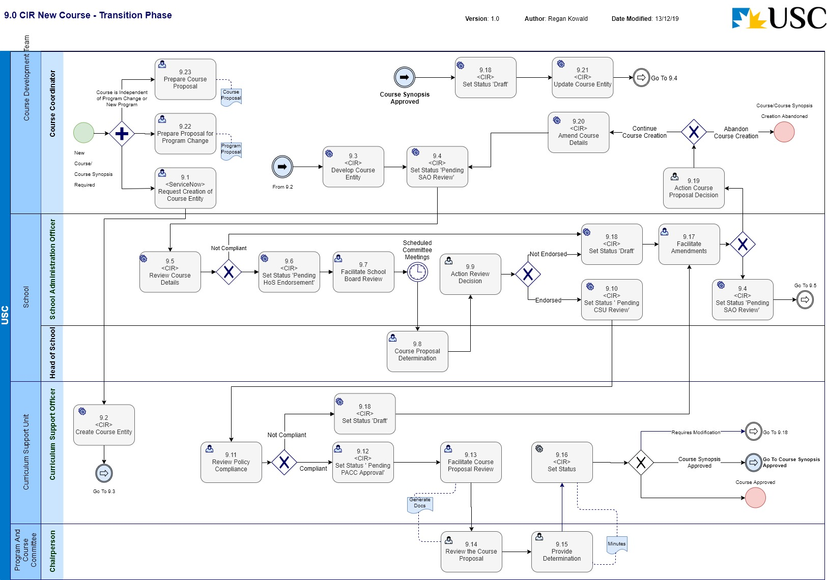

Business Process Name: | 9.0 CIR New Course
Description | This is the process required to initiate a new Course or Course Synopsis in CIR and manage the request through the formal review and approval business process.
Roles | - Course Coordinator – Course Development Team  - School Administration Officer – School  - Head of School - School  - Curriculum Support Officer – C-SALT  - PACC Chairperson – Program and Course Committee
Triggers | - A Course Coordinator initiates the request for a Course/Course Synopsis to be created.
Pre-Conditions | - The Course to be created does not exist in CIR.  - An Accredited (Approved) Program considered to be the ‘owning Program’ must exist in CIR if the Course creation is being proposed as a change to a Program.
Process Task Description | - <ServiceNow> Request Creation of Course Entity  The Course Coordinator will request the creation of a Course entity in CIR by raising a ticket in ServiceNow.
- <CIR> Create Course Entity
The CSO will access CIR and enter the minimum amount of information required to create the Course/Course Synopsis.
If the entity is a Course Synopsis, the CSO will also create a dummy Assessment item and criteria to enable the Learning outcomes to be linked to Assessment Criteria, which will be required in order for the entity to be ‘Approved’.
Note: It is anticipated that codes and reporting fields required by SIAU will be entered by the CSO.
Note: by default, the status is ‘Draft’ when creating a new entity, which allows the Course Coordinator and SAO to edit the Course details.
The Course Coordinator will facilitate the creation of the Proposal to Change Program or Course Proposal at this time.
- <CIR> Develop Course Entity
The Course Coordinator will facilitate the development of the Course information in CIR to the point where it is ready for SAO review.
Note: A link will be created in CIR to the Proposal to Change Program or Course Proposal as an attachment.
- <CIR> Set Status ‘Pending SAO Review’
The status of the Course will be set to ‘Pending SAO Review’.
If this is the initial setting of this status, The Course Coordinator will also attach the ‘Proposal to Change a Program’ or ‘Course Proposal’.
Note: This puts the entity into a state of ‘read only’ and changes cannot be made.
- <CIR> Review Course Details
The SAO upon receiving email notification, will review the details of the Course/Course Synopsis creation to determine if the details are compliant. If the current information is not compliant, the Course Coordinator will be notified, and the status of the Course will be set back to ‘Draft’ for modification.
The SAO will also review the Proposal to Change Program or Course Proposal in conjunction with the CIR information.
- <CIR> Set Status ‘Pending HoS Endorsement’
The SAO will set the workflow status to ‘Pending HoS Endorsement’. This task requires the SAO to provide a comment/s supporting the status change.
- Facilitate School Board Review
The SAO will compile the relevant documentation for the Head of School to seek informed advice from the School Board. The Head of School will consider the merit of the proposed Course/Course Synopsis on the basis of the documentation and the advice from the School Board and make a determination.
- Course Proposal Determination
The Head of School will consider the merit of the proposed Course on the basis of the documentation and the advice from the School Board and make a determination on the approval of the new Course.
- Action Review Decision
The SAO will determine what action is required of the HoS decision for the requested Course. If the creation is not endorsed, the SAO will return the request back to the Course Coordinator (Course Development Team) for modification based on the Head of School recommendations. If the creation is endorsed, the SAO will progress the process.
Note: If the proposal is not endorsed, the SAO will set the status of the Course entity to ‘Draft’ to allow editing of the information.
- Set Status ‘Pending CSU Review’
The SAO will set the workflow status to ‘Pending CSU Review’. This task requires the SAO to provide supporting comment/s with the status change.
- Review Policy Compliance
The CSO reviews the Course/Course Synopsis creation details for policy compliance (University and external reference points), data quality and completeness. If the information is not compliant, the SAO will be notified.
Note: If the proposal is not compliant, the CSO will set the status of the Course entity to ‘Draft’ to allow editing of the information.
- <CIR> Set Status ‘Pending PACC Approval’
The CSU will set the workflow status to be ‘Pending PACC Approval’.
- Facilitate Course Proposal Review
The CSO will export the information out of CIR in PDF format and facilitate the distribution to PACC. The CSO will then monitor the progress for a response.
- Review the Course Proposal
The PACC Chairperson or delegate will receive the submitted documentation from CSU and facilitate any discussions with relevant parties to provide a decision to the School.
- Provide Determination
The PACC Chairperson will decide on whether to approve the creation of the Course/Course Synopsis or not and notify CSU.
The CSU will be notified via the PACC Meeting Minutes.
- <CIR> Set Status
The CSO will set the status for the workflow dependant on the determination by the PACC:
If the decision is that the request for creation of a Course/Course Synopsis needs to be modified, the CSO will set the status ‘Draft’ and notify the SAO.
If the decision is that the request for creation of a Course or Course Synopsis is approved the CSO will set the status ‘Approved’ and notify the School.
If the workflow is for the approval of a (full course outline) Course from a Course Synopsis, the CSO will ‘uncheck’ the system Course Synopsis ‘checkbox’ field, and remove the hashtag (‘#’) from the Title field at this point in the workflow.
- Facilitate Amendments
The SAO will receive notification and commentary with the status change ‘Draft’ outlining the returning authority’s recommendation required to approve the Course. The SAO will either make the required administrative updates and refer back to the CSU for review or initiate the process to amend the Course documentation with the Course Coordinator.
- <CIR> Set Status ‘Draft’
The workflow status of the Course entity will be set to ‘Draft’ to enable editing of the Course information in CIR.
- Action Course Proposal Decision
The Course Coordinator will review and action the required changes of the Course proposal. This may require amendments to be made to the proposal or in fact abandon the creation of the Course.
- <CIR> Amend Course Details
With the status of the Course entity as ‘Draft’, the Course Coordinator will make any the changes to the Course information in CIR to meet the approval requirements.
- <CIR> Update Course Entity
The Course Coordinator will complete the input of the additional information required of the Course Synopsis for the approval as a Course.
Note: The approval process is repeated to gain Course approval.
- Prepare Proposal for Change to Program
If the creation of the Course is being proposed due to a Program change, The Course Coordinator will initiate the creation of a ‘Proposal to Change Program’ document for the ‘owning Program’. This document will be required to support the CIR generated information for the approval workflow process.
- Prepare Course Proposal
If the creation of the Course is being proposed independent of a new Program proposal or change to an existing Program, the Course Coordinator will initiate the creation of a ‘Course Proposal’. This document will be required to support the CIR generated information for the approval workflow process.
Post-Conditions | - The creation of a new Course is approved and has a CIR status of ‘Approved’; or  - The creation of a new Course Synopsis is approved and has a CIR status of ‘Approved’ (with identifiers); or  - The process to create a new Course or Course Synopsis is discontinued.
Supporting Applications/Tools | - Curriculum Information Repository
Forms/Templates | - Course proposal  - USC Course Impact Statement  - Course Administration Information  - Program Change Proposal requiring Committee(s) approval
Related Documentation | - Course Approval, Change and Discontinuation - Procedures  - Assessment: Courses and Coursework Programs - Academic Policy  - USC Program Accreditation, Change and Discontinuation – Procedures.  - Program Accreditation and Course Approval - Governing Policy  - Program Review - Procedures  - Australian Qualifications Framework  - Higher Education Standards Framework.
Business Rules | - Course Synopsis system identifier  A Course Synopsis entity in CIR will require the hashtag symbol (‘#’) suffixing the Title. The hashtag will be used both as a system identifier and visually to define the entity is a Course Synopsis.  - B1 New Course approval authority  Approval of a new course is the responsibility of the Program and Course Committee.  - A3 Scope of application  If a new course is proposed either as part of the accreditation of a program or as part of changes to a program, approval of the course is by Program and Course Committee, regardless of the new program or the program changes requiring approval either by Program and Courses Committee or Academic Board.  - A2.1 Schools plan and progress all proposed new courses, course changes and course discontinuations to meet the University timeframes for approval as identified below:  * New Course - Study Period 1 offering – approved by 31 August for the following academic year Study Period 2 offering – approved by 30 November for the following academic year.  * New course already approved as a Course Synopsis - Study Period 1 offering – approved by 31 August for the following academic year Study Period 2 offering – approved by 30 November for the following academic year.  * Change to Pre-enrolment data for existing courses - Approved by 31 August for all offerings in the following academic year.  * Change to other data fields for existing courses - Approved four weeks prior to the delivery of the course.  * Changes to “service courses” (specified data fields) - Approved by 31 August for all offerings in the following academic year.  * Discontinuation of an existing course - Approved by 31 August for implementation in the following academic year.  - B2 Development of course  B2.1 The relevant School creates a course development team and they develop the course ensuring that:  (a) consultations are held with all parties: (i) with a legitimate interest in the proposed development, including for example other schools if the course is to be made available in a cross-school or double degree program, and professional and registration bodies; (ii) for whom there may be resource or administrative implications with the proposed developments, including for example Information Technology Services, Information Services, and Student Services and Engagement;  (b) input is sought from other appropriate sources with relevant expertise, for example a school curriculum body, academic developers and curriculum support staff (CSU) available within the Centre for Support and Advancement of Learning and Teaching (C-SALT);  (c) the course is designed and developed consistent with: any applicable policies and procedures within the University, in particular the Coursework Curriculum Design – Academic Policy and related procedures, and any standards for external recognition, registration or accreditation of any program in which the new course will be offered.  - B3 Initial approval documentation  B3.1 The Course Development Team documents the proposed new course including resource needs using:  (a) the Course Proposal template;  (b) the Course Outline/Course Administration Information templates;  (c) the resource impact statement template for Library, Information Technology Services (ITS), and Student Services and Engagement;  (d) Course Synopses (only available for courses that are to be introduced in later years of a new program).  B3.2 Course Proposal  The Course Proposal is used when the course is being proposed independently of a new program proposal or a change to an existing program.  B3.3 Course Outline/Course Administration Information  The Course Outline is the description of the proposed new course that is used to assess its academic merit and which forms the basis for provision of information to students, intending students, the University community and the public concerning the course. The Course Administration Information includes data required for the establishment and administration of the course.  B3.4 Resource Impact Statements  Resource Impact Statements detail the resource needs and implications of the proposed course for provision of support and services by, Library and Information Technology Services (ITS) and Student Services and Engagement.  B3.5 Course Synopses  B3.5.1 In some circumstances, full development and documentation of new courses to be undertaken in the second or subsequent years of offer of a proposed new program or an existing program undergoing significant change may not be possible. In these cases, a Course Synopsis can be substituted for the relevant Course Outline when documenting the new program or changed existing program. Consultations should be held with any relevant professional body to confirm the acceptability of this approach for meeting conditions for external accreditation of the program.  B3.5.2 New courses documented only as Course Synopses are provisionally approved by Program and Course Committee on the condition that the course/s must subsequently be fully documented using the Course Outline template and supporting impact statements. Requests for final approval of Course Outline must be approved by the Program and Course Committee, on the recommendation of the Head of School.  - B4 Consideration by Head of School  B4.1 The course development team forwards the proposal and course outline to the relevant Head of School who considers the documentation.  B4.2 Before consideration by the Head of School, the documentation is considered by the School Board, the School Board would provide advice to the Head of School on the merit and quality of the proposed course.  B4.3 Following consideration by the School Board, the School Administration Officer completes a template to request from Student Services and Engagement the: (a) allocation of Course Codes for any new courses.  B4.4 The School Administration Officer requests Information Management Services to create a new University file in the records management system for each new course allocated a code.  B4.5 The School Administration Officer updates the course documentation and Resource Impact Statements to include program and course codes and file numbers, and then provides a copy to Student Services and Engagement (Timetabling Unit), Asset Management Services, the Library and Information Technology Services.  B4.6 The Head of School considers the academic merit of the new course on the basis of the documentation and the advice of the School Board, and sign the relevant section of the Proposal.  B4.7 The School Administration Officer arranges for the signed documentation to be submitted to the Curriculum Support Unit, C-SALT.  - B5 Progression to Program and Course Committee (PACC) for approval  B5.1 Curriculum Support Unit, C-SALT checks the documentation for completeness and clarity, accuracy, internal consistency and liaises with relevant school staff in order for appropriate actions to be taken to address any issues and for amended documentation to be submitted where needed.  B5.2 The Curriculum Support Unit, C-SALT forwards the documentation to the committee secretary for consideration by the Program and Course Committee.  B5.3 Program and Course Committee considers the academic merit of the proposed course on the basis of the documentation, and the Program and Course Committee can:  (a) resolves that the proposed new course as documented be approved; or  (b) resolves to approve the new course as documented, subject to identified amendments being made to the associated documentation; or  (c) makes such other resolutions as may be appropriate.  B5.4 If (b), the resolution is to recommend approval subject to amendments, then:  (i) the relevant parties are advised to make the amendments and resubmit to the Chairperson of the Program and Course Committee, through the committee secretary via the Curriculum Support Unit, C-SALT, the amended documentation together with a written response to the matters identified, including a statement detailing the changes made to the documentation (with page references);  (ii) the School resubmits the amended documentation for reconsideration vis the Curriculum Support Unit, C-SALT to the Secretary, Program and Course Committee; and  (ii) the Chairperson of the Committee reviews the amended documentation and if satisfied that the required amendments have been made, the Secretary, Program and Course Committee forwards the revised accreditation documentation to the Secretary, Academic Board.  B5.5 The Secretary, Program and Course Committee sends the relevant School/s the Committee minutes when they have been approved by the Chairperson. Any queries in relation to the accreditation documentation will be referred to the Curriculum Support Unit, C-SALT.
Issues | - CIR has a current issue with the ability to display the Course entity tabs when a Course has been given an approval status of ‘Synopsis Approved’. The current workaround to this issue is to identify the entity as Course Synopsis using a hashtag (‘#’) to suffix the Title and include a checkbox field in the creation of the entity. The checkbox field can be created without the assistance of Akari and expected to be configured and available prior to March 2020. This workaround is current as of 10/02/20.
Notes | - A Course Synopsis in business terms does not require assessment items to be created for the synopsis to be considered complete. However, in order for the Course Synopsis entity to meet all the mandatory field requirements to reach the ‘approved’ status, a dummy Assessment Item and relevant criteria will need to be created, so that the Learning Outcomes of the entity can be linked to Assessment Criteria and the entity can be approved.  - A checkbox field has been added to the creation of a Course entity so that a Course Synopsis can be identified as such in system integration and reporting requirements.  - Due to the system workaround required to create and manage Course Synopsis, the Course Synopsis will be approved as Version 1 of the course entity, and the full course outline will be approved as Version 2.  - If the creation of a Course is required due to a Program change, conceptually, this process will be run in conjunction with 2.0 CIR Program Change in that the request for a new Course will generate a change to the ‘owning Program’. Practically speaking, the processes are run separately, and the dependencies are managed with an informal communication process.  - It is an assumption of this business process that the: ‘Course Outline’; ‘Course Administration Information’; and ‘Course Synopsis’ as named in USC Course Approval, Change and Discontinuation - Procedures documents will be superseded by the introduction of CIR i.e. the information contained in these documents will be available as the CIR Course entity.  - This Process Map depicts the workflow expected for the initial implementation of CIR and should be considered a transitional phase. As the business outside of C-SALT become more familiar with the CIR, the CSO’s will take less of a role in facilitating the workflows through, and each role in the workflow will take the responsibility for progressing the status change through the workflow.

12.0 CIR Course Change
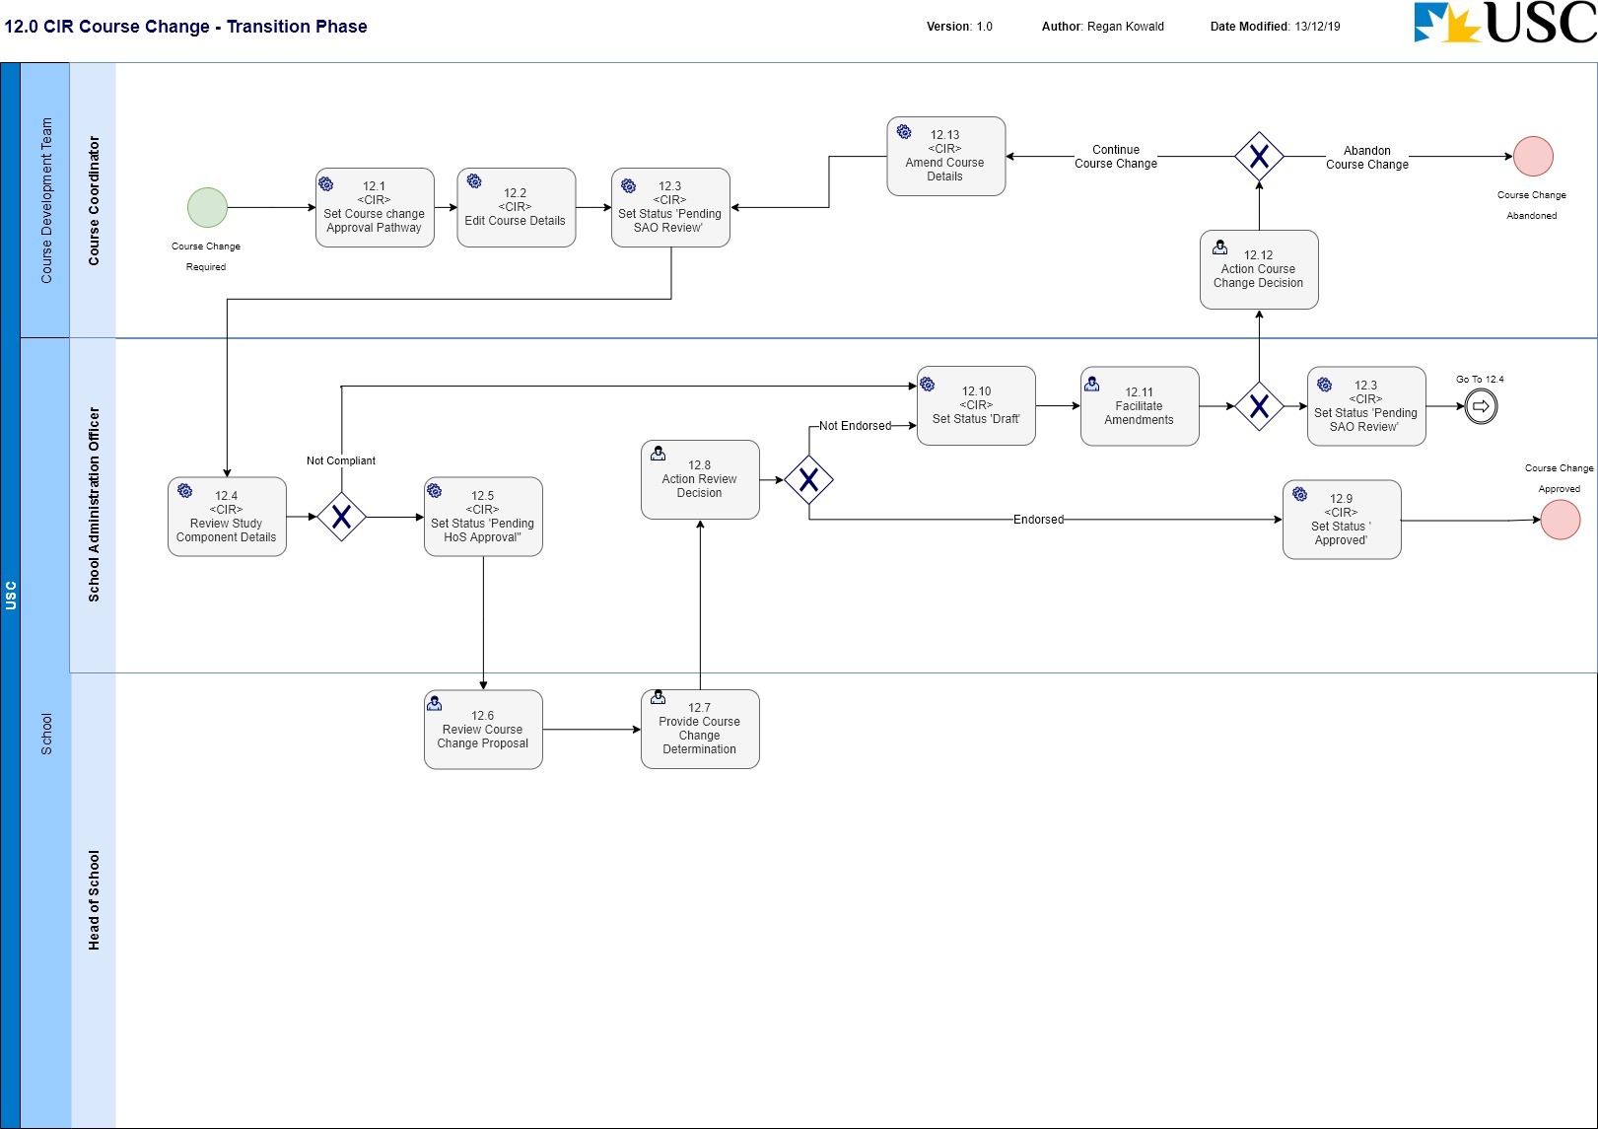
Business Process Name: | 12.0 CIR Course Change
Description | This is the process required to initiate a pre-enrolment or pre-delivery change to a Course in CIR and manage the request through the formal review and approval business process.  Note: Refer Notes for the data changes relevant to Pre-Enrolment and Pre-Delivery.
Roles | - Course Coordinator – Course Development Team  - School Administration Officer – School  - Head of School - School
Triggers | - A Course Coordinator initiates the request for a change to a Course.
Pre-Conditions | - The Course to be changed already exists in CIR.  - The change requested is not:  a change of Course Code;  a change that would result in the need for a different Field of Education to be assigned;  a change to the Course Level; or  a change to the Unit Value.
Process Task Description | - <CIR> Set Course change Approval Pathway  The Course Coordinator will access CIR and select either the ‘Course change – pre-delivery’ or ‘Course change – pre-enrolment’ Approval Pathway for the Course entity.  Note: This action will set the status of the Course entity to ‘Draft’.
- <CIR> Edit Course Details
The Course Coordinator will access CIR, and edit the relevant information required for the change to the Course.
- <CIR> Set Status ‘Pending SAO Review’
The status of the Course will be set to ‘Pending SAO Review’.
Note: This puts the entity into a state of ‘read only’ and changes cannot be made.
- <CIR> Review Course Details
The SAO upon receiving email notification, will review the details of the Course change proposal to determine if the details are compliant. If the current information is not compliant, the Course Coordinator will be notified, and the status of the Course will be set back to ‘Draft’ for modification.
- <CIR> Set Status ‘Pending HoS Approval’
The SAO will set the workflow status to ‘Pending HoS Approval’. This task requires the SAO to provide a comment/s supporting the status change.
- Review Course Change Proposal
The Head of School will consider the merit of the proposed Course change on the basis of the documentation and documented consultation with other professional and registration bodies, administrative services, curriculum expertise, and the conformity to the relevant policy and procedures.
- Provide Course Change Determination
The Head of School will consider the merit of the proposed course discontinuation on the basis of the documentation and the advice from the School Board and make a determination on the approval of the Course change.
- Action Review Decision
The SAO will determine what action is required of the HoS decision for the requested Course change. If the change is not endorsed, the SAO can facilitate amendments and/or return the request back to the Course Coordinator (Course Development Team) for review and modification based on the HoS recommendations.
If the change is endorsed, the SAO will progress the process to approve the entity.
Note: If the change is not endorsed, the SAO will set the status of the Course entity to ‘Draft’ to allow editing of the information.
- <CIR> Set Status ‘Approved’
The SAO will set the status of the Course entity to be ‘Approved’ and notify the School.
- <CIR> Set Status ‘Draft’
The Course entity will be set to a status of ‘Draft’ to enable editing in CIR.
- Facilitate Amendments
The SAO will either make the required administrative updates and approve the Course entity or initiate the process to amend the Course change documentation with the Course Coordinator.
- Action Course Change Decision
The Course Coordinator will review the amendments required to determine whether to continue the proposal to change the course or abandon the proposal.
- <CIR> Amend Course Details
With the status of the Course entity as ‘Draft’, the Course Coordinator will make any the changes to the Course information in CIR to meet the approval requirements.
Post-Conditions | - The change to the Course is approved and has a CIR status of ‘Approved’; or  - The process to change the Course discontinued.
Supporting Applications/Tools | - Curriculum Information Repository
Forms/Templates | - USC Course Impact Statement  - Course Administration Information
Related Documentation | - Course Approval, Change and Discontinuation - Procedures  - Assessment: Courses and Coursework Programs - Academic Policy  - Australian Qualifications Framework  - Higher Education Standards Framework.
Business Rules | - The following data fields represent the Pre-enrolment data that can be changed: Course Title; Co-requisites; School Owner; Anti-requisites; Location; Course Components; Teaching Session/ Year offered; Grading Scale; Course description; Attendance Mode; Enrolment Restrictions; WIL level; Pre-requisites; and Study Abroad availability.  - All fields excluding the data fields listed as Pre-enrolment data represent the Pre-delivery data that can be changed.  - A2.1 Schools plan and progress all proposed new courses, course changes and course discontinuations to meet the University timeframes for approval as identified below:  * New Course - Study Period 1 offering – approved by 31 August for the following academic year Study Period 2 offering – approved by 30 November for the following academic year.  * New course already approved as a Course Synopsis - Study Period 1 offering – approved by 31 August for the following academic year Study Period 2 offering – approved by 30 November for the following academic year.  * Change to Pre-enrolment data for existing courses - Approved by 31 August for all offerings in the following academic year.  * Change to other data fields for existing courses - Approved four weeks prior to the delivery of the course.  * Changes to “service courses” (specified data fields) - Approved by 31 August for all offerings in the following academic year.  * Discontinuation of an existing course - Approved by 31 August for implementation in the following academic year.  - C1 Proposed changes that cannot be approved  C1.1 A proposal for any of the following cannot be progressed as a change to a course:  a change of course code (See C1.3 for exception);  a change that would result in the need for a different Field of Education to be assigned;  a change to the course level (refer to section 7.4 of the Coursework Curriculum Design – Procedures);or  a change to the unit value.  C1.2 Any change of the type listed above requires the development of a New Course Proposal and an associated Proposal to Discontinue a Course. (Refer to Part B and D respectively).  C1.3 A change of course code can be approved as a Course Change if the change is confined to the alphabetic discipline descriptor component of the code.  - C2 Course changes and approval authorities  C2.1 Approval of changes to existing courses is the responsibility of the relevant Head of School, except in the following cases:  Late changes to Pre-enrolment Data fields (refer to C3.3)  Changes to a designated “Service” course (refer to C7).  - C3 Timelines  C3.1 The procedures recognise that some elements of course information (Pre-enrolment Data) are required to be approved to facilitate student enrolment for the subsequent academic year. These fields are identified in Appendix 1. This Pre-enrolment Data is required to be approved in June for the following academic year and is collected for all offerings of the course in that year.  C3.2 The Schools establish timelines annually covering all teaching periods to ensure timely progression of course change proposals to meet the identified deadlines and approval pathways.  C3.3 Late changes to Pre-enrolment Data  C3.3 1 Approval to change course data fields as submitted as part of the June collection requires the Head of School to make an application to the Dean (Academic) on the required template. The case would include a risk assessment of the proposed change and the impact on the student experience. The application should include evidence of consultation with Student Services and Engagement.  C3.3.2 The request to the Chair, Program and Course Committee is made through the Curriculum Support Unit, C-SALT to the Secretary, Program and Course Committee.  C3.3.3 The Chair, Program and Course Committee may consult with the Pro-Vice-Chancellor (Students) before making a decision on the request.  C3.3.4 The Curriculum Support Unit, C-SALT, informs the relevant School of the decision of the Chair, Program and Course Committee.  - C4 Consultation  The Course Coordinator proposed changes to the course ensuring that:  (a) consultations are held with all parties: (i) with a legitimate interest in the proposed development, including for example other schools if the course is to be made available in a cross-school or double degree program, and professional and registration bodies; (ii) for whom there may be resource or administrative implications with the proposed developments, including for example Information Technology Services, Information Services, and Student Services and Engagement;  (b) input is sought from other appropriate sources with relevant expertise, for example a school curriculum body, academic developers and CSU staff available within C-SALT;  (c) the course is designed and developed consistent with: any applicable policies and procedures within the University, in particular the Coursework Curriculum Design – Academic Policy and related procedure; any standards for external recognition, registration or accreditation of any program in which the new course will be offered.  - C5 Documentation  The Course Coordinator documents the proposed changes to the course using the appropriate templates (including an appendix that summarises all resource issues and implications identified in consultations with Information Technology Services, Library and Student Services and Engagement, and agreement reached in relation to those matters) and a Course Outline, which is a revised version of the existing Course Outline incorporating the proposed changes.  C5.1 Referral of documentation for information  If the Course Coordinator believes that the proposed changes have an impact on Information Technology Services, Library and Student Services and Engagement, they should email a copy of the proposal, the revised Course Outline and Resource Impact Statement to the relevant persons in these units.  C5.2 Referral of documentation for quality assurance  The Course Coordinator forwards the proposal and Course Outline to the School Administration Officer who checks the documents for accuracy and completeness and determines the approval authority for the proposed change. The documentation is forwarded to Head of School to approve the proposed changes.
Issues
Notes | - As at time of writing, a decision has been made to make ‘Service Courses’ a redundant concept; this is in part due to the functionality that will be available in CIR to manage the Course entities including the ability to notify all relevant dependant stakeholders.  - It is an assumption of this business process that the: ‘Course Outline’; and ‘Course Administration Information’; as named in USC Course Approval, Change and Discontinuation - Procedures documents will be superseded by the introduction of CIR i.e. the information contained in these documents will be available as the CIR Course entity.  - This Process Map depicts the workflow expected for the initial implementation of CIR and should be considered a transitional phase. As the business outside of C-SALT become more familiar with the CIR, the CSO’s will take less of a role in facilitating the workflows through, and each role in the workflow will take the responsibility for progressing the status change through the workflow.

13.0 CIR Course Discontinuation
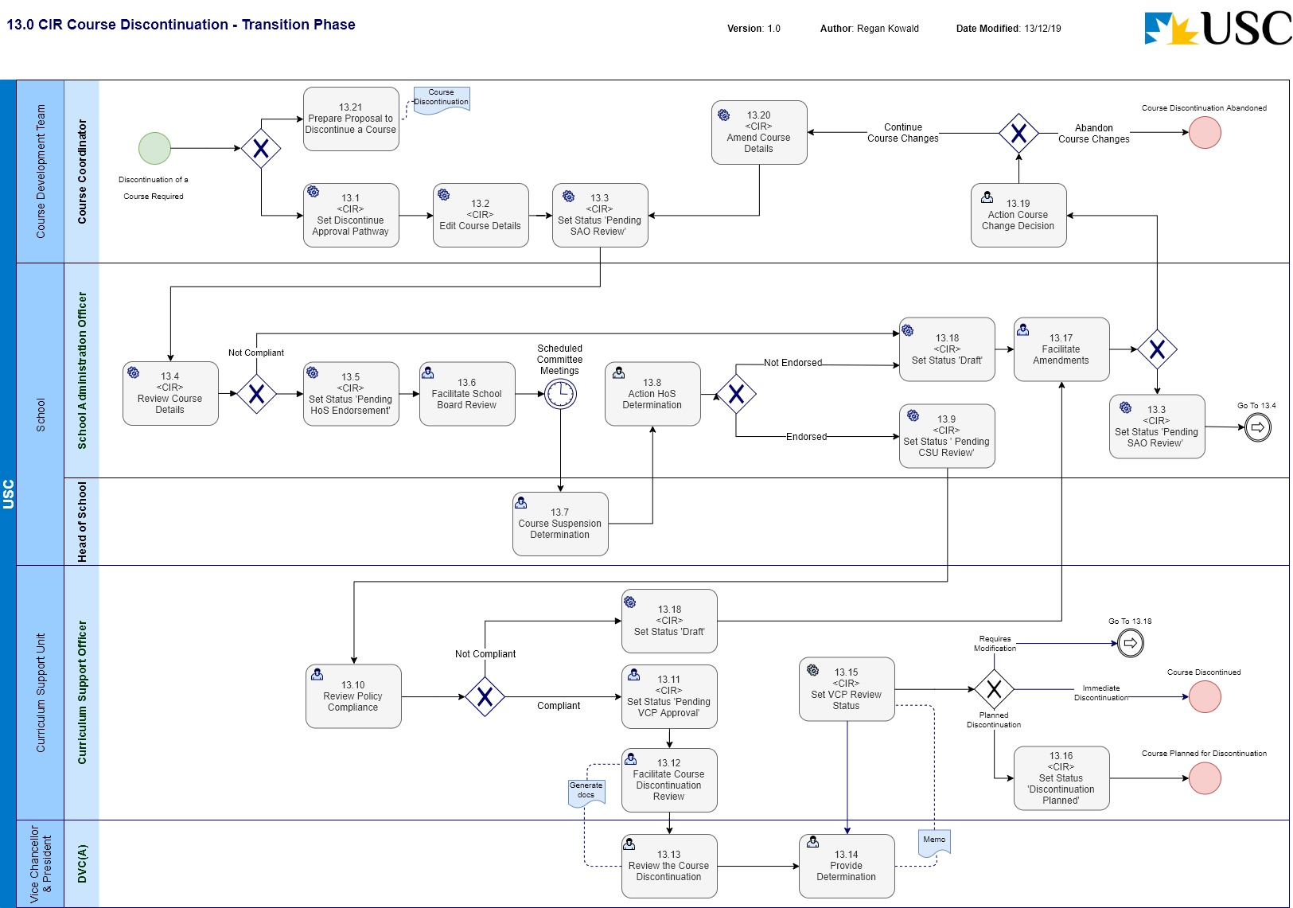
Business Process Name: | 13.0 CIR Course Discontinuation
Description | This is the process required to initiate a discontinuation of a Course in CIR and manage the request through the formal review and approval business process.
Roles | - Course Coordinator – Course Development Team  - School Administration Officer - School  - Curriculum Support Officer – C-SALT  - DVC(A) as delegate for the VCP – Office of the Vice-Chancellor & President
Triggers | - A Course Coordinator initiates the request for the discontinuation of a Course.
Pre-Conditions | - The Course to be discontinued exists in CIR.
Process Task Description | - <CIR> Set Discontinue Approval Pathway  The Course Coordinator will access CIR and select either the ‘Discontinue’ Approval Pathway for the Course entity.  Note: This action will set the status of the Course entity to ‘Draft’.
- <CIR> Edit Course Details
The Course Coordinator will access CIR, and enter the information required to discontinue the Course.
The Course Coordinator will facilitate the creation of the Proposal to Discontinue a Course at this time.
- <CIR> Set Status ‘Pending SAO Review’
The status of the Course will be set to ‘Pending SAO Review’.
If this is the initial setting of this status, The Course Coordinator will also attach the ‘Proposal to Discontinue a Course’.
Note: This puts the entity into a state of ‘read only’ and changes cannot be made.
- <CIR> Review Course Details
The SAO upon receiving email notification, will review the details of the Course discontinuation to determine if the details are compliant. If the current information is not compliant, the Course Coordinator will be notified, and the status of the Course will be set back to ‘Draft’ for modification.
The SAO will also review the ‘Proposal to Discontinue a Course’ in conjunction with the CIR information.
- <CIR> Set Status ‘Pending HoS Endorsement’
The SAO will set the workflow status to ‘Pending HoS Endorsement’. This task requires the SAO to provide a comment/s supporting the status change.
- Facilitate School Board Review
The SAO will compile the relevant documentation for the Head of School to seek informed advice from the School Board. The Head of School will consider the merit of the proposed Course on the basis of the documentation and the advice from the School Board and make a determination.
- Course Suspension Determination
The Head of School will consider the merit of the proposed course discontinuation on the basis of the documentation and the advice from the School Board and make a determination on the approval of the Course discontinuation.
- Action HoS Determination
The SAO will action the tasks required of the HoS decision for the Course. If the discontinuation is not endorsed, the SAO will return the request back to the Course Coordinator (Course Development Team) for review and modification based on the HoS recommendations. If the discontinuation is endorsed, the SAO will progress the process.
Note: If the change is not endorsed, the SAO will set the status of the Course entity to ‘Draft’ to allow editing of the information.
- Set Status ‘Pending CSU Review’
The SAO will set the workflow status to ‘Pending CSU Review’. This task requires the SAO to provide supporting comment/s with the status change.
- Review Policy Compliance
The CSO reviews the Course discontinuation details for policy compliance (University and external reference points), data quality and completeness. If the information is not compliant, the SAO will be notified, and the Course request will be sent back for amendment.
Note: If the change is not endorsed, the CSO will set the status of the Course entity to ‘Draft’ to allow editing of the information.
- <CIR> Set Status ‘Pending VCP Approval’
The CSU will set the workflow status to be ‘Pending VCP Approval’.
- Facilitate Course Discontinuation Review
The CSO will export the information out of CIR in PDF format and facilitate the distribution to the DVC(A) as delegate for the VCP. The CSO will then monitor the progress for a response.
- Review the Course Discontinuation
The DVC(A) as delegate for the VCP will review the submitted documentation from CSU and facilitate any discussions with relevant parties to provide a decision to the School.
- Provide Determination
The DVC(A) will decide on whether to approve the discontinuation of the Course or not and notify CSU.
The CSU will be notified via a DVC(A) Memo.
- <CIR> Set VCP Review Status
The CSO will set the status for the workflow dependant on the determination by the DVC(A):
If the decision is that the request for discontinuation of the Course needs to be modified, the CSO will set the status ‘Draft’ and notify the SAO.
If the decision is that the request for immediate discontinuation of the Course is approved the CSO will set the status ‘Discontinued’ and notify the School.
- <CIR> Set Status ‘Planned Discontinuation’
If the decision of the DVC(A) is that the Course has been approved for a planned (future dated) discontinuation, the CSO will set the status ‘Discontinuation Planned’. The CSO will also enter in a date for the planned discontinuation (‘final study period of offer’).
- Facilitate Amendments
The SAO will receive notification and commentary with the status change ‘Draft’ outlining the amendments required to make the Course discontinuation compliant. The SAO will either make the required amendments and refer to the CSU for review or initiate the process to amend the Course discontinuation with the Course Coordinator.
- <CIR> Set Status ‘Draft’
The Course entity will be set to a status of ‘Draft’ to enable editing in CIR.
- Action Course Change Decision
The Course Coordinator will review the amendments required to determine whether to continue the proposal to discontinue the course or abandon the proposal.
- <CIR> Amend Course Details
With the status of the Course entity as ‘Draft’, the Course Coordinator will make any the changes to the Course information in CIR to meet the approval requirements.
- Prepare Proposal to Discontinue a Course
The Course Coordinator will initiate the creation of a ‘Proposal to Discontinue a Course’ document. This document will be required to support the CIR generated information for the approval workflow process.
Post-Conditions | - The discontinuation of the Course is approved and has a CIR status of ‘Discontinued’; or  - The planned discontinuation of the Course is approved, has a CIR status of ‘Discontinuation Planned’ and the planned date for discontinuation has been recorded; or  - The process to discontinue the Course is abandoned.
Supporting Applications/Tools | - Curriculum Information Repository
Forms/Templates | - Program Change Proposal requiring Committee(s) approval
Related Documentation | - USC Program Accreditation, Change and Discontinuation – Procedures.  - Program Accreditation and Course Approval - Governing Policy  - Program Review - Procedures  - Australian Qualifications Framework  - Higher Education Standards Framework.
Business Rules | - The date associated with the ‘Planned for Discontinuation’ status will be the ‘final study period of offer’.  - D1 Course discontinuation authority  Discontinuation of a course is a decision made by the Deputy Vice-Chancellor (Academic) (as delegate of the Vice-Chancellor and President), on a recommendation of the Head of School, that:  (a) there can be no new enrolments of students into that course from a specified teaching period;  (b) the course can no longer be advertised or marketed as available to students; and  (c) the course is to be eventually removed from the suite of course available to students.  The process for approval to not offer a course at a particular location is a course change.  - D2 Timelines  D2.1 If it is proposed to discontinue a course, the School consults all interested parties and arranges for development of a timetable for the discontinuation and the final offerings of the course. The discontinuation plan takes account of:  (a) the need to provide timely information to impacted students, concerning discontinuation of the course;  (b) any consequential impact on programs containing the course;  (c) any current articulation arrangements that are in place that include the course; and  (d) any associated transition arrangements.  - D3 Consultations  D3.1 The relevant Course Coordinator undertakes consultations with all parties with a legitimate interest in the course, any relevant professional associations and Program Leader(s) if the course is compulsory or part of a required in a program or programs.  D3.2 Consultation should also occur with Student Service and Engagement and other interested parties regarding the extent of transitional and teaching out arrangements for students currently undertaking the course.  - D4 Proposal to Discontinue a Course  D4.1 The School Administration Officer documents the proposed discontinuation using the proposal to Discontinue a Course template.  D4.2 The School Administration Officer forwards the proposal and outline to the relevant Head of School who considers the documentation.  D4.3 Before endorsement, the Head of School may request that the documentation is considered by the School Board.  D4.4 The Head of School considers the merit of the discontinuation proposal for the course on the basis of the documentation and advice of the School Board and recommends to the Deputy Vice-Chancellor (Academic) that the course be considered for discontinuation.  D4.5 The Head of School considers the merit of the proposed program on the basis of the accreditation documentation and advice of the School Board and approve the proposal.  D4.6 The School Administration Officer arranges for the signed accreditation documentation to be submitted to the Curriculum Support Unit, C-SALT and captures the accreditation documentation on the relevant program and course files in the University’s records management system.  - D5 Approval by the Vice-Chancellor and President or delegate  D5.1 The Curriculum Support Unit, C-SALT checks the Course Discontinuation Proposal for completeness and clarity. The Curriculum Support Unit, C-SALT refers the proposal to the Deputy Vice-Chancellor (Academic).  D5.2 The Deputy Vice-Chancellor (Academic) (as delegate of the Vice-Chancellor and President) decides whether to approve the proposed course discontinuation and signs the relevant section of the proposal.
Issues | - Currently when a status of ‘Planned Discontinuation’ has been applied, the actual planned date for discontinuation (i.e. the final study period of offer) cannot be captured in CIR.
Notes | - As at time of writing, a decision has been made to make ‘Service Courses’ a redundant concept; this is in part due to the functionality that will be available in CIR to manage the Course entities including the ability to notify all relevant dependant stakeholders.  - It is an assumption of this business process that the: ‘Course Outline’; and ‘Course Administration Information’; as named in USC Course Approval, Change and Discontinuation - Procedures documents will be superseded by the introduction of CIR i.e. the information contained in these documents will be available as the CIR Course entity.  - This Process Map depicts the workflow expected for the initial implementation of CIR and should be considered a transitional phase. As the business outside of C-SALT become more familiar with the CIR, the CSO’s will take less of a role in facilitating the workflows through, and each role in the workflow will take the responsibility for progressing the status change through the workflow.

Appendix

A change of Course Code can be approved as a Course Change if the change is confined to the alphabetic discipline descriptor component of the code.

