Boeing 737 Max Lion Air Crash
Student’s Name
Institutional Affiliation

Boeing 737 Max Lion Air crash
Boeing 737 Max Lion Air crash, happened into the sea in October 2018 a few minutes after taking off from Jakarta, resulting in the death of 189 passengers who were on board (Rhue 2020). This paper aims to use five approaches and five whys to discuss at least ten causes that contributed to the air crash of Boeing 7373 Max Lion.
Notably, unsafe supervision is the first approach that can be used into identifying the reasons for the Boeing 737 Max Lion Air crash. This approach has been used because it shows how either the management of Boeing or the pilot failed to properly supervise or partly supervised the repairs to this plane. According to Johnston (2019), design and mechanical issues all together combined with the inexperienced pilot were the key causes of the crash of the max jet Lion Air Boeing in October 2018. A report from Indonesia showed that the first officer had notable issues in aircraft handling during the process of training and was also not familiar with the procedures.
Unsafe action could also be a second approach that would have helped in the identification of the cause via hinting at whether there was an unsafe action that was practiced by anyone in the line of management or piloting. True to this approach and fishbone, It was evident that, during the certification and design of this craft, there were assumptions relating to pilot malfunctions which later resulted to be incorrect and hence the accident.
Additionally, by using the organizational influences approach, which reveals the management resources, organizational process, and organizational climate. According to Wendel (2019), through this approach, the third factor that could have resulted in the crash is noted. There were no documentation in the flight of the aircraft and also the log of maintenance by the management relating to the continuous shaking of the stick and also the utilization of NNC Runaway Stabilizer. This hinted that the information was not getting to the crew of maintenance in Jakarta and it was as well unavailable to the accident crew thus they could not have been able to inject the wanted actions.
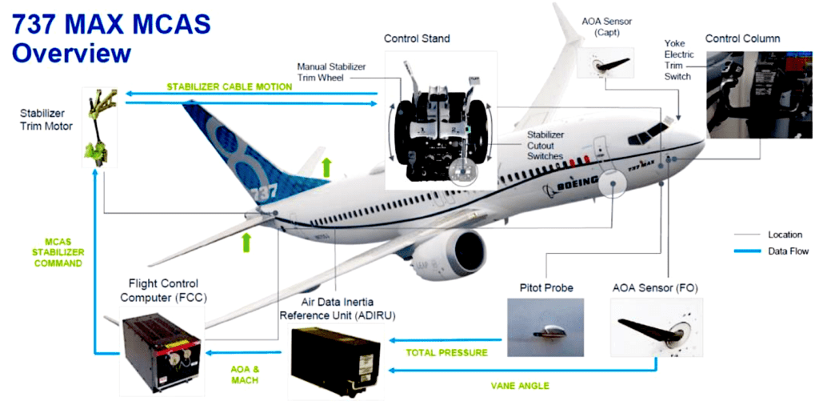
From the fishbone diagram above, it is agreeable that the crash occurred mainly not because of environmental factors but because of aircraft performance characteristics, human factor, and runaway conditions as discussed here: As a result of the incorrect assumptions relating to the pilot response and also the half-baked review of associated effects of multiple light decks, the reliance of an MCA on one sensor was perceived to be okay and met all the requirements of certification (Rhue 2020). The other contributing factor is that the MCAs were designed to depend on one AOA sensor thus making it prone to a wrong input from the sensor.
Still, the lack of guidance on MCAs or a more comprehensive use of trim in the manuals of flight and the training of the pilots blocked the crews from properly responding to uncommanded MCAS.
Still, another contributing factor was that the alert of AOA DISAGREE was not properly activated during the development of Boeing 737 8 (MAX). Resultantly, it failed to display during the process of miscalibrated AOA sensor, could not be put into documents by the operating crew and therefore it was not available to aid in the identification of the
miscalibrated AOA sensor (Wendel 2019). Additionally, the AOA sensor replacement which was in use on the accident aircraft had undergone miscalibration during a previous repair. The detection of the miscalibrated sensor was not done in the repair process.
Lastly, it was evident that there was no effective management of the several alerts, recurring MCAS activations, and also distractions relating to the numerous ATC communications. This was as a result of the situation hardships and inappropriate in manual handling, execution of NNC, and communication flight crew leading to the ineffective application of CRM and also the management of the workload. Previously, these deficiencies had been established during the training process and they also showed up during the flight of the accident.
In conclusion, it is evident from the discussion above that the Boeing 737 Max Lion Air crash happened as a result of issues that could have been avoided only if the managing company of the plane had taken such minor issues with the seriousness it required. It is believed that if one of the cases discussed above did not take place, then the probability was that the crash could not have occurred.

References
Johnston, P., & Harris, R. (2019). The Boeing 737 MAX saga: lessons for software organizations. Software Quality Professional, 21(3), 4-12.
Rhue, L., & Washington, A. L. (2020). AI's Wide Open: Premature Artificial Intelligence and Public Policy. BUJ Sci. & Tech. L., 26, 35
Wendel, W. B. (2019). Technological Solutions to Human Error and How They Can Kill You: Understanding the Boeing 737 Max Products Liability Litigation. J. Air L. & Com., 84, 379.

