Analysis and Designing Process Modelling
Name

Contents
Introduction 4
Part 1: Level 2 Business Process Modelling 5
Equipme/++nt Checking and Payment 8
Part 2: +/Business Process Problem identification and Improvement Recommendation 8
Key Issues/ Problem Discussions 8
Major issue 1 8
Major issue 2 9
Major Issue 3 9
1. Where is the process bottleneck? 10
2. How to better organize staff and allocate jobs to achieve 80% utilization? 10
Best practice 11
Part 3: Logical Automated Business Processing: 12
Analysis of Identified Solution 13
Recommendations 14
Summary on the Process Improvement if Recommendations are implemented 14
Appendix 1 Best Practices Table 15
Appendix 2 Business Process Modelling 17
References 20

Analysis and Designing Process Modelling

Introduction
BPMN can be defined as supporting to business processes by the use methods, techniques as well as the application of software design to analyze operational processes. Ideally, business processes depict a vision of ordered activities and higher level operations and company structure. The application of process mapping techniques in BPMN provide a perfect communication of the branching role of IT within the company (Gallagher, 2019). A concept can be modelled satisfy audiences from different backgrounds, simplifying the primary elements as well as processes in a manner that makes their ability to be clear. As provided in the case study of building equipment rental process, W&T Living Design Company can use BPMN to scale up and bring more benefits such as efficiency in its operations; for example when the company want to track the origin as well as direction of the main process which divert to varying potential end points. This paper aims to perform business prom identification and improvement recommendations for the case study of W&T Living Design business processes. This paper also seeks to represent the whole scenario through level 1 business process modelling by drawing BPMN diagrams accordingly. Lastly, this paper presents discussion on logical automated processing.

Part 1: Level 2 Business Process Modelling
This sections provides an overview of BPMN diagrams based on the case study of Building Equipment Rental Request. These diagrams have been constructed using the current processes using level 2 BPMN diagrams comprising of a set of level 2 AS-IS models. Additionally, the TO-BE models have been. When completing this task, the assumptions made are only those that have been provided in the case study. The level of complexity in the implementation of BPMN has been reduced tremendously thus bring efficiency. The following are BPMN diagrams for the case study provided.
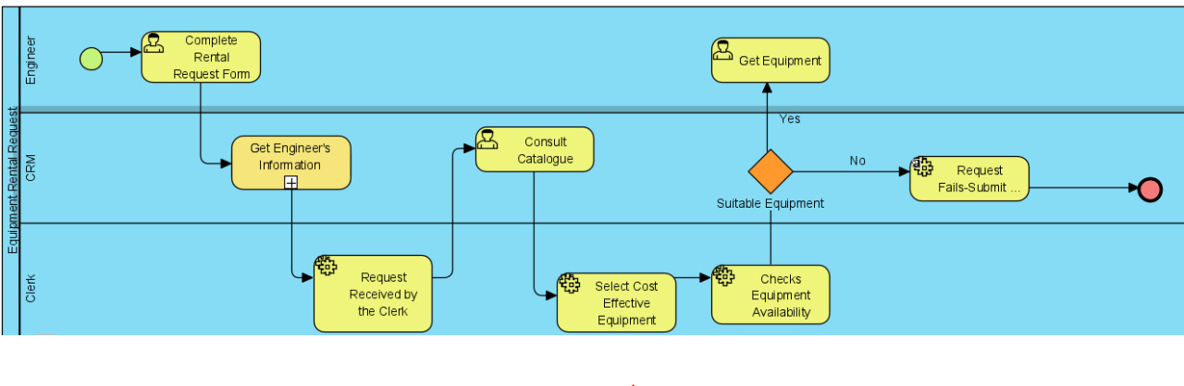
Completing Rental Form Request

Equipment Ordering Process
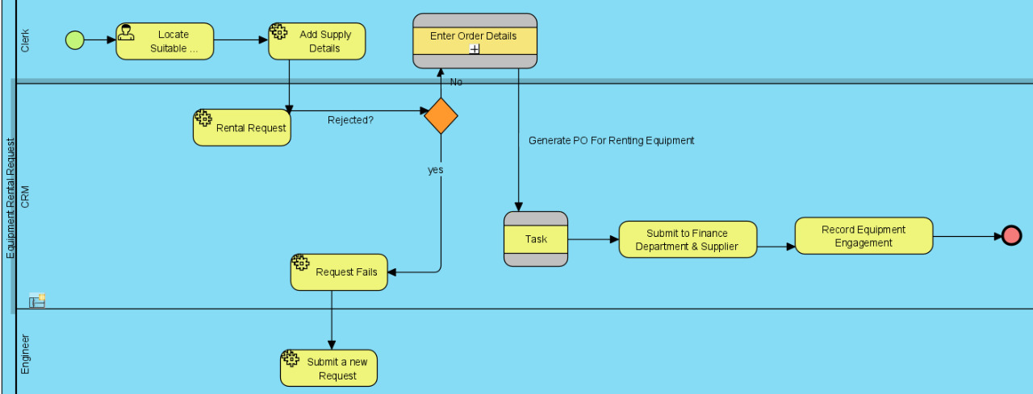
Equipment ordering process for the case study of W&T Living Design can be modelled as shown in the diagram below. Ordering process start by identifying suitable rental equipment then passing rental request, recording order details, submitting order details to the finance department as well as to recording equipment engagement.

Delivering Rented Equipment Process
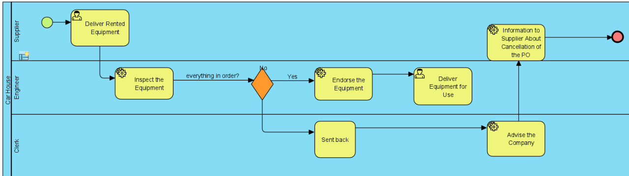
As shown in the diagram below, the processes involved in the delivery equipment involves inspecting the equipment if okay, equipment is endorsed before delivering equipment for use. The whole process has been descried as shown in the diagram below

Equipment Checking and Payment
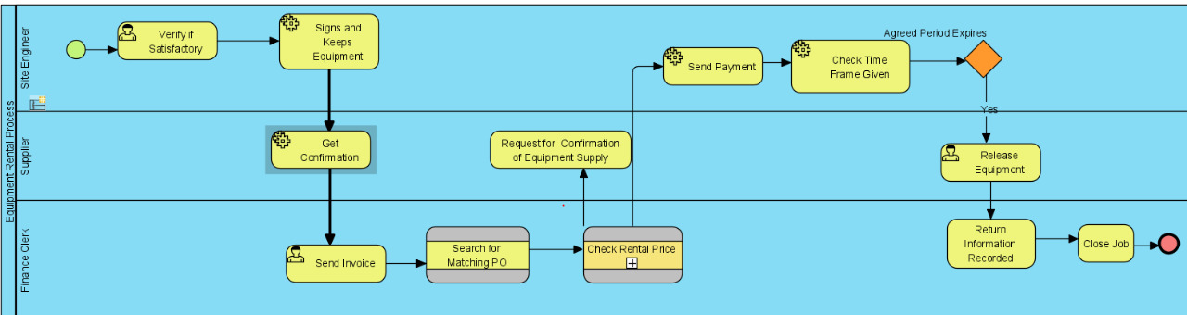
This process involves verifying if equipment is okay, if this equipment is okay, then supplier will send an invoice to the finance clerk before sending the payment.

Part 2: +/Business Process Problem identification and Improvement Recommendation

Key Issues/ Problem Discussions

Major issue 1
One of the main issue that emerges as provided in the case study is based on lack of process control. Based on the case of Building Rental request, there are a lot of processes/ activities involved within the organization when handling the key business operations. When renting a piece of equipment engineer must complete a form called Equipment Rental Request before sending it to the clerk at the organization depot, then other processes will follow the payment of the financial clerk pays for the service. The issue that is being addressed here is based on organization not having strict process control points as well as validation from the point of equipment rental request to approval as well as payment for the service

Major issue 2
The second issue faced by W&T Living Design that is based on the current processes and has an implication on the organization performance is the complexity of business processes thus resulting to a need of bringing efficiency in the processing of business activities. As mentioned in the case study of Equipment Rental Request there could be project delays which could cause cost blowout. Additionally, in case the rental request submitted by engineer fails, it appears that a new application will be done from scratch, where the clerk must find another supplier, and again this will lead to project delays. Such project delay will be a key issue and will affect organizational performance. Again, the whole process seems not to be efficient and effective.

Major Issue 3
Another issue relating to this discussion modelling each business process independently, and then integrating them so that they can produce the expected results. For example, Building Equipment Rental Request Processes comprises different processes such as “Equipment Rental Request”, which must be completed by filling a form and submitting it via email. Such business processes are autonomous and does not yield optimal organizational performance in terms of service delivery. Additionally, processes comprises of other sub processes such as consulting catalogues, submitting new revised request in case of request fails, approval of rental request by the engineers, payment by the finance clerk among others.
Another issue would be lack of understanding on how process models works or inspected, which often lead to a mismatch by humans, on what strategies ought to be taken, challenges that arise, and the nature of cognitive processes that are involved. The complex processes and sub processes can make it challenging to model all the businesses processes in a comprehensive manner. Therefore, the key issues/ problems in this discussion revolves around complexity of businesses processes for the Building Equipment Process, an issue with the nature of cognitive processes involved in the whole business case, and modelling each business process independently and then integration of all processes and sub processes to obtain expected outcomes becomes another challenge.

1. Where is the process bottleneck?
Process bottleneck is a constraint that creates a backlog around the bottleneck. Such constraints may prevent the system from achieving its goals (Lohrmann & Reichert, 2016). Ideally, process bottle necks ca either be internal or external to the system, and could be due to equipment issue, ineffective processes, and people. Notably, in the case study provided, there are some process bottlenecks include process inefficiency in renting the equipment. There are some delays which has a cost implication to the company. This is mostly notable due to many formalities expressed in the case study like waiting for approval of equipment rental request, and if the approval is rejected, it means that the engineer has to submit another application. This will also call for site engineer to have a discussion with the client regarding finding ideal solution. Additionally, the whole process of equipment rental request appears to have another bottleneck regarding communication from one process to the other, has a lot of delays.

2. How to better organize staff and allocate jobs to achieve 80% utilization?
Various approaches can be worked to ensure better performance in the organization’s business processes, such approaches include capacity and demand management whereby optimization of resource utilization through prioritization of high value work. Additionally, resource utilization are paramount in ensuring that ideal resources are available in supporting strategic goal of the organization. Another important approach of organizing staff is by performing progress and time tracking, this will be helpful in understanding the time that staff are taking in the allocated jobs especially those that are highly valuable to the organization. Comparison of the planned effort versus actual effort as a way of helping in improving estimates and better understanding where resources are being spent most. Ideally, using a realistic and comprehensive and effective resource management system that delivers the above defined capabilities will go along the way in obtaining realistic view demand and capacity to deliver on the planned effort. Similarly, with proper management of priority requests, and setting up expectations with key expectations will trigger staff in delivering what is expected of them hence ensuring over 80% utilization.
One of the key best practices I relation to the issues/ problems identified is proper definition of communication process in delivery of services. This will be critical in boosting the performance of the organization, and avoiding other bottlenecks such as delays as mentioned and noted in the case study of Building Rental Request. The problem of process inefficiency has a cost implication and this can be resolved through introduction of BPM, which enables organization in aligning business functions with the needs of customers, who are the core value of the business. Additionally, this is important in helping the top management in determining how to deploy, monitoring as well as measuring company resources.
In modern environment, organizations are having increasing pressure in delivering innovative, technologically advanced as well as services with a tight budget. It can be noted that there is ineffective and sub-optimal resource management in the equipment rental request process, which has a likelihood of leading to negative consequences such as poor productivity, process inefficiencies, increased costs, low morale, missed opportunities, decreased qualities, and delays.

Best practice
With regards to best practice in developing BPMN, it is important to note that this requires following proper standards which include consistent naming of the activities, gateways and other elements. This practice makes it easier for the reader or organization to understand the flow of business processes that are being modelled. Another best practice is breaking down of complex diagrams at multiple levels to make it easier to understand and analyse the process. Ideally, the fundamental best practice is getting rid of complex diagrams and retaining all important information of the tasks being modelled
Advice on Best practices:
In the implementation of BPMN in relation to building equipment rental request process, there are several best practices that need to be put into considerations. Such best practices include:
- Making sure that the BPMN diagram has been done accurately and that it reflect to the process logic, completed with labels, gateways, sub-processes, and intermediate events.
- Showing explicitly on handling of the events
- Making the models hierarchical with processes and sub-processes spanning from the top-level diagram.
- Consistent application of the message flows indicating business context of the processes and events.
- Proper redesigning of the business processes to offer solution to the current problem.

Part 3: Logical Automated Business Processing:
Logical automated business processing involves using technologically enabled automation that comprises of complex business processes. The primary goal of having automated business processing is streamlining businesses for simplicity, as well as achieving digital transformation. Notably, based on the case study of W&T Living Design organization, the current business process are being executed manually, and have proven to be very complex, thus causing a lot of bottlenecks such as in process inefficiency, cost blowout, delays, among others.
With the automation of business processing, this is critical in increasing service quality, improvement of service delivery, and efficient resource utilization (Indulska et al., 2009). As stated earlier, the current business process issues or problems are closely associated with process inefficiencies, complexity in business processes whereby there are a lot of processes that take place when renting an equipment from the initial equipment rental request to the delivery of equipment. This in turn leads to delay, thus bringing cost implication issue to the company. In order provide ideal solution, this will require transformation of business processes from AS-IS to logical automated processing models

Analysis of Identified Solution
Based on the analysis of identified solution, business process modelling is considered offer ideal representational capabilities as compared to other approaches. According to Aagesen and Krogstie (2010), different approaches that use BPMN are considered to be superior and are quite mature in terms of the representation capabilities of this technique. The application of BPMN can reduce the level of complexity identified as a key issue in this discussion and in line with the case study provided .i.e. Building Equipment Rental Request Processes. Additionally, further studies affirm that BPMN appears to denote considerable improvement in terms of modelling of the business process with the capabilities of coving different aspects of the processes including the properties, among others. The solution that is provided via the BPMN can be attributed by quality management, excellent process models which provides description of the methods used and working procedures. Additionally, the current BPMN is able to perform simulation and quantitative analysis with the aim of improving efficiency. Therefore, with regards to analysis of the problem based on the case study of building equipment rental processes, the identified solution is based on the application of process mappings in BPMN to improve efficiency as well as eliminating the issue of business processes complexity.

Recommendations
Ideally, the application of BPMN in processing modelling is geared towards bring efficiency and productivity in an organization. One of the key recommendation based on a case study of building equipment rental request processes for W&T Living Design Company is ensuring a comprehensive analysis of business processes have been taken, and identifying the key activities involved in rental requirement process. This will ensure that all processes and sub processes in the problem domain have been highlighted, mapped, and modelled accordingly to provide the ideal solution for the company as well as ensuring that efficiency in the business processes. Additionally, modelling the right business requirements will provide the required results, but if the requirements or business activities have not been modelled accordingly, this will lead to achievement of expected results in the long run.

Summary on the Process Improvement if Recommendations are implemented
With the implementation of business processing modelling in line with the case study provided, process improvement requires redesigning of these processes to make improvements a reality. Some of the process improvements as provided in the case study include automation of ordering process, rental request process, payment process, delivery of the equipment process, among others as described using BPMN relating to the case study under consideration. Additionally, If recommendations provided in this paper are fully implemented, process efficiency that has been described in this paper will be fully enhanced by eliminating complexity in communication and project delays as explained.

Appendix 1 Best Practices Table
Issue | Best Practice | Application Description and/ or solution | Advantages | Disadvantages
Process inefficiency | Automation of business processes and application of BPMN | With the problem of various manual processes as noted in the case study, there is a need to identify efficient way that is geared towards optimization of resources. This may include redesigning of the process and acquiring resources. | Optimization of resources, minimization of errors and risks etc. | Incorporation of changes require a complete redesigning of the business process
Cost blowout | Cost effective business processes | The current process of equipment rental request is complex in nature, thus leading to delays and hence higher cost implication. Building a BPM makes it easier to eliminate complex process, hence cost. | Eliminating unnecessary activities that are costly, hence solving the issue of cost that comes with this cost. | The whole process is dependent on the factors such as availability of resources, and usually benefit large organizations
Delay in communication process | Implementation of a business process management that solves this issue | The complexity issue can be solved by eliminating a lot of bureaucracies involved in the communication process and by building an automated communication process under one system, rather than moving than customer moving from one department to another seeking for services provided by the company | Coordination and integration of several functions immediately and providing improved viability and adequacy in the business process, by eliminating delays | Efficiency in communication for one department is improved at the expense of another. This happens in some instances

Appendix 2 Business Process Modelling
Completing Rental Form

Equipment Ordering Process

Delivering Rental Equipment Process

Equipment Checking and Payment

References
Aagesen, G., & Krogstie, J. (2010). Analysis and design of business processes using BPMN. In Handbook on Business Process Management 1 (pp. 213-235). Springer, Berlin, Heidelberg.
Radnor, Z. J. (2010). Review of business process improvement methodologies in public services (pp. 1-94). London: Aim Research.
Lohrmann, M., & Reichert, M. (2016). Effective application of process improvement patterns to business processes. Software & Systems Modeling, 15(2), 353-375.
Abramowicz, W., Filipowska, A., Kaczmarek, M., & Kaczmarek, T. (2012). Semantically enhanced business process modeling notation. In Semantic Technologies for Business and Information Systems Engineering: Concepts and Applications (pp. 259-275). IGI Global.
Flowers, R., & Edeki, C. (2013). Business process modeling notation. International Journal of Computer Science and Mobile Computing, 2(3), 35-40.
Indulska, M., Green, P., Recker, J., & Rosemann, M. (2009, November). Business process modeling: Perceived benefits. In International Conference on Conceptual Modeling (pp. 458-471). Springer, Berlin, Heidelberg.
Marcinkowski, B., & Kuciapski, M. (2012, September). A business process modeling notation extension for risk handling. In IFIP International Conference on Computer Information Systems and Industrial Management (pp. 374-381). Springer, Berlin, Heidelberg.
Gallagher, P. (2019 January, 14). Why Study BPMN? The Value of Business Process Modeling. Retrieved from https://blog.goodelearning.com/subject-areas/bpmn/benefits-of-studying-bpmn/

