ANALYSIS OF THE DOCUMENTARY MOVIE “INSIDE JOB”
Basic Information about Documentary:
Directed by | Charles Ferguson
Produced by | Audrey Marrs  Charles Ferguson
Narrated by | Matt Damon
Music by | Alex Heffes
Cinematography | Svetlana Cvetko  Kalyanee Mam
Editing by | Chad Beck  Adam Bolt
Distributed by | Sony Pictures Classics
Release date(s) | May 16, 2010 (Cannes)  October 8, 2010 (United States)
Running time | 108 minutes
Country | United States
Language | English
Introduction:
US Financial crises in 2008 hit all economies of the world and this documentary 'Inside Job' is a detailed analysis of said crisis which cost over $20 trillion, millions of people lost their jobs and homes in said crisis, The Financial crisis in 2008 was second largest financial crisis since Great Depression. Through extensive research and interviews of major journalists, politicians, academics, and financial insiders, the film tries to find out the route causes of this financial crises, the corruption in the financial and political system of US, impact of this corruption on global economies.

Five-Parts of the Documentary
The documentary has been divided into five parts which are:
Part-I : How We Got There
Part-II : The Bubble (2001-2007)
Part-III : The Crisis
Part-IV : Accountability
Part-V : Where Are We Now

Part-I: How We Got There

The Part one of the documentary explain that how this Financial took place. From where did it started.

The main cause of this Financial crisis was deregulation in 1980s of Financial Institutions which include Banks, Insurance Companies, Credit Rating Agencies etc. As a result of this deregulation, the Financial Institutions started playing in their own ways to get maximum personnel benefits. This documentary also explained that due to deregulation the three major banks (Iselandsbanki, Kaupping, and Glitnir) in Iceland created bubble in economy that burst at the end of 2008. In 1982 the Regan’s Administration allowed banking industry to making risky investment with the saving deposit of public and by the end of decade several loan companies failed this cost taxpayers $124 billions. The financial lobbiest and economists captured political system. By late 1990s the Financial Institutions consolidated into few gigantic firms, as a result the economic system was correlated with the decision of these large firms.

1999 Citicorp and Travelers merged together to form Citigroup, this merger violated the Glass-Steagal act, which prohibit making risky investment with customer deposits. In the same year the congress passed Gramm-Leach-Bliley-Act, this act was passed to facilitate the said merger, but on the basis of this new act many other mergers took place, which latter became the cause of Financial Crisis.

Before the Financial crisis of 2008, therefore short-term financial crisis in 2001, which was bubble created by Financial Institutions in Internet Companies, which latter burst in 2003, but US Govt. did not learn from this crisis and did not put the regulation on these institutions, as a result we were faced with the Global Financial Crisis in 2008.

After the deregulation, many financial companies were caught in frauds, like money laundering, bribe, cooking books, showing wrong financial performance etc.

In early 1990s, the economics and banker with the help of advancement in technology created financial products, the major innovation was derivatives. The Derivative instruments are basically speculation or betting on stock prices, bankruptcy of companies, interest rates etc. In 2000, the law was passed and derivatives were led unregulated, as a result, the unregulated derivatives market boomed after 2001.

After 2001 the financial institutions were more powerful, profitable and concentrated. The Financial industry was dominated by:
Investment Banks | Financial Conglomerates | Securities Insurance Cos.
Goldman Sachs | Citigroup | AIG
Morgan Stanley | JP Morgan | MBIA
Lehman Brother |  | AMBAC
Merril Lynch
Bear Stearns

The above financial institutions created Securitization Food Chain, which is as follows:

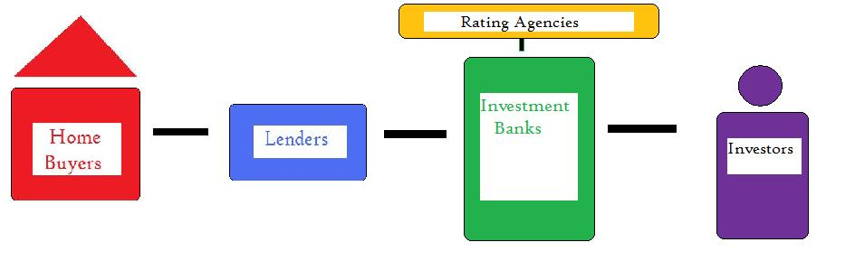
The lenders started to make mortgage loan to home buyers and they sold those mortgage loan to investment banks and the investment banks make a new product called CDO (Collateralized Debt Obligation), the investment banks paid Rating Agencies for rating CDO and these CDO received AAA rating, the highest possible rating, the investor invested huge fund on these CDO because of their highest ratings.

Part-II: The Bubble (2001-2007)
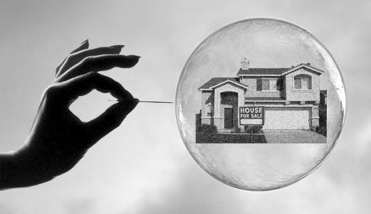
The financial bubble was created from 2001-2007, everyone could get house mortgage loan, even if they can not afford to pay it back, as a result the house price skyrocketed.
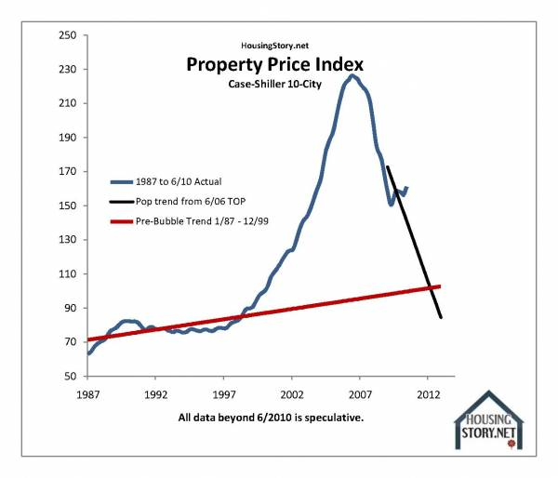

In this period of bubble the US Govt and Security and Exchange Commission of US did not monitored the banks closely. And bank also heavily borrowed in this period, the ratio of loan versus actual deposit was 33 to 01.
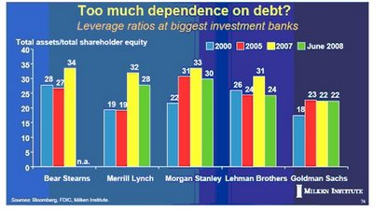
Another ticking tomb was credit default swap, these were derivative issued by AIG, Security Insurance Company to the investor who purchased CDO, in other world the company insured CDO, due to this investor felt more secure, however the AIG also issued these derivatives to those who did not own CDO.

Those financial institutions which were selling CDO were also betting against them because they knew that they will be unable to pay them back. So the CDOs were actually a fraud to the real investors and these CDO were shown as safe investment, whereas in actual, they were very risky. The rating agencies like Moody’s, Standard & Poors and Fitch made billions of profits by rating these CDO as ‘AAA’ rating.

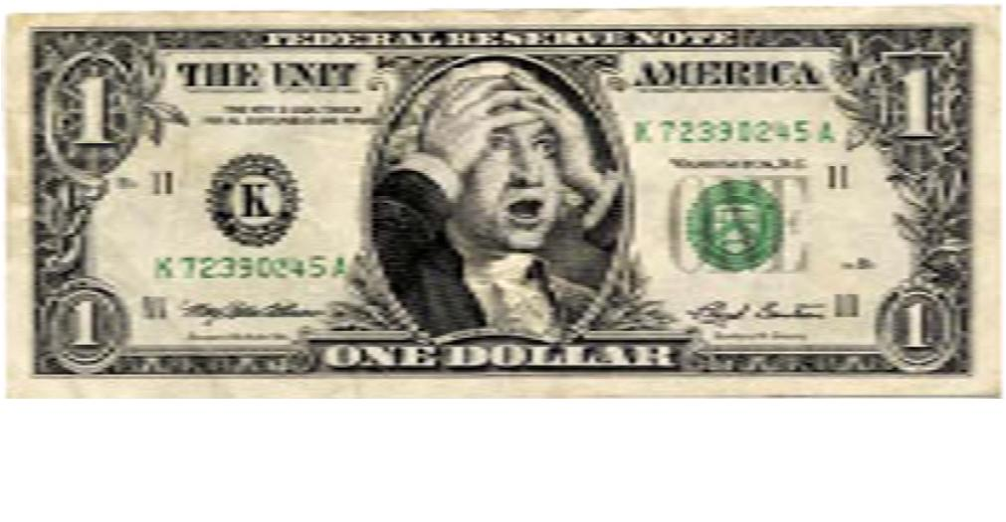

Part-III: The Crisis
Various warning were given by economist, journalist through their articles and reports in the bubble period. In 2008, mortgage loan holders failed to payback their loan to lenders, as a result the Securitization Food Chain imploded. The default on the part of mortgage borrowers were already clear, because loans were issued even to those house holders who could not afford to pay the loan back.

From the mid of 2008, major Financial Institution started to collapsed and bankrupt. The major bankruptcy was of Lehman Brothers in September, 2008 and this bankruptcy caused major disruption in the global financial markets. On September, 17 2008, the AIG was taken over and bailed out by the Government; $14 billions were only paid to Goldman Sachs out $160 billions total paid by AIG through Government bailed out.

On October 14, 2008, the President Bush signed $ 1400 billion bailed out package, but the market continued to fall. This crisis did not only hit US but it hit major economies of the world.

Nearly every house was put on sell due to default in payment of mortgage loan and the people has to live on temporary shelters.
Part-IV: Accountability
Many CEO and major decision makers who were responsible for this crisis just walked away.

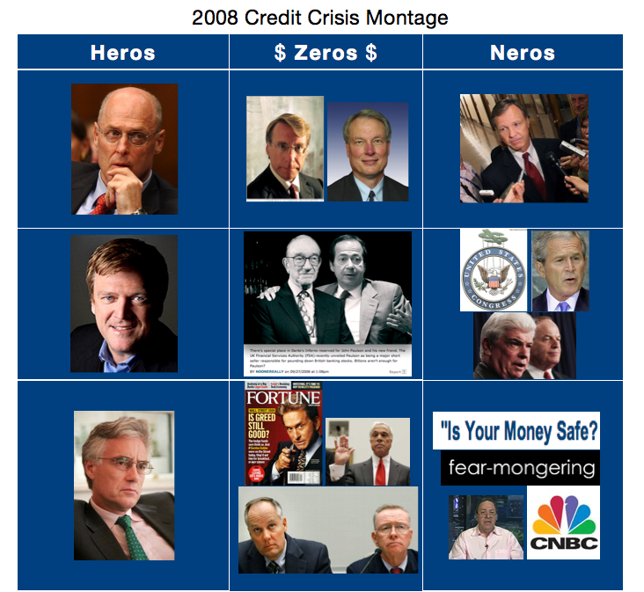

Top five executives of Lehman Brothers made millions of dollars between 2001 to 2007 (Bubble period). In march of 2008, the AIG’s Financial Product Division lost 11 Billions US dollars, instead of being fired, Joseph Cassano, the head of AIGFP was kept on as a consultant for a millions dollars a month. Many economists academics and professors were in favour of deregulation and they were appointed as advisors in economic affairs of the country and many were elected as directors of major financial institution and they made lots of money and they are also supposed to be held accountable for this financial crisis.

Part-V: Where Are We Now
The American economy is now weak as compared to what it was before the financial crisis, the competitor like China is flourishing. Unemployment and inflation has increase in US now. The construction industry is falling, however I.T industry in US is still strongest worldwide. But getting job in IT industry require high qualification and getting good qualification is very expensive now in US.

The difference between rich and poor is higher in United State than in any other company. The Brack Obama in 2008 election campaign promised changed and assured the regulation of financial industry so such financial crisis could not take place again. But after taking over office, the obama administration did not bring any reforms in financial industry as promised and even it did not charge in firm or bank excutive who earned millions of dollar during the bubble.

CONCLUSION
The main cause of financial crisis was deregulation and to give financial industry a full freedom, as a result, they acted in their own interest and made millions of dollars at the cost of taxpayers and general public investment. So It is recommended that strong actions are need to be taken against those who are responsible for this crisis, but it is unfortunate to see that those people and institutions are still in power. The Government need to bring reforms in financial industry.

